Abridged paper: Title with minimal capitalisation

Primary Author¹, Secondary Author²
¹Primary author business address
²Secondary author business address
Email for correspondence (presenting author): author@organisation.xxx

1. Introduction
This template should be used by authors preparing abridged papers for the ATRF 2023 conference. It contains detailed formatting instructions, guidelines for producing and submitting your paper, information on how papers will be assessed and approximate timelines for the conference.
In terms of content, an abridged paper is not expected to have a detailed review of literature, nor full presentation of results and discussion. However, it is expected to include a rationale for the study, justifying the methods of analysis, a brief description of data (if applicable), and the main insights from analysis, with recommendations for theory and/or practice.
If you have any questions about the paper submission and review process, please contact the conference secretariat by emailing atrfsc@gmail.com
2. Abridged paper length
Maximum 5-6 pages long, including figures and tables and references.
3. File format *NOTE new file format required
Papers must be submitted as MS Word files with line numbers shown on all lines in the original submission. Line numbers must be removed in the final version of the paper, submitted after authors respond to reviewer feedback.
4. Style guidelines
This section provides the paper format specifications. Authors who do not use MS Word should use the styles specified here as a guide.
4.1. Basic text styles and content
The pre-defined MS word text styles, which are modelled in this document, are shown in Table 1. Authors using software other than MS Word should use the specifications in Table 1 as a guide.

Table 1: Text styles for ATRF 2023 conference papers
Style | Specification
Paper title | Times New Roman, 20 point, bold, centred
Author name | Times New Roman, 12 point, normal, centred
Author addresses | Times New Roman, 10 point, normal, centred
Abstract heading | Times New Roman, 16 point, bold, centred
Normal (body text) | Times New Roman, 12 point, normal, fully justified
Captions | Times New Roman, 10 point, bold, left justified
Page headers | Times New Roman, 10 point, normal, centred
Section heading level 1 | Times New Roman, 16 point, bold, left justified
Section heading level 2 | Times New Roman, 14 point, bold, left justified
Section heading level 3 | Times New Roman, 12 point, bold italic, left justified
4.2. Headings and sub-headings
Minimal capitalisation should be used in all headings and sub-headings, including the title of the paper.

Headings and sub-headings should be numbered as shown below and in the examples throughout this document. References and Acknowledgements (if used) should use the section heading level 1 style without numbering.
4.2.1. Example of section heading level 3 style
Further levels of headings should not be used in an abridged paper.
4.3. Figures and tables
Figures and tables should fit within the page margins. For large figures and tables, landscape orientation may be used. In tables which run over multiple pages, column headers should be repeated on each page. Choices related to figure or table styles are up to the author but should be broadly consistent with the rest of the document where possible. Given the size limits, careful consideration should be given to the number of tables and figures included in an abridged paper.

Figure 1: Example figure
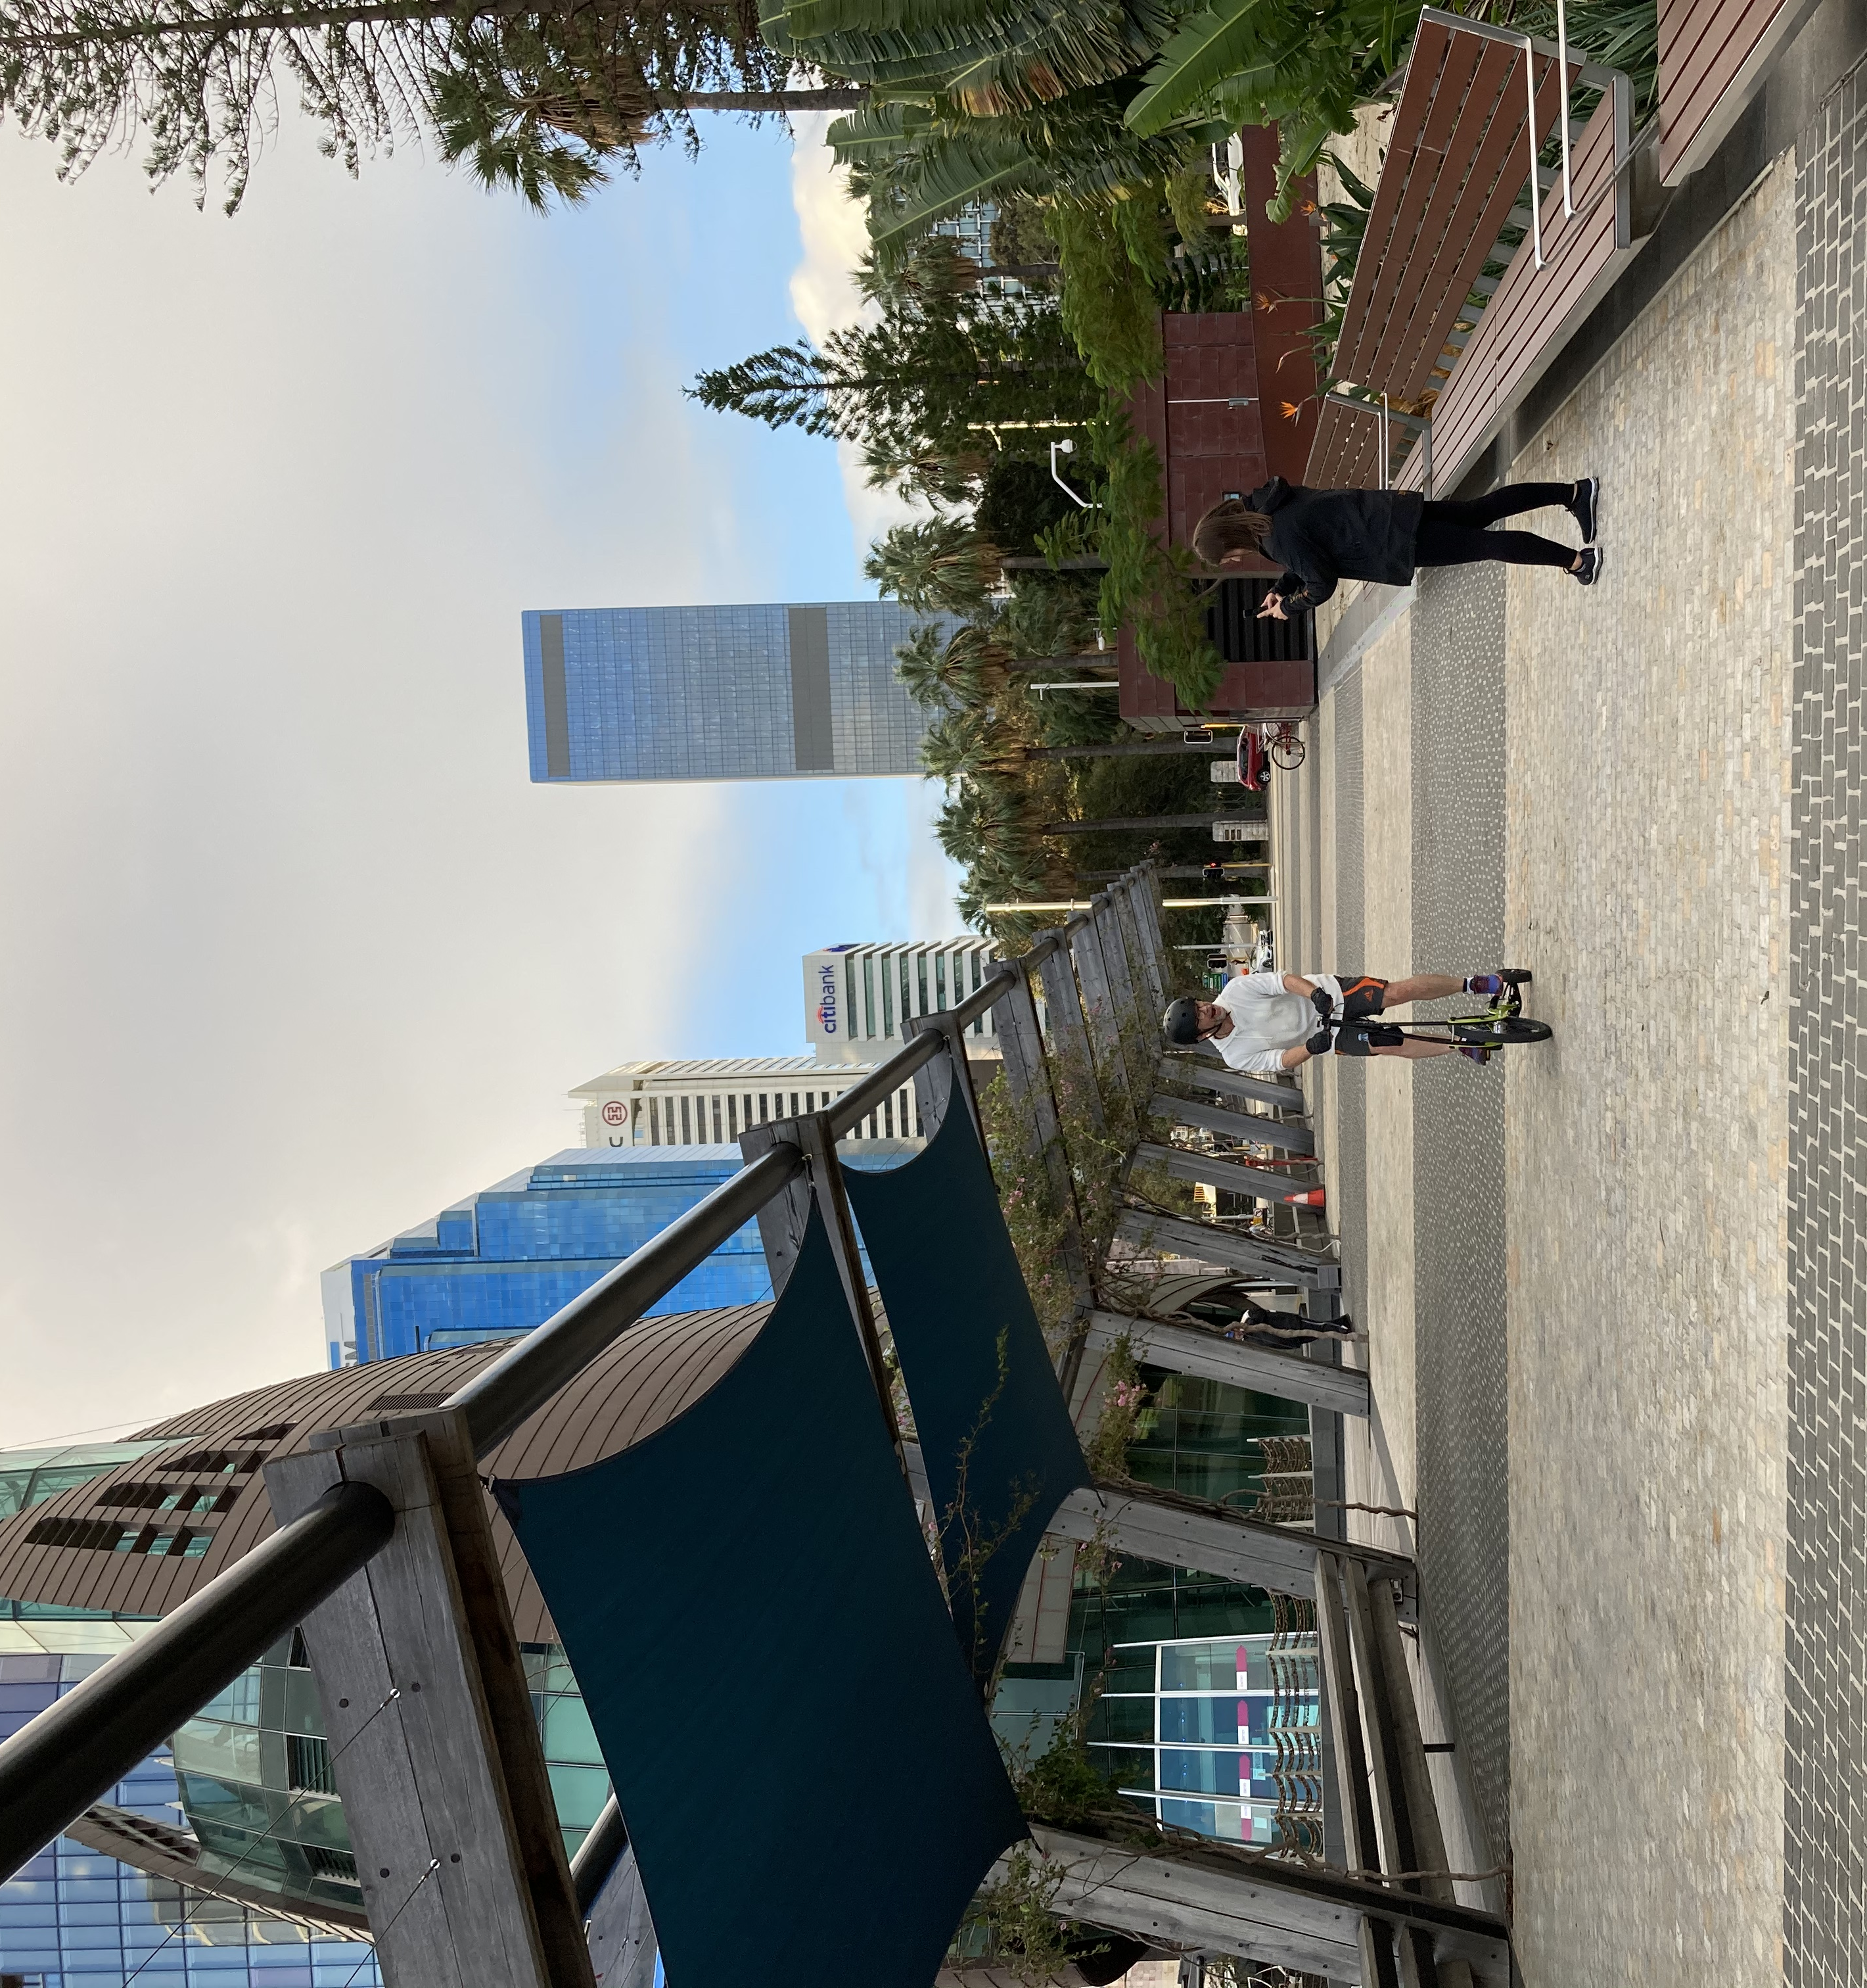
- Times New Roman, 10 point, bold, left justified
- Figure 1: – not Fig. 1
- Minimal capitalisation
- No period after caption
- Caption placed above both figures and tables

4.4. Captions, footnotes, and equations
Captions should be numbered separately with sequential integers (1, 2, 3, etc.) and placed above each figure and table.
Footnotes, if used, should be numbered sequentially throughout the document as with tables and figures.
Equations may take the numbering scheme and style chosen by the author.
4.5. References and citations
The Harvard (author/date) style must be used. All citations in the paper should correspond to an entry in a separate References section at the end of the paper. Entries should be listed alphabetically by author(s), and then chronologically, not numbered. See https://guides.lib.monash.edu/citing-referencing/harvard2020-intro for guidelines.
4.6. Miscellaneous
Page size is A4 and margins are 2.5 cm on each side with no gutter. This should not be modified, even for landscape-oriented figures or tables. Blank lines or page breaks may be used to enhance readability when necessary.

Capitalise only the first word and proper nouns as shown in this document. This includes the paper title. In text, capitalise the words Figure, Table, Section, Equation, etc. when referring to specific captioned items or to sections or sub-sections of your paper.

Please thoroughly check your paper for spelling and grammatical errors before submitting it. Please thoroughly check that your paper complies fully with formatting requirements. Papers which are unfit for publication without substantial editing may be rejected.
5. Review criteria
Authors should note that abridged papers will be assessed by at least two referees with expertise in the subject area, using the following criteria:
- Level of innovation and originality
- Rigour and contribution to transport knowledge
- Relevance to transport practitioners across a wide range of areas of interest
- Clarity of written presentation and compliance with the format specifications.

Abridged papers lacking substantive contribution, which present statements unsupported by evidence, or which inappropriately promote a particular product or service will not be accepted without major revisions.
6. Deadline and submission
The deadline for paper submission is Monday 17 April 2023. To submit your paper you need to use EasyChair – the web-based platform used to manage the paper review process. Please follow the following steps:

Go to https://easychair.org/conferences/?conf=atrf2023
- If you do not have an EasyChair account you will be prompted to set one up.
- Follow the instructions in the email you will receive from EasyChair.
- When you log in to EasyChair you will see either a ‘New Submission’ tab at the top left of the screen or a ‘make a new submission’ link. These will take you to the paper submission page.
- Select the relevant track for your paper.
- Fill in the author details, title, keywords and other information required.
- Upload your paper in MS Word format and press Submit.

Papers will be sent out for peer review by the topic chairs once submissions have closed.
7. Registration
We encourage you to register for the conference via the official conference website which will be available via a link from the permanent ATRF website: https://www.australasiantransportresearchforum.org.au/

We look forward to seeing you at ATRF 2023 in Perth.

