Professional practice papers: Instructions to authors

Primary Author¹, Secondary Author²
¹Primary author business address
²Secondary author business address
Email for correspondence: author@organisation.xxx

Abstract
This document provides instructions to authors for preparing their professional practice papers for the ATRF 2022 conference. It is also a template designed to assist authors using Microsoft Word (MS Word) to prepare their paper in compliance with the conference formatting requirements. If you have further questions on the paper submission and review process, please contact the conference secretariat by emailing atrfsc@gmail.com
1. Introduction
This is the template for ATRF 2022 professional practice papers. It also contains guidelines for producing and submitting your paper, information on how papers will be assessed, and approximate timelines for the conference. Please read this document thoroughly before attempting to submit your paper.
2. Paper length
The paper should be max 15 pages long. This includes the abstract, which should not exceed 300 words, tables and graphics, and references.
3. File format
All papers must be submitted as .pdf files.
4. Style guidelines
This section provides the paper format specifications. Please note that, although authors are not required to use MS Word, it is expected that they will follow the styles specified here as closely as possible. Submissions should not require editing to correct formatting. Papers which do not comply with these guidelines will be returned to the author for correction.
Line numbers are to be shown on all lines in the original paper. These must be removed in the final version of the paper which authors will submit after they respond to reviewer feedback.
4.1. Basic text styles
The pre-defined MS Word text styles, which are modelled in this document, are shown in Table 1. Authors using software other than MS Word should use the specifications in Table 1 to assist them in correctly formatting their paper.

Table 1: Text styles for ATRF 2022 conference papers
Style | Specification
Paper title | Times New Roman, 20 point, bold, centred
Author name | Times New Roman, 12 point, normal, centred
Author addresses | Times New Roman, 10 point, normal, centred
Abstract heading | Times New Roman, 16 point, bold, centred
Normal (body text) | Times New Roman, 12 point, normal, fully justified
Captions | Times New Roman, 10 point, bold, left justified
Page headers | Times New Roman, 10 point, normal, centred
Section heading level 1 | Times New Roman, 16 point, bold, left justified
Section heading level 2 | Times New Roman, 14 point, bold, left justified
Section heading level 3 | Times New Roman, 12 point, bold italic, left justified
4.2. Headings and sub-headings
Headings and sub-headings should be numbered as shown below and in the examples throughout this document. The references section heading should use the section heading level 1 style without numbering. Minimal capitalisation should be used in all headings.
4.2.1. Example of section heading level 3 style
Further levels of headings should use the style for heading 3 with additional levels of numbering. Before including level 4 or higher-level headings in your paper please consider whether this is absolutely necessary.
4.3. Figures and tables
Figures and tables should fit within the page margins. For large figures and tables, landscape orientation may be used. In tables which run over multiple pages, column headers should be repeated. Choices related to figure or table styles are up to the author but should be broadly consistent with the rest of the document where possible.

Figure 1: Example figure
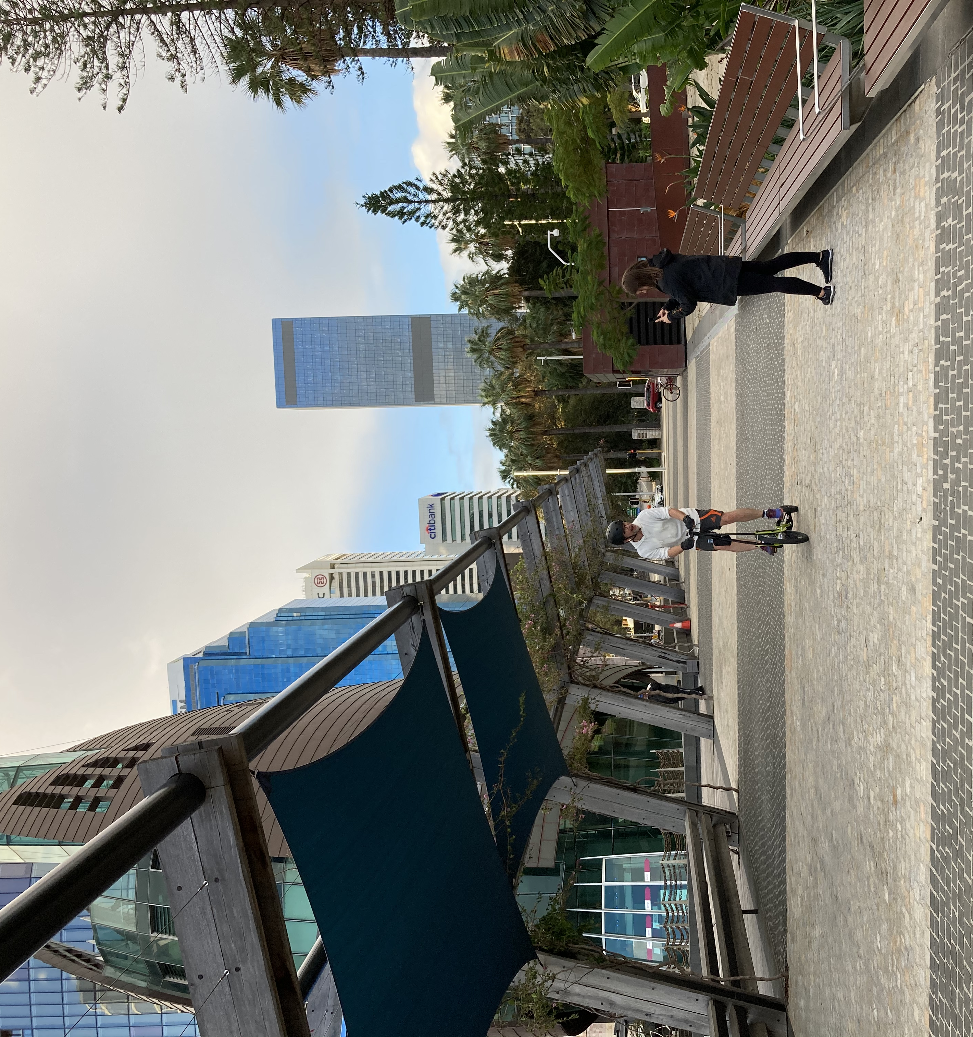

4.4. Captions, footnotes, and equations
Captions should be numbered separately with sequential integers (1, 2, 3, etc.) and placed above each figure and table. Footnotes, if used, should be numbered sequentially throughout the document as with tables and figures. The numbering scheme and style used for equations and other numbered items is up to the author.
4.5. References and citations
References and citations should use the Harvard (author/date) style. All citations in the paper should correspond to an entry in a separate References section at the end of the paper. In this section, entries should be sorted alphabetically by author(s), and then chronologically. A useful guide to Harvard style is provided by Monash University (see https://guides.lib.monash.edu/citing-referencing/harvard2020-intro).
4.6. Miscellaneous
The page size is A4 and margins are 2.5 cm on each side with no gutter. This should not be modified, even for landscape-oriented figures or tables. Blank lines or page breaks may be used to enhance readability when necessary.

Headings and captions should not end with a period. In headings and captions please capitalise only proper nouns and the first word as shown in this document. This includes the paper title. In text, capitalise the words Figure, Table, Section, Equation, etc. when referring to specific captioned items or to sections or sub-sections of your paper. Please use single spacing between sentences.

Please thoroughly check your paper for spelling and grammatical errors before submitting it. Authors submitting papers which are unfit for publication without substantial editing risk the paper being rejected.
5. Review criteria
Authors should note that professional practice papers will be assessed by at least two referees, practitioners with expertise in the subject area, using the following criteria:
- Relevance to transport practitioners across a wide range of areas of interest (e.g., administration, planning, design or operation of the transport system, the economic, social and environmental impacts of investments in transport infrastructure)
- Contribution to policy and practice
- Clarity of written presentation and compliance with the format specifications.

Papers which lack substantial content, which present statements unsupported by evidence, or which inappropriately promote a particular product or service will not be accepted without major revisions.
6. Deadline and submission
The deadline for paper submission is Friday 20 May 2022.
To submit your paper you need to use EasyChair - the web-based platform used to manage the paper review process. Please follow the following steps:

Go to https://easychair.org/conferences/?conf=atrf2022
- If you do not have an EasyChair account you will be prompted to set one up.
- Follow the instructions in the email you will receive from EasyChair.
- When you log in to EasyChair you will see either a ‘New Submission’ tab at the top left of the screen or a ‘make a new submission’ link. These will take you to the paper submission page.
- Select the relevant track for your paper.
- Fill in the author details, title, abstract, keywords and other information required.
- Upload your paper in .pdf format and press Submit.

Papers will be sent out for peer review by the relevant topic chairs once submissions have closed.
7. Registration
We encourage you to register for the conference via the official conference website which will be available via a link from the permanent ATRF website: https://www.australasiantransportresearchforum.org.au/

We look forward to seeing you at ATRF 2022 in Adelaide.

