Remote transport efficiency - a case study from Central Australia

Gillian Akers1, Nigel Graves2

1Director AkersConsult, 2General Manger Central Land Council

Email for correspondence: gillian@akersconsult.com.au

Abstract

The Central Land Council (CLC) is a Council of 90 Aboriginal people elected from communities in the southern half of the Northern Territory - an area of 776,549 square kilometres, of which traditional Aboriginal landowners own 407,985 square kilometres of Aboriginal freehold land under the Aboriginal Land Rights Act.

CLC provides a wide range of services for the benefit of traditional owners and other Aboriginal residents of the CLC region, delivered by a staff of over 230, based largely in Alice Springs but with significant presence in regional offices. A major component of CLC’s work involves travel over long distances in remote country and often involves transport of Aboriginal residents between multiple locations. CLC owned and operated a vehicle fleet of over 105 passenger and other registered vehicles and was seeking a review of transportation needs to achieve cost-saving efficiencies, to improve safety and to ensure compliance with recent regulatory changes.

Because of the unique and complex nature of CLC’s transport task, the review was conducted from first principles. It followed “simple” transport planning principles of relating the travel market to its transport needs

This paper describes the review process, with emphasis on the interaction of multiple data sources. It demonstrates significant cost savings able to be achieved by an integrated mix of measures while still supporting all CLC activities.

1. Introduction

CLC commissioned a transportation study in early 2013. The need for the study was based on the CLC Enterprise Agreement 2012-2105 a condition of which was that *“..during this agreement the CLC will, with employee participation, complete a transportation study with a view to implementing efficiencies that may result in cost savings to the organisation. Whilst the review seeks to improve efficiency and to lower costs, the service delivery of the organisation should not be compromised.”*

A secondary factor that led to the need for the study was the introduction of compulsory seatbelt laws in the Northern Territory in early 2013, with implications for the seating of passengers in vehicles and specifically the restraint of children in approved child restraints.

The ultimate aim was to deliver a medium-term strategy to CLC for meeting its ongoing transportation requirements in a manner that is cost effective, safe and efficient.

* 1. The study area

CLC has jurisdiction over the lower two thirds of the Northern Territory (NT), shown in **Figure 1**. The study area covered the extent of CLC vehicle travel which somewhat exceeded the formal NT boundaries as language and kinship groups do not observe administrative boundaries and CLC business often extends into Western Australia, Queensland and South Australia in addition to the remainder of the NT.

At the time of the study, CLC had a staff of nearly 230, based in Alice Springs head office, nine Regional Offices and various other support facilities and Ranger units.

|  |
| --- |
| Figure 1: Study area |
| *CLC Regions (Simple Map) map2010-153a.jpg* |

2. The study process

Because of the unique and complex nature of CLC’s transport task, the study was conducted from first principles. It followed “simple” transport planning principles:

* understanding the market, in this case CLC’s business across all Units, by undertaking staff and constituent consultation
* underpinning the study with evidence of observed travel patterns from a range of data
* linking current travel to markets (group size, road conditions and trip purpose)
* identifying options to provide an efficient and safe transport solution and
* recommending a fleet structure, vehicle mix and size and a range of strategic and operational measures.

|  |
| --- |
| Figure 2: Study process |
|  |

3. Data sources

3.1. Organisational data

The use of sound data on current travel was a critical element of the study. Data sources comprised predominantly CLC’s own data, supplemented by two surveys:

* **CLC intranet data:** vehicle information, staff listings and travel allowances, meeting calendars were used to quantify the current fleet, garaging location and status (restricted use or pool vehicle), identify the extent and nature of meeting transport and as a sample frame for surveys
* **CLC’s Vehicle Booking System** (VBS) was the initial source of evaluation of vehicle use, allocation and availability, later supplemented by and compared with actual use of vehicles via the tracking data
* **NAVMAN vehicle tracking data**, extracted for six months and analysed in detail to determine the actual use of vehicles over a broad range of measures; this was later expanded to 12 months to test for seasonality impacts of the detailed findings
* An online **survey of CLC staff** who received a Travel Allowance to elicit details about their vehicle trip, including vehicle, trip location, purpose, vehicle occupants, locations of pickups
* A **survey of meeting organisers** identified from the CLC calendars to measure the number of people present, vehicles and drivers, the use of CLC pick up versus self transport for participants. Both surveys provided the opportunity for comments on transport issues encountered during the trip/meeting, expanding the consultation process to a broader range of staff than was possible in face-to-face consultation.

Considerable effort was taken to cleanse the various data sources so that they could be linked for analysis.

3.2. Data cleansing and exploratory analysis

***3.2.1. NAVMAN data***

Raw data from six months of vehicle tracking was downloaded from the online NAVMAN database of CLC vehicles. The NAVMAN unit installed in each vehicle records the vehicle’s location in latitude/longitude at engine start, engine stop and every two minutes while the engine is running. Bespoke coding by the NAVMAN software into locality names was not used as it lacked the locational precision required in the study.

Vehicles can be tracked in real time or retrospectively, but this level of detail far exceeded the study’s needs. Pre-defined management-level reports were insufficiently detailed although they were used to provide some overview statistics such as weekly kilometres travelled.

Sufficient detail was achieved by the extraction of individual vehicle trip records, where a trip was defined as an ignition-on and ignition-off event.

During the study period NAVMAN units were not installed in all CLC vehicles. Checks were undertaken early in the analysis phase to identify the level of under-reporting of travel and any biases that might be introduced. Using the VBS system data, a number of tests were undertaken to compare the use of vehicles; the following key measures showed no substantial bias between those with and those without NAVMAN:

* Destination type (community size, towns, etc)
* Vehicle occupancy
* Vehicle utilisation (days used vs days available for use)
* Number of days used in each month.

***3.2.2. Place names***

A master list of locations was developed and augmented as data analysis progressed. Aboriginal place names are spelled phonetically and less common locations have multiple spellings. Harmonisation was essential to enable the linking of multiple data sources. Other locations have names which to non-indigenous ears, sound identical. For example, **Arlparra** is a family community on the Sandover Highway and is also known as: Ahalpere, Angarapa, New Shop, Urapuntja Store, Utopia New Store; **Alpara** is a family outstation in the Amata area just north of the South Australian border; they are 500 km apart. **Artekerr**, or Artekkerre, Atikirra, Three Bores, is a family outstation on the Sandover River; **Artekerre**, or Arterre, Harry Creek, McGrath Flat is an outstation near the Stuart Highway about 50 km north of Alice Springs; they are over 150 km apart. Misspellings abound in various data sources and considerable effort was required to harmonise location definitions in the various data sources.

Eventually, the list of 300 or so CLC communities was expanded to include CLC offices and suppliers, towns, often visited on-country locations such as song lines, some sacred sites, mining exploration areas and other identifiable localities including segments of major roads. A total of 738 locations were defined.

***3.2.3 Geocoding NAVMAN trip ends***

The 738 locations were used to geocode each ignition event. Several rounds of geocoding ensued to identify clusters of activity that warranted the creation of new locations, especially in remote areas. Typical remote activities included mining exploration licencing field trips, cultural events such as bush medicine trips and song lines, Council meetings, pastoral leases and other field sites.

Proximity ranges were used to allocate each trip end to a location based on their size and the proximity of other identified locations. For example:

* CLC office 0.2 km
* Major and minor community 5 km
* Family community 2 km
* Road segment 0.1 km
* Mining site 20 km

State suburbs were used as residual dump zones, to which only four per cent of trip-ends were allocated.

***3.2.4. Trip linking***

Over 151,000 ignition events were logged in the six-month survey period. Each vehicle trip is in theory a combination of an ignition-on event at the origin and an ignition-off event at the destination. Redundant ignition events, sequential events within a short time period and occurring at the same location, were eliminated, resulting in just under 55,000 vehicle trips.

Further trip linking was undertaken to convert individual trips into journeys by removing intermediate stops less than 30 minutes in duration. Journey attributes were:

* Vehicle
* Date (a journey by definition did not extend over more than one day)
* Start and end times
* Origin and destination locality
* Number and total duration of intermediate stops
* Total travelling time
* Total distance
* Average moving speed.

Just over 19,000 journeys were undertaken in the six-month study period.

4. Study analysis

The study involved substantial and detailed analysis of vehicle use, travel patterns, occupancy, purpose of travel, using individual data sources and combined analysis. This section provides samples of the types of analysis undertaken.

4.1. The fleet

In November 2013, CLC maintained a fleet of 133 vehicles. Twenty-one of these vehicles were specialist vehicles: trucks, ATVs used by Ranger groups and various earthmoving equipment. The remaining 105 vehicles were passenger-carrying vehicles, most of which also have the capability of carrying a significant load of goods and materials, whose locations are shown on **Table 1**. **Figure 3** shows the typical mix of CLC vehicles at a major meeting.

Table 1: Summary of CLC passenger vehicle fleet

|  |  |  |  |  |  |
| --- | --- | --- | --- | --- | --- |
| **Garage location** | **Vehicle type** | | | | |
|  | **Troopies** | **Other 4WD** | **Trayback (single and dual cab)** | **Sedan /wagon** | **Total** |
| Alice Springs | 43 | 5 | 20 | 9 | 77 |
| Regional Offices | 22 | 0 | 4 | 1 | 27 |
| Ranger groups | 7 | 0 | 1 | 0 | 8 |
| Total | 72 | 5 | 25 | 10 | 112 |

Figure 3: CLC and constituent vehicles at Council Meeting at Atitjere/Harts Range

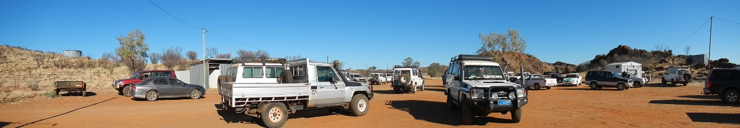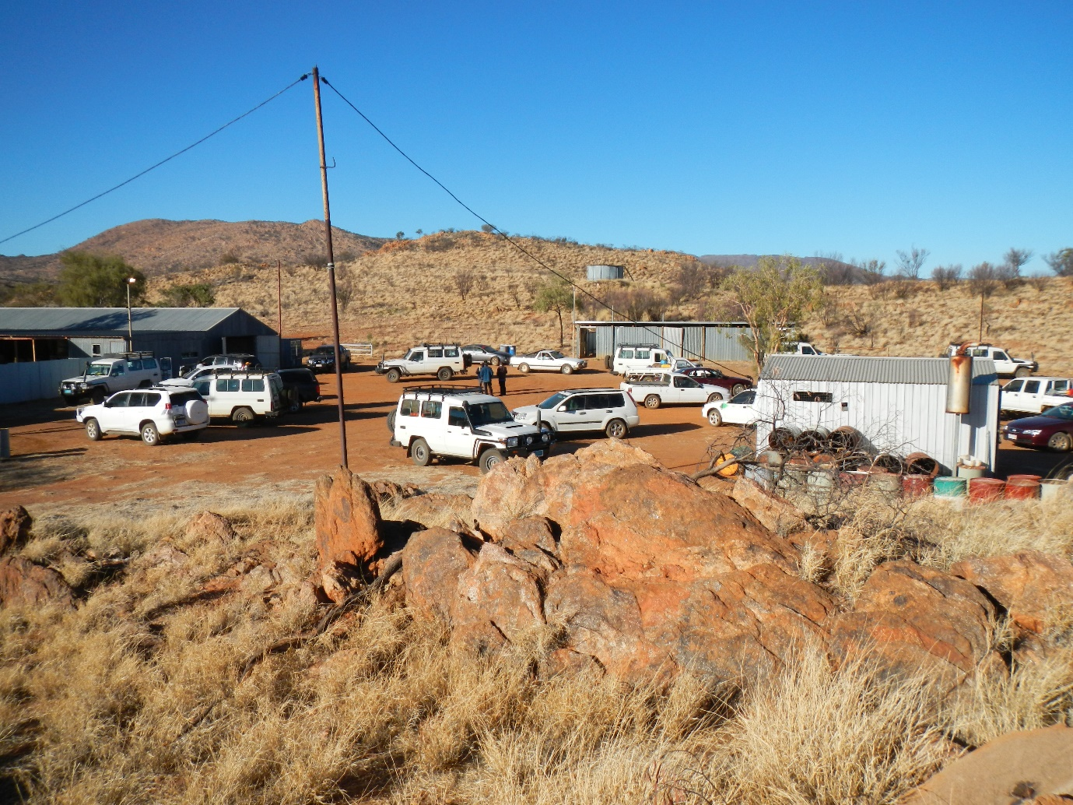

4.2. Vehicle booking patterns

Vehicles are generally allocated to CLC Units which are the nominal custodians of their fleet. Two booking classifications exist:

* Pool vehicles which are notionally available for any CLC staff to use
* Restricted vehicles which are in principle only available for staff working in the designated Unit. Very few of these vehicles are procured using tied grant funding.

The allocation of vehicles to each unit is shown in **Figure 4**; overall, just over 75 per cent of the fleet has restricted booking status.

Figure 4: CLC Fleet Summary – Unit allocation



Figure 5: Diagram of Troop Carrier bookings



|  |  |
| --- | --- |
| Pool |  |
| Restricted |  |

Even at this high level, the booking records show clearly:

* the long block booking of some restricted vehicles, allocated to Regional Offices
* the high proportion of restricted vehicles not booked and
* the high demand for pool vehicles.

Overall, when measured against total vehicle-days, the booking utilisation was 56 and 54 per cent for pool and restricted use vehicles respectively although the demand was much more evenly spread across all pool vehicles than across the range of restricted vehicles.

Bookings do not fully capture the actual use of the fleet which was measured from the tracking data, but this early analysis provided useful insights and guided more detailed analysis of vehicle utilisation.

4.3. Fleet utilisation

***4.3.1. Seasonality***

NAVMAN Executive Summary reports were used to provide an overview of vehicle use over a full twelve-month period. For the six-month study period, a much more detailed data set was extracted, logging each vehicle movement.

In general, the duration of each booking compared well between VBS and NAVMAN. An exception was seen for artificially long bookings of some ranger vehicles, known to be block booked rather than being allocated permanently to the Ranger unit.

Overall, the absence of significant bias indicated that NAVMAN trip information could be used to pattern the remainder of the fleet. Expansion factors were later applied to quantify the market segments as input into the final recommendations regarding fleet size and composition; other analysis was based on unexpanded observed movements.

The twelve-month overview is shown in **Figure 6**. It shows a significant drop in activity over the December-January holiday period, with a slow return to normal activity during February. Apart from the summer holiday period, the six months of the detailed study appears to be reasonably representative of normal activity levels.

Several patterns are present in the level of travel activity:

* generally, school holidays and public holiday weeks result in less travel
* from the beginning of May through to the second week in December, travel in weeks unaffected by school or public holidays is generally above average
* there is a sudden and dramatic drop in travel at the beginning of the summer school holidays and the Christmas-New Year break. During this period the Centre experiences extreme heat conditions and it is also the traditional time for Aboriginal ceremony, so field staff are encouraged to take leave.
* some high demand weeks are due to special activities such as remote Council meetings.

Figure 6: Seasonality – all vehicles

|  |  |  |
| --- | --- | --- |
|  | | |
|  | Non-holiday week |
|  | School holiday week |
|  | Public holiday week |

***4.3.2. Where did vehicles travel?***

Over the full 12-month period 92 vehicles had NAVMAN fitted. The 92 vehicles travelled just over 1.8 million kilometres in the 12-month period, and were on the road for over 33,000 hours. Troopies bore the major share of total travel overall and also travel the highest average distance per vehicle, over 22,000 kilometres.

Table 2: Annual travel by vehicle type

|  |  |  |  |
| --- | --- | --- | --- |
| **Vehicle type** | **Distance travelled (km)** | **Travel time (hrs)** | **Fleet size** |
| **Total fleet travel** | | | |
| Troopie | 1,317,770 | 23,870 | 59 |
| Trayback | 402,176 | 7,019 | 23 |
| Other 4WD/Car | 44,901 | 1,522 | 6 |
| Truck | 39,198 | 747 | 4 |
| **Total** | **1,804,044** | **33,158** | **92** |
| **Average per vehicle** | | | |
| Troopie | 22,335 | 405 |  |
| Trayback | 17,486 | 305 |  |
| Other 4WD/Car | 7,484 | 254 |  |
| Truck | 9,799 | 187 |  |
| **Average all vehicles** | **19,609** | **360** |  |
| **Maximum per vehicle type** | | | |
| Troopie | 46,900 | 778 |  |
| Trayback | 36,600 | 520 |  |
| Other 4WD/Car | 10,850 | 325 |  |
| Truck | 15,800 | 300 |  |

Geographically, travel is spread throughout the CLC region and well beyond. The study examined trip geography in some detail. **Figures 7 and 8** summarise the diverse location of vehicle activity and the origin-destination combination of travel. **Figure 9** shows typical unsealed road conditions on the Plenty Highway.

Figure 7: Trip destinations

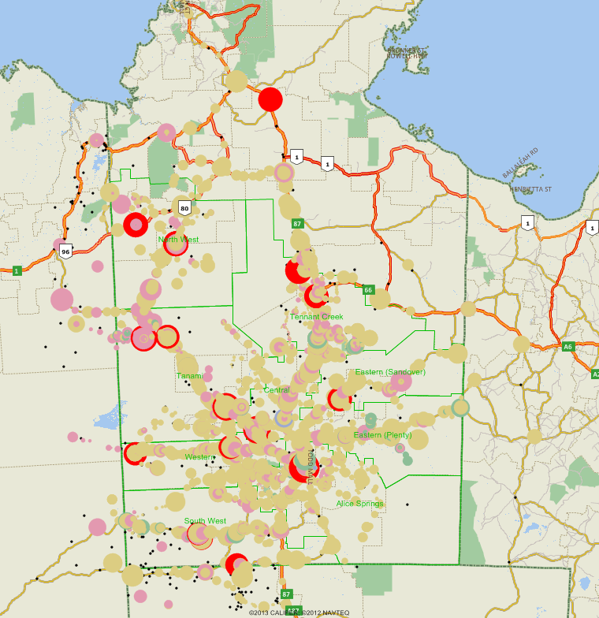

|  |  |
| --- | --- |
| Troopies |  |
| Traybacks |  |
| Trucks |  |
| More than 500 trips |  |

Figure 8: All journeys - all vehicles (single journeys hidden)

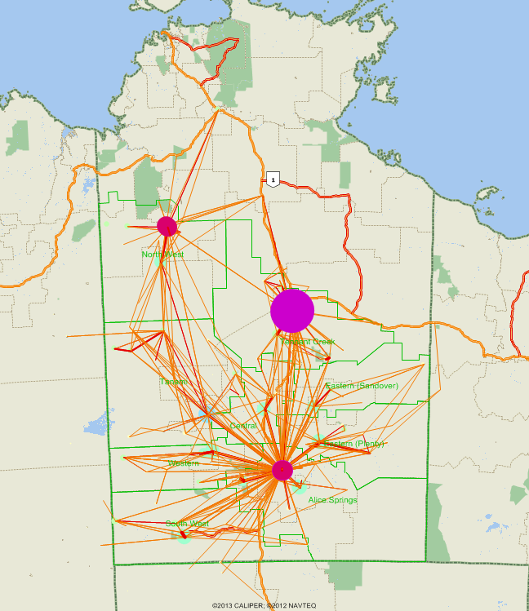

Note: the apparently smaller number of trips internal to Alice Springs in comparison to Tennant Creek is due to the co-incidence of multiple suburban locations.

Figure 9: Plenty Highway – typical unsealed highway

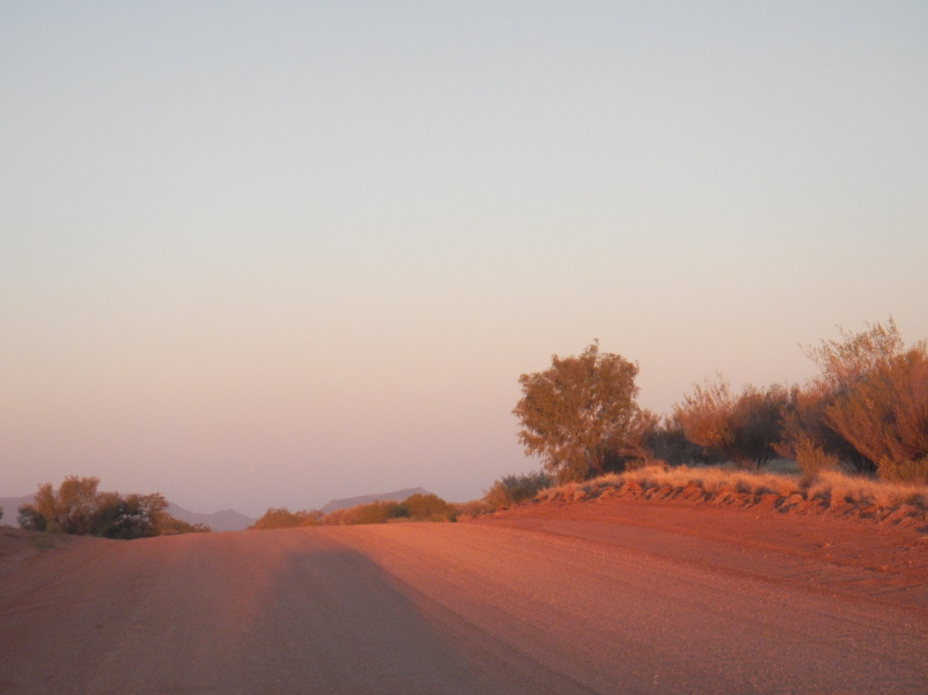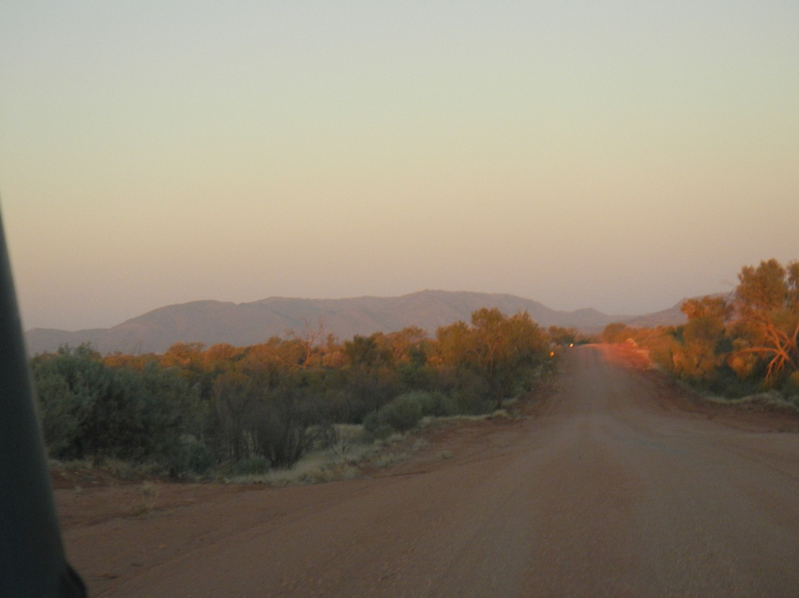

***4.3.3. Bookings vs use of vehicles***

A comparison of bookings with the actual use of vehicles identified:

* vehicles which are booked and used on the day of booking
* vehicles which are booked, but not used on the booked day
* vehicles which are used without being reserved in the VBS.

Ideally, all use of a vehicle would fall into the first category. However, there is a significant number of days when a vehicle was booked but not used or used without having been booked. **Figure 10** shows the extent of each category overall, then separately by vehicle type, CLC Unit, location and restricted status.

Figure 10: Bookings and vehicles used – weekdays

|  |
| --- |
|  |
|  |

Both these situations present different management problems. The non-use of booked vehicles precludes their use by others, with the potential for over-sizing of the fleet due to perceived difficulties in securing vehicles, indicated by the area above the 100% line on **Figure 10**. The use of vehicles without being booked has implications for fleet management and maintenance, and for staff safety as the practice can potentially bypass vehicle and equipment safety checking. Thirty per cent of Troopie bookings fall into this class.

5. Market segmentation and travel needs evaluation

5.1. Market segmentation

The study objective was to identify an efficient fleet size and mix of vehicles that could perform CLC’s transport task.

Extensive analysis was undertaken merging the vehicle tracking data with the booking calendar and staff surveys to evaluate the location of travel, its purpose and vehicle occupancy. A framework was developed, shown on **Figure 11**, that combined group size, trip duration, the nature of the terrain (sealed, unsealed roads and on-country)

Figure 11: CLC Market Segments – people and destinations

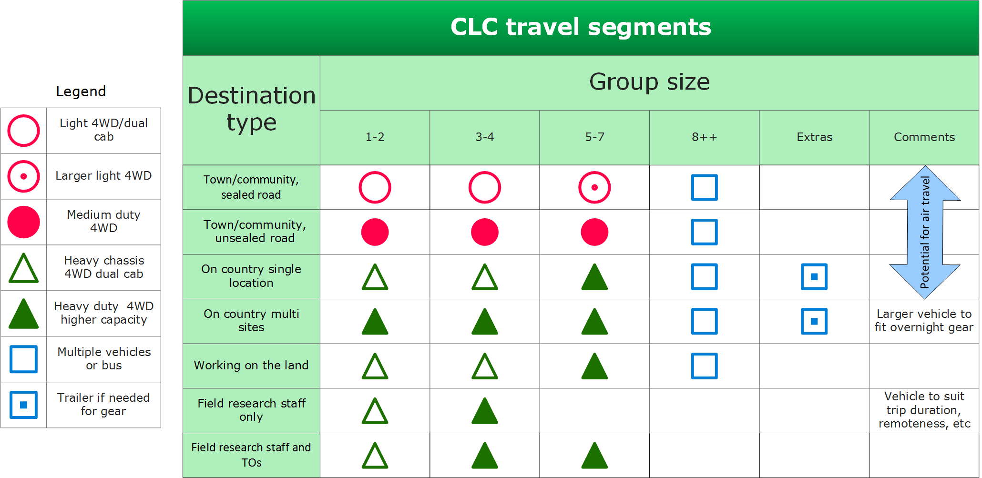

In order to quantify the size of each market segment, primary segmentation of trip data was undertaken by the class of road, adopting a hierarchy of sealed, unsealed and off-road journeys, shown on **Table 3**. Each journey was classified according to the most arduous conditions encountered, as a journey, once commenced, must be completed in the original vehicle which must be fit for the worst terrain encountered on the entire journey. As well, rather than focus on journey length, duration measured in full days was the more appropriate measure, as there is little scope for the one vehicle to be booked and used for only part of a day, with the exception of town vehicles.

Table 3: Primary journey segmentation

|  |  |  |  |  |  |
| --- | --- | --- | --- | --- | --- |
| **Vehicle type** | **Travel by vehicle type (vehicle-days in 6 months)** | | | | |
|  | **Light vehicle** | **Trayback** | **Troopie** | **Total** | **% of total vehicle days** |
| 1 - Sealed | 797 | 413 | 1,359 | 2,569 | 31% |
| 2 - Unsealed | 19 | 447 | 1,929 | 2,395 | 29% |
| 3 - Off Road | 19 | 519 | 2,769 | 3,307 | 40% |
| **Total** | **835** | **1,379** | **6,057** | **8,271** | **100%** |

This primary segmentation found that for travel on unsealed roads and off-road, the appropriate vehicles were already in use. For travel entirely on sealed roads, over two thirds of trips were made with heavy 4WD vehicles when a lighter vehicle would normally suffice.

Further detailed sub segments were developed covering occupancy and the need to carry equipment and the normal garaging location of the vehicle was also considered.

For travel based in Alice Springs, a large proportion of trips were demonstrated to be undertaken in troopies simply because they were available. These trips were predominantly on sealed or high quality unsealed road and could have used much lighter, cheaper and more fuel efficient vehicles.

A different set of needs emerged for regionally based travel, much of which was undertaken with at most a driver and one passenger. Most of these trips were undertaken in troopies, when a robust off-road dual cab vehicle would have sufficed.

5.2. Fleet composition

The proposed fleet composition was derived for Alice Springs and regionally based vehicles independently. The number of vehicle-days required for each proposed vehicle type is built up segment by segment using a simple process:

* For each segment, document existing vehicle days
* Reallocate each segment to the recommended alternative vehicle type
* Sum the total vehicle days for each vehicle type over all travel segments
* Divide by the number of days in the analysis (130 working days)
* Add 10 per cent for vehicle servicing
* Add 20 per cent factor of safety
* Round the resulting value to the next whole number.

Once a theoretical fleet mix was obtained, two final checks were undertaken against historical data to test the ability of the reduced fleet to cater for peak demand:

* Were there any single or concurrent events that required a large fleet of large off-road vehicles and could they have been rescheduled to reduce vehicle demand, and
* Would smaller fuel tanks limit long trips?

No instances were found where single large or concurrent smaller events would stress the ability of the smaller fleet. Additionally, the more rigorous use of the booking calendar can ensure that clashes are avoided. Smaller fuel tanks were accompanied by a significantly lower fuel consumption and a longer range of travel that the current large vehicles. Therefore, neither of these conditions was found to constrain the recommended change in fleet composition.

6. Strategy implementation

The final study report (2014) identified a significant opportunity to change the fleet mix which would potentially result in financial savings and improvement in employee/passenger safety. This would mainly result from fleet pooling, use of lower capital cost and lower fuel usage from using a number of medium sized 4WD vehicles and the disposal of some large 4WD (Toyota Troopies). However, this required a substantial change in work practices that had developed over decades and an all staff commitment (most staff are drivers to a greater and lesser degree, or engaged in fleet booking and management). The aim was to have a progressive strategy implementation, subject to an annual review as a safeguard.

Productivity improvements are expected to be achieved from:

* pool fleet management which would replace the current sectional allocation of vehicles, thus creating a more efficient sharing of the fleet across the business
* an associated increase in pool management staff to ensure that vehicles are maintained, clean and that safety and equipment checks are undertaken before each booking
* a fleet mix that meets the tasks
* associated improvements such as work, health and safety improvements (progressive phasing out of rear side-facing passenger seats and a redesign of cargo storage and securing)
* introduction of electronic fuel cards now becoming more available in Central Australia and
* reduced travel time.

The fleet size of the vehicles targeted by the study at commencement of change was 105. The key fleet changes being implemented are:

* Reduction in the number of large vehicles and large dual-cab fleet by 2018
* Progressively increasing the number of medium size 4WD Alice Springs fleet and
* Increase the size of the ‘town’ car fleet at Alice Springs by 3 vehicles.

Table 4: Staged implementation of transport study recommendations – Alice Springs

|  |  |  |  |  |
| --- | --- | --- | --- | --- |
| **Action** | **Total change** | **2015/16** | **2016/17** | **2017/18** |
| **Acquisition/replacement** |  |  |  |  |
| Medium 4WD – additional (eg Prado, base model 200) | +18 | +8 | +6 | +4 |
| Light car fleet - additional | +3 | +3 | 0 | 0 |
| **Total** | **+21** |  |  |  |
| **Disposal (non-changeover)** |  |  |  |  |
| Troopies/70s | -30 | -14 | -10 | -6 |
| Dual cab/off-road | -6 | -2 | -2 | -2 |
| **Total** | **-36** |  |  |  |

Following completion of the study a period of internal consultation ensued prior to incorporating the recommended changes in forward capital budget estimates.

Year 1 implementation was deferred until late in the year due to a delay in approval by the Minister of the CLC’s capital budget; implementation commenced in May 2016. There has been a slight divergence in the actual fleet replacement selection, as the release of the new Toyota Hilux range has provided the option of a readily available 5 star rated vehicle that suits much of the required work. It is now unlikely that many Prado-type vehicles will be purchased. The staged strategy means that any future new models can be incorporated in the strategy if they meet the overall requirements.

The net present value of the fleet change is currently estimated at $3.3 million, comprising:

* a reduction in capital expenditure from the change in fleet mix,
* a reduction in fuel and other operational costs,
* the sale and non-replacement of some vehicles (5 in year 1, 6 in year 2 and 4 in year 3) and
* an improvement in the resale value of medium size vehicles which are popular in the second hand 4WD market.

Additional staff costs will be incurred in fleet pool management, but they are more than offset by productivity improvements of other staff. Fuel savings also result in carbon emission savings, estimated at 260 tonnes over 3 years.

The Minister of Indigenous Affairs has recognised the sound management practices used to improve efficiencies in a tight fiscal environment.

7. Conclusions

Central Land Council faced an environment of ever increasing transportation costs and the challenge of financing, managing and maintaining a large fleet of vehicles in one of the most demanding operating environments in Australia. Additionally, a change in the regulatory environment precipitated a major change to the way large groups of people had traditionally been transported to remote meetings, as the carriage of unsecured passengers in side-facing troop carriers had become illegal. CLC had the foresight to link potential efficiency gains by restructuring the fleet with their Enterprise Bargain agreement.

The Transportation Study was undertaken in a consultative framework with significant staff inputs. The level of rigour of analysis of the current transport needs was a major component in the ultimate acceptance by staff of the recommended changes. The restructuring of the fleet composition and its management has been undertaken in a way that demonstrates that staff can work more efficiently and safely.

This paper only touches on a small sample of the multifaceted study approach and provides an understanding of the difficulties of applying basic transport planning in a complex and challenging environment.

Acknowledgements

The foresight of the Central Land Council in undertaking this study is acknowledged and applauded. The opportunity to undertake basic research in such a challenging and unique environment was an enriching experience for the consultant who gained firsthand experience of the challenges facing Aboriginal people as they continue to manage their land and protect their connection with the land and its sacred sites. She discovered a new-found respect for the integrity, humour and customs of the traditional owners of the land.