Viability of high speed rail alternatives in southern India
Leonard Johnstone¹, Vatanavongs Ratanavaraha²
¹Suranaree University of Technology, 111 University Avenue, Suranaree Sub-district, Muang District, NakhonRatchasima 30000, Thailand
²Suranaree University of Technology, 111 University Avenue, Suranaree Sub-district, Muang District, NakhonRatchasima 30000, Thailand
Email for correspondence: D5840502@g.sut.ac.th
Abstract
Regional inter-urban travel is a growing aspect of people movement in Asia. In southern India, there are more than ten cities with population in excess of three million people including the metropolitan regions of Hyderabad, Chennai and Bengaluru. Regional travel is currently via car, bus, air or the existing rail network. The intention of this paper is to examine the viability and the attractiveness of an improved higher speed rail system for southern India. Already higher speed rail systems exist and or are under consideration in other parts of Asia but currently none exist in India. The government of India wanted to quickly understand the viability of higher speed rail and the likely diversion of regional travel to this new mode from the existing modes.
In southern India, there were little available data on the movement of people across the region. In response, a series of surveys were conducted at the major regional centres likely to be connected via an improved higher speed rail service. A total of 7,000 interviews were undertaken across southern India focusing on existing travel via air, car, bus and rail. The intention was two-fold to obtain the existing modal travel patterns and to secondly via a stated preference survey to estimate the likely diversion to high speed rail from the existing mode of travel. From this investigation, the modal diversion was estimated of future travellers via the calibration of hierarchical logit model segmented by purpose and income class. Thus there was a forecast of the estimation of attracted passengers to the new mode of travel. The results enabled the optimization of the routes and station configuration along the two corridors under consideration from Hyderabad to Chennai and Chennai to Thiruvanthapuram. This paper focuses on the later corridor
Keywords – Regional Travel, High Speed Rail, India, Passenger Behaviour
1. Introduction
High-speed rail (sometimes referred to as “bullet trains”) is, broadly defined, as rail transportation that is significantly faster than regular rail. Most new rail projects are considered “high-speed” if they reach speeds of at least 250 kilometers per hour (kph). In doing so this requires either an upgrade to existing rail or, in order to reach speeds in excess 250 kph, entirely new tracks”. However speeds in excess of 250 kph are not always associated with the appropriate rail system to improve regional connectivity.
The evolution of the national transport strategy for India will incorporate higher speed rail over the long term. To that extent, the development of the estimation for higher end rail usage requires a robust numerical underpinning. Toward that end, this paper develops the strategy for such analysis along a specified corridor.

1.1. An overview of High Speed rail
High Speed Rail (HSR) transport is a fast, comfortable, convenient, and environmental-friendly mode of transport. HSR started in Japan which is recognized as the first country in the world to have a dedicated high-speed line in 1964 between Tokyo and Shin-Osaka. This early HSR service provided a significant improvement in travel time even though the average operational speed then was only 160 kph with a maximum speed of 210 kph. Since 1980 as is seen in Figure 1 (Profillidis & Botzoris 2013), there has been a rapid increase in the route length of HSR from 1,000 km in 1980 to 12,000 km in 2010, a growth of nearly 9% per annum. Today China leads the way with a route length greater than that of the route length of Japan and France combined together.
Figure 1: Extent of worldwide development of high speed rail
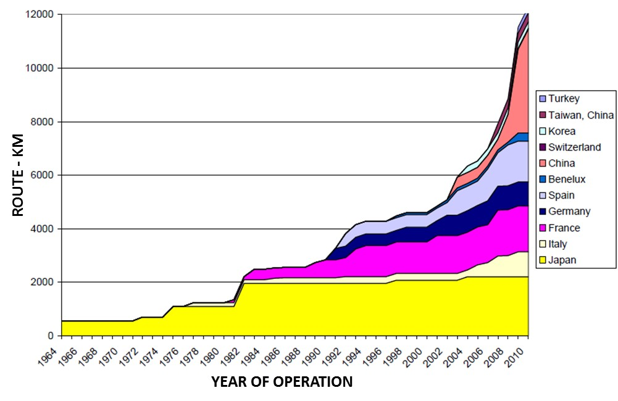
Source: Profillidis & Botzoris 2013
1.2. High speed rail under consideration
Today the extension of HSR is under consideration in such varied localities as the USA, India, Thailand and the Middle East. So far in Asia, HSR is not operational outside of Japan, China and Taiwan. This paper will focus on the development of such a high speed rail corridor in India. In this paper, there is first an overview of international experience followed by a discussion on the preparation of the analysis of a particular line in southern India.
2. The project context
Before one brings new technology into a market, one should consider the experience and impact and existence of that technology in its existing market. For that reason, one first must understand the experience of HSR in its principle existing market localities of Japan, Europe, Taiwan and China.
2.1. An international perspective
Long distance or intercity transport takes many forms today in various parts of the world with Asia and Europe leading the development of HSR. It is clear from a review of existing HSR:
- High speed rail offers an advantage in terms of travel time (door to door) over medium distances but is not effective for short distance trips or with current proven technology over longer distance trips. This medium distance is between 400 and 800 km as depicted in Figure 2 (Profillidis & Botzoris 2013);
- In Europe and Asia, higher end rail networks have been developed not only for speed but also simply for the need to increase the capacity of the transport system as the demand for travel is growing all the time; and
- High speed rail is most commonly introduced to link major population centres with Intermediate stations providing regional distribution.
High speed rail as seen in the figure below is faster than air travel for door to door journeys in the medium distance range. For short journeys, conventional rail is even faster than air or HSR. This is because conventional rail will often take you closer to your final destination.
Figure 2: Comparative advantage of HSR over specified distance
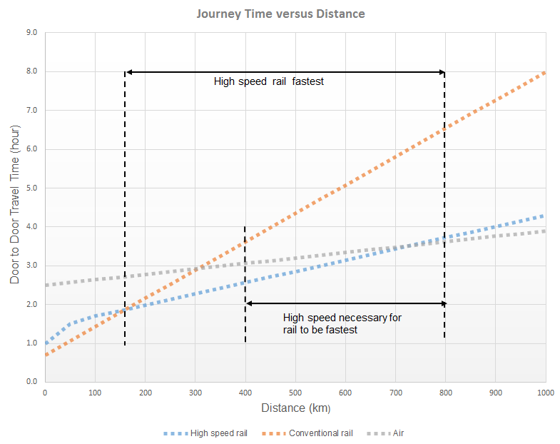
Source: Profillidis & Botzoris 2013
For the medium distance HSR is better in terms of time. However with the advent of low cost flight carriers, the overall fare also plays a part in the passenger decision of modal choice. The main competitor in the terms of costing for HSR is the low cost carrier. However over the median distance, HSR is significantly faster in the European context. The high frequency of service along some routes also increases the convenience factor for HSR.
The introduction of HSR services will also attract more passengers to the overall rail network. This is clearly seen in the European experience as presented in Table 1 derived from earlier work (Wardman et al. 2002).This is of course the result of significant reduction in travel time. Following the introduction of HSR between Paris and Lyon, a distance of some 600 km, the air modal share was reduced from 31% to 7% as was the modal share of car travel from 29% to 21%. Although not documented here, there would most likely been a significant shift within the rail sector from the inferior non HSR towards the HSR portion of the rail sector. A similar result is seen in the introduction of HSR into the transport system of Spain, also reported in Table 1. In the Spanish situation, the air mode of travel decreased from a market share of 40% to 13%.
Table 1: Mode shift following the introduction of HSR
Mode of travel | Paris to Lyon |  | Madrid to Seville
Mode of travel | Before | After | Before | After
Air | 31% | 7% | 40% | 13%
Rail | 40% | 72% | 16% | 51%
Road (Car and Bus) | 29% | 21% | 44% | 36%
Source: Wardman et al. 2002

2.2. The Indian perspective
India is on the threshold of development of HSR. This is part of Vision 2020 for the Indian national railways and it is hoped that this will decrease the leakage of modal share from rail to other modes. It is seen in Figure 3 and sourced from the Government of India that in the fifty years between 1950 and 2000 that the modal split between road and rail has been reversed in nature. In 1950 the road modal share in terms of passenger kilometres was 20%. By 2000, it was 80%. Although this trend is not expected to continue especially with the introduction of tolls on the principal national highway system, it is still disturbing. It is anticipated that the introduction of HSR into the market will play a part in reversing this trend and assist in the revitalization of the Indian rail passenger market especially attracting the high end business passengers as well as people from those households with a high disposable income.
Figure 3: Modal shift from road to rail in India
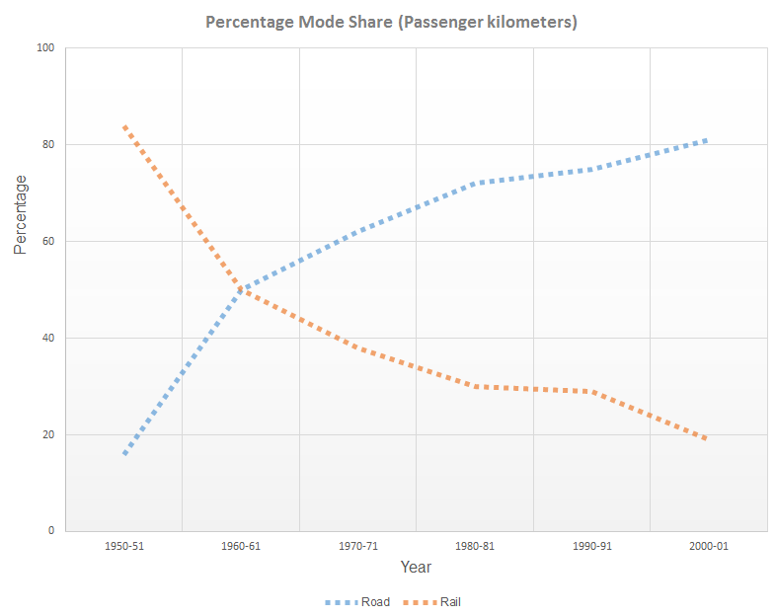
Source: The Working Group Report on Road Transport for the Eleventh Five Year Plan, Government of India.
The government of India has plans to develop an extensive HSR in the medium term future. The extent of this is shown in Error: Reference source not found. The map in this corridor identifies seven potential corridors.
Figure 4: Transportation corridors under consideration for HSR in India
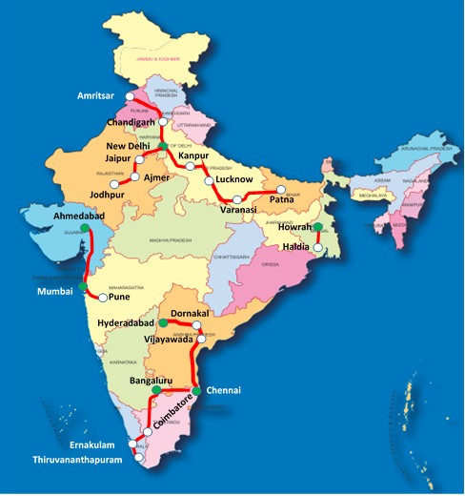
3. The project structure
The corridor under detailed consideration in this paper is the corridor from Chennai to Thiruvananthapuram including the urban centres of Bengaluru, Coimbatore, Ernakulam. In order to appreciate the viability of said system, it is necessary to project socio-economic characteristics within the same time frame as the HSR ridership forecasts whilst at the same time understanding the existing travel patterns in preparation for the estimation of future travel patterns.
3.1. The data challenge
The challenge of data collection was three fold namely:
- The assembling of socio economic data for both today and the future at a finer level than simply state level;
- The understanding of the current transport infrastructure; and
- The appreciation of the existing travel patterns including the sensitivity to fare and travel time.
This necessitated data collection across three states namely Tamil Nadu, Karnataka and Kerala. Projection of socio economic data was prepared across 39 districts with some districts being split yielding a total of 50 small areas. These small area later became traffic zones within the framework of the transport demand forecast. An area of influence was defined as the catchment of the HSR as presented in Figure 5 which is taken as a snapshot of the transport model. This is the area for which socio-economic data was prepared in this analysis. Figure 5 also highlights all potential stations. This area of influence was defined by the inclusion of all the districts adjacent to the alignment. The importance of this area was confirmed by a review of all the observed trips from the survey dataset.
The population of the urban areas of the three possible terminal stations alone of Chennai, Bengaluru and Thiruvananthapuram in 2011 was 8.5 million, 9.6 million, and 3.7 million people, respectively (Registrar General & Census Commissioner, India 2011). The population of the three hubs is expected to grow by the year 2045 to 12.6 million, 13.9 million and 5.4 million people respectively as sourced from (Preliminary Study on the Formation of High-Speed Railway Project in India Hyderabad –Vijayawada–Chennai (No.5) & Chennai – Bengaluru – Ernakulam–Thiruvananthapuram (No.6) Corridors 2012). Thus by 2045, the three centres have a combined estimated population of nearly 32 million. It was a requirement within the framework of this analysis to estimate the passenger demand for HSR from the opening year through to 2045.
Figure 5: Area of Influence
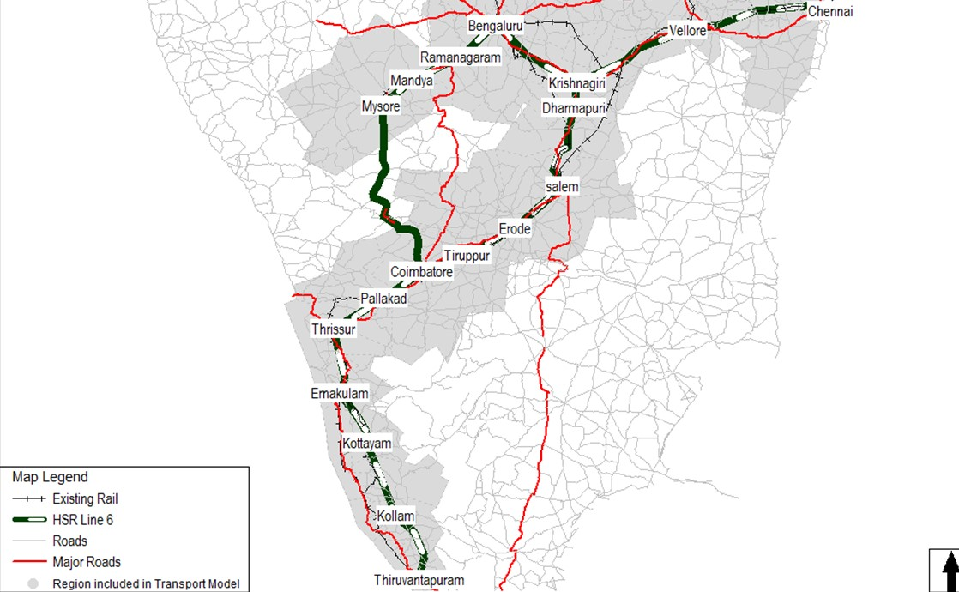
In addition, in 2011, none of the proposed stations represent districts with a populations less than 1 million people. By 2045, the districts associated with these stations will represent a population of 59 million people excluding the three proposed terminal stations mentioned earlier.
The other key aspect of socio economic analysis was the regional gross domestic product. Long term economic growth whilst difficult to estimate is a necessary input into any analysis of future passenger demand within the corridor. Few national bodies make such forecasts today. However such long term forecasts were available from Goldman Sachs (Wilson et al. 2011). The regional GDP of the three anchor stations of Chennai, Bengaluru and Thiruvananthapuram in 2011 is 708 billion Indian Rupee(INR), 959 billion INR and 228 billion INR, respectively as reported by the Central Statistics Office of India. The regional GDP of these three hubs is projected to increase by the year 2045 to 5,227 billion INR, 7,077 billion INR and 1,682 billion INR, respectively in nominal prices.
This implies that the GDP per capita of Chennai, Bengaluru and Thiruvananthapuram in 2011 is 83, 100 and 62 thousand INR, respectively. The regional GDP per capita of the three anchors is projected to increase by the year 2045 to 415, 509 and 311 thousand INR, respectively. This is a measure of the affordability of the higher order regional transport system as well as the propensity of travel. The GDP per capita of these three localities will grow at between 5 and 6 percent per annum.
In the calculus for the analytical estimation there are two parts of the preparation stage namely demand and supply. On the supply side, it is necessary to identify all transport network infrastructure within the corridor, or that of the road, rail and air infrastructure. This infrastructure, with the exclusion of the air network, is shown in the earlier Figure 5. In the case of the air network, there are interlinking commercial air services provided only at Chennai, Bengaluru, Coimbatore, Ernakulam and Thiruvananthapuram. The infrastructure network was taken from available maps on the internet and supplemented with on ground survey data for example to confirm the number of lanes on a particular highway.
In the preparation of the demand forecast it was necessary to collect survey data to form an understanding the existing travelling public and that of likely HSR passengers. For that reason, the surveys focused on those travellers at the higher end of the market. This part of the market included those travelling by air, car and the higher end of the bus and rail mode. The surveys were needed in order to develop the variables required to define the parameters associated with new high order transport infrastructure. In particular, the specification of the surveys must allow for the development of a modal choice model that will estimate the passenger demand for the HSR.
The surveys were divided into the following three sections:
- Section A – Personal Information;
- Section B – Today’s Trip Information; and
- Section C – Stated Preference.
The key personal information requested during the survey is outlined below:
- Age and gender of interviewee;
- Location of residence of interviewee;
- Car ownership and household income of interviewee.
The key information requested for the trip being undertaken that day during the survey is outlined below:
- Payment for the trip;
- Trip frequency;
- Boarding location (e.g. railway station);
- Reason for travelling by chosen mode (Is the trip optional such as leisure that is a discretionary trip or is it a non- optional or non-discretionary trip such as a business trip);
- Trip costs such as fare or toll as well as associated waiting time;
- Trip origin and destination and associated trip purpose; and
- Access and egress mode and associated fare if appropriate.
The key information requested during the stated preference portion of the survey is outlined below:
- Additional payment prepared to be made for a trip with significant time saving; and
- At what fare level was the interviewee prepared to use the new service for example between Chennai and Thiruvananthapuram.
During the last part of the stated preference section of the survey, four fare levels were interwoven into the survey fabric at the levels of 2.5, 3.75, 5 and 6.25 INR per km. The later fare level is equivalent a ticket price of 5,300 INR on the new service between Chennai and Thiruvananthapuram. In comparison, economy airline ticket in June, 2012 was 4,500 INR on the same route. A total of 4,581 interviews were conducted during the transport surveys. Of these travellers surveyed, 47 percent were rail passengers, 17 percent were car drivers, 18 percent were bus passengers and 18 percent were air passengers.
3.2. Highlights of the survey results
The distribution of discretionary and non-discretionary trip makers with reference to household income is tabulated Table 2. With air trips as seen in the table, nearly 50 percent of the observed trips were non-discretionary whilst 40 percent were not only non-discretionary but also undertaken by persons in the mid to high income range. In the case of car trips nearly 80% of the trips are discretionary.
However with rail and bus trips, between 45 and 65 percent of trips were undertaken by persons in the lowest income ranges. In the case of bus, more than 70 percent of the trips were discretionary trips.
In the case of discretionary trips, there are a high proportion of trips paid for by oneself of the order of 90 percent for those people travelling via bus or rail. This drops to around 70 percent for non-discretionary trips for bus and rail. In the case of air transport, the statistics are different. The percentage of interviewees who paid for a discretionary trip via the air mode is high of the order of 60 to 70 percent across all three income groups for air passengers whereas it is significantly lower for non-discretionary trips.
An interesting fact from the survey analysis was an insensitivity towards cost amongst the trip makers within the high order modes of car and air. Cost was simply not seen as an important reason for modal choice. That is, 90% of respondents stated that the main reason for selecting car and air modes was related to either travel time or comfort. In the case of the lower order modes of bus and rail mode, 9.1 and 11.1 percent of respondents, respectively, said that travel time was an important factor in mode selection.
Table 2: Observed mode of travel by purpose and income class
Monthly income range(INR) | Purpose | Percentage distribution
Monthly income range(INR) | Purpose | Air | Car | Rail | Bus
<60,000 | Discretionary | 10.7 | 10.5 | 34.3 | 45.7
60,000-99,999 | Discretionary | 23.3 | 34.4 | 31.1 | 18.2
>99,999 | Discretionary | 18.7 | 32.5 | 8.0 | 6.6
<60,000 | Non-Discretionary | 6.3 | 3.1 | 11.5 | 19.3
60,000-99,999 | Non-Discretionary | 19.4 | 10.7 | 9.5 | 7.0
>99,999 | Non-Discretionary | 21.6 | 8.8 | 5.6 | 3.2
Total |  | 100.0 | 100.0 | 100.0 | 100.0

3.3. Demand forecast
The demand forecast procedure was developed for higher end trip makers in six categories or clusters as discussed earlier in the survey findings and defined as follows:
- Cluster 1 – Low Income Discretionary;
- Cluster 2 – Medium Income Discretionary;
- Cluster 3 – High Income Discretionary;
- Cluster 4 – Low Income Non-Discretionary;
- Cluster 5 – Medium Income Non-Discretionary; and
- Cluster 6 – High Income Non-Discretionary.
These clusters are incorporated into the later modal analysis. The calculus is performed via the following four steps:
- Trip Generation;
- Trip Distribution;
- Mode Split; and
- Assignment of HSR trips to the network.
The demand is estimated on the basis of traffic zones. As stated previously there are some 50 traffic zones within the area of influence for the HSR service.
In the development of the trip production and attraction equations for the trips at the zonal level several zonal variables such as population and regional GDP were tested in a multi-linear regression analysis. There was a limitation on the socio economic variables that could be used in the model development as any variable incorporated into the model had to be able to have a comparable forecast value in the future. Finally the trip generation equation parameters were a combination of population and regional GDP per capita as this relationship produced a better coefficient of determination.
The person trip distribution for inter zone travel is developed around the Gamma Function as the friction factors for the Gravity Model in the estimate of distribution.
The model structure for deriving the modal split for person trip types is depicted in Figure 6. That is, person trips are distributed between five modes (air, HSR, private car, rail and bus) via a hierarchy of binary logit modal splits. In this case it is for three levels with four choices. The proportion of trips between any two zones i and j that choose one mode out of a subset of two choices is given as:
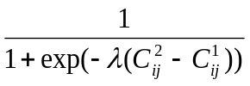 (1)
Where: is the scale parameter; 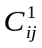is the generalized cost of travel for hierarchical choice 1 and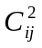is the generalized cost of travel for hierarchical choice 2 between any two zones i and j.
The generalized cost of travel is defined to include all perceived costs of travelling between any origin and destination within the corridor. In the case of travel by car, this cost will include time, any road tolls and the perceived vehicle operating costs. In the case of non- car travel, the generalized cost includes fare, travel time and waiting time. There is also a relative bias associated with each mode of travel.
Figure 6: Mode split hierarchy
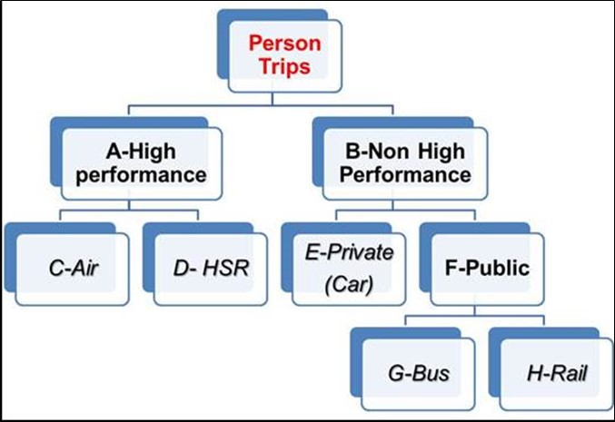
In the mode split, the choice probabilities are calculated by starting at the bottom of the tree and moving up the hierarchy, calculating the choice probabilities and the composite costs in each nest. In this model the process begins from the bottom level.
Firstly, conditional probabilities for each of the two choices at Level 3 namely bus and rail are calculated and then the composite based public transport cost are calculated within the lowest level. The costs associated with the level above are calculated in the same way until you reach the top level. It is then necessary to move back down the hierarchy forecasting demand for each mode with the information derived above, so that this then becomes an iterative procedure.
Of course, the key input into the above detailed mode split is the generalized cost of travel between any two zones as described here in detail. This is the linear combination of several variables for private vehicles and they are as follows:
- Travel Time;
- Value of Time;
- Vehicle Operating Cost;
- Modal Bias; and
- Road Toll.
In the case of public transport, the cost is the linear combination of the following variables:
- Line Haul Travel Time;
- Access/Egress Travel Time;
- Value of Time;
- Line Haul Fare;
- Access Fare;
- Modal Bias; and
- Waiting Time.
The scale parameters, for mode choice are calculated from the slope of the linear plot of the natural log of the ratio of P1 and (1-P1) against the cost difference between the two modes where P1 is the probability of Choice 1. In the case of the new HSR mode, this is estimated from the surveys discussed earlier. This estimation is estimated for the mode choice for each cluster defined earlier.
A key variable in this analysis is the value of time which is derived from the surveys. The survey findings lead to an analysis of the value of time which is an input into the value of travel. In the graphic, Figure 7 there are curves which indicate for a particular income level the percentage of travellers for a certain value of time. The value of time was chosen at the fifty percent level.
Of course the question must be asked about the overall performance of these equations and the replication of the existing situation today when there is no HSR option. Such a comparison between the observed and estimated mode of travel is presented in Table 3. This table shows a good comparison between the existing and observed corridor mode split at each mode within one percent. The transport modelling procedure for the four step model was derived within the framework of the CUBE modelling software, a proprietary product of Citilabs Inc.
Figure 7: Illustration of distribution of interviews with respect to value of time
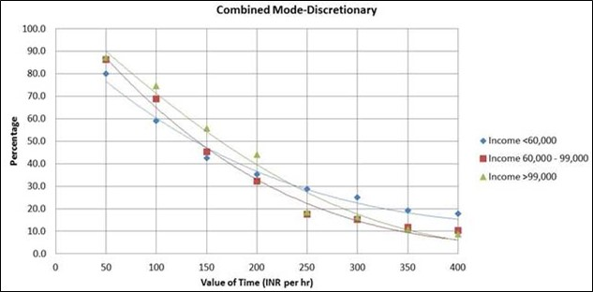
Table 3: Modal comparison of model results
Mode | Observed | Estimated
Air | 10.8 | 10.8
High Speed Rail | - | -
Private Car | 51.9 | 50.5
Rail | 8.7 | 8.8
Bus | 10.8 | 10.8
Total | 100.0 | 100.0

3.4. Structure of HSR corridor proposal
The operational structure showing two corridor standard services between Chennai and the two terminal of Mysore and Thiruvananthapuram as well as the express service between Chennai and Thiruvananthapuram are shown in Table 4.
An alternative single direct service from Chennai to Thiruvananthapuram via Bengaluru and Mysore was rejected on a two-fold basis namely that there were significant environmental issues on the section between Mysore and Coimbatore. Secondly this direct service would eliminated 4 potential stations with a combined existing population of nearly 10 million people.
Thus this service configuration was able to maximize the service area of the proposed high speed rail in southern India and the mobility of long distance trip makers within the region bringing the possibility of significant change in travel patterns.
.
Table 4: HSR operational characteristics
Station | Service 1-Express | Service 2-Standard | Service 3-Standard
Chennai | X | X | X
Vellore |  | X
Krishnagiri | X | X | X
Bengaluru |  | X
Ramanagaram |  | X
Mandya |  | X
Mysore |  | X
Dharmapuri
Salem |  |  | X
Erode | X |  | X
Tiruppur |  |  | X
Coimbatore | X |  | X
Palakkad |  |  | X
Thrissur |  |  | X
Ernakulam | X |  | X
Kottayam |  |  | X
Kottarakkara |  |  | X
Thiruvananthapuram | X |  | X

3.5. Appropriateness of HSR
Between the years 2020 to 2045, the population in the vicinity of this line in southern India is expected to increase by three fold. Thus by providing a HSR service that will operate at a speed between 300 kph and 350 kph with a likely reference fare of 4 INR per km, there will be a significant mode shift away from existing modes as presented in Table 5. This fare applied between Chennai and Thiruvananthapuram is equivalent to about eighty percent of the existing low cost airfare referenced earlier in this paper.
By 2045, the HSR mode is anticipated to attract more than a quarter of a million passengers daily with key stations at Chennai, Bengaluru, Coimbatore, Ernakulam whilst Krishnagiri is a major interchange station. The relative passenger boardings for each station in relation to the total are presented in Figure 8.
Key stations besides the anchor stations are Krishnagiri, Coimbatore and Ernakulam. Krishnagiri is the interchange station between the two lines. Ernakulam is the first station on the western coast of India. It is a major tourist centre with a coastal linkage to Mumbai. Coimbatore is a key station in central India. The population of this city is anticipated to increase to around five million people by the year 2045.
The phenomenon known as “Ramp Up” is incorporated into the forecast. This phenomenon is the situation whereby transport models tend to over- estimate the usage of new high order transport (Allport. 2010). This factor was established at 0.75 for the opening year forecast and increased to 0.9 over the following 10 years. In the subsequent 10 year forecast it was increased to unity.
Table 5: Mode Distribution in Percentage
Mode of travel | Observed | Estimation -2020 |  |  | Estimation -2045
Mode of travel | Observed | No HSR | With HSR |  | No HSR | With HSR
Air | 10.8 | 11.3 | 6.2 | 11.7 |  |  | 6.4
High Speed Rail | - | - | 13.6 | - |  |  | 18.1
Private Car | 51.9 | 49.4 | 43.4 | 48.6 |  |  | 39.4
Rail | 8.7 | 10.2 | 8.8 | 7.9 |  |  | 6.5
Bus | 10.8 | 29.1 | 28.0 | 31.8 |  |  | 29.6
Total | 100.0 | 100.0 | 100.0 | 100.0 |  |  | 100.0

Fare and socio-economic sensitivity is also included in this analysis. If the reference fare is increased to 6 INR per km then ridership is forecast to fall by nearly 18% on the HSR Line in the opening year. There is a similar pattern of change in 2045. The fare for optimal revenue is around 7 INR per km with a decrease in ridership of 25%. It should be noted that exact ridership numbers are not included in this paper for reasons of confidentiality.
Figure 8: Passenger boarding profile in 2045
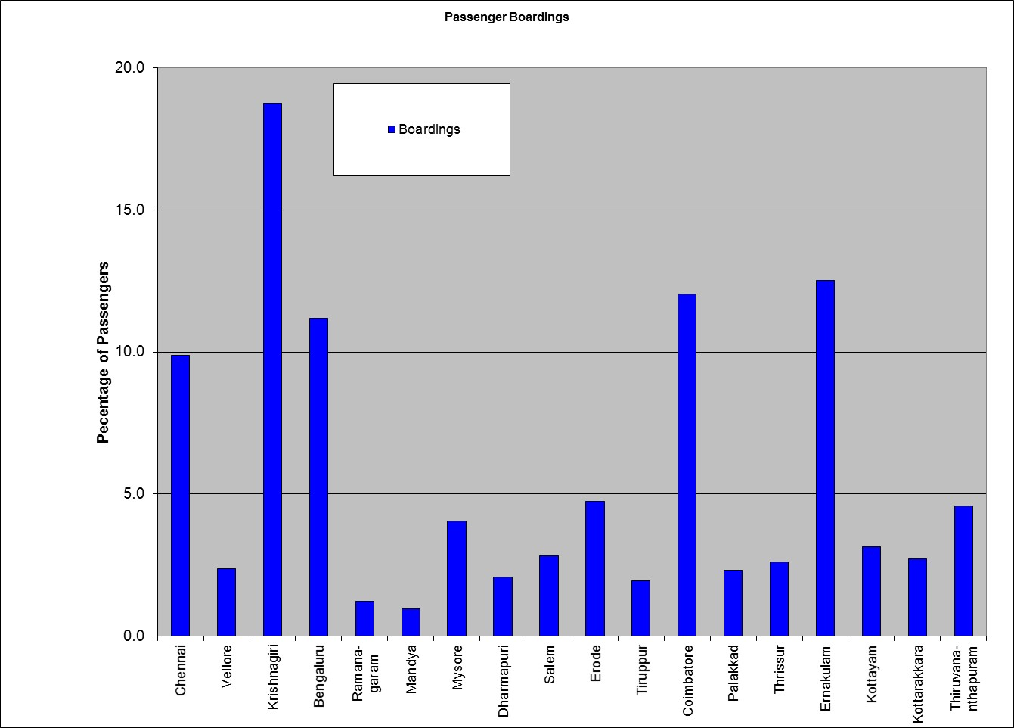
An important aspect of the introduction of HSR is that it will also reduce the necessity for additional road and air infrastructure. Without HSR, the number of people travelling by these two modes will have increased three fold as there is little difference in the future mode shares in the case without HSR. Now if HSR is operational in 2045, the modal share of air will reduce by 45% and that of car by 19%. This implies that in absolute terms considering the overall growth in trips that growth will have been reduced by around 50% and 20% for the air and car mode respectively. This would somewhat alleviate the need for new air and road infrastructure.
There is logic and appropriateness in the building of this HSR route as it will attract significant passengers whilst relieving the pressure on other modes of transport. This same appropriateness is likely in other countries that are considering HSR.
4. Conclusion
HSR has a role to play not only in regional connectivity but also in regional development. The regional development is linked to the regional station. This regional station will become a hub to spur growth.
4.1. What is the outcome of HSR?
From this investigation, the modal diversion was estimated from the existing modes via the calibration of hierarchical logit model via trip purpose and income class. Thus there was a forecast of the estimation of attracted passengers to the new mode of travel. The results enabled the optimization of the routes and station configuration along the southern most corridor under consideration from Chennai to Thiruvanthapuram. In consequence, the output from the analysis was input into the economic and financial evaluation of higher speed rail in southern India.
This example in India shows that there is a clear case not only in southern India but also in other localities for a consideration plan for the development of HSR to improve connectivity and regional development.
4.2. Implications on future modelling practice
Prior to the analysis of high speed rail in southern India, there was no framework for a regional transport model. The process for the model understanding has shown that it is possible and appropriate to develop a multi-purpose model for the analysis of a regional transport project. Prior to this analysis, there existed within the framework of a geographical information system different transport infrastructure networks and databases containing socio-economic characteristics.
Now these networks and datasets have been combined with travel survey data into the framework of a transport model. There is thus developed a modelling structure that enables a transport practitioner to not only analyse the impact of this high speed rail project but other projects that the Government of India may consider for this region.
4.3 Further Development of HSR Analysis
Within this paper, there is a clear implication that the development of higher speed rail service has the likelihood of improving the mobility of people within a specific corridor. Such a service by its very nature is developed always as an electrified service. Thus a clean transport service is provided within the chosen corridor.
This analytical approach has been further refined in the estimation of passenger flows along the north-west corridor in India between Mumbai to Ahmedabad. As stated earlier in this paper, high speed rail along this corridor is now in the detailed design phase. Whilst this analytical approach may not be unique in other regions of the world, such a detailed approach is not usual in this region. It is intended now that this approach of specific detail will become the standard within the Indian sub-continent.
5. Acknowledgement
All ideas and views expressed in this paper are those of the authors. They do not necessarily reflect any of the sponsoring authorities of projects discussed in this paper or the organizations employing the respective authors.
6. References
Allport, R, 2011, Planning Major Projects, London: Thomas Telford
Preliminary Study on the Formation of High-Speed Railway Project in India Hyderabad –Vijayawada–Chennai (No.5) & Chennai – Bengaluru – Ernakulam–Thiruvananthapuram (No.6) Corridors 2012, Ministry of Land, Infrastructure, Transport and Tourism, Government of Japan, March 2012.
Profillidis, V, & Botzoris ,G 2013, High-Speed Railways: Present Situation and Future Prospects, Journal of Transportation Technologies, 2013, Volume 3, pp 30-36.
Registrar General & Census Commissioner, India 2011, The 2011 Census Data http://www.censusindia.gov.in.
Wardman, M, Bristow, A, Toner, J & Tweddle, G 2002, Review of Research Relevant to Rail Competition for Short Haul Air Routes, Eurocontrol Experimental Centre, Institute of Transport Studies, University of Leeds, UK.
Wilson, D, Trivedi, K, Carlson, S & Ursua, J 2011 The BRICs 10 Years On: Halfway Through The Great Transformation, global Economics Paper No:228, Goldman Sachs Global Economics, Commodities and Strategy Research.

Subsequent to this project analysis, the government of India has taken a decision to allocate the highest priority for the implementation of HSR to the corridor from Mumbai to Ahmedabad. This is now in detail design phase.
The higher end of the bus and rail market is the air conditioned market segment.
In all a total of 7,000 surveys were undertaken in southern India. The focus of some of the surveys was on the route between Chennai and Hyderabad.
The waiting time included a weight factor of 1.5.

