Bike share in the Australian city: Assessing the feasibility of a future bike share program for Adelaide
Dr Elliot Fishman¹, Martin von Wyss¹
¹Institute for Sensible Transport
Email for correspondence: info@sensibletransport.org.au
Abstract
This paper describes the process of accessing the suitability a bike share program for a low density Australian city (Adelaide). Australia's experience with bike share has been disappointing, with the Brisbane and Melbourne schemes failing to achieve ridership forecasts, in contrast to the success of systems in Europe, North America and Asia.
This project sought to capitalise on the lessons learnt from Brisbane and Melbourne, as well as the best practice examples from abroad to design a bike share system for Adelaide. The project upon which this paper is based was commissioned by the City of Adelaide and used a data-led, GIS intensive approach, breaking Adelaide up into the smallest geographical parcels used by the Australian Bureau of Statistics to develop a Bike Share Propensity Index. This Index was made up of attributes known to influence bike share use (e.g. density, demographics, current cycling levels). In addition to this catchment mapping activity, emerging technological opportunities were explored, such as electric assist bicycles, mobile phone activated sign up and integration with smartcard public transport ticketing. Innovative policy measures to support bike share were also developed, including the need to investigate the effectiveness of a helmet waiver for bike share users, enhanced bicycle infrastructure and lower speed limits.
This investigation found that it would take around four years for Adelaide to develop the necessary pre-conditions to support a successful bike share scheme. This analysis has found that once the necessary preconditions are met, a bike share scheme would assist Adelaide in achieving its goal of a safer, more sustainable transport system and a more accessible, liveable city.

- Introduction
The City of Adelaide has supported the Adelaide Free Bikes program since 2005, which includes 200 bicycles, available for free hire at 19 hire nodes. Unlike most contemporary bike share programs, Adelaide Free Bikes are only available in staffed locations, such as libraries and do not have any automated, digital infrastructure in contrast to the majority of the world’s bike share programs. Whilst Adelaide Free Bikes has strong public support, the rapid pace of international bike share development since 2005 opens up several possibilities to modernise the provision of bike share in Adelaide.
There are currently over 1,000 cities that operate bike share programs globally, up from just 13 in 2004. Many of these systems are well used, boosting levels of sustainable transport access. Many cities are expanding their bike share programs to include larger portions of their urban area. The Australian experience has not been as positive (Fishman 2015, Fishman et al. 2014b). Melbourne and Brisbane launched bike share programs in 2010 and neither program has enjoyed the same usage levels as is commonplace internationally (Fishman and Schepers 2016). Usage levels typically remain less than one trip per day, per bike in both Melbourne and Brisbane. The Melbourne and Brisbane bike share programs consist of 545 and 1,832 bicycles respectively. This paper does not attempt to detail each of the reasons for Australia’s disappointing experience with bike share, which have been canvassed elsewhere (e.g. see Fishman et al. 2015c, Fishman 2012, Fishman 2011).
The lower than expected level of use has made other Australian cities cautious. Interested cities (e.g. Perth, Sydney and Adelaide) are now undertaking a careful examination of the various costs, risks and benefits these programs present in the Australian context, in light of the disappointing performance of the Melbourne and Brisbane schemes.
Some of the reasons for the low usage levels in Melbourne and Brisbane include mandatory helmet legislation, limited network of protected bicycle infrastructure, small catchment size, and poor marketing and promotion and contracts that fail to incentivise maximum use by the operator (Fishman 2016b, Fishman et al. 2015c, Fishman 2014). Moreover, there was a distinct absence of stakeholder engagement in the planning of these schemes and this resulted in programs that failed to meet the expectations of the public (Fishman 2014).
Bike share offers cities several important benefits, including enhanced transport choice and flexibility, increased levels of physical activity, and reductions in congestion, transport costs and air pollution (Shaheen et al. 2013). A strong strategic alignment exists between bike share and Adelaide’s strategic version. Adelaide’s vision to be a ‘smart, liveable boutique city full of rich experiences’ and the themes of ‘smart, green, liveable and creative’ (Adelaide City Council 2016) are supported by a high quality, technological advanced bike share system that meets the needs of locals and visitors. Further, bike share may enhance Adelaide’s reputation as a festival city, by offering a low cost, independent, sustainable and fun way to experience the city. Bike share may also help to normalise the image of cycling (Goodman et al. 2013), transforming it from a lycra based, high performance pursuit, to a more relaxed, slower paced activity undertaken as a part of everyday life.
This paper presents an analysis of Adelaide’s ability to support a well used bike share program and offers a geospatial analysis of variability in potential usage via a Bike Share Propensity Index. A recommended set of design features are offered, with the view of maximising ridership, including hardware, technology, catchment, pricing structure and integration with public transport.
- Method
This assessment of the feasibility and design for a future bike share program for Adelaide involved the following sequential components.
- Global review of bike share research
A global review of bike share research and best practice was undertaken. This review involved both a synthesis of published material (e.g. Woodcock et al. 2014, Parkes et al. 2013, Fishman and Schepers 2016, Fishman 2015, Goodman and Cheshire 2014), as well as direct discussion with bike share practitioners in Australia, Great Britain and North America. These discussions with operators provided insights into the funding models, costs and operational issues. A review of the barriers and facilitators to bike share use was also undertaken, which is particularly pertinent in light of the low usage levels from Australia’s two bike share programs. Finally, an assessment of the impacts of bike share was undertaken and whilst results are not reported in this paper, these have been documented elsewhere (e.g. Fishman and Schepers 2016, Woodcock et al. 2014, Fishman 2016b, Fishman et al. 2015b, Fishman et al. 2014a).
- Professional stakeholder workshop
A three-hour workshop was held with transport planners across a number of Adelaide local government areas. This workshop explored the risks and opportunities bike share may present to Adelaide, accounting for local contextual factors that may assist or hinder the performance of a future bike share program.
The evidence emanating from the global review of bike share research has been used as the foundation upon which the Bike Share Propensity Index was developed. The stakeholder workshop was used to ensure there were no significant, local contextual factors that had not been captured in the review of bike share research.
The principal original contribution arising from the analysis presented in this paper is a Bike Share Propensity Index, and the methodology employed in its development is described below.
  - Bike Share Propensity Index
The review of international bike share literature revealed a number of predictors for bike share use. These data relate to known determinants of bike share membership in Australia, as described in Fishman, Washington, Haworth, & Watson (2015c). These predictors have been used to create a Bike Share Propensity Index. The objective of the Bike Share Propensity Index is to show geo-spatial variation in the propensity to use bike share. The datasets that have been used to act as the basis for the Bike Share Propensity Index are drawn from Adelaide data collected in the 2011 Census, including:
- Residential Population Density, measured as people per hectare
- Central Business District Employment Density, measured as number of people working per hectare. This data was provided by the City of Adelaide.
- Density of young adults, measured as number of people aged 18 – 34 years of age per hectare.
- City based employment, measured as the number of employed people across Adelaide with employment destinations within the City of Adelaide, by residential SA2.
- Low motor vehicle ownership, measured as the number of households with one or zero motor vehicles per hectare.
- Bicycle use - origin, measured as the proportion of workers who used the bicycle for at least one stage of their trip to work, by residential SA2.
- Bicycle use – destination, measured as the proportion of workers who used the bicycle for at least one stage of their trip to work, by destination SA2.

The Bike Share Propensity Index has been designed to show the variation in the relative propensity to use bike share at the highest possible level of spatial detail. The 2,256 individual geographic areas covering Adelaide were mapped and are shown in Figure 2. Geographic areas that rank in the bottom quintile (Q1) receive a score of 0.2 for that attribute, while those in the top quintile receive 1.0, as shown in Table 1. The mapped values are aggregates of the seven attributes’ scores. Appendix 1 provides the scores received for each of the quintiles across the seven categories.

Table 1: Ranking system for geographic areas and Index categories
Geographic areas ranked lowest to highest | Quintile | Index Score
0 - 451 | 1 | 0.2
452 - 902 | 2 | 0.4
903 – 1354 | 3 | 0.6
1355 – 1805 | 4 | 0.8
1806 - 2256 | 5 | 1.0

It should be noted that not all factors influencing bike share use have been included in the Bike Share Propensity Index. The factors known to be omitted from the Index include hotel room density, public transport hubs, major sporting and shopping destinations, convention centres, entertainment venues and bike infrastructure. Should Adelaide choose to establish a bike share program in the future, these factors will need to be considered in the deployment of docking stations.

- Results and discussion
  - Barriers to bike share
This analysis found Adelaide’s low-density development is a major barrier to bike share and there are no cities of a similar density to Adelaide that have high levels of bike share use (e.g. above three trips per day per bike). Low density works against bike share in at least three ways. Firstly, it increases average trip distance, lowering the competiveness of active modes (Heinen et al. 2011b, Heinen et al. 2010). Secondly, low-density housing reduces the ‘latent demand’ for bike share, because there are fewer constraints to owning and storing a private bicycle. In higher density cities like Paris and London, the typical housing stock makes bike storage difficult, thus those without a strong interest in cycling are unlikely to own a bicycle. It is reasonable to suggest therefore that when bike share became available in higher density cities like Paris and London, there may have been a wider pool of the population with a moderate interest in using a bicycle who did not own a bike. Finally, and perhaps most importantly, in a low-density city, there are less people living and working in close proximity to each docking station, further reducing the intensity of bike share use, as measured by trips per bike, per day. For instance, the City of Paris (bordered by the Boulevard Peripherique) has a population of over 2.2m yet is the same size geographically as inner Adelaide with a population of only 380,500. Thus for every 100 people that may live close to a docking station in a future Adelaide bike share program, there my be ~800 living within the same proximity for the Paris bike share program. It is therefore important to recognise that Adelaide’s low density means it is unlikely to experience usage levels close to those of Paris (for example), regardless of the quality of bicycles or other system design characteristics a future Adelaide bike share program may employ.
The relatively low levels of traffic congestion in Adelaide, and ease of car parking also presents a significant barrier to bike share. In a study of why people in Brisbane do not use bike share, the convenience of car use emerged as the most powerful barrier (Fishman et al. 2014b) and Adelaide’s level of service for automobile use is broadly comparable to Brisbane’s.
Mandatory helmet legislation is also noted as a barrier to bike share (Fishman and Schepers 2016), and a mitigation strategy is suggested in the Section 3.2 below. Finally, a cultural resistance to alternative modes of travel may exist in Adelaide. Adelaide, like other Australian cities, has a very high level of car use (Australian Bureau of Statistics 2012), and this has been present for several decades. For a large proportion of the Adelaide population, the car features as a central component of their day-to-day experience. The social and economic investment in car based lifestyles (e.g. where people live, work and housing type) can be very difficult to change, and there will be a significant proportion of the population that will resist using bike share, even in cases in which it offers a time or economically competitive alternative. Amplifying this resistance to alternatives to car use is the fact that many people have developed a strong emotional attachment in terms of feelings of independence and privacy when inside their car (Kent 2014).
A lack of protected bicycle infrastructure is a key barrier to the uptake of cycling and non cyclists (which is the market bike share is principally aimed at) are the most sensitive to riding environments that involve cycling in mixed traffic (Fishman and Schepers 2016).
The barriers presented above represent some of the more substantive barriers to bike share, that are unlikely to change in the short term (2 – 5 years). In the case of density, the time scale for substantial change should be measured in decades rather than years (Hirsch et al. 2005). Many of the other potential barriers to bike share, such as lack of awareness and lengthy sign up procedures are system design features that are within the control of the bike share operator. Whilst they will undoubtedly supress bike share usage, there are important steps Adelaide is able to take to mitigate against them, as described below. Both the barriers and (potential) facilitators to bike share use in Adelaide have been distilled and illustrated in Figure 1.

  - Bike share facilitators: recommendations for Adelaide
The review of the bike share literature undertaken as part of this project identified a number of factors known to increase bike share use. Those listed in this section should be seen as potential factors supporting bike share use in Adelaide. They do not currently form part of the transport environment in Adelaide, but rather, present the recommended preconditions for a successful bike share program, based on the findings from empirical data collection on the determinants of bike share membership (Fishman et al. 2012a, Fishman et al. 2015c). The facilitators described briefly below have been developed to address the key factors identified in earlier papers as contributing to the weak usage levels from the Brisbane and Melbourne bike share programs (e.g. see Fishman 2015, Fishman et al. 2014b, Fishman et al. 2013, Fishman 2012). The facilitators described below have also been informed by an understanding of best practice bike share, from cities with high rates of usage.
Mandatory helmet waiver investigation
Mandatory helmet legislation as identified earlier is a potent deterrent to bike share (Alta Bike Share 2011). Tel Aviv and Mexico City both repealed their mandatory helmet laws to make way for bike share (Sadik-Khan and Solomonow 2016). The potential to create a voluntary helmet requirement for bike share users is a policy option worthy of further investigation. Bike share users are significantly less likely to be involved in a serious injury or fatality than a private bike rider (Fishman and Schepers 2016, Martin et al. 2016). This is suspected to be due to a combination of bike share bikes being heavier (slower), more upright and fitted with a full time safety light. In addition, the typical catchment for bike share is within the central area of the city, which usually has better bicycle infrastructure and slower vehicle speeds than outer areas. There is also some evidence that drivers show more courtesy to those on bike share bikes. Given the reduction in crash levels associated with the establishment of bike share programs found in other studies (Graves et al. 2014, Teschke and Winters 2014), a study to determine the overall population health impact of amending mandatory helmet legislation, to include an exemption for bike share users is justified. Such a study would include examination of the impact of an exemption in relation to riding levels, head injuries, and changes to physical activity levels. As with other bike share schemes operating in a voluntary helmet environment, the operator will still be required to encourage helmet use.
Although it is not possible to estimate with any certainty the impact a waiver might have on usage, based on previous studies (Fischer et al. 2012, Alta Planning + Design 2012, Alta Bike Share 2011, Fishman 2015, Fishman 2014), it is reasonable to expect voluntary helmet requirements may increase usage substantially. Previous studies have found the benefits of increased cycling outweigh the risks associated with crashes, at least in countries with strong cycling safety records (de Hartog et al. 2010).
Electric assist bicycles
Electric assist bicycles are now used in a growing number of bike share programs internationally (Fishman and Cherry 2015). In bike share programs with a combination of conventional and electric assist bicycles, people are some five times more likely to choose the e-bike version (Fishman 2016a). Electric bikes are particularly well suited to a low-density city in which temperatures regularly exceed 25 degrees Celsius, as long trip distance and excessive heat has been shown to reduce the propensity to cycle (Heinen et al. 2011a). It is recommended the assistance offered to the rider be cut off at between 20 – 22km/h rather than the current legal limit of 25km/h to reduce the risk of injury to the rider, should future investigations find a strong case for waiving mandatory helmet requirements described earlier.
Integration with public transport
In cities with well-used bike share programs, users often integrate their trips with public transport (Transport for London 2014, Shaheen et al. 2013, LDA Consulting 2013) and it is increasingly seen as the last mile solution to public transport, helping to reduce door-to-door travel time. Positioning bike share docking stations to maximise the catchment of public transport will help to increase the attractiveness of both bike share and public transport in Adelaide, as cycling to public transport increases the public transport catchment by a factor of 15 (Hudson 1982). Moreover, offering seamless interoperability between Adelaide’s public transport smartcard and a future bike share program (as is done in some bike share programs) will help increase the spontaneity with which new users are able to access bike share. As the average bike share trip is around 16 minutes in duration (Fishman et al. 2015b), spontaneity of use is particularly important.
Pricing and sign up
Bike share pricing typically involves a choice of membership periods (e.g. annual, monthly, daily), with additional usage fees only charged for trips in excess of 30 minutes. Some systems have a 45-minute period before usage fees are incurred.
To maximise the success of a future Adelaide bike share program, it is recommended no membership fee should be charged. Users will still be required to register their credit card details (to act as a form of identification and security), as well as to enable automatic payment for trips that exceed the 30-minute free period. Given that the greatest risk for a bike share program in Adelaide is under-use, combined with the fact that the current bike share program offered in Adelaide is free, any future bike share program will dampen use by imposing a cost. Unlike other forms of public transport, bike share, as with other types of cycling, offers governments substantial health benefits, which have been quantified on a $/km basis (Fishman et al. 2015a). In addition to capturing these benefits, a free system would also act as a catalyst for the most powerful marketing/promotional strategy any bike share program can have – seeing other people using it (Fishman et al. 2012a). Based on an evaluation of its first year of operation, the introduction of a usage fee can be examined.
Bike share systems that are slow to attract ridership often suffer from depressed usage levels, even when the value proposition to users is improved, as people have become accustomed to seeing the bikes sit unused (Fishman 2014). The proposed bike share system for Adelaide also includes Near Field Communication integration, enabling instantaneous sign up via Smartphone tap, helping people make spontaneous use of the program.
Catchment design
As with any other mode of transport, bike share systems must be large enough to form a useful network/catchment for potential users (New York City Department of City Planning 2009). The system proposed for Adelaide, detailed in Figure 2, captures the areas of Adelaide with the highest propensity for bike share use. Whilst the Stage 1 deployment that will be described in Section 3.3 covers a relatively modest proportion of Adelaide, its density of docking stations will offer a convenient alternative for trips originating on the periphery of the Parklands (open space surrounding central Adelaide) with destinations around Adelaide’s central core.
Bicycle-friendly design
To decrease the risk of an under-used bike share program the bicycle infrastructure network in inner Adelaide will need to undergo an extensive expansion. The availability of protected bicycle infrastructure is a crucial minimum service expectation for potential users (Institute for Transportation & Development Policy 2013). Moreover, speed limits will need to be reduced, to 30km/h on streets without dedicated bicycle infrastructure to mitigate against the major reason people choose not to cycle in Australian cities – fear of collision with motorised traffic (Fishman et al. 2012b). Whilst many of these recommendations may appear bold, experience from Australian and international bike share programs suggest they are necessary in order for Adelaide to have a well-used bike share program.
Figure 1 summarises the key barriers (in black) and (potential) facilitators (in white) to bike share use in Adelaide.

Figure 1: Barriers and facilitators to bike share use in Adelaide
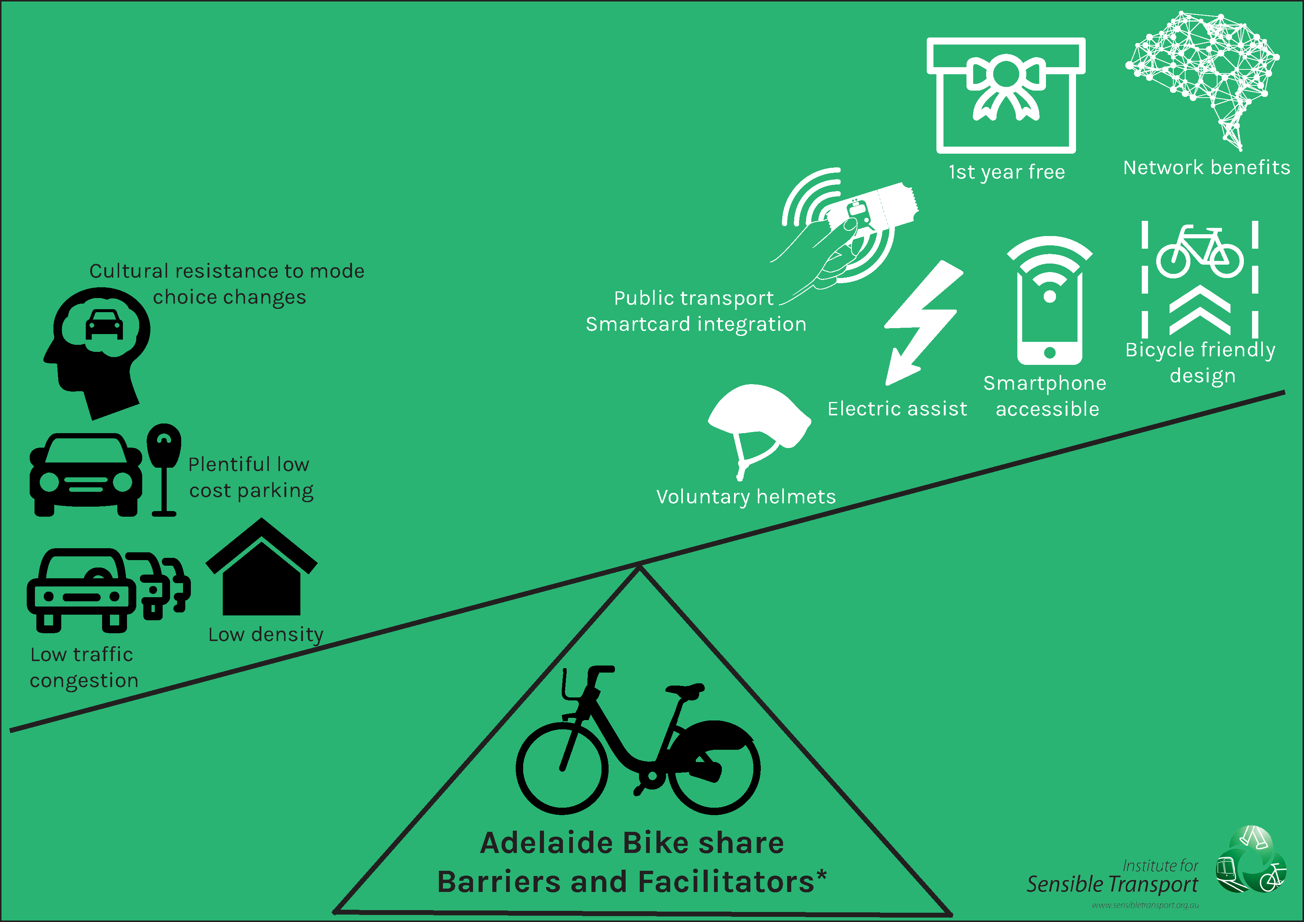
Source: Fishman (2016a)
NB: *The facilitators are not currently present but reflect design recommendations made in this paper. The degree to which they act as facilitators is dependent on their adoption. Many of these factors represent substantial changes from current conditions and require the involvement of state government (e.g. changes to mandatory helmet legislation and enhanced conditions for safe cycling).

  - Bike share propensity index for Adelaide
By international standards, Adelaide is a low density city (Loader 2015) and therefore it will not be economically feasible to provide coverage for the entire metropolitan area when designing a bike share system for Adelaide. To ensure the catchment is designed to maximise use, it is important to begin by providing coverage across the areas of Adelaide with the greatest likelihood of bike share use.
The datasets outlined in Section 2.1 have been used to assess each of the 2,256 individual spatial areas that the ABS divide Adelaide into, in order to rank their propensity for bike share use.
Figure 2 illustrates the outcome of the Bike Share Propensity Index, with darker regions indicating higher likelihood of bike share use. It is important to note Figure 2 shows relative propensity for bike share use. Thus, the darkest regions are only indicative of high levels of bike share use relative to the other areas of Adelaide. No comparison can be made with other cities. The areas displaying the strongest attributes for bike share include central Adelaide, Unley, and the corridors immediately east and west of the central city area. A corridor extending southwest, towards Glenelg has also been identified. In general, the darker areas represent areas with a combination of higher existing levels of cycling, higher population and/or employment density, lower levels of household car ownership and a greater proportion of households’ with occupants aged 18 – 34. All of these factors have been shown to be significant predictive factors for bike share membership in Australia (Fishman et al. 2015c).
The bike share catchment shown in Figure 2 consists of 162 docking stations, each holding ten bikes. Each docking station is approx. 300m apart, which is consistent with best practice (NACTO 2016). Whilst a detailed assessment of the costs associated with a bike share system such as the one shown in Figure 2 is beyond the scope of this paper, it is estimated at between $9.7m and $21m.

Figure 2: Bike share propensity index for Adelaide
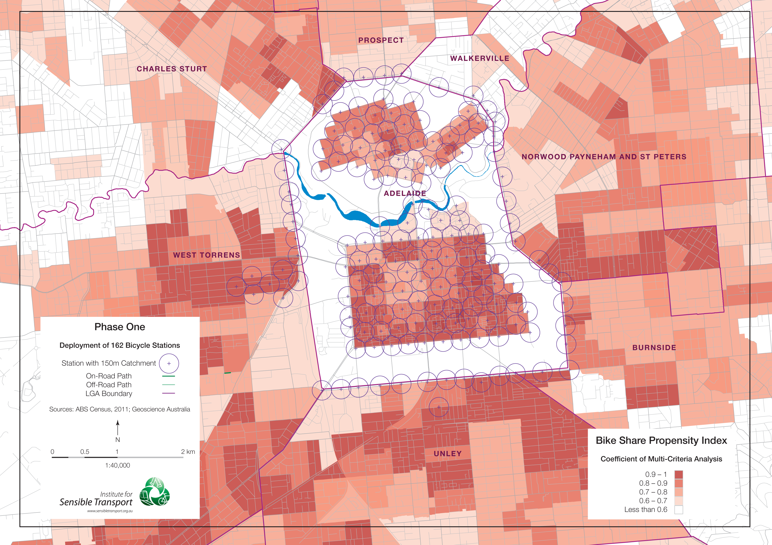
Creating the physical and policy conditions supportive of bike share in Adelaide is a long-term process. Section 3.4 describes the suggested sequencing of preparatory activities.
  - Implementation timeline
This paper has identified that a number of major policies require implementation before the necessary preconditions for an Adelaide bike share program are met. It is likely that the process of meeting these pre-conditions will take in the order of four years, meaning a future bike share program that stands the greatest chance of success is unlikely before 2020.
A lack of supportive bicycle infrastructure was one reason the Brisbane and Melbourne bike share schemes failed to achieve substantial ridership (Fishman et al. 2014b). It is therefore necessary to make a significant investment in the bicycle infrastructure network prior to launching a bike share program in Adelaide. This must include protected bicycle infrastructure, which has been shown to overcome the real and perceived risk associated with urban cycling (Teschke et al. 2012, Winters et al. 2011, Winters and Teschke 2010, Reynolds et al. 2009). Figure 3 provides a summary of the suggested milestones and broad scale timelines should Adelaide choose to begin the process of implementing a bike share program.

Figure 3: Implication timetable
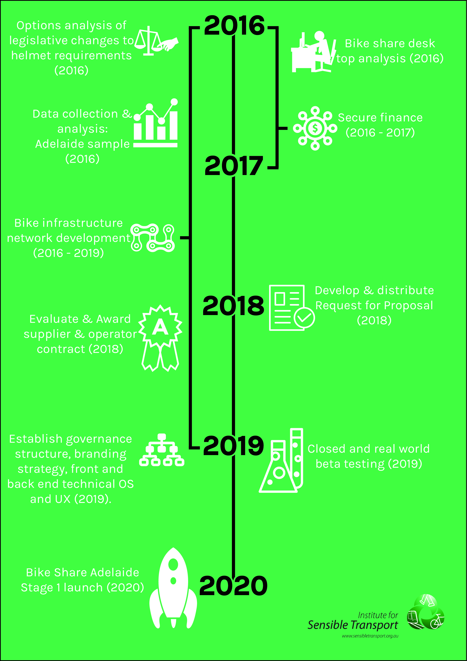

- Conclusion and summary of recommended options
This paper has provided an assessment of options for a future Adelaide bike share program. The assessment has found that Adelaide does not currently have the necessary conditions to support a successful bike share program. There are a number of pre-conditions that require implementation before Adelaide is likely to support a well used bike share program. Establishing a bike share program before these pre-conditions are met is likely to result in an underused system. These pre-conditions include:

- Electric assist bicycles.
- Public transport smartcard integration.
- Smartphone unlocking of bicycles using NFC technology.
- Higher density catchment design than other Australian bike share systems.
- Comprehensive marketing and branding strategy.
- Contractual and organisational structure that incentivizes usage.
- Free basic fare structure (at least for first year).
- Safer bicycle infrastructure network and lower motor vehicle speeds.
- Voluntary helmet regulation.
Implementing a bike share program that satisfies the pre-conditions identified above will provide Adelaide with the best possible prospect of success. However, there are limits to the impact these actions can have on ridership, as they do not eliminate the negative impact on usage associated with a low-density city and a transport system still heavily in favour of car use. Thus, this assessment of bike share options for Adelaide has found that although it is unlikely Adelaide will achieve the high usage levels of some bike share cities, bike share should be seen as a step Adelaide can take to begin the transition to a more sustainable transport system. The choice to use bike share must be seen as a complex decision making process that involves an assessment of all potential modes of transport. Ultimately the ability of a future bike share program to provide a compelling value proposition to potential riders will determine its popularity.
  - Further research
The following sequential set of research activities are proposed should Adelaide choose to establish a bike share program.

    - Research and public consultation
- Conduct focus groups to identify key barriers and facilitators to bike share, based on the Adelaide context, with people who live, work or study in inner Adelaide, including current cyclists and non-cyclists, as well as visitors.
- Conduct online and intercept surveys with target markets, to inform program design (e.g. bike hardware capabilities, pricing structure) as well as ridership forecasts.
- Undertake a benefit cost analysis for bike share, over the life of the program, including health, environmental, visitor experience and transport benefits, against capital and operational costs.
- Investigate the current bicycle infrastructure network in central Adelaide, for its ability to support a safe riding environment for a future bike share program, including a gap analysis and recommended actions.

    - Management and operational structure
- Conduct an analysis of best practice bike share management and operational structures.
- Assess local capacity to manage and operate bike share program in Adelaide.
- Develop preferred management and operational structure for bike share in Adelaide.

    - Sponsorship
- Conduct analysis of sponsorship opportunities and revenue forecasts.
- Develop, in conjunction with a branding agency and bike share consultant, a digital and hardcopy prospectus to attract potential program and station sponsors.

    - Develop Request for Proposals (RFP) document
- Using the results of the above activities, develop a detailed RFP document that includes desired specifications in relation to:
  - Minimum bicycle hardware requirements
  - Catchment size
  - Number of bicycles
  - Technology (both customer interface and backend) and data sharing policies, usage analytics interface
  - Fee structure and payment options
  - Proposed marketing strategy and target markets
  - Operations structure and capabilities.

Central to any assessment of the capacity for Adelaide to support a successful bike share program is the degree to which it provides compelling value proposition to potential users. This in turn is dependent on bike share’s ability to offer a convenient, time competitive alternative to existing modes, at least for a small proportion of trip types. Just as public transport planners have been encouraged to ‘think like a passenger’, it is helpful for bike share planners to ‘think like a rider’. What compelling value proposition do people have to use bike share in Adelaide? Is it faster than competing travel options? Is it more pleasant to use? Is it cheaper than other forms of transport? Are docking stations located close to where people live, work and shop? Does it feel safe to use? Is sign up easy and fast? Can users integrate bike share with public transport easily? Designing a system with these questions in mind is crucial to the success of a future bike share program.

- References

Adelaide City Council (2016). City of Adelaide 2016 - 2020 Stategic Plan.
Alta Bike Share (2011). Melbourne Bike Share Survey. Alta Bke Share, Melbourne.
Alta Planning + Design (2012). King County Bike Share Business Plan, Alta Planning + Design, Seattle
Australian Bureau of Statistics (2012). Census 2011. Canberra: Australian Government.
De Hartog, J, Boogaard, H, Nijland, H & Hoek, G (2010). Do the Health Benefits of Cycling Outweigh the Risks? Environmental Health Perspectives, 118, 1109-1116.
Fischer, C M, Sanchez, C E, Pittman, M, Milzman, D, Volz, K A, Huang, H, Gautam, S & Sanchez, L D (2012). Prevalence of Bicycle Helmet Use by Users of Public Bikeshare Programs. Annals of emergency medicine, 60, 228-231.
Fishman, E (2011). Evaluating the benefits of public bicycle schemes needs to be undertaken carefully. British Medical Journal, 343.
Fishman, E. 2012. Fixing Australian bike share goes beyond helmet laws [Online]. The Conversation. Available: https://theconversation.edu.au/fixing-australian-bike-share-goes-beyond-helmet-laws-10229 [Accessed Accessed 26th June 2013.
Fishman, E. (2014). Bikeshare: barriers, facilitators and impacts on car use. PhD Thesis by Publication, Queensland University of Technology.
Fishman, E (2015). Bikeshare: A Review of Recent Literature. Transport Reviews, 1-22.
Fishman, E (2016a). Bike Share Options for Adelaide, Institute for Sensible Transport, Melbourne. Available: http://sensibletransport.org.au/project/bike-share-feasibility-study-for-adelaide/
Fishman, E (2016b). Cycling as transport. Transport Reviews, 36, 1-8.
Fishman, E & Cherry, C (2015). E-bikes in the Mainstream: Reviewing a Decade of Research. Transport Reviews, 1-20.
Fishman, E & Schepers, P (2016). Global bike share: What the data tells us about road safety. Journal of Safety Research, 56, 41-45.
Fishman, E, Schepers, P & Kamphuis, C B M (2015a). Dutch Cycling: Quantifying the Health and Related Economic Benefits. American Journal of Public Health, e1-e3.
Fishman, E, Washington, S & Haworth, N (2012a). Barriers and Facilitators to Public Bicycle Scheme Use: A Qualitative Approach. Transportation Research Part F-Traffic Psychology and Behaviour 15, 686-698.
Fishman, E, Washington, S & Haworth, N (2012b). Understanding the fear of bicycle riding in Australia. Journal of the Australasian College of Road Safety, 23, 19-27.
Fishman, E, Washington, S & Haworth, N (2013). Bike Share: A Synthesis of the Literature. Transport Reviews, 33, 148-165.
Fishman, E, Washington, S & Haworth, N (2014a). Bike Share’s Impact on Car Use: Evidence from the United States, Great Britain, and Australia. Transportation Research Part D: Transport & Environment, 31, 7.
Fishman, E, Washington, S & Haworth, N (2015b). Bikeshare’s impact on active travel: Evidence from the United States, Great Britain, and Australia. Journal of Transport & Health, 2, 135-142.
Fishman, E, Washington, S, Haworth, N & Mazzei, A (2014b). Barriers to bikesharing: an analysis from Melbourne and Brisbane. Journal of Transport Geography.
Fishman, E, Washington, S, Haworth, N & Watson, A (2015c). Factors influencing bike share membership: an analysis of Melbourne and Brisbane. Transportation Research Part A, 71, 17-30.
Goodman, A & Cheshire, J (2014). Inequalities in the London bicycle sharing system revisited: impacts of extending the scheme to poorer areas but then doubling prices. Journal of Transport Geography, 41, 272-279.
Goodman, A, Green, J & Woodcock, J (2013). The role of bicycle sharing systems in normalising the image of cycling: An observational study of London cyclists. Journal of Transport & Health, 1, 5-8.
Graves, J M, Pless, B, Moore, L, Nathens, A B, Hunte, G & Rivara, F P (2014). Public Bicycle Share Programs and Head Injuries. American Journal of Public Health, e1-e6.
Heinen, E, Maat, K & Van Wee, B (2011a). Day-to-Day Choice to Commute or Not by Bicycle. Transportation Research Record, 9-18.
Heinen, E, Maat, K & Wee, B V (2011b). The role of attitudes toward characteristics of bicycle commuting on the choice to cycle to work over various distances. Transportation Research Part D: Transport and Environment, 16, 102-109.
Heinen, E, Van Wee, B & Maat, K (2010). Commuting by Bicycle: An Overview of the Literature. Transport Reviews, 30, 59-96.
Hirsch, R, Bezdek, R & Wendling, R (2005). Peaking of work oil production: Impacts, mitigation, and risk management.
Hudson, M (1982). Bicycle Planning: Policy and Practice, Architectural Press.
Institute for Transportation & Development Policy (2013). The Bike-sharing Planning Guide.
Kent, J L (2014). Driving to save time or saving time to drive? The enduring appeal of the private car. Transportation Research Part A: Policy and Practice, 65, 103-115.
LDA Consulting (2013). 2013 Capital Bikeshare Member Survey Report.
Loader, C. (2015). Are Australian cities becoming denser? Charting Transport [Online]. Available from: https://chartingtransport.com/2013/11/05/are-australian-cities-becoming-denser/ 2016].
Martin, E, Cohen, A, Botha, J & Shaheen, S (2016). Bikesharing and Bicycle Safety.
Nacto (2016). Bike Share: Station Siting Guide.
New York City Department of City Planning (2009). Bike-Share: Opportunities in New York City.
Parkes, S D, Marsden, G, Shaheen, S A & Cohen, A P (2013). Understanding the diffusion of public bikesharing systems: evidence from Europe and North America. Journal of Transport Geography, 31, 94-103.
Reynolds, C C O, Harris, M A, Teschke, K, Cripton, P A & Winters, M (2009). The impact of transportation infrastructure on bicycling injuries and crashes: a review of the literature. Environmental health: a global access science source, 8, 47-47.
Sadik-Khan, J & Solomonow, S (2016). Streetfight: Handbook for an Urban Revolution, New York City, Viking.
Shaheen, S, Cohen, A P & Martin, E W (2013). Public Bikesharing in North America: Early Operator Understanding and Emerging Trends. Transportation Research Record: Journal of the Transportation Research Board, 83–92.
Teschke, K, Harris, M A, Reynolds, C C O, Winters, M, Babul, S, Chipman, M, Cusimano, M D, Brubacher, J R, Hunte, G, Friedman, S M, Monro, M, Shen, H, Vernich, L & Cripton, P A (2012). Route Infrastructure and the Risk of Injuries to Bicyclists: A Case-Crossover Study. American Journal of Public Health, 102, 2336-2343.
Teschke, K & Winters, M (2014). Letter to Editor, American Journal of Public Health.
Transport for London (2014). Barclays Cycle Hire customer satisfaction and usage survey: Members Only.
Winters, M, Davidson, G, Kao, D & Teschke, K (2011). Motivators and deterrents of bicycling: comparing influences on decisions to ride. Transportation, 38, 153-168.
Winters, M & Teschke, K (2010). Route preferences among adults in the near market for bicycling: findings of the cycling in cities study. Am J Health Promot, 25, 40-7.
Woodcock, J, Tainio, M, Cheshire, J, O'brien, O & Goodman, A (2014). Health effects of the London bicycle sharing system: health impact modelling study. BMJ, 348.

- Appendix One

Bike share Propensity Index Variables and Quintiles
Measure | Scale for Index quintile
 | Q1 | Q2 | Q3 | Q4 | Q5
People per hectare | 0 – 13.945 | 14.011 – 20.931 | 20.941 – 24.873 | 24.876 – 29.000 | 29.002 – 90.234
Number of people working per hectare | 0–1.483 | 1.567 – 3.416 | 3.416 – 6.127 | 6.127 – 8.531 | 8.531 – 198.023
Number of people aged 18 – 34 years of age per hectare. | 0 – 2.728 | 2.734 – 4.423 | 4.423 – 5.855 | 5.860 – 7.799 | 7.804 – 61.982
Number of employed people across Adelaide with employment destinations within the City of Adelaide, by number in SA2 | 0-874 | 874-1088 | 1088-1545 | 1545-1912 | 1912-2926
Number of households with one or zero motor vehicles per hectare. | 0 – 1.973 | 1.973 – 3.534 | 3.534 – 4.968 | 4.968 – 6.788 | 6.788 – 32.325
Proportion of workers who used the bicycle for at least one stage of their trip to work, by residential SA2 | 0 – .009 | 0.009 – .016 | 0.016 – 0.021 | 0.021 – 0.033 | 0.033 – 0.050
Proportion of workers who used the bicycle for at least one stage of their trip to work, by destination SA2 | 0 – 0.004 | 0.004 – 0.010 | 0.010 – 0.015 | 0.015 – 0.0236 | 0.0236 – 0.0340

Since the early 1990s Australian states (including South Australia) have had mandatory helmet laws for people while riding bicycles.
An SA2 is a Statistical Area Level 2, as defined by the Australian Bureau of Statistics. An SA1 is the smallest area of output for the Census of Population and Housing. See http://www.abs.gov.au/ausstats/abs@.nsf/Latestproducts/88F6A0EDEB8879C0CA257801000C64D9
This includes the residential populations of the following Local Government Areas: Adelaide, Charles Sturt, Prospect, Walkerville, Norwood Payneham and St Peters, West Torrens, Holdfast Bay, Unley and Burnside.
This recommendation is not in favour of changes to mandatory helmet legislation, but rather an empirical study into its impact, and the impact of creating a waiver for bike share users. Only after the completion of such a study would it be possible to recommend any changes in current helmet legislation.
A more detailed assessment of bike share costs was provided in the full report provided to the City of Adelaide in Fishman (2016a).
As highlighted earlier, this is subject to the outcome of the recommended investigation and determined by the overall impact on population health.

