Large scale multiclass modelling for addressing the challenges, opportunities and future trends of new urban transport systems
Majid Sarvi¹, Saeed Asadi Bagloeei¹, Abbas Rajabifard¹, Russell G. Thompson¹,
¹Smart Cities Transport Group, Department of Infrastructure Engineering, Melbourne School of Engineering, The University of Melbourne, Victoria 3010, Australia
Email for correspondence: saeed.bagloee@unimelb.edu.au
Abstract
Emerging technologies in automation, IT communications and social (virtual) networks are rapidly changing the landscape of urban transportation. Some examples include autonomous vehicles, tesla vehicles (electric cars), Uber, and drone transport. Future transport requires new thinking and new modelling approaches as well as new modelling tools. In this paper we discuss the new features of transport and shed light on the challenges, opportunities and future trends. We stand by the belief that, though macro modelling will still exist as a tool for planning, detailed simulation (micro simulation) will become a necessity. This will require a whole different subjects pertaining to Big Data, network of networks, Internet of Things (IoT) and sensor networks. We also provide evidence (from literature) that the future transport will consist of a blend of distinct traffic patterns for which the concept of multiclass modelling becomes indispensable. To this end, we present a mathematical model where distinct traffic patterns can coexist in a single and unified model.
Key words: Autonomous vehicles, drone transport, Internet of Things, Big Data, electric cars,
- Introduction
Transport is the backbone of a society crucial for its success and it is associated with perils and promises. Transport promises economic prosperity and personal wellbeing while, with the environmental impacts can be one its perils. Regardless, advances in technology in recent decades (or years) have completely changed the landscape of transport. The transport community is becoming a multifaceted industry in which one can hear a wide spectrum of voices including psychology, electrical engineering, IT communication, mathematician, schools of philosophy and civil engineering.
People including transport authorities, scholars, transport planners as well as the public members are becoming more savvy and mindful of environmental concerns as well as transport safety to the extend they are being considered in the process of (transport) projects assessments .
In addition, there is a sense of excitement relating to the presence of emerging technologies and ideas such as electrical vehicles, the shared economy, Uber, Autonomous Vehicles, drone transport and sensors. This has placed transport on the cusp of a revolution which calls for different and noble notions such as Big Data, sensors revolution, machine learning, super networks and the Internet of Things (IoT).

A question to be asked is: what will the future hold when it comes to transport? This is a crucial question to motivate us to prepare for the new challenges as well as opportunities. To this end, one must fully comprehend the existing situation, emerging technologies and ideas and to identify persistent and pervasive trends and to project them into the future.
In this manuscript we present a number of the underlying traits of transport and map out some of the emerging technologies and ideas. Ever improving computational power is helping us to improve modelling tools and software to the extent that detailed modelling approaches such as agent-based models are able to applied in an increasing number of areas and scales that were not possible in the past. Nevertheless, macro modelling still retains its own merits when it comes to planning for the future. To this end we proposed a comprehensive multiclass modelling framework based on the nonlinear complementarity method to capture the range of behaviour of the users in the transport system.
- Sharing economy
The Shared Economy is a socio-economic ecosystem built around sharing of human, intellectual and physical resources. It includes the shared creation, distribution, trade and consumption of services and goods by different organisations and people. In fact the old fashion thinking of ownership is deemed to be obsolete . For instance, there is less desire for car ownership which was a dream in the past, when we can share cars with each other. Communication technologies and ease of financial transactions has made this concept a reality and it has already become popular practice especially amongst the younger generation. By doing so, the costs of ownership and maintenance are eliminated, while sharing is economically more viable . Figure 1 depicts an outlook for the shared economy.
Figure 1 An outlook for the shared economy (By Laura Recio Hidalgo - Own work, CC BY-SA 4.0, https://commons.wikimedia.org/w/index.php?curid=38178653)
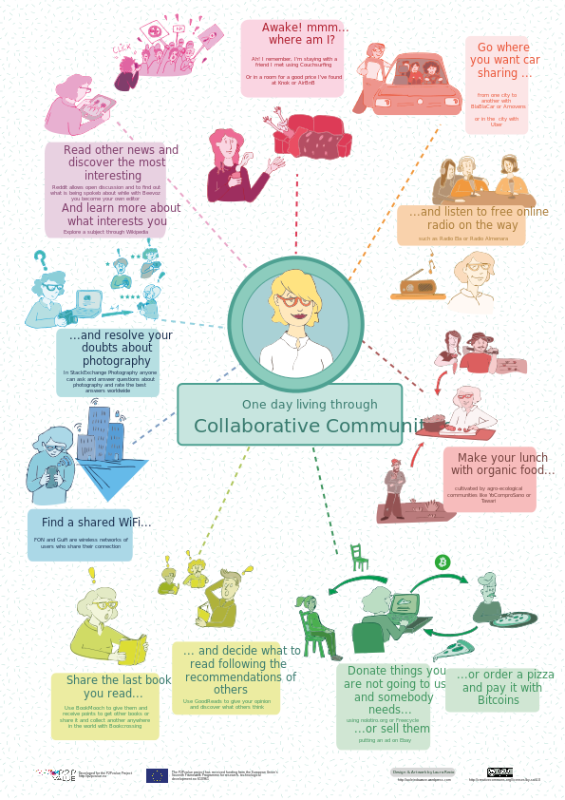
The shared economy concept is not limited to the transport, in fact, transport is only one of the applications. For instance in the housing, hospitality and tourism sectors, Airbnb has come as a landslide phenomenon. Airbnb is an online community marketplace that connects people looking to rent their homes with people who are looking for accommodation . Last year Airbnb raised $1.5 billion in funds that brought the value of the company to about $25.5 billion . This shows the extent of such a revolutionary idea in business. The idea is to make accommodation cheap and accessible on the back of grassroots society which also contributes to the prosperity of the households involved in this business. In other words, the big conglomerate corporates are replaced by ordinary people and the money and wealth are distributed and circulated among the people not big companies.
This concept in transport has led to a number of interesting phenomena. As mentioned before, car ownership is one of such area that has been impacted. Studies have shown that car ownership is on the decline in developed countries to the extent number of driving license holders are also on a downward trend. In some case studies, private cars, solo driving to work and not using public transport has become unfashionable or “not cool” .
Uber is an example of such a new trend. The way Uber works is pretty simple. A passenger calls for a car with a smartphone running the Uber app. An Uber driver then is called to the passenger’s location, who then takes the passenger to their destination. No cash is exchanged – payment is taken automatically from the passenger’s debit card – and no tip is required. This service is now available in over 60 countries and 404 cities worldwide .
Furthermore, transportation in the modern era has also become a lucrative and thriving business, to the extent that investment funds and entrepreneurs are keenly willing to bid. As such the concept of Public-Private-Partnership is becoming a well-established business model which helps the public sector to push for even cash-intensive transport projects .
- Teleworking
Broadband internet, cloud computing and other communication technologies have paved the way for much awaited demand of teleworking which can write off a big slice of daily commutes. Therefore, it is becoming a business model to hire home-staying employees for enterprises. This concept has gone beyond boarders such that companies are able to outsource part of their operations to overseas even in different time zones. Figure 2 illustrates the infrastructure needed for teleworking and its profound and positive impact on it has had on the economy.
- Real-time data
Computational power, data storage capacity, detectors, sensor revolution and communication technology have worked hand in hand to make rich and real-time transport related data readily available. Such a plethora of data can be applied powerfully in traffic management and transport planning. Access to live traffic data, provides enormous opportunities, including in-trip planning and traffic incident management. These data have been also used in some popular mobile apps, for example helping users in their daily commutes.
It also plays a central role in traffic management and in practices such as trip origin-destination estimation which can enhance the realism, dynamism and reliability of traffic management schemes.

- Big data
The unprecedented size and quality of data is beyond capacity of conventional software, hardware and knowledge to be stored, retained and processed. Figure 3 demonstrates a glimpse of the explosion of data in recent years. Accordingly, Big Data underpins the use of predictive analytics and other advanced methods to extract value from data. Accuracy in Big Data may lead to more confident decision making, and better decisions can result in greater operational efficiency, cost reduction and reduced risk. For instance, loop detector data at junctions and controlled signals are readily available in most of the cities which can be access online in many cases. Such data can easily amount to hundreds of gigabytes over the span of a year for a medium sized city. Conventional database software are generally unable to handle such a gigantic stack of information . The notion of Big Data has a key role in traveller information system where the aim is to assist commuters to make informed travel decisions. In doing so, given the existing infrastructure, the efficacy of the system is enhanced at no significant cost .
Figure 2 Teleworking – Figure on the top shows infrastructure needed for teleworking. (http://www.alliedworldwide.com/articles/the-pros-and-cons-of-teleworking-and-how-businesses-can-adapt-to-it.aspx), Figure on the bottom shows saving out the teleworking in the United States (http://deloitte.wsj.com/cio/2013/04/11/telework-and-the-federal-government/)
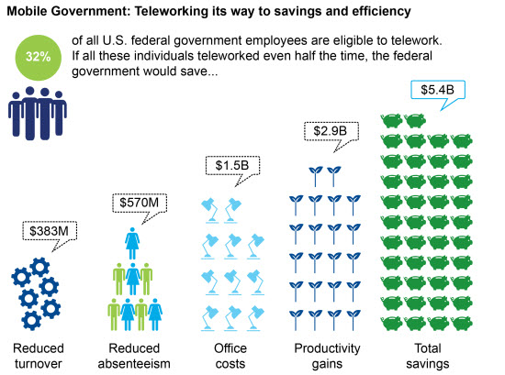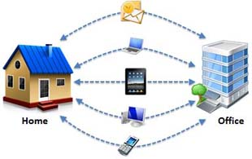

- Machine learning
Data itself, no matter how big or small it is cannot solve problem(s). It must be analysed and processed to derive a trend or pattern that can be used as a decision support component for the future operation. Generally speaking, since transport is intertwined with human and human behaviour, which is not easy to comprehend, it is hard to find an easy and straightforward way to derive a convincing pattern form Big Data. Machine learning is a method of data analysis that automates analytical model building . Using algorithms that iteratively learn from data, machine learning allows computers to find hidden insights without being explicitly programmed where to look. It is a perfect tool to assist us to process transport and traffic data. One of the prime example of the transport and machine learning can be found in solving large scale optimization problems which is highly appealing to the industry, traffic authorities and practitioners. For examples techniques such as genetic algorithm, ant colony, neural networks etc are becoming an indispensable part of any solution to the problems such as road network design , prioritization and parking planning etc.
- Drone transport
Ever becoming omnipresent drones have given a lot of excitement to our life as well as transportation. In a very short amount of time, drones have been implemented by some enterprises such as search/rescue and delivery services. They are also known as delivery drone, or parcelcopter, which is an unmanned aerial vehicle (UAV) utilized to transport food or other goods (see Figure 4).

- Electric vehicles
An electric vehicle (EV), also referred to as an electric drive vehicle, uses one or more electric motors for propulsion. An electric vehicle may be powered through a collector system by electricity from off-vehicle sources, or may be self-contained with a battery or generator to convert fuel to electricity. Electric motors give electric cars instant torque, creating strong and smooth acceleration .
Electric cars produce no tailpipe emissions, reduce our dependency on oil, and are cheaper to operate. Of course, the process of producing the electricity moves the emissions further upstream to the utility company’s smokestack, but even dirty electricity used in electric cars usually reduces our collective carbon footprint (see Figure 5).
In fact the EVs have a mandate to obviate fossil fuels in transport. Perhaps a major barrier to the large scale adoption of EVs is range anxiety, where the fear that a vehicle has insufficient range to reach its destination and would thus the vehicle's occupants would become stranded.
Figure 3 A schematic view of the explosion of data which led to Big Data
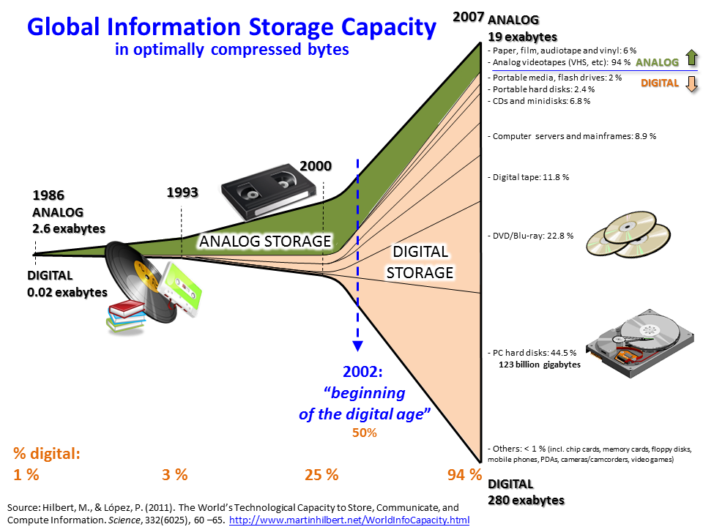
The main strategies to alleviate range anxiety among electric car drivers is the deployment of extensive charging infrastructure, the development of higher battery capacitis at a cost-effective price, battery swapping technology, use of range extenders, accurate navigation and range prediction and availability of free loaners for long trips.
- Internet of Things
The IoT is a proposed development of the Internet in which everyday objects have network connectivity, allowing them to send and receive data .
More precisely, The IoT is a system of interrelated computing devices, mechanical and digital machines, objects, animals or people that are provided with unique identifiers and the ability to transfer data over a network without requiring human-to-human or human-to-computer interaction.
A thing, in the IoT, can be a person with a heart monitor implant, a farm animal with a biochip transponder, an automobile that has built-in sensors to alert the driver when tire pressure is low -- or any other natural or man-made object that can be assigned an IP address and provided with the ability to transfer data over a network .
Connectedness is the fruit of the IoT to transportation which will have revolutionary implications in all corners of transport systems. This brings improved safety, speed, accessibility, convenience and reliability to services and operations.
Figure 4 A schematic illustration of drones used in delivery service
(http://www.psfk.com/2015/07/first-drone-delivery-approved-by-us-government-flirtey.html)
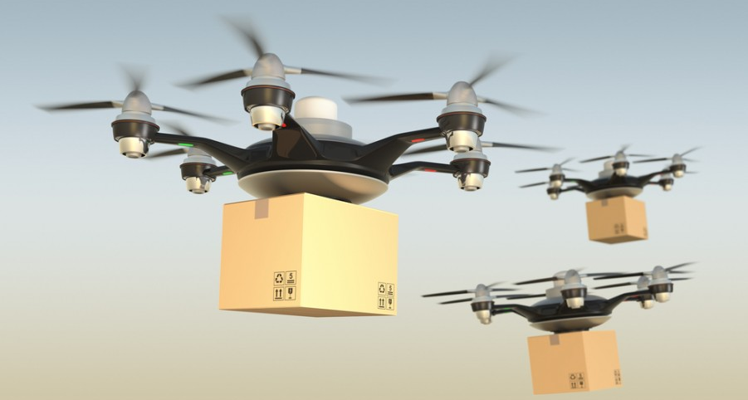

Figure 5 Electric vehicle versus fossil fuelled vehicle (http://www.plugincars.com/electric-cars)
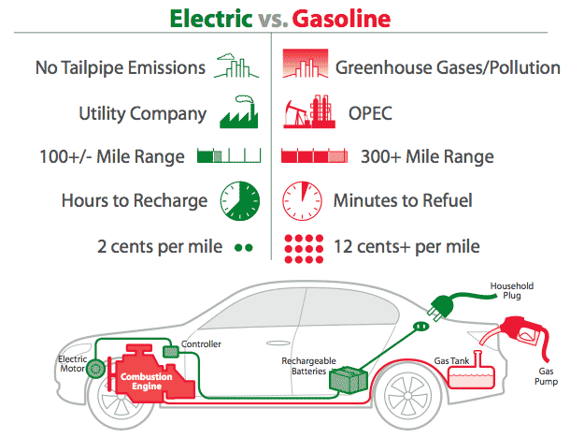

- Autonomous Vehicles
A driverless car (sometimes called a self-driving car, an automated car or an autonomous vehicle) is a robotic vehicle that is designed to travel between destinations without a human operator. To qualify as fully autonomous, a vehicle must be able to navigate without human intervention to a predetermined destination over roads that have not been adapted for its use.
The application of new technologies in communication networks and robotics have had substantial influence in our daily lifestyle and transportation is of no exemption. These technologies have given rise to Autonomous Vehicles (AV) that aim to reduce crashes, energy consumption, pollution and congestion as well as increase transport accessibility. AVs combine many disciplines from Electrical Engineering to Philosophy. In this article we look at AV from atransportation point of view.
Although the idea of driver-less cars has been around for decades, high costs have hindered large-scale production . Nevertheless, significant efforts have been thrown behind the idea to bring AV to a reality. The advent of the Google car brought AV into the spotlight . Rapid developments in communication technologies combined with aging populations is making AV a necessity and a vital business paradigm. The fierce competition amongst car manufacturers has slated year 2020 the horizon year to offer the market with commercial AV .
Recently, an extensive review on transportation themes and implications of AV in domains such as safety, fuel consumption, road pricing and parking requirement was provided . Nonetheless AV touches (directly or indirectly) other areas such as licensing, testing standard, liabilities, insurance, (data) security concerns and data privacy. In particular, they highlight the challenges, opportunities and implication that come by the introduction of AV in a transport system. In doing so, they first introduce AV and its context as well as some related terminologies. They then try to depict the looming picture of the AV in the short run as well as in the long run based on the previous studies. The results are articulated as the opportunities and challenges associated with AV. These subjects are also receiving much attention .
Generally speaking, AV operate on a three-phase design “sense-plan-act” which is the premise of many robotic systems . A difficult challenge for AV rests in the first phase to make sense of the complex and dynamic driving environment . Our sight and cognition of visual data can vary and be limited in adverse conditions such as darkness, rain, or can be impaired through the use of drugs or alcohol . Therefore, a variety of sensors installed on vehicle are in charge of data collection which is then passed on to software for analysis and then conducting actions. The raw data related to the outside world as well as vehicle related information are compiled.
Software and algorithms browse through the raw data to draw a picture of what is happing in and around the vehicle. This process is aimed at developing plans for the vehicle’s actions. These plans entail immediate decisions, such as acceleration, lane changing and overtaking and which are then passed to the vehicle control system (i.e. throttle, brakes and steering) in the form of actionable commands.
The driving environment is dynamic and complex which poses many challenges for AV. A blend of surveillance technologies has been employed to cope with such difficult tasks. Here, we briefly introduce some monitoring technologies used in AV
Shortcomings of sensors, cameras, radars, GPS and other devices are well known to researchers, hence, usual practice is to develop suites of complementary sensors that are installed around the vehicle to prevent blind spots. Figure 6 shows a typical car equipped with sensors, cameras and other devices .
Despite all these efforts, due to the environmental challenges these devices may still malfunction. Given the above difficulties, the ideas of vehicle-to-vehicle communication (V2V) as well as vehicle-to-infrastructure communication (V2I) have been proposed. The idea is to share the knowledge compiled from a fleet of connected vehicles to leave no space for error. The success of this idea lies on how the communication is set out which also has a central place in the Internet of Things.
Figure 6 1 Communication technologies, (courtesy of DiClemente et al., 2014)
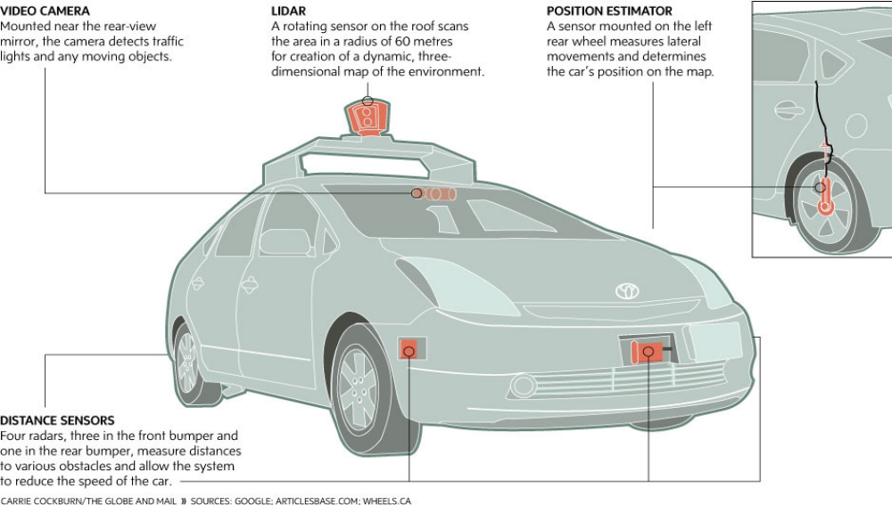

- Connectedness and efficient traffic circulation
Connectedness as an indispensable component of any development in AV. Itcan also be exploited to arrive at a more efficient and smoother circulation of traffic. To this end we propose the concept of vehicle navigation instead for the routing problem for AV while they are mixed with non-AV. We then formulate a traffic assignment model for the mixed AV and non-AV which is a combination of system optimal and user equilibrium conditions. There exists two general traffic patterns, non-cooperative or user equilibrium (UE) and a more efficient and cooperative system optimal (SO) in which the total cost of the transport system is minimized . The aim is move from UE to SO for which connectedness is a force to be reckoned with.
Let us consider 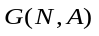a traffic network as a graph consisting of 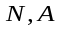 sets of nodes and links respectively on which is a set of destinations.
Since set of roads are defined based on nodes (i.e. ), we represent roads using a single character 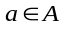as well as start and end nodes: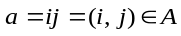. At equilibrium conditions both UE and SO traffic arrive at a stable situation in which no car changes its route. Hence for the UE part, consider 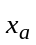is non-cooperative traffic flow on road while 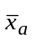denotes AVs as the background traffic volume on the respective road . Therefore the UE traffic pattern can be formulated as a non-linear programing problem (throughout the manuscript, all terms are non-negative unless otherwise stated):
[UE-TAP]:
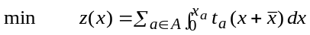 (1)
s.t.: (2)
(3)
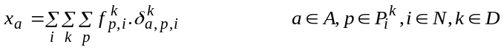 (4)
where the Beckmann objective function to be minimized; 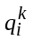: non-cooperative travel demand from to ; 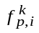:the flow of non-cooperative cars on path from to ; 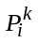: set of all paths available to non-cooperative cars from to ; 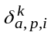: the link-path incidence (1: if link belongs to path from to available to non-cooperative cars, and 0 otherwise). Similarly at equilibrium, AVs volume 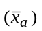in the context of background traffic of non-cooperative volume 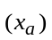 can be formulated as follows:
[SO-TAP]:
(5)
s.t.: (6)
(7)
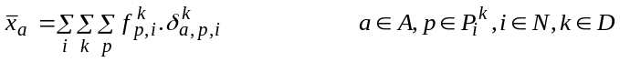 (8)
The notations are similar, the bar on top of the terms represent the AV. Both AV and non-cooperative travel demand share the same network (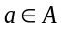). The difference lies in the objective function. There is a plethora of methods proposed to solve the UE-TAP efficiently. As such, one easy way to solve a SO-TAP is to transform it to an UE-TAP. To do so, one just needs to replace the delay function 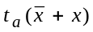 with the marginal delay function: 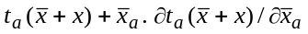. Therefore both UE-TAP and SO-TAP can be combined as a single UE-TAP but with two different delay functions and travel demand matrices. Such arrangement in transportation is very common and is called multiclass traffic assignment problem (MC-TAP). Solving a MC-TAP is computationally more intensive than a single class TAP for which a variety of methods such as Variational Inequality, Complementarity Method, Fixed-Points and Entropy Maximization as well as origin-based (or bush based) methods has been proposed .
The SO traffic pattern is the most desirable traffic pattern in which the total travel time spent on the network (as a network performance index) is minimized. In reality people follow the shortest path which leads to a traffic pattern known as UE. In terms of the total travel time spent on the network (also an index for congestion level), the gap between UE and SO can reach as high as 2.15. In other words, one can significantly improve the congestion level up to 2.15 times by enforcing a SO rather than a UE traffic pattern. This gap has been a motive for a variety of traffic management (or control) measures and policies such as parking planning, congestion pricing and ramp metering. The advent of AV can also be added to these schemes. Although the above formulation includes two distinct classes, methods such as nonlinear complementarity programing (NCP) or Variational Inequality (VI) can accommodate more vehicle classes.
- Conclusion
Transport is undergoing revolutionary changes on the back of emerging technologies such as sensors revolution and new business models such as the shared economy. In order to have the upper hand on these matters one has to comprehend such pros and cons. In this paper we identified some of these emerging technologies and their associated concepts and described their implications for transport system. Though expected opportunities are very promising there are also considerable challenges and concerns. We also highlighted the new concept of connectedness which is the core entity of the IoT and AV. Based on these development we formulated a new model to provide an efficient traffic pattern namely vehicle navigation.
All in all, emergency technology like automation, big data is rising. New technology bring new problems and new modelling approaches are required. There is no reason to doubt that modelling for micro transportation phenomenon is very necessary. It is reasonable to see that the future transport is a combination of distinct traffic patterns. Thus, a mathematical tool is necessary to be applied to model different modes in a single and unified model.
References

