Determining route choice behaviour of public transport passengers using Bayesian statistical inference

Mohadeseh Rahbar1*, Mahmoud Mesbah1, Mark Hickman1, Ahmad Tavassoli1

1School of Civil Engineering, the University of Queensland, Australia

*Email for correspondence: m.rahbar@uq.edu.au

**Abstract**

Using smart card systems for public transport fare collection has provided a great opportunity to access large scale and high quality travel data of transit users. This data has the potential to be used for modeling passenger behavior. In this paper, Bayesian statistical inference is used to model passenger route choice behavior and to estimate attributes of travel time components. The Bayesian approach provides a comprehensive posterior knowledge of the system. The posterior density integrates the observed passenger travel data with our prior knowledge about the transit network. Due to the high dimensional nature of the parameter space, the Markov Chain Monte Carlo Method is utilized to compute the mean value for each parameter. The suggested model is calibrated and validated using the fare card data from Brisbane, Australia in March 2013. The dataset contains those journeys with an educational purpose. The inference results for link travel times are compared with the scheduled times from Brisbane’s General Transit Feed Specification to show the reliability of public transport services. The estimated route choice parameters indicate that transfer time is seven times more important than in-vehicle time for transit passengers.

1. **Introduction**

Public transport has a significant role in urban transport systems. It is paramount to analyse the route choice behaviour of transit passengers to capture the spatiotemporal distribution pattern of passenger flow in a transit network (Liu et al., 2014). Also, maintaining service reliability would be improved by knowing flow assignment patterns in a transit network (Desaulniers and Hickman, 2007). Automated fare collection (AFC) has provided an excellent opportunity to access a large scale and high quality of travel data of transit users to analyse both passenger behaviour and system reliability. Obtaining these components may require further analysis and modelling.

Passengers make their route choice decisions by considering several factors such as in-vehicle time, transfer time (or the number of transfers), waiting time, crowdedness, etc. (Davidson et al., 2014). Estimating these factors as the route choice parameters, considering the fact that network cost attributes might be non-deterministic, is complicated. To tackle this complexity, a Bayesian statistic approach is suggested in this paper, due to the role of prior knowledge of travel time components such as in-vehicle time, transfer time, and service frequency in the estimation of a statistical model. Bayesian logic combines prior knowledge, typically in the form of a statistical distribution, with current data (such as AFC data), to derive a meaningful posterior distribution. Various transportation studies have applied the Bayesian statistic approach (Hazelton, 2008, Hazelton, 2010, Sun et al., 2015, Wei and Asakura, 2013). The suggested approach is becoming popular in transportation because of the applicability of the Bayesian models through the use of Markov Chain Monte Carlo (MCMC) methods for estimating Bayesian parameters (Robert, 2014, Washington et al., 2011). MCMC, as a simulation process, repeats sampling from probability distributions over an infinite state space that results in a Markov chain (Washington et al., 2011). In this paper, Bayesian statistical inference using large scale travel data of transit users provided by AFC, and prior knowledge of our transit network, are utilized to model passenger route choice behaviour and to estimate travel time attributes of the network simultaneously.

The remainder of this paper is structured as follows. Reviewing of previous studies on detecting route choice behaviour, analysing travel time reliability, utilizing AFC data, and applying the Bayesian approach in transit network modelling are presented in section 2. The proposed modelling framework is the topic of section 3. Case study application and posterior inference are discussed in section 4. Finally, conclusions and suggested directions for future research are provided in section 5.

1. **Literature review**

In early studies, it was assumed that route choice in transit networks is determined by a deterministic travel time (Sheffi, 1987). However, more researches have shown that passengers choose their paths based on an estimated deterministic travel time and travel time reliability (Bekhor et al., 2008, Mirchandani and Soroush, 1987, Sumalee et al., 2011). In comparison with traditional methodologies, Liu et al. (2010) have introduced a category of studies as “emerging approaches” that considers complexities in transit users’ behavioural mechanisms of decision-making.

Routes using shared common sections in the transit network (Chriqui and Robillard, 1975, Marguier and Ceder, 1984), the role of hyperpaths in transit networks and overlapping lines (Nguyen and Pallottino, 1988, Spiess and Florian, 1989), and providing timely information on the status of transit vehicles (Cats et al., 2011, Gentile et al., 2005, Hickman and Wilson, 1995, Hickman, 1993) are the most important factors that makes passengers’ route choice behaviour more complicated (Nassir et al., 2015).

For making informed planning decisions, transit operators should know how passengers behave and how these systems perform (Sun and Xu, 2012). Automated fare collection (AFC) systems have provided a great opportunity to access large scale and high quality travel data of transit users, which enable researchers to extract passengers’ behaviour and service performance. Pelletier et al. (2011) presented a comprehensive review of uses of smart card data in the public transit context. In AFC systems, when the traveller taps his/her card on an entry/exit card reader, some valuable data such as date, time, location, bus number, route number, direction, etc. are recorded. Such data was used by Shimamoto et al. (2005) to calibrate a hyperpath choice model for public transport users. Schmöcker et al. (2013) proposed a nested model based on a smart card dataset in which the choice set formation (the upper level) is based on utility maximisation of personal preferences and the choice of a particular bus from the choice set (lower level) is given by their frequency distribution. To our knowledge, the research presented by Sun et al. is the only study that paid attention to the both travel time attributes of the network and passenger route choice behaviour simultaneously (Sun et al., 2015); however, that study only analysed a metro (urban rail) system.

In this paper, Bayesian statistical inference is utilized to model passenger route choice behaviour and to estimate travel time attributes of the network including all modes, namely: bus, train, and ferry. The fare card dataset used in this research is from the public transit services in Brisbane, Australia in March 2013, and also contains those journeys with the educational purpose to The University of Queensland (UQ).

1. **Methodology**
   1. **Data pre-processing**

In this study, the main focus is on those journeys with an educational purpose which start within a weekday morning peak (7-9 am) and finish within or after this period. Using the regional smart card fare payment system, the “Go Card”, all essential data such as date, time, boarding and alighting location, bus number, route number, and direction of each transaction is provided. Each passenger who uses Go Card has a unique smart card ID that is available in our data. Using this unique ID and the time of an alighting and the next boarding, transfer time can be calculated. In Brisbane, a 60-min transfer time is used for fare collection (Alsger et al., 2015). Therefore, if the calculated transfer time is less than 60 minutes, these two trip legs are associated with one journey.

For estimating the origin-destination (OD) matrix, the boarding stop of the first trip leg for a unique card ID is an origin and the alighting stop of its last trip leg (with transfer time less than 60-min) is a destination. According to this condition, our case study network reconstruction is done by adding transfer links into the network, and the OD matrix is estimated. All train stations/bus stops/ferry terminals are defined nodes in our network and are connected via transit links. Then, the route choice set *Rod* for each OD pair *od* is generated. Because of the existence of numerous possible routes for each OD pair in our transit network, only those routes that are actually used by passengers are extracted from the dataset and put into the route choice set. So, for each OD pair, we have one route choice set *Rod* which contains one or more routes, and several observations (travel time by travellers) *Tod* with specific travel times *t* for each OD pair.

* 1. **The Bayesian Approach**

The aim of this study is to detect passengers’ route choice behaviour and simultaneously to estimate travel time attributes of the network. Given that services are not punctual due to operational disturbances, we assume that travel time (cost) *ca* on each link *a* is a random variable that follows a specific distribution. Also, the transfer time *cf* on a transfer link *f* is a random variable with a particular distribution. On the other hand, in applying a route choice model, we are using a Multinomial Logit Model (1) which is a function of route attribute (link travel time). A parameter vector () is defined using the coefficients for each attribute.

|  |  |
| --- | --- |
|  | (1) |

The value of unknown parameters and variables in our model are obtained by using available observations (*T*) from the Go Card data. These variables and parameters are travel time on each link *ca*, transfer time *cf*, and the impact of in-vehicle time  and transfer time  on passenger route choice behaviour. In this paper, it is assumed that all link costs are independent. In this case, we can obtain benefits of the Bayesian logic that combines our prior knowledge about the Brisbane transit network with the travel time observations to derive an improved posterior distribution. We show this posterior probability using formula (2), where  is the conditional probability of observing *T* given all parameters,  is the prior probability of parameters, and *p*(*T*) is the marginal density for *T*.

|  |  |
| --- | --- |
|  | (2) |

Based on our previous assumption about independence of parameters, we have

|  |  |
| --- | --- |
|  | (3) |

where  is the likelihood function and  and  are our prior distributions.

As mentioned before, each route set often contains more than one alternative route for each OD pair, and the probability of observing travel time *t* from a passenger depends on the selected route. Therefore, the probability of observing travel time *t* for each route *r* can be expressed as (4):

|  |  |
| --- | --- |
|  | (4) |

where  is the probability of observing *t* given route *r* and other parameters, and  is the probability of selecting route *r* from route choice set *Rod* given all parameters. Based on our assumption that a link’s travel time follows a normal distribution and all of the link travel times are independent, we can say that  also follows a normal distribution and its probability function is as (5).

|  |  |
| --- | --- |
|  | (5) |

where the cost *ci* contains both in-vehicle links and transfer links in the network.

Taken together, formula (2) can be written as follows:

|  |  |
| --- | --- |
|  | (6) |

1. **Case study and results**

In this section, we apply the suggested Bayesian framework on the Brisbane transit network. In this study, our main focus is on journeys with a UQ destination during the am peak period. For calibrating our model, we required a combination of various types of routes, such as with/without transfer links, for each OD pair. Thus, we divided our network into traffic analysis zones (TAZs) and selected UQ and four other TAZs, with 1580 trip legs, 1290 journeys to UQ, and 54 OD pairs, during five weekdays (18-22 March 2013). These selected journeys to UQ use 196 nodes and 275 links (*ca*) and 22% of them have at least one transfer link. Using data from four zones helps us to track the performance of our model precisely. As can be seen in Figure 1, UQ is the destination and zones 44, 128, 188, and 190 contain the selected origin stops. In this sample, we defined one type of transfer link that is employed in all transfer points, and the transport modes are bus and ferry.

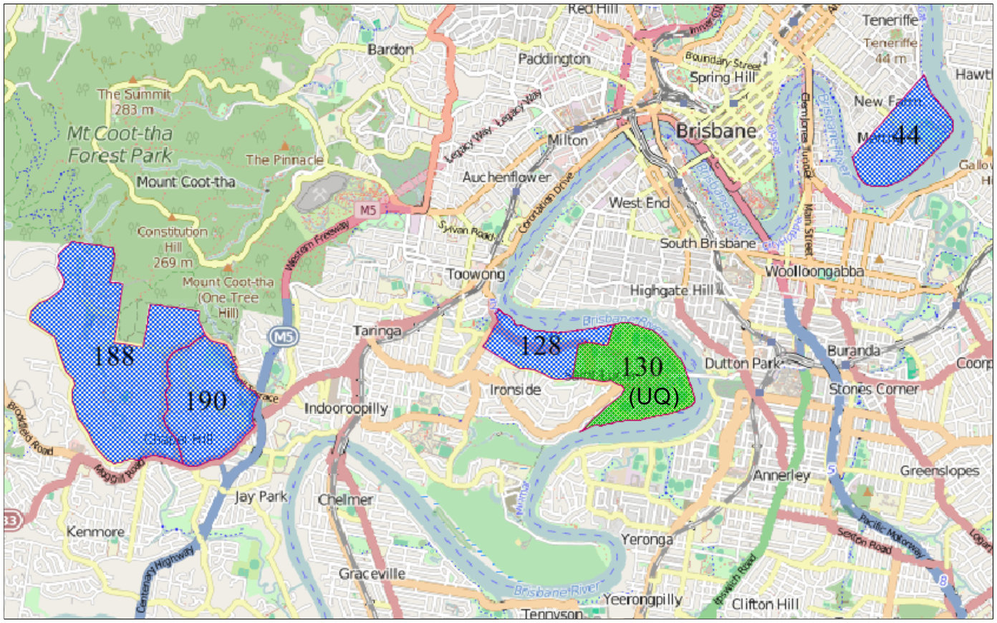

**Figure 1: The position of selected TAZs in Brisbane for the case study**

In the Bayesian inference framework, the prior distribution will be specified from researchers’ subjective perspectives, independent of data. In this study, we assume that link travel time follows a normal distribution (formula 7) since this was assumed by some previous researchers such as (Li et al., 2013, Hofleitner et al., 2012, He et al., 2002). In terms of  distribution, due to lack of prior information for route choice parameters, it is assumed that the  vector follows a uniform distribution, as shown in (8).

|  |  |
| --- | --- |
|  | (7) |
|  | (8) |

We implemented the suggested Bayesian framework in the R programming language.

In this case study, the travel time of links related to different modes varies between 1 to 12 minutes. By assuming a variety of data models, model-based approaches identify the most likely model and the number of clusters. Using the model-based clustering, the model and number of clusters with the largest BIC (Bayesian information criterion) are selected. Table 1 shows the characteristics of the selected model and the suggested number of clusters. As can be seen, the suggested number of clusters is three clusters. Figure 2 illustrates the density and clustering plots of the data. Therefore, we categorized links into three groups with *µ*=1, 3, and 7 and =2.

**Table 1: The Clustering Output**

|  |  |  |  |
| --- | --- | --- | --- |
| **Log-likelihood** | **Size of Data** | **BIC** | **Number of Clusters** |
| -347.601 | 275 | -728.8807 | 3 |

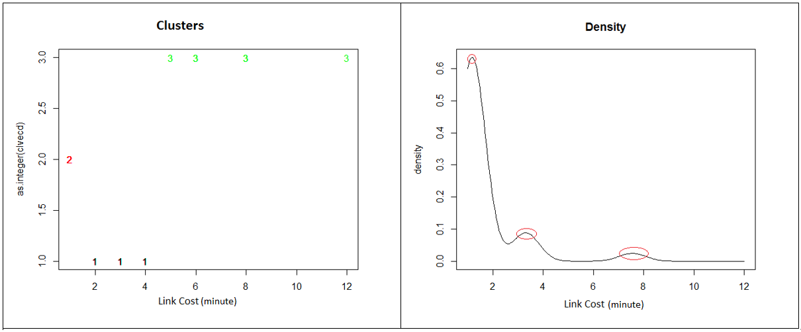

**Figure 2: Density and clusters of the data**

For route choice parameters , we assume that *a*=-2 and *b*=0. Three times run of the model with different values for *a* (*a*=-1, -2, and -3) showed that the posterior value for  will not change. Therefore, the authors selected -2 for parameter *a*.

The aim of Bayesian inference is to get an accurate representation of the posterior distribution by sampling a large number of representative points (Kruschke, 2010). By using Markov Chain Monte Carlo (MCMC) techniques, we can generate representative random values to assess the properties of a target (Kruschke, 2010). We use the JAGS (Just Another Gibbs Sampler) that automatically builds MCMC samples for our model. JAGS is a program that receives the description of our hierarchical model for data and returns an MCMC sample of the posterior distribution.

We created our model in JAGS with three chains of 10,000 iterations and 2000 steps for the burn-in period, and then generate MCMC samples with 15,000 iterations. Table 2 shows the estimated value of all parameters based on those effective samples. The second and third columns represent the prior distribution and the posterior distribution of each parameter, respectively. It can be seen that transfer time is seven times more important than in-vehicle time for transit passengers. This confirms the observation of previous study that passengers value transfer time more than in-vehicle time (Raveau et al., 2014, Sun et al., 2015) in a route choice context.

**Table 2: Parameters and their estimated values**

|  |  |  |
| --- | --- | --- |
| **Parameter** | **Prior distribution** | **Posterior Distribution** |
|  |  |  |
|  |  |  |
|  |  |  |
|  |  |  |
|  |  |  |
|  |  |  |
| … |  |  |
|  |  |  |

The diagnostic information for all in-vehicle time links, transfer link, and parameters are analysed. For instance, figures 3 and 4 show diagnostic information for the  (impact of transfer time) and *c1* (in-vehicle time for link 1), respectively. It is also important to check if chains represent the posterior distribution suitably. The upper-left plot that says there are no orphaned chains. The lower-right density plot shows the three sub-chains are well superimposed, and the Monte Carlo standard error (MCSE) is small enough.

One other common numerical check is the shrink factor (Gelman and Rubin, 1992) that is shown by the lower-left plot. The shrink factor measures the relation of the variance within chains to the variance between chains. It can be seen that after the burn-in period, the measure quickly converges to 1.0, meaning that all three chains have settled into representative samples. In this step, we have some assurances that chains represent the posterior distribution.

In the next step, we should make sure that a large enough sample for stable and accurate numerical estimates of the distribution is available, and also, we need a measure of the “clumpiness” of the chain. Therefore, using the upper-right plot, we will measure clumpiness as autocorrelation, which is the correlation of the chain values with the chain values *k* steps ahead. In fact, we are looking for the sample size of a non-autocorrelated chain. In our sample, there are three chains, each with 15,000 steps, yielding 45,000 steps overall. Thus, the ESS (Effective Sample Size) that is shown in the upper-right plot is suitable for an accurate and stable picture of the posterior distribution.

As it is shown in Figure 3, the posterior distribution for  is a normal distribution, but its prior distribution was a uniform distribution. It proves the important effect of the data on the posterior distribution.

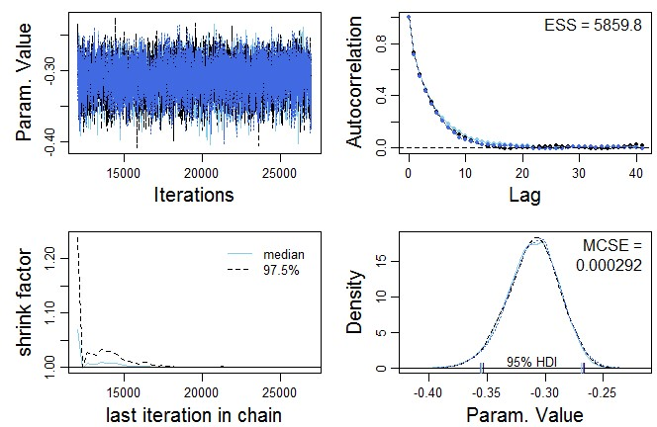

**Figure 3: Convergence diagnostic for**

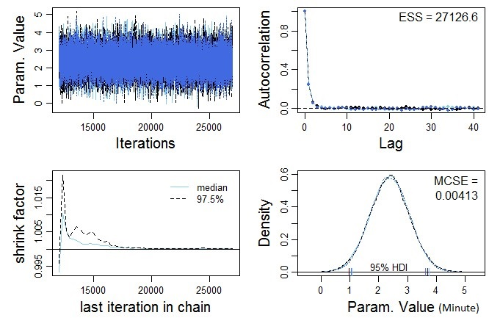

**Figure 4: Convergence diagnostic for** 

Using the estimated values of parameters by Bayesian approach, we computed the probability of choosing each route for two other regular days (12-13 March 2013) with 46 OD pairs and compared these results with the actual choice data. The results are shown in Table 3. The column “*Route*” shows the routes for each OD pair, so, route 1 in OD pair 5 is different from route 1 in OD pairs 6, 28, and 42. The largest route choice set belongs to OD 5 with nine routes. Columns “*PA*” and “*Data*” present the probability of choosing a route by the proposed algorithm and our observations (data), respectively. Column “*TL*” shows the number of transfer links in each route.

**Table 3: Result of the proposed algorithm**

|  |  |  |  |  |  |  |  |  |  |  |  |  |  |
| --- | --- | --- | --- | --- | --- | --- | --- | --- | --- | --- | --- | --- | --- |
|  | **OD pairs** | | | | | | | | | | | | |
| **Route** | **5** | | | | **6** | | | **28** | | | **42** | | |
| **PA** | **Data** | **TL** | **PA** | | **Data** | **TL** | **PA** | **Data** | **TL** | **PA** | **Data** | **TL** |
| 1 | 0.04 | 0.05 | 1 | 0.00 | | 0.07 | 2 | 0.01 | 0.03 | 2 | 0.30 | 0.57 | 1 |
| 2 | 0.05 | 0.07 | 1 | 0.07 | | 0.27 | 1 | 0.06 | 0.14 | 1 | 0.33 | 0.14 | 1 |
| 3 | 0.57 | 0.58 | 0 | 0.07 | | 0.07 | 1 | 0.07 | 0.11 | 1 | 0.36 | 0.29 | 1 |
| 4 | 0.05 | 0.07 | 1 | 0.08 | | 0.27 | 1 | 0.08 | 0.17 | 1 |  |  |  |
| 5 | 0.06 | 0.09 | 1 | 0.71 | | 0.27 | 0 | 0.67 | 0.50 | 0 |  |  |  |
| 6 | 0.05 | 0.02 | 1 | 0.06 | | 0.07 | 1 | 0.05 | 0.03 | 1 |  |  |  |
| 7 | 0.06 | 0.03 | 1 |  | |  |  | 0.06 | 0.03 | 1 |  |  |  |
| 8 | 0.07 | 0.03 | 1 |  | |  |  |  |  |  |  |  |  |
| 9 | 0.05 | 0.03 | 1 |  | |  |  |  |  |  |  |  |  |

Although the results of the model (column “*PA*”) matches the data (column “*Data*”) for most OD pairs, such as OD pair 5 and 28, there are still some cases for more discussion. For example, in OD pair 6, it seems that the number of transfer links does not affect the passengers’ route decisions. Also, in OD pair 42, all three routes have one transfer point, and their average travel times based on data are 55, 46, and 60 minutes, respectively. But, 57% of users prefer to use route 1. This kind of difference between the result of our model and passenger’s behaviour prove that more attributes such as waiting time and level of crowdedness should be taken into consideration, which were not directly available in the smart card dataset. Since the exact time and location of all tap on/off of passengers are available, the number of passengers on services at each stop is known. So, the level of crowdedness can be calculated with more effort. In terms of waiting time, it is not available for each individual, but an average is available. The waiting time can be included by assuming a distribution around this average in the Bayesian method.

Regarding the reliability of public transport services, we compared the travel time of links with those of the scheduled times from Brisbane’s General Transit Feed Specification (Google Developers 2016). The average gap is about 0.4 minutes which confirms the on-time performance of operators regarding the travel times in this study.

1. **Conclusions**

In this paper, a large scale and high quality of travel data in Brisbane transit network are used to develop a Bayesian statistical framework to model passenger route choice behaviour and to estimate travel time attributes of the network. The important variables and parameters of this model are the travel time on each link, transfer time, the impact of in-vehicle time, and the impact of transfer time on passenger route choice behaviour. Results show that passengers value transfer time seven times more than in-vehicle time. Also, regarding the reliability of public transport services, the obtained results show the on-time performance of operators. The proposed framework can be applied in bigger or more complex networks to understand the related travel time reliability and passengers’ route choice behaviour. The proposed framework has a good capacity to provide valuable information regarding passenger route choice behaviour, critical transfer points, and travel time reliability.

This study models the route choice behaviour from observed passenger travel. However, there are still some limitations to be addressed in future research. First, the presented route choice model only takes into account two effective parameters in making route choice decision, in-vehicle time and transfer time. In reality, there are more parameters such as waiting time and crowdedness which were not directly available in the smart card dataset. Since the exact time and location of all tap on/off of passengers are available, the number of passengers on services at each stop is known. So, the level of crowdedness can be calculated with more effort. In terms of waiting time, it is not available for each individual, but an average is available. The waiting time can be included by assuming a distribution around this average in the Bayesian method.

Second, the application of the suggested framework and the calibration of its parameters has been made only for am peak period, and applying the proposed process for different periods of the day is recommended.

**Acknowledgements**

The authors would like to acknowledge TransLink (the public transport authority of Queensland) for providing the data for this research. Also, we would like to acknowledge the partial support of the Australian Research Council through grant DE130100205.

**References**

ALSGER, A. A., MESBAH, M., FERREIRA, L. & SAFI, H. 2015. Use of Smart Card Fare Data to Estimate Public Transport Origin-Destination Matrix. *TRANSPORTATION RESEARCH RECORD***,** 88-96.

BEKHOR, S., TOLEDO, T. & REZNIKOVA, L. 2008. A path-based algorithm for the cross-nested logit stochastic user equilibrium traffic assignment. *Computer-Aided Civil and Infrastructure Engineering,* 24**,** 15-25.

CATS, O., KOUTSOPOULOS, H. N., BURGHOUT, W. & TOLEDO, T. 2011. Effect of real-time transit information on dynamic path choice of passengers. *Transportation Research Record,* 2217**,** 46-54.

CHRIQUI, C. & ROBILLARD, P. 1975. Common Bus Lines. *Transportation Science,* 9**,** 115-121.

DAVIDSON, B., VOVSHA, P., ABEDINI, M., CHU, C. & GARLAND, R. Impact of capacity, crowding, and vehicle arrival adherence on public transport ridership: Los Angeles and Sydney experience and forecasting approach. 2014.

DESAULNIERS, G. & HICKMAN, M. D. 2007. Chapter 2 Public Transit. Elsevier B.V.

GELMAN, A. & RUBIN, D. B. 1992. Inference from Iterative Simulation Using Multiple Sequences. *Statistical Science,* 7**,** 457-472.

GENTILE, G., NGUYEN, S. & PALLOTTINO, S. 2005. Route Choice on Transit Networks with Online Information at Stops. *Transportation Science,* 39**,** 289-297.

HAZELTON, M. L. 2008. Statistical inference for time varying origin–destination matrices. *Transportation Research Part B,* 42**,** 542-552.

HAZELTON, M. L. 2010. Bayesian inference for network-based models with a linear inverse structure. *Transportation Research Part B,* 44**,** 674-685.

HE, R. R., LIU, H. X., KORNHAUSER, A. L. & RAN, B. 2002. *Temporal and spatial variability of travel time*, the Institute.

HICKMAN, M. 1993. Assessing the impact of real-time information on transit passenger behavior *PhD Dissertation*.

HICKMAN, M. D. & WILSON, N. H. M. 1995. Passenger travel time and path choice implications of real-time transit information. *Transportation Research Part C,* 3**,** 211-226.

HOFLEITNER, A., HERRING, R. & BAYEN, A. Probability distributions of travel times on arterial networks: a traffic flow and horizontal queuing theory approach. 91st Transportation Research Board Annual Meeting, 2012.

KRUSCHKE, J. R. 2010. *Doing Bayesian data analysis: a tutorial introduction with R and Bugs,* Burlington,MA, Elsevier Science.

LI, R., CHAI, H. & TANG, J. 2013. Empirical Study of Travel Time Estimation and Reliability. *Mathematical Problems in Engineering,* 2013.

LIU, S. S., YAO, E. J., ZHANG, Y. S. & LU, L. Study on route choice behavior of urban rail transit passengers. 2014. 2252-2256.

LIU, Y., BUNKER, J. & FERREIRA, L. 2010. Transit Users' Route-Choice Modelling in Transit Assignment: A Review. *Transport Reviews,* 30**,** 753-769.

MARGUIER, P. H. J. & CEDER, A. 1984. Passenger Waiting Strategies for Overlapping Bus Routes. *Transportation Science,* 18**,** 207-230.

MIRCHANDANI, P. & SOROUSH, H. 1987. Generalized Traffic Equilibrium with Probabilistic Travel Times and Perceptions. *Transportation Science,* 21**,** 133-152.

NASSIR, N., HICKMAN, M., MALEKZADEH, A. & IRANNEZHAD, E. 2015. Modeling Transit Passenger Choices of Access Stop. *TRANSPORTATION RESEARCH RECORD***,** 70-77.

NGUYEN, S. & PALLOTTINO, S. 1988. Equilibrium traffic assignment for large scale transit networks. *European Journal of Operational Research,* 37**,** 176-186.

PELLETIER, M.-P., TRÉPANIER, M. & MORENCY, C. 2011. Smart card data use in public transit: A literature review. *Transportation Research Part C,* 19**,** 557-568.

RAVEAU, S., GUO, Z., MUNOZ, J. C. & WILSON, N. H. M. 2014. A behavioural comparison of route choice on metro networks: Time, transfers, crowding, topology and socio-demographics. *TRANSPORTATION RESEARCH PART A-POLICY AND PRACTICE,* 66**,** 185-195.

ROBERT, C. P. 2014. Bayesian Computational Tools. PALO ALTO: ANNUAL REVIEWS.

SCHMOCKER, J. D., SHIMAMOTO, H. & KURAUCHI, F. 2013. Generation and calibration of transit hyperpaths. *TRANSPORTATION RESEARCH PART C-EMERGING TECHNOLOGIES,* 36**,** 406-418.

SHEFFI, Y. 1987. Urban transportation networks: Equilibrium analysis with mathematical programming methods *Transportation Research Part A: General,* 21**,** 481-484.

SHIMAMOTO, H., KURAUCHI, F. & IIDA, Y. 2005. Evaluation of effect of arrival time information provision using transit assignment model. *International Journal of ITS Research*.

SPIESS, H. & FLORIAN, M. 1989. Optimal strategies: A new assignment model for transit networks. *Transportation Research Part B,* 23**,** 83-102.

SUMALEE, A., UCHIDA, K. & LAM, W. H. K. 2011. Stochastic multi-modal transport network under demand uncertainties and adverse weather condition. *Transportation Research Part C,* 19**,** 338-350.

SUN, L. J., LU, Y., JIN, J. G., LEE, D. H. & AXHAUSEN, K. W. 2015. An integrated Bayesian approach for passenger flow assignment in metro networks. *TRANSPORTATION RESEARCH PART C-EMERGING TECHNOLOGIES,* 52**,** 116-131.

SUN, Y. S. & XU, R. H. 2012. Rail Transit Travel Time Reliability and Estimation of Passenger Route Choice Behavior Analysis Using Automatic Fare Collection Data. *TRANSPORTATION RESEARCH RECORD,* 2275**,** 58-67.

WASHINGTON, S., KARLAFTIS, M. G. & MANNERING, F. L. 2011. *Statistical and econometric methods for transportation data analysis,* Boca Raton, FL, CRC Press.

WEI, C. & ASAKURA, Y. 2013. A Bayesian approach to traffic estimation in stochastic user equilibrium networks. *TRANSPORTATION RESEARCH PART C-EMERGING TECHNOLOGIES,* 36**,** 446-459.