Capacitate​d traffic assignment problem subject to variable demand, a nonlinear formulation cum solution code in GAMS
Saeed Asadi Bagloee¹, Majid Sarvi ¹
¹Smart Cities Transport Group, Department of Infrastructure Engineering, Melbourne School of Engineering, The University of Melbourne, Victoria 3010, Australia
Email for correspondence: saeed.bagloee@unimelb.edu.au
Abstract
Despite many realistic features represented by capacity constraints in traffic assignment problem (TAP), they are largely overlooked due to the inherent mathematical complexities. Extension of the conventional traffic assignment to elastic demand is also found widely missing. To overcome such complexities, we build on the work of (Ferris et al., 1999) and add side constraints to explicitly consider the physical capacity of the roads. The main advantage of this formulation over the past studies in the literature is to obviate any need for introducing additional parameter(s). The capacitated TAP is formulated and solved in GAMS and it is applied to the benchmark networks of Sioux-Falls and Melbourne CBD. Though GAMS is not necessarily a customized program for the TAP and computation time for large sized networks might be a concern, there exists a convincing argument in favour of GAMS: GAMS and its associated solvers can be effectively utilized in transportation planning when solving a (capacitated) TAP as a sub-problem is always inevitable. The network design (road extension decisions) and road pricing are of such practical problems which are known to be extremely difficult. To this ends, GAMS offers effective modules/methods such as, mpec module (mathematical programming with equilibrium constraint), mixed complementarity problem (mcp).
1. Introduction
Finding traffic flow on a network for a given origin-destination travel demand is called Traffic Assignment Problem (TAP). The TAP is widely formulated based on the Wardrop principals to ensure that commuters seek least cost or shortest paths. This leads to user-equilibrium traffic flow . In the basic models of Wardrop’s equilibrium conditions, the cost is a synonym for “travel time” or “travel delay”. In order to keep the TAP mathematically and computationally tractable, no capacity constraint is considered for the delay functions. As such, one may find oversaturated links in the equilibrium solution of the TAP. In other words, the issue of queues being built up in the oversaturated roads is overlooked. Capacity constraint is also studied under a broader umbrella, referred to as “side constraint” in the optimization literature. Obviously, the true meaning of the capacity is the physical capacity of the road to process a certain traffic flow. In addition, many realistic features, otherwise omitted, can also be included in the formulation as side constraints similar to capacity. These are: (i) refinement of the traffic equilibrium , (ii) environmental constraint , (iii) replicating traffic count , (iv) traffic control , (v) congestion pricing , (vi) queuing effects , (vii) combined/integrated modelling . Moreover, the concept of capacity can also be utilized in the network design problem (NDP). In particular, in the Lagrangian-based algorithms proposed for the NDP such as Benders decomposition or Lagrangian relaxation, one needs to solve a capacitated traffic assignment . Due to the importance of the TAP in traffic analysis, an attempt to take the capacity into consideration aiming to enhance the realism of the model is a worthwhile endeavour . The prominent methods developed for the capacitated TAP (in short: CTAP) can be classified as Lagrangian multipliers or a penalty function , inflated travel time method .
The inherent mathematical complexities involved in the CTAP have resulted in solution algorithms laden with a number of parameters to be calibrated, which is a prohibitive factor. In addition, arriving at an initial feasible solution on which to launch the algorithm is also a challenge.
In a completely different front, elasticity of the travel demand has been extensively studied in the past aiming to enhance the modelling realism and applications of the traffic assignment. The demand elasticity stands for considering the fact that the travel demand may change in response to changes in the supply side. In particular, the travel demand is sensitive to travel time in the network. A comprehensive review on the demand elasticity is provided by .
Alternatively, in this study the CTAP subject to variable demand (CTAP-VD) is formulated as a convex nonlinear mathematical programming problem and it is encoded in GMAS. Our motive is to provide a variety of optimization tools and solvers available in the GAMS to transport planners in addressing some of the traffic related problems. Of examples are network designs and road (or congestion) pricing problems which are found to be extremely difficult . It also can be used for origin-destination estimation , safety and environment concern in road project evaluation as well as road construction prioritizations . These kinds of problems can be cast as bilevel programing problem with a leader problem at the upper level optimizing the overall performance of the network while accounting for traffic assignment in the lower bound. Hence the problem can be solved using mpec (mathematical programming with equilibrium constraints) module of the GAMS. Furthermore, some of the problems can also be formulated as a mixed complimentarity problem to which GAMS provide a promising solver called “PATH” .
This manuscript is built on the work of in which a succinct formulation for the TAP subject to variable demand (TAP-VD) is provided. also code and solve the TAP-VD using GAMS. We show that it is easy to subject the TAP-VD to the roads capacity by amending the Ferris’ GAMS code.
A mathematical formulation for the CTAP-VD is first presented in section 2. In section 3 a GAMS code is proposed, followed by numerical tests on the networks of Sioux-Falls and central business district (CBD) of Melbourne
2. Mathematical Features
Consider 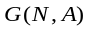a traffic network as a graph which consists of 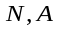 sets of nodes and links respectively on which 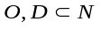are sets of origins and destinations respectively. The CTAP-VD can be formulated as a non-linear programing problem as follows (throughout the manuscript, all terms are non-negative unless otherwise stated):

[CTAP-VD]:
(1)
s.t.: (2)
(3)
(4)
(5)
where : is the Beckmann objective function to be minimized; 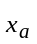: is the traffic flow on link which is the aggregated traffic flow of all classes on link; 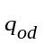 is the travel demand from to ; 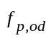is the traffic flow on the path from to ; 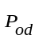is the set of all paths available from to ; 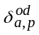 is the link-path incidence (1: if link belongs to path from to and 0 otherwise); 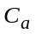: is the capacity of link and 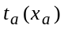is non-decreasing convex delay function; 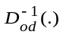is the inverse of the travel demand function associated with origin and destination.
Note that is a decreasing function of the travel time between origin and destination. Constraints (2), (3) and (4) enforces the traffic flows of the paths to meet the demand (known as multi-commodity flows). Multi-commodity formulation sometimes could become a laborious task laden with a myriads of equations. To this end, the formulation proposed by (Ferris et al., 1999) provide a compact and efficient representation of the model, permitting direct solution with “off-the-shelf” algorithms. The following constraints enforces flow conservative and satisfies demand which can be easily encoded in the GAMS.
In case the travel demand is higher than the capacity of the network, the problem becomes infeasible. It is important for any algorithm to have some mechanism to detect and address the infeasibility cases. To this end one can introduce a dummy node connected with all zones via uncapacitated links associated with high travel time. Therefore, the problem always remains feasible. As such, in the case of a residual traffic load on dummy links after a safely converged and terminated assignment, one can label it as a capacity-infeasible scenario.
The CTAP-VD as formulated above is proven to be convex and hence the existence of a unique solution is guaranteed . The feasible set is convex, because the constraints are linear. It is also non-empty provided the link capacities are not too low, which is always the case when dummy links exist. The only requirement for the delay function is to be non-decreasing, integrable and positive which all holds for the BPR function (see equation (6)). If so, then the corresponding marginal delay function becomes positive and continuous. With the same token, the second term in the objective function (the inverse variable function) needs to be continuous, non-empty, convex and compact feasible set which all holds for the logit formula (see equation (7)). For more information, the interested reader can consult with .
In order to encode the above programming problem in GAMS, one needs to cast aside the integral expression in the objective function. In the next section we elaborate on the GAMS formulation and prerequisite properties of the delay and demand functions
3. GAMS coding
The GAMS is a powerful optimization language to efficiently and succinctly model and solve complicated problems. The GAMS also is associated with a wide range of solvers tailored to a variety of problems such as non-linear Programming (NLP), mixed complementarity problems (MCP), mathematical programs with equilibrium constraints (MPEC) and mixed-integer non-linear programming (MINLP). It is worth noting that many of transport planning problems can also be formulated as either of the above mentioned problems. In this context arriving at a unifying platform to simultaneously solving a TAP and a transport planning problem is of highest importance . This papers aims to serve such mandate.
The delay functions are often set to comply with a format proposed by the U.S. Bureau of Public Road (BPR) as 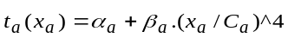 where 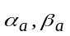 are parameters to be calibrated by field survey data. Hence the delay function is an integrable function:
(6)
After establishing the first term of the objective function (1) we turn our attention to the second term: demand function. The elasticity of the travel demand is widely formulated using the well-behaved logit models as follows:
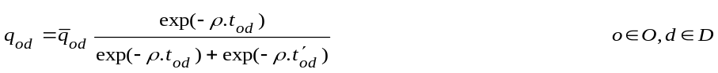 (7)
where 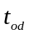is the travel time from origin to destination ; is a parameter to be calibrated using modal split survey data; 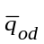is a constant value representing maximum possible travel demand (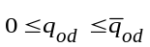) and 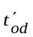denotes travel time on alternative transport mode. The inverse travel demand can be easily derived from (7):
(8)
The inverse demand function is integrable, hence the second term of the objective function can be derived as:
(9)
For illustration purpose, we consider travel time obtained from fixed travel demand as the time for the alternative transport mode () and the maximum demand is assumed as twice the fixed demand (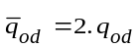). Hence, it ensures setting 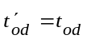at equilibrium.
4. NUMERICAL RESULTS
This section provides specifications for the formatting of your paper. Please note that although authors are not required to use Microsoft Word to prepare their paper, it is expected that the styles specified here will be used, where possible. Submitted papers should not require editing to correct formatting.
A desktop PC with a 3.70GHz CPU and 64 GB of RAM was employed. Two case studies of Sioux-Falls and Melbourne CBD are undertaken. A tableau of the GAMS commands encoding Sioux-Falls dataset (network and demand) as well as the CTAP-VD as articulated in (1)..(5),(6) and (9) is provided in appendix A. In order to ensure feasibility of solution -due to consideration of the capacity-, we introduce a dummy node connected to all other nodes centroid (representing the traffic zones) with dummy links.
4.1. Sioux-Falls
The Sioux-Falls network has 76 links, 24 nodes and a 24×24 demand matrix of 528 nonzero entries of total trips of 396.44. The dummy links have infinity capacity (i.e. 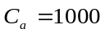) and a very high delay (i.e. 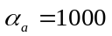) to only attract the excessive demand as the last choice.
For comparison purpose we first run the code for the fixed demand without capacity constraints and the traffic volumes on the roads are shown in Figure 1(a). The result of capacitated traffic flow with elastic demand is also shown in Figure 1(b). The computation time took 3.078 seconds.
4.2. Melbourne CBD
The Melbourne CBD consists of 787 links, 293 nodes and a 90×90 demand matrix of 4713 nonzero entries of total trips of 27,862. In a similar fashion, for comparison sake, we first run the code for the fixed demand without capacity constraints and the traffic volumes on the roads are shown in Figure 2(a). The result of capacitated traffic flow with elastic demand is also shown in Figure 2(b). The computation time took 3.078 seconds.
5. CONCLUSION
The capacitated traffic assignment problem subject to variable demand (CTAP-VD) is a cornerstone of traffic analysis. Computational difficulty of considering the capacity constraint is still a prohibitive factor in the literature. Alternatively, we provide a succinct formulation for the CTAP-VD as a convex nonlinear programming problem in GAMS. In the context of the previous studies and methods such as Augmented Lagrangian Method, Inner Penalty function and Dynamic Penalty Function, the proposed formulation obviates any additional parameter. Furthermore the use of GAMS and its solvers is very effective tool in addressing a variety of problems arising in the traffic equilibrium analysis. In these problems, solving a CTAP-VD as a sub-problem is often inevitable. In this view, applications of mpec available in GAMS in network design problems and road pricing are worth noting.
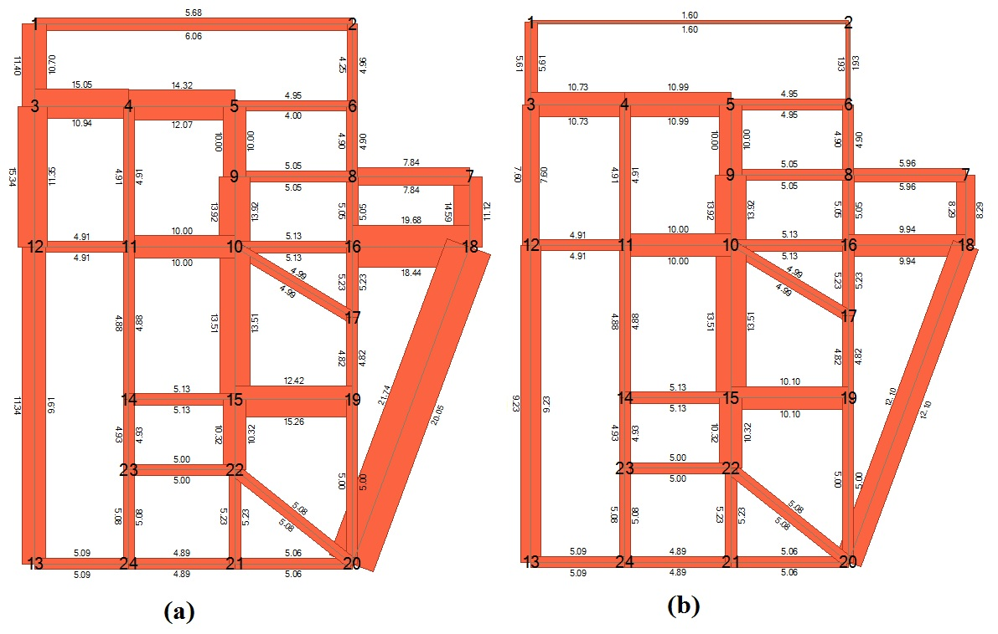
Figure 1 Traffic volume on the Sioux-Falls network; (a) uncapacitated scenario, (b) capacitated scenario
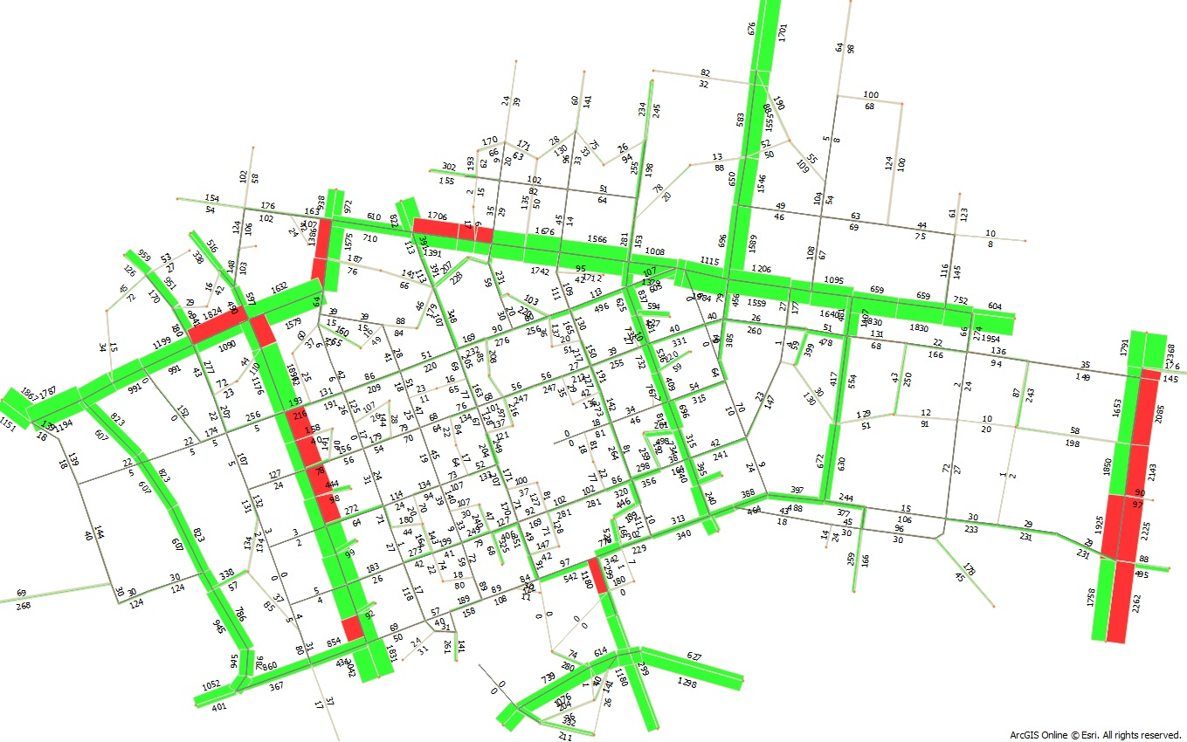
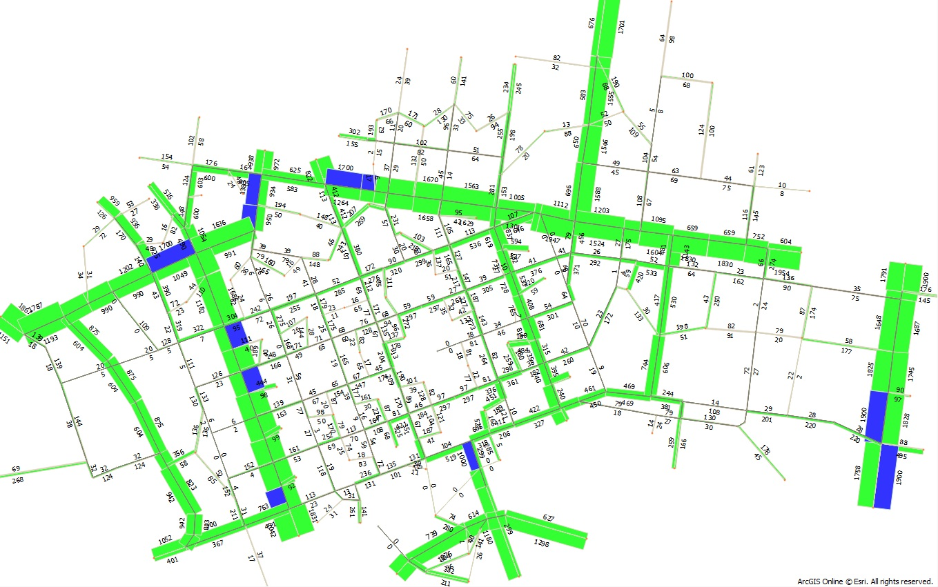
Figure 2, The Melbourne CBD network, traffic volume plot; (a) uncapacitated scenario (red coloured roads are over the capacity), (b) capacitated scenario (blue covered roads are at the capacity)
References
Aashtiani, H.Z., 1979. The multi-modal traffic assignment problem. PhD dissertation, Massachusetts Institute of Technology.
Babonneau, F., Vial, J.-P., 2008. An efficient method to compute traffic assignment problems with elastic demands. Transportation Science 42, 249-260.
Bagloee, S.A., Asadi, M., 2015. Prioritizing road extension projects with interdependent benefits under time constraint. Transportation Research Part A: Policy and Practice 75, 196-216.
Bagloee, S.A., Asadi, M., in press. Side constrained traffic assignment problem for multiclass flow. International Journal of Operational Research.
Bagloee, S.A., Asadi, M., Bozic, C., 2012. A Sustainability Approach in Road Project Evaluation, Case-Study: Pollutant Emission and Accident Costs in Cost Benefit Analysis, Sustainable Automotive Technologies 2012. Springer, pp. 295-303.
Bagloee, S.A., Asadi, M., Richardson, L., 2011. Identifying Traffic Count Posts For Origin-Destination Matrix Adjustments: An Approach to Actual Size Networks. Journal of Transportation Management 22, 79-88.
Bagloee, S.A., Ceder, A., 2011. Transit-network design methodology for actual-size road networks. Transportation Research Part B: Methodological 45, 1787-1804.
Bagloee, S.A., Florian, M., Sarvi, M., 2016. A New Policy in Congestion Pricing: Why only Toll? Why not Subsidy? Centre Interuniversitaire de Recherche sur les Réseaux d'Entreprise, la Logistique et le Transport (CIRRELT), Montreal, Canada.
Bagloee, S.A., Sarvi, M., 2015. Heuristic Approach to Capacitated Traffic Assignment Problem for Large-Scale Transport Networks. Transportation Research Record: Journal of the Transportation Research Board, 1-11.
Bagloee, S.A., Tavana, M., 2012. An efficient hybrid heuristic method for prioritising large transportation projects with interdependent activities. International Journal of Logistics Systems and Management 11, 114-142.
Bagloee, S.A., Tavana, M., Ceder, A., Bozic, C., Asadi, M., 2013. A hybrid meta-heuristic algorithm for solving real-life transportation network design problems. International Journal of Logistics Systems and Management 16, 41-66.
Bell, M.G., Shield, C.M., Busch, F., Kruse, G., 1997. A stochastic user equilibrium path flow estimator. Transportation Research Part C: Emerging Technologies 5, 197-210.
Boyce, D., 2013. Beckmann's transportation network equilibrium model: Its history and relationship to the Kuhn–Tucker conditions. Economics of Transportation 2, 47-52.
Boyce, D., 2014. Network equilibrium models for urban transport, in: Fischer, M.M., Nijkamp, P. (Eds.), Handbook of Regional Science. Springer Berlin Heidelberg, pp. 759-786.
Brooke, A., Kendrick, D., Meeraus, A., 1996. GAMS Release 2.25: A user's guide. GAMS Development Corporation Washington, DC.
Chen, A., Zhou, Z., Ryu, S., 2011. Modeling physical and environmental side constraints in traffic equilibrium problem. International Journal of Sustainable Transportation 5, 172-197.
Dafermos, S., 1982. The general multimodal network equilibrium problem with elastic demand. Networks 12, 57-72.
Ferrari, P., 1997. Capacity constraints in urban transport networks. Transportation Research Part B: Methodological 31, 291-301.
Ferris, M.C., Meeraus, A., Rutherford, T.F., 1999. Computing Wardropian equilibria in a complementarity framework. Optimization Methods and Software 10, 669-685.
Ferris, M.C., Munson, T.S., 2000. GAMS/PATH user guide: Version 4.3. Washington, DC: GAMS Development Corporation.
FHWA, 2002. Status of the Nation’s Highways, Bridges and Transit: Conditions and Performance. . US Department of Transportation Washington, DC,.
Fisk, C.S., Boyce, D.E., 1983. Alternative variational inequality formulations of the network equilibrium-travel choice problem. Transportation Science 17, 454-463.
Friesz, T.L., Bernstein, D., Mehta, N.J., Tobin, R.L., Ganjalizadeh, S., 1994. Day-to-day dynamic network disequilibria and idealized traveler information systems. Operations Research 42, 1120-1136.
Gao, Z., Wu, J., Sun, H., 2005. Solution algorithm for the bi-level discrete network design problem. Transportation Research Part B: Methodological 39, 479-495.
Gartner, N.H., 1980a. Optimal Traffic Assignment with Elastic Demands: A Review Part I. Analysis Framework. Transportation Science 14, 174-191.
Gartner, N.H., 1980b. Optimal Traffic Assignment with Elastic Demands: A Review Part II. Algorithmic Approaches. Transportation Science 14, 192-208.
Hearn, D., 1980. Bounding flows in traffic assignment models. Technical report Research Report 80-4.
Hearn, D., Ribera, J., 1980. Bounded flow equilibrium problems by penalty methods, Proceedings of IEEE International Conference on Circuits and Computers, pp. 162-166.
Inouye, H., 1987. Traffic equilibria and its solution in congested road networks, IFACIFIPIFORS CONFERENCE ON CONTROL IN.
Larsson, T., Patriksson, M., 1992. Simplicial decomposition with disaggregated representation for the traffic assignment problem. Transportation Science 26, 4-17.
Larsson, T., Patriksson, M., 1995. An augmented Lagrangean dual algorithm for link capacity side constrained traffic assignment problems. Transportation Research Part B: Methodological 29, 433-455.
Larsson, T., Patriksson, M., 1999. Side constrained traffic equilibrium models— analysis, computation and applications. Transportation Research Part B: Methodological 33, 233-264.
Larsson, T., Patriksson, M., Rydergren, C., 2004. A column generation procedure for the side constrained traffic equilibrium problem. Transportation Research Part B: Methodological 38, 17-38.
Marcotte, P., Patriksson, M., 2007. Traffic equilibrium. Handbooks in Operations Research and Management Science 14, 623-713.
Morowati-Shalilvand, S., Mehri-Tekmeh, J., 2013. AN EXTENDED ORIGIN-BASED METHOD FOR SOLVING CAPACITATED TRAFFIC ASSIGNMENT PROBLEM. Acta Universitatis Apulensis, 169-186.
Nie, Y., Zhang, H., Lee, D.-H., 2004. Models and algorithms for the traffic assignment problem with link capacity constraints. Transportation Research Part B: Methodological 38, 285-312.
Patriksson, M., 2004. Algorithms for computing traffic equilibria. Netw Spat Econ 4, 23-38.
Patriksson, P., 1994. The traffic assignment problem: models and methods, VSP BV, The Netherlands. Facsimile reproduction published in 2014 by Dover Publications, Inc., Mineola, New York, NY, USA.
Prashker, J.N., Toledo, T., 2004. A gradient projection algorithm for side-constrained traffic assignment. European Journal of Transport and Infrastructure Research 4, 177-193.
Ryu, S., Chen, A., Choi, K., 2014a. A modified gradient projection algorithm for solving the elastic demand traffic assignment problem. Computers & Operations Research 47, 61-71.
Ryu, S., Chen, A., Xu, X., Choi, K., 2014b. A Dual Approach for Solving the Combined Distribution and Assignment Problem with Link Capacity Constraints. Netw Spat Econ, 1-26.
Sarvi, M., Bagloee, S.A., Bliemer, M.C., 2016. Network design for road transit priority, in: Bliemer, M., Mulley, C., Moutou, C. (Eds.), Handbook on Transport and Urban Planning in the Developed World. Edward Elgar Publishing Ltd., Institute of Transport and Logistics Studies, University of Sydney, Australia pp. 355–374.
Shahpar, A.H., Aashtiani, H.Z., Babazadeh, A., 2008. Dynamic penalty function method for the side constrained traffic assignment problem. Applied Mathematics and Computation 206, 332-345.
Sheffi, Y., 1985. Urban transportation networks: equilibrium analysis with mathematical programming methods. Prentice-Hall, Inc., Englewood Cliffs, New Jersey
Yang, H., Bell, M.G., 1997. Traffic restraint, road pricing and network equilibrium. Transportation Research Part B: Methodological 31, 303-314.
Yang, H., Yagar, S., 1994. Traffic assignment and traffic control in general freeway-arterial corridor systems. Transportation Research Part B: Methodological 28, 463-486.
Yang, H., Yagar, S., 1995. Traffic assignment and signal control in saturated road networks. Transportation Research Part A: Policy and Practice 29, 125-139.

Appendix A; GAMS code for the capacitated traffic assignment subject to variable demand (CTAP-VD)


