Training the Logisticians of the Future: skill implications of technological changes in the Transport and Logistics industry
Gwendaline Jossec¹, Olivia Shanahan²
¹TLISC, 10-12 Brisbane Avenue, Barton 2600 ACT.
²Ibid.
gwendaline.jossec@tlisc.org.au
Abstract
Transport and Logistics businesses globally are experiencing a rapid growth in freight volumes along with significant changes away from traditional models of delivery and into ‘personal supply chains’. As companies are working with increasing levels of automation, big data and robotics, there is an increasing need for higher-order skills across the workforce.
While the Australian Transport and Logistics industry has recorded higher-than-average productivity growth in recent years, the continued economic success of the industry will depend to a large extent on its ability to draw on a highly skilled workforce. The adequate supply of skilled labour will be instrumental in sustaining the growth of the industry in the future.
This research provides a multi-level analysis of current and future skill needs in the Road Transport, Logistics and Warehousing segments of the industry. Persisting occupational shortages are identified, and a comparison of forecast training needs against the observed uptake of selected Vocational Education and Training (VET) qualifications in recent years is undertaken, leading to the identification of skills mismatches. Skills mismatches are gaps between individuals’ skill sets and knowledge, and the demands of specific jobs or markets. The identification of occupational shortages and skill mismatches provides a background for the rest of the study.
Industry’s current and emerging skills needs are then outlined, drawing on extensive industry stakeholder consultations and industry research to derive the workforce implications of the latest technology development and to identify priority areas. Findings are discussed in the broader context of recent literature on workforce issues across the industry, highlighting where particular focus will be needed from both industry and government to better meet industry skill requirements in the short to medium term.
1. Background
Transport and Logistics businesses globally are experiencing a rapid growth in freight volumes along with significant changes away from traditional models of delivery and into ‘personal supply chains’ (IBISWorld 2014). Customer demand for rapid order and same day deliveries are placing these Transport and Logistics businesses under significant pressure as they endeavour to keep up with demand, offer quality customer service, and manage operational efficiencies to reduce costs. Meanwhile, technological innovation has been occurring at a tremendous rate, allowing for increased productivity and flexibility in supply chains. However, the uptake of new technology by businesses occurs at varying rates.
In Australia, the Transport and Logistics industry has been a strong performer in recent years, recording higher-than-average productivity growth (CEET 2013), with both technology uptake and workforce training delivering substantial productivity improvements for businesses.
Figure 1 below outlines the economic contribution of the 745,000-strong Road Transport, Logistics and Warehousing workforce. Between 2013 and 2018, there will be 42,100 net new jobs in this segment of the industry, representing a net 5.7 per cent increase. In the same time period, industry revenue is forecasted to increase by 11.3 per cent, while the value added by the industry to the economy is expected to increase by 16.3 per cent. This means substantial productivity gains are expected to be realised in the immediate future. The continued economic success of the industry will depend to a large extent on its ability to draw on a highly skilled workforce delivering the productivity benefits of training across the country.
Figure 1. Economic contribution of the Road Transport and Logistics workforce 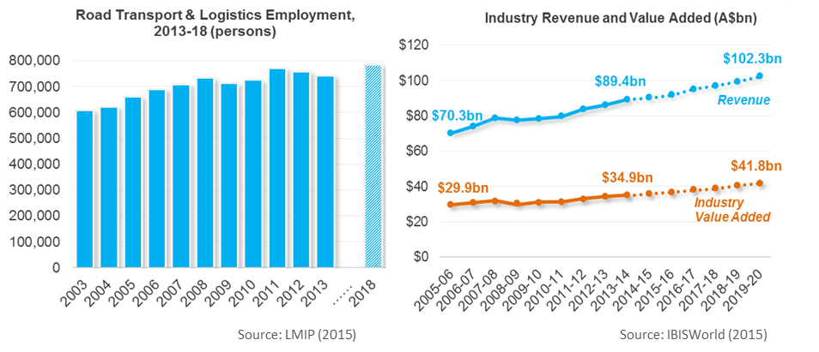
As technology and business practices change in the coming years, employers will be looking for new talent that closely matches the skills gaps and future needs of the industry such as technology readiness, customer service skills, leadership and mentoring abilities and ‘Big Data’ analytical skills. For those already working within the industry, employers will be looking to upskill using specialty Skill Sets and qualifications.
However, a majority of Transport and Logistics employers report difficulties in attracting or retaining skilled workers, with many citing the lack of suitably trained workers as a major concern (TLISC 2015). With the growth in transport volumes and the rate of technological change continuing, there is a risk that the industry’s economic performance be compromised by an inability to access the required skills.
The following sections of this paper seek to analyse the skills gaps in the industry by examining the skills in high demand and skills in shortage, labour issues, and technological disruptions.
2. Occupational needs in the Logistics and Road Transport industry
2.1 Historical occupational shortages
Occupational shortages exist where employers are unable to fill, or have considerable difficulty filling vacancies for an occupation, or significant specialised skill needs within that occupation, at current levels of remuneration and conditions of employment, and in reasonably accessible locations.
Table 1. below summarises the Logistics, Warehousing and Road Transport occupations that have been identified more than once as being in shortage or in high demand in successive editions of TLISC’s annual Environmental Scan since 2010. TLISC’s annual Environmental Scan identifies the multi-level factors affecting the skills needs of the Transport and Logistics workforce, current skills shortages, and how well the national VET system is responding to industry needs.
A majority of occupations that were identified as being in shortage or in high demand in 2010 remained so in 2015, indicating the existence of chronic, or persisting, skill shortages in the industry. Such persisting skill shortages are particularly prevalent for Driver roles with a specialised skill set such as interstate driving, delivery, or dangerous goods certification. The growth in domestic freight and parcel delivery is such that Truck Drivers with specialist experience and qualifications (e.g. Delivery Drivers, interstate drivers or with Dangerous Goods expertise) will continue to be in very high demand, with customer service skills highly valued.
Table 1. Logistics, Warehousing and Road Transport occupations in shortage, 2010-2015
Occupations | 2010 | 2011 | 2012 | 2013 | 2014 | 2015 | Total
Transport/Logistics Manager |  |  |  |  |  |  | 6
Truck Driver - General Freight |  |  |  |  |  |  | 6
Truck Driver - Local Delivery (M/R - H-R) |  |  |  |  |  |  | 6
Forklift Operator |  |  |  |  |  |  | 5
VET Trainers/Assessors |  |  |  |  |  |  | 5
Storeperson |  |  |  |  |  |  | 4
Truck Driver - Dangerous Goods |  |  |  |  |  |  | 4
Bus Driver |  |  |  |  |  |  | 3
Driving Instructor |  |  |  |  |  |  | 3
Supply and Distribution Manager |  |  |  |  |  |  | 3
Truck Driver - B-Double |  |  |  |  |  |  | 3
Truck Driver - Multi-Combination |  |  |  |  |  |  | 3
Warehouse Manager |  |  |  |  |  |  | 3
Customs Broker/Freight Forwarding Operator |  |  |  |  |  |  | 2
Taxi Driver |  |  |  |  |  |  | 2
Fleet Manager/Allocator/Scheduler |  |  |  |  |  |  | 2
Warehouse Administrator |  |  |  |  |  |  | 2

The rise of online shopping and personal supply chains have had a significant impact on labour demand in the Logistics, Warehousing and Road Transport sectors, compounding existing shortages and leading to strong demand for new combinations of skills.
There has been a strong increase in demand for Fleet Managers, Allocators and Schedulers, whose task is to optimise the utilisation of assets and resources in real time and through long-term demand planning. These tasks are also an increasing component of the Transport and Logistics Manager role, which has been continuously in shortage since 2010 due to strong competition within the industry for this skill set. For these occupations, thorough knowledge of the organisation’s systems is a highly valued skill, and the ability to adapt quickly to new systems is a core requirement for contract positions and new entrants.
Entry-level positions such as Storepersons experience high turnover rates, which hinder the ability of many businesses to respond to changes in activity levels, particularly for small businesses or businesses in rural or remote locations. For these occupations, ‘job-readiness’ is the requirement most often cited – or, put simply, the ability to learn quickly how to follow business practices and use technology to adapt to a new role.
VET Trainers and Assessors with Transport and Logistics expertise (including Driving instructors) are in shortage across the country, as qualified candidates tend to stay in operational positions which offer higher pay – thus compounding the difficulty of addressing skills shortages in the industry.

2.2 Industry VET training needs
The Vocational Education and Training (VET) system in Australia is designed to produce a highly skilled, adaptive and mobile workforce that can be easily recognised across jurisdictions and between enterprises. Vocational competency standards for skills in the Road Transport, Logistics and Warehousing industry are largely covered by TLISC’s TLI10 Transport and Logistics Training Package, which contains a range of qualifications from Certificate I through to Advanced Diploma. These cover a vast range of job roles and provide for upskilling and development of career pathways.
Around 67,000 net new jobs are forecast to be created in the Logistics and Road Transport industry in the period from 2013 to 2017 (CEET 2013). Figure 2 below summarises the corresponding vocational training needs forecast for the industry during this period. It provides a breakdown by level of the minimum qualifications that need to be completed by the Transport and Logistics workforce by 2017 in order to match industry growth and technological developments. These training needs include the training of new entrants to the industry as well as the upskilling that may be required of existing workers.
More than 37 percent of the final VET qualifications brought into the Road Transport and Logistics and Warehousing workforce between 2013 and 2017 need to be at least a Diploma or an Advanced Diploma. By comparison, Diploma- or Advanced Diploma-level qualifications are currently estimated to be the highest qualification held for 18 per cent of the VET-trained Road Transport workforce, and 23 per cent of the VET-trained Logistics workforce (CEET 2013). Correspondingly, the share of Transport and Logistics workers that currently hold a Certificate III/IV or a Certificate I/II as their highest-level qualification is respectively higher and significantly higher than the share of these qualifications in the forecast training needs. Thus, in order to meet the short-term workforce needs of the industry outlined above and lift the overall capability of the Transport and Logistics workforce, tremendous effort is needed in the immediate future to train new cohorts at the required level, as well as to upskill existing workers.

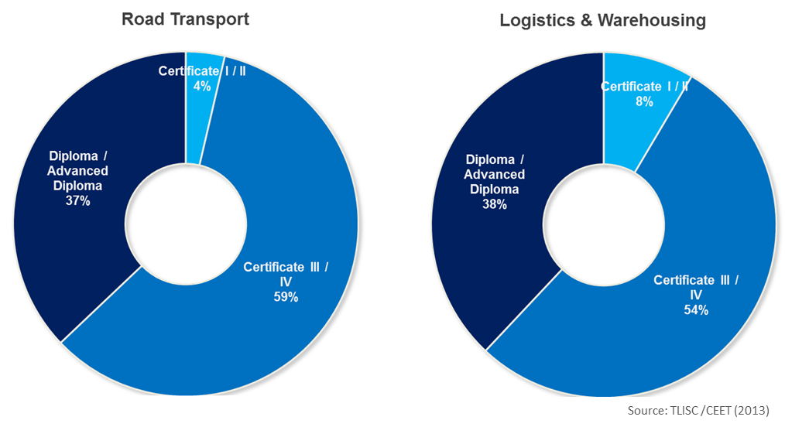
Figure 2. Identified training needs for VET courses by qualification level, 2013-2017

2.3 Actual VET course enrolments and skills mismatches
2.3.1 VET enrolments by AQF qualification level
From 2010 to 2013, there were around 51,700 publicly-funded VET enrolments (for which national data are available) in Road Transport, Logistics and Warehousing qualifications throughout Australia (NCVER 2015). Almost all of these enrolments were in Certificate I through to Certificate IV qualifications, with a maximum of 2 per cent enrolled in publicly-funded Diploma-level courses (Figure 3).
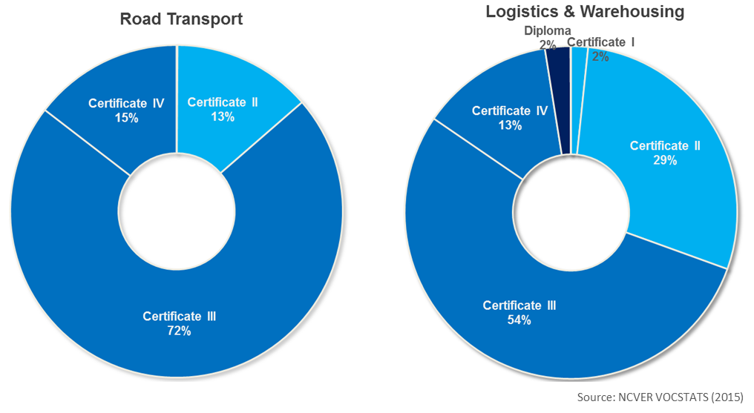
Figure 3. Students commencing publicly-funded VET courses by qualification level, 2010-2013

The discrepancy observed indicates a mismatch between the current focus of VET training funding and the industry’s short term training needs (particularly in the Road Transport sector). A skills mismatch is the gap between an individual’s skill set and knowledge, and the demands of a specific job or market as a whole. Skills mismatches can be chronic or temporary; in either case the mismatch between workers’ skills and their tasks at work can adversely affect economic and social outcomes for both businesses and individuals.
While the NCVER enrolment figures shown above are useful to establish a mismatch between government funding policy and industry needs, they are incomplete in that only around half of all VET enrolments are publicly funded and thus recorded in NCVER’s database. The remainder are privately funded by students and/or industry, with the majority of Diplomas and Advanced Diplomas being privately funded.
2.3.2 Most popular Transport and Logistics VET qualifications
To try and establish whether the mismatch identified above is representative of a broader mismatch in student enrolments into Transport and Logistics qualifications, we set out to compare:
- the ten Road Transport, Logistics and Warehousing VET qualifications that had the highest total number of publicly-funded student enrolments (NCVER-collected data) between 2010 and 2014; and
- the ten VET qualifications most frequently taught by Registered Training Organisations (RTOs), as reported in a 2015 TLISC survey. This includes a mix of publicly-funded courses and fee-for-service delivery.
Results are summarised in Table 2 below. The similarity of the two columns confirms the existence of a mismatch between the uptake of VET qualifications and the industry’s identified training needs. With the exception of the Diploma of Logistics (ranked 5th for RTOs and 10th for publicly-funded courses), RTOs overwhelmingly report delivering a majority of Certificate III and IV qualifications. This suggests that the higher order skill needs of the industry are likely to remain acutely felt across the industry in the short to medium term at least.
Table 2. Most popular Road Transport, Logistics and Warehousing VET qualifications
# | Qualifications with the largest number of publicly-funded enrolments  (NCVER VOCSTATS, 2010-14) | Qualifications most often taught by RTOs (publicly and privately funded)  (TLISC RTO Survey, 2015)
1 | Certificate III in Warehousing Operations | Certificate III in Warehousing Operations
2 | Certificate II in Warehousing Operations | Certificate III in Driving Operations
3 | Certificate III in Driving Operations | Certificate III in Logistics
4 | Certificate III in Transport And Logistics (Road Transport) | Certificate IV in Warehousing Operations
5 | Certificate IV in Warehousing Operations | Diploma of Logistics
6 | Certificate III in Logistics | Certificate IV in Logistics
7 | Certificate II in Driving Operations | Certificate III in International Freight Forwarding (Operator)
8 | Certificate IV in Driving Operations | Certificate IV in Driving Operations
9 | Certificate IV in Transport And Logistics (Road Transport) | Certificate IV in International Freight Forwarding (Senior Operator)
10 | Diploma of Logistics | Certificate III in Mobile Crane Operations
3. Current priority skills areas for the Transport and Logistics workforce
3.1 Skills in high demand
Since 2010, Transport and Logistics employers consistently ranked the following skills area as being the most pressingly needed in their company (TLISC 2010-15):
- Leadership and management
- Teaching and training
- Problem solving
- Information technology
- Financial management
- Language, literacy and numeracy (LLN)
As technological changes and demand for a more highly skilled workforce increase, leadership and management skills will continue to be critical to successful strategic business and workforce planning, including succession planning. Managers will need to have a solid understanding of, and ability to implement, career path development strategies to upskill and retain staff. The existence of teaching and training skills within the workplace is equally critical to the ongoing development of a productive and engaged workforce. When these two sets of skills are poorly represented in a business, any existing technical skill shortages tend to be exacerbated, resulting in complex, structural skill shortages that are likely to threaten the business’ viability in the longer term.
The uptake of new technology means that workers across the supply chain need to be proficient at using the systems (‘Information technology’ skill area) and at reacting autonomously to the information (‘Problem solving’). Ongoing learning is required of both new entrants and existing workers in order to keep up with new technology and changes in business practices.
3.2 Technology disruption and emerging skill needs
The adoption of new technology and the rise of personal supply chains have had a considerable impact on the Transport and Logistics industry in recent years, reshaping business practices and workforce skill requirements.
The fast-paced rate of technology disruption experienced in the past decade is expected to continue in the coming years, with no signs of slowing down. This is predicted to put tremendous pressure on both the industry (CEDA 2015) and the VET sector (DEEWR & Ai Group 2010). Table 3 outlines the business improvements and skill implications that are associated with some of the technological innovation areas that have had a significant impact on business activity in the Transport and Logistics industry.
Table 3. Impact of key technology innovations on business practices and skill needs
Technology innovation | Business improvements | Skill implications
Automation | - Speeding up highly repetitive processes  - Eliminating or reducing the risk of human error  - Reduced labour costs  - Improved efficiency and productivity | - Sortation conveyor systems  - Intelligent objects, smart packages and load units  - Automated pickup and drop-off points  - Fast processing and transfer within stores  - Occupational health and safety
Big Data | - Transport schedules adjusted in real time  - Optimised utilisation of assets and labour capacity  - Reduced risk of supply chain disruption  - Opportunity for value-adding, differentiating services  - Improved customer service | - Real-time order management  - Real-time tracking systems  - Real-time inventory management  - Predictive analytics and long-term forecasting  - Real-time tracking of intelligent logistics objects  - Data security  - Personal data privacy compliance
Robotics | - Reduction of traffic and congestion  - Increased reliability and reduction of human error  - Reduced risk of accidents  - Increased operational productivity | - ‘Pick and place’ robots  - Driverless vehicles (e.g. mining trucks)  - Automated straddle cranes for transferring shipping containers  - Occupational health and safety  - Planning and managing interaction between humans and robots

Increasingly sophisticated forecasting and planning tools are used by Supply Chain Managers and Fleet Managers/Allocators/Schedulers, the ‘Planners’ of the industry. Long-term demand forecasting allows businesses to predict their future resourcing needs and support asset investment decisions. Predictive analytics, which have grown in importance along with online retailing, are notably used for early route planning and for pre-emptively moving stock in anticipation of future customer purchases. The understanding and proficient use of ‘Big Data’ analytics is expected for a growing number of occupations.
Real-time order management, automation and robotics have dramatically reshaped the nature of warehousing work. The ability to work alongside such systems, keep up with the fast pace of order fulfilment, process and relay the large amounts of information relayed, and adapt to ongoing technology upgrades, is fast becoming a core requirement for working on a warehouse floor.
Table 4 below outlines the skills areas that were identified as being emergent during the extensive stakeholder consultation process undertaken by TLISC, for the 2014 and 2015 Environmental Scans. As the demand for these skills increases, particular focus from industry and the VET sector in the coming years will be critical to address the gap between current workforce skills and future needs. Increasing the extent of VET and workplace training in these areas in the shorter term is a necessary foundation to the industry’s ability to absorb greater capacity in the use of new and emerging technology in the longer term.

Table 4. Expected impact of emerging skills
Emerging skill | Workforce implications
Business management and leadership | - Greater emphasis on business and financial management and career pathways for mid-level managers  - Leadership and mentoring skills a differentiating factor for operational workers
Compliance and systems | - Large-scale training in systems security, privacy regulation and fraud risk management required at various levels across logistics roles  - Dedicated compliance roles
Fleet management | - Unique mix of operational, analytical and management skills  - Strong promotion opportunities for Truck Drivers with leadership and technology skills
New vehicle technology | - Requirement for higher levels of digital literacy among drivers  - Decision-making and problem-solving becoming a core part of the Truck Driving skill set  - Greater implication of Truck Drivers in business planning and financial management  - Greater analytical skills required of operational supervisors and mid-level managers
Supply chain | - Thorough understanding of supply chain interactions required of mid-level managers to operate in an increasingly complex environment
Systems and technological | - Systems integration necessitating consistent, large-scale training  - Analytical skills increasingly required at varying levels across occupations  - Basic electro-technical checking and maintenance skills becoming part of entry-level training
3.3 Skill Sets
Skill Sets are a nationally recognised training product and comprise of one or more units of competency relating to job roles, licensing or regulatory requirements. They are not full qualifications, however relate to specific job tasks or functions, whereas qualifications specify learning outcomes for whole occupations. A number of Skill Sets have been developed by TLISC in response to industry needs. They directly respond to skills needs, including emerging skill needs, and have the potential to address skills mismatches at a lower cost.
Skill sets are reportedly becoming a fast growing tool for businesses aiming to upskill their workforces as efficiently as possible while offering flexibility and career pathways for employees. However, enrolment data for Skill Sets is not yet available on a national scale; this research will be updated once data is available.
4. Concluding remarks: challenges and barriers to meeting industry skill needs
4.1 Focus of funding a major mismatch at the policy level
As discussed in Section 3 of this paper, there is a mismatch between the increasing need of the industry for higher level education and the current distribution of publicly-funded enrolments, which may be partially offset by the use of Skill Sets.
There is a strong need for industry and policy makers to jointly support the uptake of higher level qualifications (Certificate IV, Diploma and Advanced Diploma) in order to meet the higher-order skill needs of the industry in the near future. In the absence of corrective action, the continued focus of publicly-funded training on lower-level qualifications (Certificate I to IV) will result in a structural skills mismatch that is likely to affect the performance of the industry in the future. Skill Sets have a key role to play in bridging a gap between Certificate I – IV and higher qualifications, as they provide targeted training and upskilling in specific job roles.
4.2 Training for jobs that do not exist yet
For training providers and employers, the challenge is to ‘provide training for jobs that do not exist yet’, to deliver job-readiness for new entrants and highly portable skills for all workers in anticipation for the changes that lie ahead. Innovative and flexible methods of training delivery by RTOs can be instrumental in allowing small and isolated businesses to access the productivity benefits of training.
The chronic shortage of qualified Vocational Education Teachers with industry expertise and currency of knowledge significantly constrains the ability of many RTOs to respond swiftly to new technologies and changes in business practices. This cannot be achieved without a significant involvement of industry in training and upskilling its own workforce, which in turn requires deliberate workforce strategies at the business level. In any case, the shortage of qualified VET Teachers puts pressure on many businesses to develop in-house training capability to meet skill needs.
4.3 Opportunities and challenges at the business level
Overall, industry should be looking to acquire the emerging skills identified in this paper as a minimum foundation to absorb future technology disruption and increase the portability of skills in our workforce. Workplace mentoring schemes and tailored training programs are a keystone for ongoing staff upskilling.
Managers have a key role to play in devising and implementing workforce development and career management strategies, in order to realise the full productivity benefits of training (Mehta et al 2014). Regulatory compliance is currently the main driver of training in businesses, and the concern that employees will become more attractive to other employers is regularly cited as a barrier to investing in training (TLISC 2014). Employers tend to invest less in the training of females, older workers and part-time workers (Shah 2013), which may lead to an inadequate distribution of training, particularly in the context of an ageing, increasingly casualised workforce (TLISC 2014-15). Improving retention rates and offering clear career pathways will be instrumental in sustaining the industry’s fast-paced growth in the near future. At the business level, staff training and upskilling need to be part of a deliberate workforce development strategy that is given the same level of attention as general business and financial planning.
Smaller businesses and businesses operating in rural or remote locations will continue to face greater difficulties in attracting and retaining skilled workers, as larger employers can offer better wages and benefits to improve staff retention rates (TLISC 2010-15). In addition, smaller operators are severely constrained in their ability to access training, due to low profit margins and the pressure of technology disruption and a growing freight task. As the rate of technology disruption is expected to continue at the same fast pace in the coming years, there is a significant risk that a large portion of smaller operators are left behind.
In many instances, low levels of Language, Literacy and Numeracy (LLN) skills and low levels of digital literacy are an obstacle to the acquisition of higher-order skills (AiG 2013). Nearly 90 per cent of Registered Training Organisations (RTOs) in the Transport and Logistics industry report encountering LLN issues on a regular basis, with more than half encountering them ‘commonly’ or ‘very commonly’ (Figure 4). More than 75 per cent of employers report that their business was affected by low LLN levels at least to some extent (TLISC 2014). While most VET teachers and assessors are trained in this area, a vast majority of employers and managers estimate they are poorly equipped to recognise and address LLN issues.
Figure 4. Frequency of Language, literacy & numeracy (LLN) issues encountered by RTOs in their dealings with students, 2015
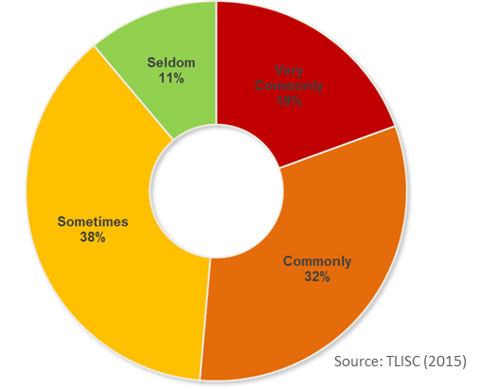
4.4 Lifting workforce skills across the industry
The persistence of labour shortages for a number of Road Transport, Logistics and Warehousing occupations, compounded by chronic shortage of VET Trainers and Assessors puts segments of the industry at risk of operational disruption. There will continue to be a strong competition for skilled workers both within and outside the industry, with international competition increasing.
The industry overall suffers from a relatively small pool of candidates to choose from (CEET 2013), and efforts to increase the diversity of the workforce need to be continued. Workforce ageing is a major issue across the industry, with particularly high risks of operational disruption for Road Transport businesses, where succession planning is a significant concern for the majority of employers (TLISC 2015). There is a strong competition for skilled Transport and Logistics workers from other industries, especially Mining and Construction, with smaller operators and regional or remote businesses particularly affected. Attracting young people and more women into the industry will be crucial in mitigating those risks.
Industry groups and syndicates can play an important role in designing and running workforce development programs at the state, regional and local level to support small businesses in attracting, upskilling and retaining new workers.

About TLISC
TLISC is an independent, not-for-profit organisation establishing national skills standards and providing strategic workforce development advice for the Transport and Logistics Industry in Australia – including Road Transport, Logistics, Rail, Aviation and Maritime and Ports. A key function of TLISC is to continuously gather intelligence on the skills and workforce development needs of the industry.
References

ACIL Allen Consulting. The economic significance of the Australian logistics industry. 2014.
Australian Industry Group (AiG). Getting it Right: Foundation Skills for the Workforce. AiG, 2014.
AiG. Emerging technologies project report. AiG, Sydney, February 2010.
Bubner N, Bubner N, Helbig R and Jeske M. Logistics Trend Radar. DHL Trend Research, DHL Customer Solutions and Innovation, Germany, May 2014.
CEDA. Australia’s Future Workforce? Melbourne, July 2015.
Centre for the Economics of Education and Training (CEET). Australian transport and logistics industry forecasts of labour and skill requirements 2013-17. Monash University and TLISC, June 2013.
Department of Employment. Past and Future Employment Levels and Growth. Department of employment Trend Data and Projections Data Tool (Labour Market Information Portal). November 2014.
Ferrier Hodgson. Transport and logistics insights the road ahead. January 2014.
Gordon C. Developing Management and Leadership Capacity: A Strategic Scan. Published by TLISC, Melbourne, July 2014.
Healy J., Mavromaras K., Sloane P.J. Skill shortages: prevalence, causes, remedies and consequences for Australian businesses. National Institute of Labour Studies, Flinders University, published by the National Centre for Vocational Education Research (NCVER), September 2012.
IBISWorld. Courier Pick-up and Delivery Services in Australia. Industry Report I5102. Melbourne, October 2014.
IBISWorld. Customs Agency Services in Australia. Industry Report I5291. Melbourne, May 2014.
IBISWorld. General Warehousing and Cold Storage in Australia. Industry Report I5309. Melbourne, January 2015.
IBISWorld. Long Distance Bus Transport In Australia. Industry Report I4621. Melbourne, January 2014.
IBISWorld. Rail, Air and Sea Freight Forwarding in Australia. Industry Report I5292b. Melbourne, October 2014
IBISWorld. Removalists in Australia. Industry Report I4611. Melbourne, June 2014.
IBISWorld. Road Freight Forwarding in Australia. Industry Report I5292a. Melbourne, October 2014.
IBISWorld. Road Freight Transport in Australia. Industry Report I4610. Melbourne, November 2014.
IBISWorld. Urban Bus and Tramway Transport in Australia. Industry Report I4622. Melbourne, December 2014.
IBISWorld. Taxi and Limousine Transport in Australia. Industry Report I4626. Melbourne, January 2015.
Manners-Bell J, Lyon T and Lyon K. The impact of robotics and automation on logistics. Transport Intelligence Ltd, UK, February 2014.
Mehta N., Parry E., Lawrence J. Strategic Talent Management Survey Results 2014. Cranfield University, UK, 2015.
Mills J., Bowman K., Crean D., Ranshaw D. Workforce skills development and engagement in training through skill sets: literature review. National Vocational Education and Training Research and Evaluation Program Occasional Paper. May 2012.
Mills J., Crean, D., Ranshaw, D,. Bowman K,. Workforce skills development and engagement in training through skill sets. November 2012.
Monash University’s Centre for Economics, Education and Training (CEET). Productivity and Productivity Growth in the Australian Transport and Logistics Industries. Published by TLISC, Melbourne, June 2013.
Organisation for Economic Co-operation and Development (OECD). Skills mismatch. Available online at http://skills.oecd.org/hotissues/skillsmismatch.html. Accessed June 2015.
Oxford Economics. Workforce 2020: The Looming Talent Crisis. UK, September 2014.
Shah, C. Analysis of National Workforce Development Fund training—transport and logistics industries. CEET/TLISC, December 2013.
Transport and Logistics Industry Skills Council (TLISC). 2015 Environmental Scan. April 2015.
TLISC. 2014 Environmental Scan. April 2014.
TLISC. 2013 Environmental Scan. April 2013.
TLISC. 2012 Environmental Scan. April 2012.
TLISC. 2011 Environmental Scan. April 2011.
TLISC. 2010 Environmental Scan. April 2010.
TLISC. Employer Survey. April 2015.
TLISC. RTO Survey. April 2015.
Watson I. Skills in Use: Labour Market and Workplace Trends in Skills Usage in Australia. New South Wales Department of Education and Training, Sydney, September 2009.

Source: TLISC, Environmental Scan (2010-15).
TLISC, 2015 Environmental Scan (2015), compiled from various sources.
TLISC, 2015 Environmental Scan (2015), compiled from various sources.

