Changes in Cycling Following an Infrastructure Intervention

Stephen Greaves¹, Richard Ellison¹, Adrian Ellison¹, Melanie Crane², Chris Rissel², Chris Standen¹
¹Institute of Transport & Logistics Studies, University of Sydney
²School of Public Health, University of Sydney
Stephen.greaves@sydney.edu.au
Abstract
As part of the effort to stem the growing obesity epidemic, as well as meet more general objectives around sustainable urban transport systems, many Australian cities are investing in infrastructure designed to encourage use of active travel, particularly cycling and walking. However, questions remain around the impact of such interventions due to the lack of before and after information on travel characteristics. The current paper reports on changes in cycling for a cohort of the population before and after the installation of a major piece of separated cycleway in inner-Sydney. Data for this investigation comes from the Sydney Travel and Health Study, a multi-year study of travel, quality of life, and physical activity of inhabitants of inner-city Sydney. The cohort comprises 435 participants (aged 18-59, without disability and who had ever ridden a bicycle) who completed a questionnaire capturing physical activity and demographic information, plus a 7-day online travel diary both before and four months after construction of the cycleway. The travel diary forms the basis for analysis in this paper. The sample is split between the area around the cycleway (intervention area) and a neighbouring area where no cycleway is being constructed (control area). Results at the aggregate level show cycling trips have remained stable in the intervention area (7.66% to 7.59%, ns) and control areas (4.48% to 4.20%, ns). Around three-quarters of those cycling did so in both waves. Kernel density spatial estimation methods suggest a shift in the destination of cycling trips to an area in close proximity to the cycleway, indicative of a destination-choice effect on cycling trips if not cycling rates per se. Finally, we anticipate it needs longer than four months for a discernible effect of the new cycleway to be assessed, something that will be assessed through a further round of data collection from the cohort participants planned for later in 2015.
- Introduction
As part of the effort to stem the growing obesity epidemic, as well as meet more general objectives around sustainable urban transport systems, many Australian cities are investing in infrastructure designed to encourage use of active travel, particularly cycling and walking. However, questions remain around the impact of such interventions due to the lack of before and after information on travel characteristics. The current paper reports on changes in cycling for a cohort of the population before and after the installation of a new 2.4 kilometre bi-directional separated cycleway on George Street in inner-Sydney. Data for this investigation comes from the Sydney Travel and Health Study, a multi-year study of travel, quality of life, and physical activity of inhabitants of inner-city Sydney. The cohort comprises 435 participants (aged 18-59, without disability and who had ever ridden a bicycle) who completed a questionnaire capturing physical activity and demographic information, plus a 7-day online travel diary with an optional smartphone app that tracked location, both before and after construction of the George Street cycleway. The travel diary forms the basis for analysis in this paper.

- Literature Review
Bicycle infrastructure has the potential to increase cycling participation and improve health. However, empirical evidence of the impact of cycling infrastructure is needed, particularly in areas where a cycling culture is not yet established (Yang et al., 2010). This poses serious challenges, as it is widely acknowledged that conducting the “gold standard” randomised controlled trials (RCTs) for transport interventions is particularly challenging (Ogilvie et al., 2004). In the absence of RCTs, evaluations of the effectiveness of cycling interventions have used cross-sectional studies, typically simple volume counts or surveys. Changes in volume counts provide some aggregate indication of whether usage of a facility has gone up or down. However, while volume counts are indicative of usage, these tell us nothing about the user and are in themselves subject to equipment malfunctions. For example, bicycle counts cannot establish whether infrastructure has attracted new cyclists or existing cyclists changing routes, the characteristics of cyclists, what types of trips are being made and so on. Intercept surveys have the advantage of targeting users of the facility. However, they engender their own challenges, typically around the amount of information that can be reasonably collected in a short space of time.
Compounding the limitations of cross-sectional studies is that fundamentally, they are not able to effectively measure change over time. This has led to renewed interest in using panel/cohort studies as a mechanism for measuring the dynamics of transportation system changes over time (Stopher and Greaves, 2007). This is particularly valuable if the panel can be formed and studied before an intervention and subsequently monitored after the intervention (Greaves et al., 2013; Moutou et al., 2015). Ideally, this monitoring after the intervention should be continued to establish the longevity/permanence of any change. For instance, Moutou et al. (2015) evaluated TravelSmart voluntary behaviour change intervention over six years using annual surveys of the same group of participants. Clearly, the benefits of using a panel have to be offset against the potentially higher initial recruitment costs, and attrition as panel members either move away from the study area or drop out for other reasons. A recent review of several panel surveys suggests attrition rates are around 20-30% per annum (Ortúzar et al., 2011).
In the context of cycling, such panel before-and-after studies are rare. Where they have been done, questions remain around an appropriate time-frame over which to assess the effectiveness of a facility as well as more fundamental issues around what criteria should be included in the assessment. In terms of an appropriate time-frame, evidence suggests at least two years are needed for discernible changes in levels of walking and cycling following construction of a cycleway (Deenihan and Caulfield, 2014). For instance, at one year post-construction Goodman et al. (2014) found no change in physical activity in the iConnect study in the UK and it was not until the second year that changes in walking, cycling and overall physical activity were observed. Similarly, in New Zealand, walking and cycling increased by 37%, while no change in physical activity was observed one year post implementation (Keall et al., 2015). Other authors have suggested an even longer time-frame is needed (up to a decade), over which to assess full effectiveness of a cycleway (Schweizer and Rupi, 2013).
In terms of criteria for inclusion in the assessment of cycling facilities using survey data, these have primarily revolved around changes in general travel, usage of the facility and physical activity. Changes in travel and usage of the facility can be directly obtained through questioning or using more sophisticated approaches involving GPS tracking and smartphones (Greaves et al., 2014). Evidence suggests that usage will depend on a host of factors pertaining to the cyclist (socioeconomics, level of cycling experience) and the extent to which the cycleway provides a reasonably direct and continuous route between origins and destinations (Hunt and Abraham, 2006) although cyclists have been observed to detour to varying degrees to use a good quality facility (Krenn et al., 2014). Usage also depends on awareness of the facility, which evidence suggests can be often lacking – for instance, an investigation of awareness of adults living within 5km of a new 16.5km cycleway in Western Sydney revealed that only 34% were aware of its existence three months after it was completed (Merom et al., 2003). In terms of physical activity, while there is strong evidence attesting to the general benefits of active travel (Hamer and Chida, 2008; Pucher et al., 2010), fundamental questions remain over how precisely this should be assessed at a project level. Among the many challenges that remain are that health benefits of cycling may accrue differently in persons who are sedentary versus those who are physically active (Warburton et al., 2006). Additionally, health benefits from the intervention decline over time (Macmillan et al., 2014), confounding the earlier statements around the length of time that should be used to establish effectiveness.
- Methods
3.1 Data Collection
The aim of the survey was to recruit a minimum of 800 participants from a geographic area encompassing a new cycleway in inner Sydney (intervention area), and a neighbouring area of similar demographics with no new planned bicycle infrastructure (control area) – see Figure 1. In addition to residing in these areas and indicating they planned to stay there for at least one year, recruits needed to be aged 18-55, had ridden a bicycle in their life and had no current disability preventing them from riding, and had sufficient English to complete the survey. Survey instruments comprised a 20-minute questionnaire focused around general travel and health issues, and a 7-day online travel diary supplemented by an optional smartphone app designed to passively log travel and assist participant recall of travel (Greaves et al., 2014). Following six months of pilot testing of survey instruments and methodologies, baseline data (before construction of the cycleway) were collected in September-November 2013 (Wave 1), which marks the warmer months of spring in Sydney.
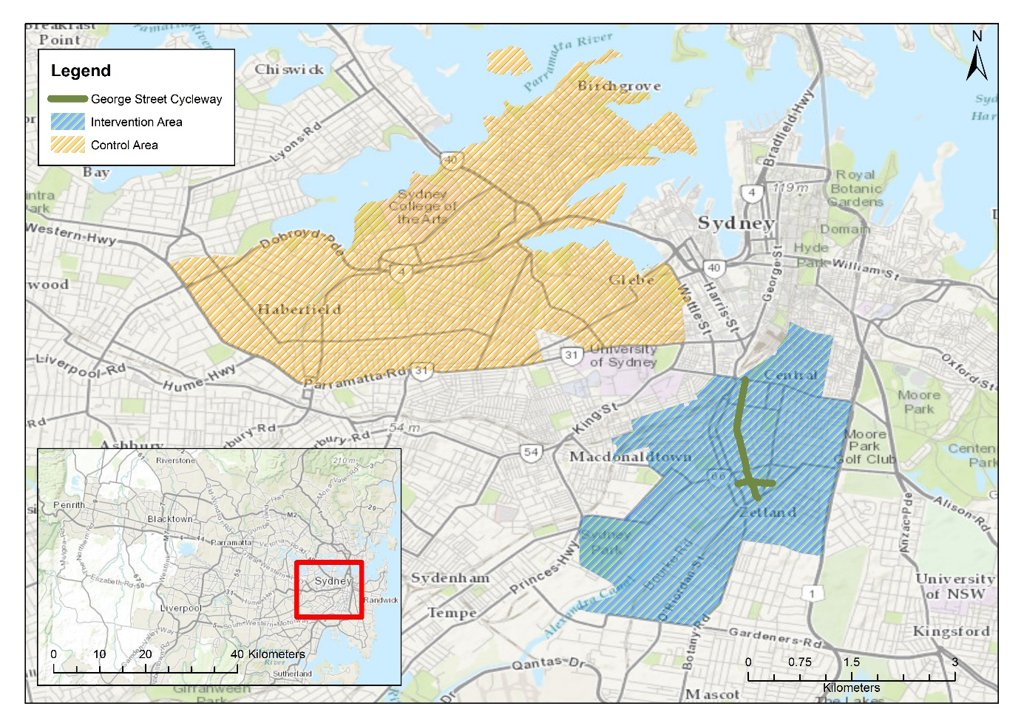
Figure 1: Study Area Showing Intervention and Control Areas
Given the specificity of the geographic area, the sample itself, and the demands of the survey, recruitment proved challenging, despite the offer of a $50 AUD incentive, meaning a variety of methods had to be employed. These included the use of an online consumer panel, cold-calling to households within the study area, Facebook groups focused around cycling, (primarily) student-based electronic circulation lists, mailbox drops, and intercept events focused around cycling, with agreeable participants then sent a URL to begin the survey. Despite the number of recruitment methods employed the evidence suggests there was no impact on completion rates (Greaves et al., 2015). The 12-month data were collected in September-November 2014 (Wave 2) using the same methods. Ethics approval was provided by the University of Sydney Human Ethics Committee.
3.2 The Intervention
The intervention comprised a 2.4km length of separated bi-directional cycleway linking the inner-city suburbs of Green Square in the south with the Central Business District (CBD) through Redfern and Waterloo (see Figure 1). The George Street cycleway adds to several pre-existing bi-directional cycleways within the City of Sydney Local Government Area (LGA) that include King Street, Kent Street, Bourke Street, Bourke Road, College Street, and Union Street totalling a distance of 11.0 kilometres (as of October 2014). The George Street cycleway was officially opened in June 2014, meaning it had only been operational around four months at the time of the Wave 2 survey - clearly this must be borne in mind when drawing conclusions over effects on usage (Goodman et al., 2014). The cycleway presently emerges onto a busy city intersection, with plans to connect the cycleway thorough to the city centre currently under negotiation between transport and local council authorities.
3.3 Analysis
Statistical analyses were conducted using Stata 13 (StataCorp, LLC, College Station, TX) and SPSS (Version 22). Sample characteristics of the cohort were compared using McNemar’s test for binary outcomes and one-way repeated measures ANOVA tests for >2 categories. Changes in aggregate travel behaviour across the two Waves were evaluated using paired sample t-tests. Analysis conducted on destination change effects was done using a kernel density estimation method (Venables and Ripley, 2002) and is detailed in a later section.
- Results
In total, 846 questionnaire responses (398 in the intervention and 448 in the comparison area) were collected at baseline. Of these, 608 participants completed all 7 days of the diary and provided usable data after an extensive cleaning process. The 664 participants who provided high quality data for the questionnaire and/or diary were invited to participate in the follow-up questionnaire 12 months later, of which 512 participants agreed. Of these, 435 participants completed all 7 days of the diary, forming the eligible before and after sample for inclusion in the analysis presented here. The characteristics of participants at baseline and follow-up are shown in Table 1. Evidently, the final sample is more likely than the baseline sample to be older, female, higher income and less likely to cycle. The loss of cyclists, while surprising, may reflect the deliberate over-sampling of cyclists at baseline and the fact that the survey, despite the health/travel context, deliberately masked the intent of the survey so as not to artificially influence behaviour. It is also worth noting that, given the focus of this paper is on change, this is not a crucial issue per se, but it is nevertheless important to acknowledge.

Table 1: Characteristics of cohort sample
 | Baseline Sample (n=846) | Before & After Diary Sample (n=435) | Significance
Cycling frequency ⁽¹⁾
At least weekly | 237 (28.0%) | 109(24.1%) | **
Within 12 months | 236 (27.9%) | 133 (29.3%)
Longer than a year | 373 (44.1%) | 211 (46.6%)
Usual mode to work ⁽¹⁾
Bicycle | 113 (13.4%) | 40 (8.8%) | **
Walk | 168 (19.9%) | 90 (19.9%)
Public transport | 332 (39.2%) | 166 (36.6%)
Car | 198 (23.4%) | 124 (27.45)
No travel | 35 (4.1%) | 33 (7.3%)
Age⁽¹⁾
18-24 | 149 (17.6%) | 46 (10.2%) | **
25-34 | 214 (25.3%) | 93 (20.5%)
35-44 | 217 (25.7%) | 108 (23.8%)
45-55 | 266 (31.4%) | 206 (45.5%)
Gender⁽²⁾
Female | 494 (41.9%) | 277 (61.1%) | *
Male | 352 (58.1%) | 176 (38.9%)
Education⁽²⁾
Less than tertiary | 255 (30.4%) | 118 (26.1%) | ns
Tertiary or higher | 585 (69.6%) | 334 (73.9%)
Income⁽²⁾
Less than $80K (AUS) | 286 (37.3%) | 120 (29.8%) | **
$80K or more | 481 (62.7%) | 283 (70.2%)
⁽¹⁾ One-way repeated measures ANOVA; ⁽²⁾McNemar’s test for binary outcomes; ns – no significant difference, * p<0.05, ** p<0.01.

4.1 Changes in Aggregate Travel Behaviour
Aggregate measures of travel behaviour for the intervention and control areas for the two waves are shown in Table 2. Evidently, there has been little change in travel in the intervention area with trip rates, no travel days, and trip durations largely stable. Of (arguably) more interest is the fact that the duration of time spent cycling and on public transport have increased, while that of private vehicle has declined, although the changes are not statistically significant based on pair-wise comparisons of mode shares. The control area demonstrates higher rates of travel per se with a statistically significant reduction in average trip lengths. This could be attributable to the fact that, unlike the intervention area, there has been a shift from public transport to the generally quicker private vehicle modes.

Table 2: Aggregate Indicators of Travel Over the Travel Diary Week
 | Intervention (n=184) |  |  | Control (n=251)
Trip Information | Wave 1 | Wave 2 |  | Wave 1 | Wave 2
Average Trips/Week | 24.92 | 24.90 | ns | 28.82 | 28.10 | ns
No travel days | 96 | 100 | ns | 90 | 87 | ns
Average Trip Time (in minutes) | 23.33 | 23.47 | ns | 24.16 | 22.63 | **
Mode Duration (proportion of total time spent travelling over the week)
Bicycle | 6.4% | 7.5% | ns | 4.8% | 4.8% | ns
Public Transport (train, bus, light rail, ferry) | 17.8% | 19.3% |  | 13.7% | 13.0%
Private Vehicle (car, motorcycle) | 30.1% | 28.1% |  | 44.2% | 46.1%
Walk/Run | 43.8% | 43.8% |  | 34.7% | 34.5%
Other | 1.9% | 1.2% |  | 2.7% | 1.5%
Paired sample t-test; ns – no significant difference, * p<0.05, ** p<0.01.

4.2 Changes in Cycling
Aggregate assessments of changes in cycling, shown in Table 3, again suggest that overall, little changed between the two waves. The proportion of participants who cycled was marginally higher in the intervention area compared to the control area, with higher rates of cycling overall and among those who did cycle. In both areas, around three-quarters of those cycling did so in both waves, suggesting there was around a quarter of cyclists in Wave 1 who did not cycle in Wave 2 and vice versa. A more intriguing finding is the increase in bicycle trip duration in the intervention area, which although not statistically significant, is indicative of a change that warrants further investigation.

Table 3: Aggregate Indicators of Changes in Cycling Over the Travel Diary Week
 | Intervention (n=184) |  |  | Control (n=251)
 | Wave 1 | Wave 2 | Sig. | Wave 1 | Wave 2 | Sig.
No. of people who cycled at all | 40 (21.74%) | 42 (22.83%) | ns | 50 (19.92%) | 49 (19.52%) | ns
No. who cycled in both waves | N/A | 30 | ----- | N/A | 36 | -----
Bicycle Trips (trips with at least 1 bicycle leg) | 342 (7.66%) | 339 (7.59%) | ns | 314 (4.48%) | 291 (4.20%) | ns
Bicycle Trips/Person (all people) | 1.86 | 1.84 | ns | 1.25 | 1.16 | ns
Bicycle Trips/Person (only those who cycled) | 8.55 | 8.07 | ns | 6.28 | 5.94 | ns
Average Bicycle Trip Duration (minutes) | 19.63 | 23.12 | ns | 25.91 | 25.72 | ns
Trips Using George Street Cycleway | N/A | 41/339 (12%) | ----- | N/A | 2/291 (0.01%) | -----
Trips using any cycleway in the City of Sydney LGA | 104/342 (30%) | 142/339 (42%) | * | 58/314 (18%) | 75/291 (26%) | ns
Paired sample t-test; ns – no significant difference, * p<0.05, **p<0.01
Table 3 also shows that 12% of bicycle trips taken by participants in the intervention area used the new George Street cycleway. Further analysis showed these trips were made by 16 participants, 12 of whom already rode a bicycle in Wave 1 and four new users. This suggests that despite only being open four months at the time of the Wave 2 survey, the George Street cycleway had attracted a small number of new users as well as providing an option for existing cyclists. Placing this in context, the table also indicates the change in the proportion of cycling trips using any cycleway in the City of Sydney LGA. In total, there was a 12% increase (significant at the 95% level of confidence) in the proportion of cycling trips made using these cycleways by participants living in the intervention area. Further analysis showed they were made by 29 participants, 23 of whom rode a bicycle in Wave 1 and six new users.

Destination Changes
The aggregate trip statistics suggest that the construction of the new cycleway had little discernible effect in generating more cycling trips four months after opening. However, this does not necessarily imply that the cycleway had no effect on the cycling trips that did occur, and the increase in the total duration of bicycle trips in the intervention (but not the control) is an indication that the George Street cycleway may have had an effect on where bicycle trips occurred.
One measure of these spatial changes is the changes to the choice of destination. Although the time-frame to compare change in this study is arguably too short a period of time in which people are likely to change where they work or where their children go to school, it is possible that changes to other destinations as well as a change in mode for specific destinations can occur within one year. Figure 2 shows a spatial density plot, calculated using a kernel density estimation method (Venables and Ripley, 2002), of the destinations for each mode by intervention group for both Wave 1 (2013) and 2 (2014), for destinations within approximately 15km of the CBD. Each band represents 20% of trip destinations. It shows that for both the control and intervention areas the destinations visited by participants remained reasonably stable with the exception of bicycle trips. The destinations visited by participants in the intervention group in Wave 2 included a larger number of (and more frequent visits to) destinations in the area directly to the south of the new cycleway. This indicates that any changes to destinations for bicycle trips for the intervention could (at least in part) be a result of the new cycleway or other bicycle facilities.
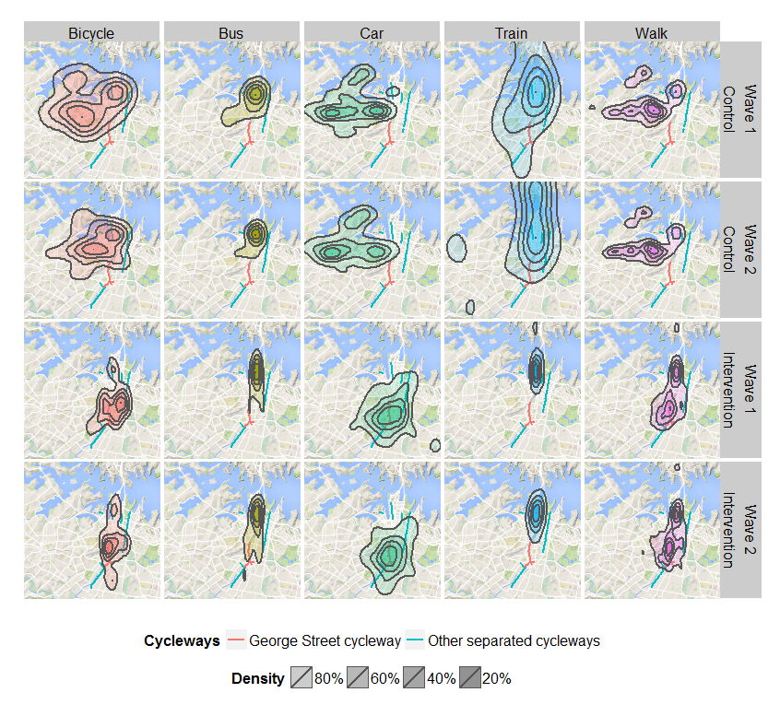
Figure 2: Spatial density of destinations by purpose, wave and intervention group

A χ² test can be used on the spatial properties of the density bands to determine if the differences in the density of the overall distribution are statistically significant. It must be emphasised this does not mean that an individual band has not changed if the overall change is not significant. Furthermore, this test does not take into account whether the shape has changed. Running this test for the modes and groups shown in Figure 2 shows that the overall area covered by each band is statistically different for cycling trips in the control area and cycling, car and train in the intervention (albeit only at the p < 0.1 level). The changes to the density of destinations for train and car trips are possibly a result of the introduction of the Opal card in the intervention area, with destinations for train becoming less concentrated and car destinations more so. The change to the geographic centre of the distribution was only significant for cycling trips in the control area, and bus and train trips in the intervention area, suggesting that much of the change that occurred was in the tails of the (spatial) distribution.
Looking more closely at the changes to destinations of bicycle trips specifically (see Figure 3), there has been a small but noticeable shift in destinations to locations that are either close to the new cycleway (shown in red on the map), or to areas that are now more accessible using the cycleway but which cannot be directly accessed using it. This is corroborated by an analysis of the changes to the distribution of the distances of the destinations to the new cycleway. This analysis shows that a higher proportion of bicycle trips in the intervention area have a destination within 500 metres of the new cycleway than before its construction. However, this has been offset by a (roughly equal) decrease in destinations 500 metres to 1km from the new cycleway. This suggests that trips that had previously been made to destinations within 1km of the cycleway have been replaced by trips with destinations on the route of the new cycleway (or adjoining streets).
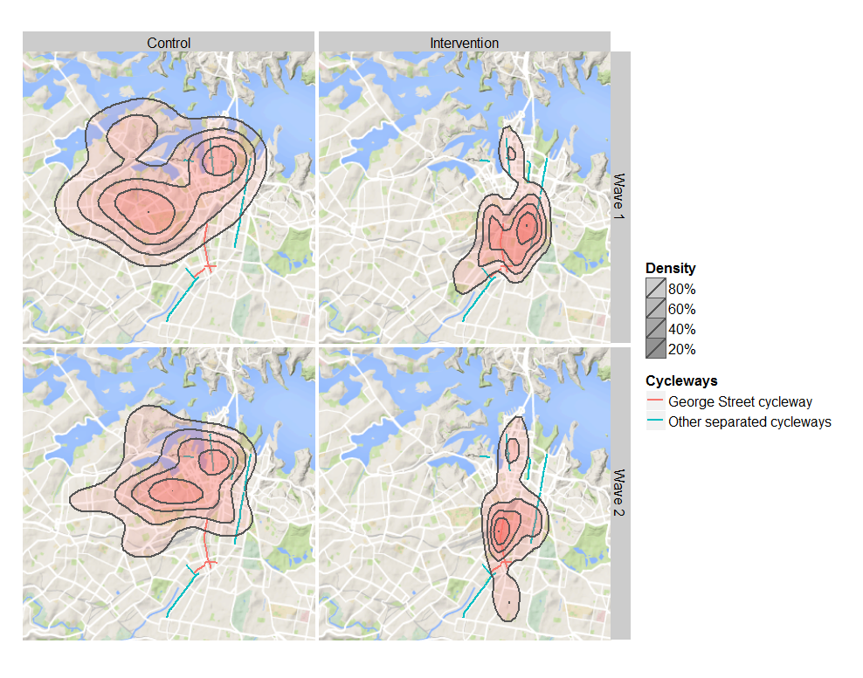
Figure 3: Spatial density of bicycle destinations

Further analysis suggests a split in how the cycleway is used depending on the purpose. For non-work trips, destinations accessed by bicycle were closer to the location of the new cycleway in Wave 2. However, for commuting trips, destinations were more spread out in Wave 2, but in only a narrow corridor following the route from the new cycleway towards the CBD. However, it is not yet clear from this analysis if the changes to commuting trips have been driven by a small number of commuters who may have switched to bicycle trips (that could be attributable to the new cycleway) or who changed where they work (which is less likely). Distance between the cycleway and place of residence as investigated by others may shed a different perspective (Goodman et al., 2014; Heinen et al., 2015).
- Discussion
The findings from the diary data largely corroborate those from the questionnaire that, while there has not been a discernible increase in cycling participation following construction of the cycleway, there has been an increase in usage of the cycleway (Rissel et al., under review). This has to be placed in context, as following a period of steady growth in cycling in the City of Sydney since the mid-2000s, there has been some stabilisation of growth, suggesting ongoing promotion efforts and better linking of bicycle network paths are needed for further growth of cycling. More intriguingly, while the direct impacts of the cycleway on new adoption of cycling may be too early to predict, there appears to be a destination choice effect that seems to (at least in part) be attributable to the cycleway. Such relationships between transportation infrastructure and land-use are well-known, particularly in the context of highway-oriented and transit-oriented developments (Cerin et al., 2007; Cao et al., 2009). A more contemporary phenomenon coined as ‘new urbanism’ extends these concepts to active transport-focused developments, creating a safe/pleasant environment for people to reach destinations by cycling and walking. The area of Sydney in and around the new cycleway is currently going through a transformation along these lines. In turn, this raises questions around whether the cycleway in itself will lead to a general increase in the desirability of the intervention area in the longer term, something that the study team will investigate through the Wave 3 data collection planned for later in 2015.
It must be reiterated that the cycleway, while providing the opportunity for the before and after analysis, is part of an (as yet) incomplete cycling network in inner-Sydney. This should be borne in mind when assessing the impact per se and we would argue that, until the network is complete, it would be premature or misleading to conclude from the current analysis that the new cycleway has had little impact on cycling overall. Based on the literature, we might also be justified in anticipating it needs longer than four months for a discernible effect to be noted. The findings from this study however do suggest that inner city cyclists are using a number of the cycleways currently available re-enforcing the importance of the City of Sydney cycleway program more broadly in appealing to new and existing cyclists. The findings also highlight the importance of the Wave 3 data to be collected 18 months after the cycleway has been open. Wave 3 will also provide further opportunity to assess whether the intervention/control trends are retained, and the extent to which cycling infrastructure is important in both retaining as well as attracting new cyclists. Much of the ‘surge’ in cycling in Sydney and Australian cities more generally over recent years has come from middle-aged cohorts, fuelled by both health concerns and the provision of safe cycling environments; cycleways appear imperative to this cause.
Despite the innovative nature of this study, particularly around the survey design, there are acknowledged limitations, which must be considered when drawing conclusions. Primarily, these revolve around the use of naturalistic studies of (travel) behaviour, which despite their appeal for studying travel phenomena, come with many challenges. The current study was no exception, with recruitment and retention of participants proving particularly challenging for the younger age cohorts. Further attrition (loss of sample) is anticipated for Wave 3, and clearly this must be accounted for in ensuring the remaining sample is sufficiently representative to draw reasonable inferences for the population of the study area. An equally significant challenge is isolating the impacts of the intervention per se over other confounding effects. Clearly, the control area was crucial in this regard and gave greater confidence to the isolation of potential effects from the cycleway, particularly in retaining cyclists and spatial impacts. However, there were confounders beyond our control, particularly the changes to public transport ticketing in the intervention area, which made it both easier and cheaper (for the majority) to travel by this mode. This is believed by the authors to underlie some of the shift towards public transport, which has likely attracted some marginal cyclists as well as private vehicle users. At the time of the Wave 2 survey, the ticketing changes had not been implemented in the control area, although they have subsequently, making it intriguing whether similar modal changes will be observed in Wave 3. It should also be added that, compounding the Wave 3 study is the likely disruption to many private and public transport services due to construction of a Light Rail service in the Sydney CBD beginning in October, 2015.
- Conclusions
This paper presents insights from a naturalistic quasi-experimental study of the impacts of a new cycleway on cycling in inner-city Sydney, Australia. The investigation uses a panel/cohort of 435 participants in an intervention area around the cycleway, and a neighbouring control area where no cycleway is being constructed. Aggregate level indicators of travel suggest there has been little overall change, in terms of the number of trips and time spent travelling, between the two waves in both areas. However, there have been modal changes in the intervention area, most notably a decline in car travel and a commensurate increase in public transport, largely attributed to the roll-out of the Opal electronic ticketing system, which made public transport easier and cheaper for most travellers. Indicators of cycling activity have largely remained unchanged in both the intervention and control areas. An intriguing finding was a small but notable spatial shift in the destination of cycling trips to an area in closer proximity to the new cycleway, indicating a possible destination choice impact of the new infrastructure. Finally, we anticipate it needs longer than four months for a discernible effect of the new cycleway to be assessed, something that will be important when Wave 3 is conducted later in 2015.

- Acknowledgements
The research reported here was funded through an ARC-Linkage grant with partners comprising Transport for New South Wales, Australian Heart Foundation, NSW Health, PCAL, and the City of Sydney.
- References
Cao, X. (Jason), Mokhtarian, P. L. and Handy, S. L. (2009). The relationship between the built environment and nonwork travel: A case study of Northern California. Transportation Research Part A: Policy and Practice, 43(5), 548–559.
Cerin, E., Leslie, E., Toit, L. Du, Owen, N. and Frank, L. D. (2007). Destinations that matter: Associations with walking for transport. Health and Place, 13(3), 713–724.
Deenihan, G. and Caulfield, B. (2014). Estimating the health economic benefits of cycling. Journal of Transport & Health, 1(2), 141–149.
Goodman, A., Sahlqvist, S. and Ogilvie, D. (2014). New walking and cycling routes and increased physical activity: one-and 2-year findings from the UK iConnect Study. American journal of public health, 104(9), e38–e46.
Greaves, S. P., Ellison, A. B. and Ellison, R. B. (2015). Participation and Diligence in a Multi-Day, Multi-Year Survey: Impact of Recruitment Methods and Demographics, in 14th International Conference on Travel Behaviour Research. Windsor, United Kingdom.
Greaves, S. P., Ellison, A. B., Ellison, R. B., Standen, C., Rance, D., Rissel, C., et al. (2014). A Web-Based Diary and Companion Smartphone app for Travel/Activity Surveys, in International Conference on Transport Survey Methods. Leura, Australia.
Greaves, S. P., Fifer, S. and Ellison, R. B. (2013). Exploring Behavioral Responses of Motorists to Risk-Based Charging Mechanisms. Transportation Research Record: Journal of the Transportation Research Board, 2386, 52–61.
Hamer, M. and Chida, Y. (2008). Active commuting and cardiovascular risk; a meta-analytic review. Preventative Medicine, 46(91), 9–13.
Heinen, E., Panter, J., Mackett, R. and Ogilvie, D. (2015). Changes in mode of travel to work: a natural experimental study of new transport infrastructure. International Journal of Behavioral Nutrition and Physical Activity, 12(1), 81.
Hunt, J. D. and Abraham, J. E. (2006). Influences on bicycle use. Transportation, 34(4), 453–470.
Keall, M., Chapman, R., Howden-Chapman, P., Witten, K., Abrahamse, W. and Woodward, A. (2015). Increasing active travel: results of a quasi-experimental study of an intervention to encourage walking and cycling. Journal of epidemiology and community health.
Krenn, P. J., Oja, P. and Titze, S. (2014). Route choices of transport bicyclists: A comparison of actually used and shortest routes. The International Journal of Behavioral Nutrition and Physical Activity, 11(1), 31.
Macmillan, A., Connor, J., Witten, K., Kearns, R., Rees, D. and Woodward, A. (2014). The Societal Costs and Benefits of Commuter Bicycling: Simulating the Effects of Specific Policies Using System Dynamics Modeling. Environmental Health Perspectives, 122(4), 334–344.
Merom, D., Bauman, A., Vita, P. and Close, G. (2003). An environmental intervention to promote walking and cycling - The impact of a newly constructed Rail Trail in Western Sydney. Preventive Medicine, 36(2), 235–242.
Moutou, C., Stopher, P., Longden, T. and Liu, W. (2015). The Challenges and Opportunities of In-Depth Analysis of Multi-day and Multi-year Data. Journal of Transport Economics and Policy.
Ogilvie, D., Egan, M., Hamilton, V. and Petticrew, M. (2004). Promoting walking and cycling as an alternative to using cars: systematic review. British Medical Journal, 329(7469), 763–6B.
Ortúzar, J., Armoogum, J., Madre, J. and Potier, F. (2011). Continuous Mobility Surveys: The State of Practice. Transport Reviews, 31(3), 293–312.
Pucher, J., Buehler, R., Bassett, D. and AL, D. (2010). Walking and cycling to health: a comparative analysis of city, state, and international data. American Journal of Public Health, 100(10), 1986–1982.
Rissel, C., Greaves, S. P., Weng, L.-M., Crame, M. and Standen, C. (under review). Use of and short-term impacts of new cycling infrastructure in inner-Sydney, Australia. Journal of Behaviour and Nutrition.
Schweizer, J. and Rupi, F. (2013). Performance evaluation of extreme bicycle scenarios, in DeSousa, J., DeSousa, J., Costa, A., Farias, T., and Melo, S. (Eds.), Transportation: Can We Do More with Less Resources? -16th Meeting of the Euro Working Group on Transportation, 508–517. Procedia Social and Behavioral Sciences.
Stopher, P. R. and Greaves, S. P. (2007). Household travel surveys: Where are we going? Transportation Research Part A: Policy and Practice, 41(5), 367–381.
Venables, W. N. and Ripley, B. D. (2002). Univariate Statistics, in Modern Applied Statistics with S, 107–138. Springer-Verlag, New York.
Warburton, D., Nicol, C. and Bredin, S. (2006). Health benefits of physical activity: The evidence. Canadian Medical Association Journal, 174(6).
Yang, L., Sahlqvist, S., McMinn, A., Griffin, S. and Ogilvie, D. (2010). Interventions to promote cycling: systematic review. British Medical Journal, 341(c5293).

The College Street cycleway is currently being removed.
The Opal ticketing smartcard system was not fully implemented in the control area until after Wave 2 was complete. Among other benefits, after making eight public transport trips of any cost in a week, users are entitled to free public transport travel for the rest of the week.

