CO2 intensity and the importance of country level differences: an analysis of the relationship between per capita emissions and population density
Thomas Longden
Institute of Transport and Logistics Studies - The University of Sydney Business School
Faculty of Business and Economics - Macquarie University
Email for correspondence: tom.longden@mq.edu.au
Abstract
Previous studies have found an inverse (or negative) correlation between urban population density and per capita emissions from land transport. In contrast, this paper finds a positive relationship between per capita CO2 emissions from transport and population density using a dataset of over 200 cities from 28 countries. This positive relationship holds when a range of variables are accounted for and the specification of the regression analysis captures the distinction between country level differences, high/low emission intensity or city specific fixed effects. Separating the cities into two groups based on the clustering that occurs on either side of a crucial point of three tonnes of CO2 emissions per capita highlights the peculiarity of the higher emission intensity of North American cities. Rather than finding a consistent relationship across all cities, this paper finds that cities in North America are distinct from those located in other countries and that the estimated relationship between urban population density and emissions from transport is different across the two groups of countries. The results of this paper have consequences for policy prescriptions that are related to previous results that find that a reduction in per capita emissions tends to occur with an increase population density.

1. Introduction
Urban population density has been associated with an inverse (or negative) correlation with GHG emissions from land transport (Kennedy et al., 2009; Mishalani et al., 2014; IPCC, 2014). Closely related to this relationship is a negative correlation between gasoline consumption per capita and urban population density (Newman and Kenworthy, 1989), as well as a negative correlation between passenger car vehicle km travelled per capita and urban density (McIntosh et al., 2014). The close association between emissions and gasoline consumption (or car use) was noted in Kennedy et al. (2009) with the statement that “since GHG emissions from ground transportation are highly dependent on the use of fossil fuels, earlier conclusions on the density dependence of transportation energy on urban density carry across to GHG emissions” (Kennedy et al., 2009: 7299). Upon discussing these negative relationships, Rickwood et al. (2008) noted that even though there is still a debate about the causal mechanism involved, “it is clear that on an aggregate level, densely populated cities use less transport energy per capita, and per passenger kilometre, than do sparsely populated ones” (Rickwood et al., 2008: 74). And while Rickwood et al. (2008) stated that the notion of a critical level of “population or activity density where effects from the positive land use/transport feedback start to become large is plausible” (Rickwood et al., 2008: 74), this paper finds that accounting for city, country or regional level differences results in marginal effect estimates for population density that are positive. And while the size of the marginal effect estimates differ based on the country grouping; the analysis finds that cities with higher population density have higher per capita emissions than cities with a lower population density. The results of this paper have consequences for policy prescriptions that are related to previous results that find that a reduction in per capita emissions tends to occur with an increase population density.

Before focusing on the analysis of per capita CO2 emissions, it should be noted that both of these relationships (population density in relation to gasoline consumption and GHGs) were originally established using a limited range of cities , bivariate analysis that omits other important explanatory variables and that the research does not fully explain the underlying cause/nature of the relationship (Gomez-Ibanez, 1991; Maat et al. 2005; van de Coevering and Schwanen, 2006; Gordon, 2008; Rickwood et al. 2008, Baur et al. 2014). And while Baur et al. (2014) also found a negative relationship with regards to per capita GHG emissions and population density, they noted that “the geographical scope of analysis crucially influences the correlation of population density with GHG emissions” (Baur et al. 2014: 8). Baur et al (2014) also raises two points of concern, the first being that Newman and Kenworthy (1989) and Kennedy et al. (2009) concentrated on the largest and most important cities in the countries they reviewed, and as a result, the cities under analysis may have been similar in important urban aspects. Baur et al. (2014) note urban structures, urban economy, transportation design, or city and population size as examples. The second point of concern raised by Baur et al. (2014) was originally raised by Mindali et al. (2004) who noted that the “data collection method used by Newman and Kenworthy is subject to inconsistencies due to different definitions used by the respondents and inaccuracies resulting from an attempt to recollect data for a period 20 years earlier” (Mindali et al., 2004: 160). Mees (2009) also noted that the Newman-Kenworthy data contained errors and that “the effect of density is outweighed by other factors unless the differences in density are huge” (Mees, 2009: 65).

In contrast to all of these studies, this paper finds a positive relationship between per capita CO2 emissions from transport and population density using multivariate analysis that includes country or region specific dummy variables. These dummy variables capture differences in the level of per capita CO2 that are unrelated to the explanatory variables (that includes population density). The dataset used is the OECD Metropolitan Areas Database that contains observations for over 200 cities from 28 countries (OECD, 2013). Table 1A and Table 2A within Longden (2015) present the range of cities and countries that are contained in this dataset. Upon reviewing the relationship between per capita CO2 emissions from transport and population density, this paper confirms that a bivariate analysis of these two variables has a negative relationship. In contrast, a positive relationship is found when there is an allowance for inherent differences between cities with high and low emission levels or when country/city specific intercepts are incorporated into the analysis. Kenworthy (2003) noted that contrasts between cities tended to correspond with regional differences seeing US cities generate over four tonnes of CO2 per person, compared to between 2.4 tonnes and 1.3 tonnes for Canadian, Australian and Western European cities (Kenworthy, 2003: 17). Coevering and Schwanen (2006) also highlighted the importance of accounting for regional differences and other explanatory variables in a review of the relationship between density and distance travelled by car. Coevering and Schwanen (2006) found a positive relationship for Europe and Canada, but not the US, and in doing so noted that “the sample of cities in the current study is small … so the findings should be considered as preliminary rather than definitive” (van de Coevering and Schwanen, 2006: 238). It should be noted that the results of each analysis are driven, in part, by the range of countries and cities that are included within the dataset and while in this paper the range of cities is quite comprehensive with respect to the OECD, the impact of missing variables and cities that do not appear in the dataset should be considered. In accordance, avenues for future research are discussed in section 4.

The paper is structured as follows. Section 2 reviews the dataset that contains over 200 cities from 26 countries using bivariate analysis and analyses how the trends in the data differ based on clustering between two groups of countries. This grouping coincides with cities from North America in comparison to cities from the remaining countries, which includes cities from Asia, Europe, Central America and South America. Section 3 then utilises multivariate analysis to allow for the impact of country specific dummies and other explanatory variables, including GDP per capita, polycentricity, fragmentation and unemployment. Section 4 then discusses the results of the paper with respect to unaccounted drivers of CO2 intensity (section 4.1), polycentricity and the importance of density (section 4.2), as well as the amount of people living in hinterland areas and the level of fragmentation (section 4.3). Section 5 then concludes the paper.

2. Bivariate analysis of per capita CO2 emissions
This section reviews the differences in per capita emissions across the cities with a specific focus on population density and then conducts a brief review of some key indicators, which includes the percentage of population in the hinterland of the urban area, GDP per capita, polycentricity (defined as the number of non-contiguous core areas), fragmentation (defined as the number of local governments per 100,000 inhabitants) and the amount of green areas per capita. Note that while this section reviews the relationship between per capita CO2 emissions from transport and the other explanatory variables using bivariate analysis, section 3 will review the relationships using multivariate analysis.

Figure 1 confirms that the use of bivariate analysis shows that urban population density has an inverse (or negative) correlation with per capita CO2 emissions from transport with a plotted regression line for the 2008 data having a negative exponent related to population density. This is consistent with the results of Kennedy et al. (2009), Rickwood et al. (2011) and Mishalani et al. (2014) where density was associated with a negative correlation with emissions from transport. With a strong relationship between energy use and emissions, it is expected that this is also consistent with the results of Newman and Kenworthy (1989). Figure 1 highlights the cities that are contained in the dataset and were also reviewed in Newman and Kenworthy (1989) and Kennedy et al. (2009). These cities are highlighted in green. Fitting a line to only these cities results in a higher goodness of fit and while there is a negative relationship, there also seems to be evidence of a U-shaped curve rather than an inverse (or negative) relationship. This U-shaped curve is also present in the full sample for 2008. Upon reviewing the clustering that occurs in Figure 1 there are two distinct groups of cities based on emissions that are above and below emission levels of three tonnes of CO2 emissions per inhabitant. Figure 2 reviews the relationship between emissions and population density for 2008 with the observations of selected countries highlighted. This shows that the US and Canada form a distinct group of cities that have more than three tonnes of CO2 emissions per inhabitant. In addition, the spread of cities within each country indicates that there is a positive relationship between CO2 emissions and population density for almost of all of the countries.

Splitting the data using a level of three tonnes of CO2 emissions per inhabitant produces two groups that are classified as group 1 and group 2 and corresponds with cities that have a high or low level of CO2 emissions per inhabitant, respectively. Table 1 reviews the correlation between per capita emissions and population density for a select group of cities and the two groups. All but one of the countries has a positive correlation between per capita CO2 emissions and population density. Table 4 presents a summary of the percentage of cities that are in group 1 and group 2 for each country. The majority of cities that fall into group 1 are in North America with some European cities also being classified as having high per capita CO2 emission levels. Examples of European cities in group 1 include Antwerp, Brussels, Graz, Milan and Madrid. Figure 3 focuses upon 2008 and shows the result of separating the cities into the two distinct groups that are based on emission levels of three tonnes per inhabitant. In accordance with the correlations in Table 2, there is a positive relationship between urban population density and per capita CO2 emissions from transport. Differences in the fitted curves between the two groups are shown in both the intercept and positive exponent estimate related to population density. Outliers include Mexico City, Tokyo, Busan, Changwon and Seoul with a range in population density of between 3.6 and 4.8 thousand persons per km squared in 2008. In comparison, New York, Pittsburgh, New Orleans and Boston had per capita CO2 emissions close to or above seven tonnes per inhabitant in 2008. Cities with the lowest per capita emissions and the lowest population density tend to be those from Mexico, however it should be noted that sensitivity testing has shown that the finding of a positive relationship is not dependent upon by these observations.

Figure 1: Per capita CO2 emissions from transport and population density in 275 cities in 2005 and 2008
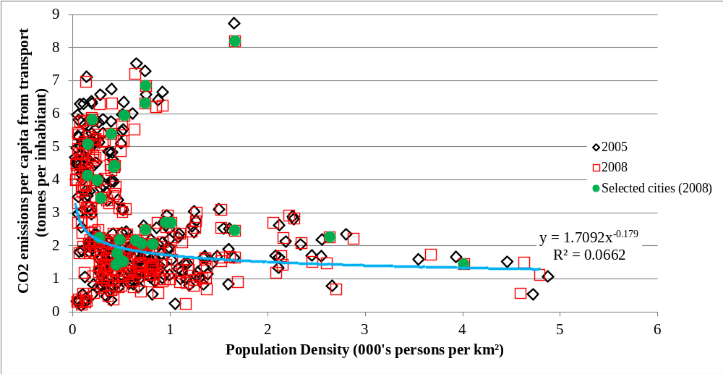

Figure 2: Per capita CO2 emissions from transport and population density across cities in 2008
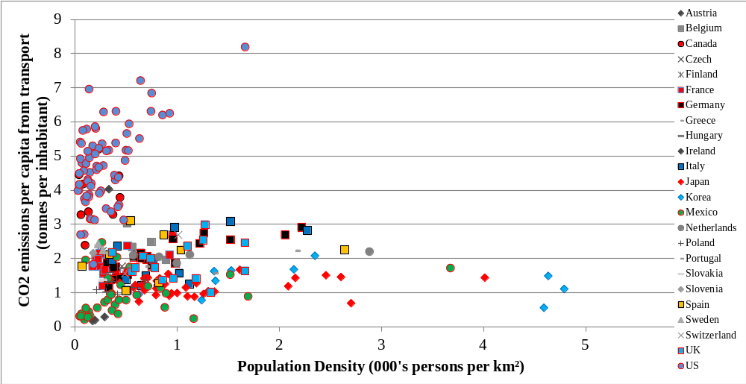

Figure 3: Per capita CO2 emissions from transport and population density across two groups of cities
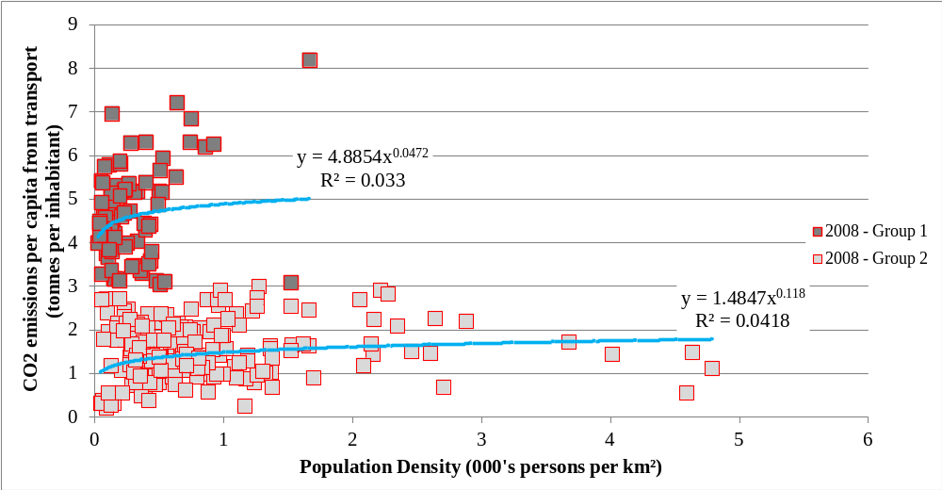

Table 1: Correlation between emissions and population density for selected cities and group 1 and 2 in 2008
Country | Correlation | N
Canada | 0.1722 | 9
France | 0.4041 | 15
Germany | 0.8599 | 24
Italy | 0.5323 | 11
Japan | 0.0922 | 36
Korea | -0.1896 | 10
Mexico | 0.3038 | 33
Netherlands | 0.5551 | 5
Poland | 0.1733 | 8
Spain | 0.1722 | 8
United Kingdom | 0.1315 | 15
United States | 0.5443 | 70
Group 1 | 0.3228 | 81
Group 2 | 0.0465 | 194
Overall | -0.2550 | 275

Table 2: Spread of cities across group 1 and group 2
Country | Percentage of Cities in Group 1 | Percentage of Cities in Group 2 | Cities in Group 1
Austria | 67% | 33% | Graz
Belgium | 25% | 75% | Antwerp, Brussels, Ghent
Canada | 89% | 11% | All except for Calgary
Chile | 0% | 100% | None
Czech Republic | 0% | 100% | None
Denmark | 0% | 100% | None - Single city reviewed
Estonia | 0% | 100% | None - Single city reviewed
Finland | 0% | 100% | None - Single city reviewed
France | 0% | 100% | None
Germany | 0% | 100% | None
Greece | 0% | 100% | None
Hungary | 0% | 100% | None - Single city reviewed
Ireland | 100% | 0% | None - Single city reviewed
Italy | 9% | 91% | Milan
Japan | 0% | 100% | None
Korea | 0% | 100% | None
Mexico | 0% | 100% | None
Netherlands | 0% | 100% | None
Norway | 0% | 100% | None - Single city reviewed
Poland | 0% | 100% | None
Portugal | 0% | 100% | None
Slovak Republic | 0% | 100% | None - Single city reviewed
Slovenia | 0% | 100% | None - Single city reviewed
Spain | 13% | 88% | Madrid
Sweden | 33% | 67% | Malmö
Switzerland | 0% | 100% | None
United Kingdom | 3% | 97% | Birmingham (only in one period)
United States | 96% | 4% | All except for El Paso, Mcallen and Charleston (only in one period)

3. Multivariate analysis of per capita CO2 emissions
This section reviews the relationship between per capita CO2 emissions and population density using multivariate analysis. The multivariate analysis occurs with four different stages of focus. The first utilises an intercept for the whole sample and focuses on only two variables to confirm whether this dataset replicates the previous results of Newman and Kenworthy (1989) and Kennedy et al. (2009). The second set of regressions expands the number of variables and includes country specific dummy variables to capture differences in per capita CO2 emissions that are not captured in the explanatory variables. For the first two sets of regressions, the use of Generalised Least Squares (GLS) allows for an adjustment of the standard errors for the existence of heteroscedasticity. These regressions are shown in equations 1 and 2 with the estimates presented in table 3 and table 4. Within equation 1 and equation 2, defines a vector of variables that differs across the regressions, is the intercept for the regression with no allowance for country differences in the level of per capita emissions and are the country dummy variables that control for country specific determinants of per capita CO2 emissions. The third set of regressions utilises Fixed Effects (FE) to control for city specific determinants of per capita CO2 emissions that are not captured in the other explanatory variables. In these regressions heteroscedasticity is adjusted for by applying robust standard errors. The specification of these regressions is shown in equation 3 and the estimates are presented in table 5. The last set of regressions reviews the changes in the key variables between 2005 and 2008 with adjustments for the existence of heteroscedasticity and country level dummy variables applied. Equation 4 shows the specification of these regressions and the estimates are presented in table 6.
(1)
(2)
(3)
(4)

Having focused upon the relationship between per capita CO2 emissions and population density, this next paragraph focuses upon a range of additional explanatory variables that are potentially important in explaining the differences in per capita CO2 emissions across cities. These variables have been identified as the percentage of population in the hinterland of the urban area, GDP per capita, polycentricity (defined as the number of non-contiguous core areas), fragmentation (defined as the number of local governments per 100,000 inhabitants) and the amount of green areas per capita. Table 3A in Longden (2015) reviews the correlation between all of the variables. The correlation between the percent of the overall population of the city that resides in the hinterland and per capita emission is negative with a correlation of -0.079. The correlation between per capita emissions and GDP per capita is 0.640. A positive relationship between the level of GDP per capita and CO2 emissions per inhabitant is likely to be related to a range of factors such as wealth, economic activity and levels of car ownership. Note that the issue of car ownership and the peak car phenomenon will be discussed in section 4.1. The correlation between per capita emissions and polycentricity is 0.014. Polycentricity of above two non-contiguous core areas tends to coincide with low emissions, however it should be noted that 99% and 97% of the cities in group one and two have polycentricity of two or less, respectively. Those cities with more than two non-contiguous core areas are Barcelona, Lyon and Stockholm (with polycentricity of three), Amsterdam (with polycentricity of four), Paris (with polycentricity of five) and London and Montreal (with polycentricity of six). As there is a limited number of cities with high polycentricity, fragmentation (defined as the number of local governments per 100,000 inhabitants) has been added to the analysis to account for the spatial dimension of the city and how many clusters of localities are contained within each city. The correlation between per capita emissions and fragmentation is 0.090. For the amount of square metres of green area per person, there is a clustering of cities with a low amount of green areas and low carbon emissions that coincides with the distinction between group 1 and group 2. The correlation between per capita emissions and green areas per person is 0.397, which is likely to be related to the overall size of the city. Cities with more than 4000 square metres of green area per person are all located in North America and are Edmonton, Des Moines, Madison, Winnipeg, Kansas City, Nashville, Louisville and Ottawa-Gatineau.

Table 3 contains the estimates for a two variable regression with and without the allowance for unobserved factors at the individual country level. Regression one uses a single constant, , with one explanatory variable (population density) and a dummy variable for the year 2008. The estimation results for regression one show a negative relationship between per capita emissions and population density and this corresponds to the relationship shown in Figure 1; as well as that found by Newman and Kenworthy (1989) and Kennedy et al. (2009). The marginal estimate for an increase in population density is -0.543 and is interpreted as a 0.543 tonne decrease in per capita emissions for an increase in population density of 1000 persons per km squared. In contrast, regression two shows a positive relationship between population density and per capita CO2 emissions once country specific exogenous factors are accounted for with the inclusion of country specific dummy variables. Note that in this regression, the constant () captures the intercept for Chile and Estonia. In regression two the US, Canada and Italy have the largest intercepts. The marginal estimate for an increase in population density is 0.260 and is interpreted as a 0.260 tonne increase in per capita emissions for an increase in population density of 1000 persons per km squared. Table 4A in Longden (2015) confirms that a positive relationship is also found when group 1 and group 2 dummy variables are used to capture the constant. In this case, the marginal estimate for an increase in population density is 0.120 and is interpreted as a 0.120 tonne increase in per capita emissions for an increase in population density of 1000 persons per km squared.

In regression three additional explanatory variables are added to the formulation of regression two. With these additional explanatory variables, the US, Canada, Ireland and Austria have the largest country specific intercepts and this corresponds with most of the cities from these countries being classified within group 1. The marginal estimate for an increase in population density is 0.291 and is interpreted as a 0.291 tonne increase in per capita emissions for an increase in population density of 1000 persons per km squared. To review the importance of the group 1 and group 2 classifications, regression four separates population density and fragmentation into two corresponding variables where the value is retained for a given group and zero values are set for the opposing group. This leads to notably different beta estimates for population density 1 () and population density 2 () as well as fragmentation 1 () and fragmentation 2 (). The relationship between population density and CO2 emissions is positive for both groups and the marginal impact of an increase in the level of population density is higher for group one than group two. The marginal estimate for an increase in population density for group 1 is 2.361 and group 2 is 0.189. This is interpreted as a 2.361 tonne increase in per capita emissions associated with group 1 for an increase in population density of 1000 persons per km squared, compared to a 0.189 tonne increase in per capita emissions for group 2. These differences are statistically significant with a 1% confidence interval, as shown in the two different Chow tests. Note that Chow 1 tests whether while Chow 2 tests whether and . In addition, a comparison of the two Chi-square estimates of goodness of fit shows that regression two has higher explanatory power and the separation of these variables into two groups improves the accuracy of the fitted model.

Allowing for city level differences in per capita CO2 emissions through the application of city specific fixed effects, as shown in Table 5 and specified in equation 3, also results in a positive relationship between CO2 emissions and population density. These results are impacted by an allowance for city level differences that did not change between 2005 and 2008; hence the results have to be reviewed accordingly. Consequently, these results are liable to a removal of heterogeneity as minor changes in population density that did occur in group 1 are likely to be correlated to the city specific fixed effects. Figure 4 confirms that the changes in population density were broader in group 2 than in group 1 and this may have impacted the estimate associated with population density 1. This difference is reflected in the significance of the first Chow test and the differences in the beta estimates for population density. As a result, further investigation of the changes between 2005 and 2008 is warranted and the discussion surrounding Table 6 will focus on the change between 2005 and 2008.
Table 3: GLS Regression Results - Per capita CO2 emissions from transport - 2005 and 2008
Variable | Reg. 1 | Reg. 2 | Variable | Reg. 1 (cont..) | Reg. 2 (cont..)
Constant | 3.044*** | 0.860*** | Sweden Dummy |  | 1.677***
 | (64.55) | (36.52) |  |  | (13.47)
Austria Dummy |  | 2.373*** | Switzerland Dummy |  | 0.918***
 |  | (45.19) |  |  | (6.91)
Belgium Dummy |  | 1.657*** | UK Dummy |  | 0.932***
 |  | (72.41) |  |  | (23.81)
Canada Dummy |  | 3.079*** | US Dummy |  | 4.197***
 |  | (52.68) |  |  | (133.09)
Czech Dummy |  | 1.155*** | Population Density | -0.543*** | 0.260***
 |  | (11.84) |  | (-27.87) | 19.33
Finland Dummy |  | 1.355*** | 2008 Dummy | -0.110*** | -0.117***
 |  | (23.69) |  | (-3.98) | -11.88
France Dummy |  | 1.507***
 |  | (20.24)
Germany Dummy |  | 1.106***
 |  | (35.38)
Greece Dummy |  | 1.055***
 |  | (34.24)
Hungary Dummy |  | 0.676***
 |  | (5.42)
Ireland Dummy |  | 0.839***
 |  | (8.49)
Italy Dummy |  | 3.157***
 |  | (26.71)
Japan Dummy |  | 1.081***
 |  | (25.99)
Korea Dummy |  | 0.293***
 |  | (15.13)
Mexico Dummy |  | 0.0441
 |  | (0.60)
Netherlands Dummy |  | 0.0222
 |  | (0.81)
Poland Dummy |  | 1.157***
 |  | (23.24)
Portugal Dummy |  | 1.303*** | N | 550 | 550
 |  | (21.48)
Slovak Dummy |  | 0.267*** | Chi-Square | 796.08*** | 31515.17***
 |  | (4.13)
Slovenia Dummy |  | 0.787***
 |  | (7.66)
Spain Dummy |  | 0.580***
 |  | (7.43)
Note: * p<0.10, ** p<0.05, *** p<0.01.

Table 4: GLS Regression Results - Per capita CO2 emissions from transport - 2005 and 2008
Variable | Reg. 3 | Reg. 4 | Variable | Reg. 3 (cont..) | Reg. 4 (cont..)
Constant | 0.447*** | 0.652*** | Sweden Dummy | 1.367*** | 1.355***
 | (5.89) | (10.84) |  | (16.70) | (18.23)
Austria Dummy | 1.590*** | 1.196*** | Switzerland Dummy | 0.199 | 0.391**
 | (12.94) | (6.82) |  | (1.21) | (2.17)
Belgium Dummy | 1.184*** | 0.949*** | UK Dummy | 0.706*** | 0.732***
 | (24.22) | (9.26) |  | (13.57) | (16.78)
Canada Dummy | 2.762*** | 2.079*** | US Dummy | 3.813*** | 3.062***
 | (23.81) | (16.07) |  | (58.11) | (47.46)
Czech Dummy | 0.651*** | 0.910*** | Population Density | 0.291***
 | (4.90) | (7.33) |  | (17.94)
Finland Dummy | 1.147*** | 1.188*** | Population Density 1 |  | 2.361***
 | (15.70) | (18.27) |  |  | (39.19)
France Dummy | 0.608*** | 0.790*** | Population Density 2 |  | 0.189***
 | (8.07) | (11.18) |  |  | (17.43)
Germany Dummy | 0.638*** | 0.759*** | Perc. Population in Hinterland | 0.00420*** | 0.00477***
 | (11.89) | (20.61) | Perc. Population in Hinterland | (5.85) | (10.62)
Greece Dummy | 0.432*** | 0.562*** | Polycentric | 0.0862*** | 0.0482***
 | (4.63) | (3.63) |  | (5.15) | (5.52)
Hungary Dummy | 0.544*** | 0.589*** | Fragment | 0.0123***
 | (5.60) | (6.31) |  | (5.23)
Ireland Dummy | 2.701*** | 2.049*** | Fragment1 |  | 0.0546***
 | (21.91) | (17.82) |  |  | (8.51)
Italy Dummy | 0.674*** | 0.755*** | Fragment2 |  | 0.00520**
 | (9.44) | (15.72) |  |  | (2.48)
Japan Dummy | 0.0976** | 0.185*** | GDP per capita | 0.0135*** | 0.0105***
 | (2.10) | (5.85) |  | (9.24) | (9.45)
Korea Dummy | -0.219*** | -0.0221 | Unemployment rate | -0.00510 | -0.00899**
 | (-3.38) | (-0.34) |  | (-1.11) | (-2.32)
Mexico Dummy | 0.0671 | 0.0608 | Green areas | 0.0335 | 0.0357**
 | (1.37) | (1.55) |  | (1.88) | (1.95)
Netherlands Dummy | 0.602*** | 0.796*** | 2008 Dummy | -0.123*** | -0.147***
 | (10.99) | (20.27) |  | (-9.82) | (-17.17)
Poland Dummy | 0.209*** | 0.226***
 | (3.02) | (4.14)
Portugal Dummy | 0.541*** | 0.707*** | N | 538 | 538
 | (8.16) | (11.69)
Slovak Dummy | -0.0248 | 0.126* | Chi-Square | 22278.0*** | 61116.2***
 | (-0.33) | (1.86)
Slovenia Dummy | 0.913*** | 0.928*** | Chow 1 |  | 1324.6***
 | (9.16) | (9.77) | Chow 2 |  | 1502.4***
Spain Dummy | 0.881*** | 0.801***
 | (7.89) | (13.58)
Note: * p<0.10, ** p<0.05, *** p<0.01.

Table 5: FE Regression Results - Per capita CO2 emissions from transport - 2005 and 2008
Variable | Reg. 5 | Reg. 6
Constant | 0.330 | 0.684
 | (0.41) | (0.98)
Population Density | 1.244**
 | (2.22)
Population Density 1 |  | 0.839
 |  | (1.44)
Population Density 2 |  | 1.092**
 |  | (1.96)
Perc. Population in Hinterland | 0.0204 | 0.0230
 | (0.96) | (1.11)
Polycentric | - | -
 | - | -
Fragment | 0.0664
 | (0.95)
Fragment1 |  | 0.117
 |  | (0.95)
Fragment2 |  | -0.0102**
 |  | (-2.15)
GDP per capita | 0.0132 | 0.0118
 | (1.51) | (1.37)
Unemployment rate | -0.0353*** | -0.0357***
 | (-5.26) | (-5.32)
Green areas | 0.940** | 0.828**
 | (2.43) | (2.02)
2008 Dummy | -0.163*** | -0.164***
 | (-7.98) | (-8.17)
N | 538 | 538
F stat | 17.54*** | 15.08***
Chow 1 |  | 3.30*
Chow 2 |  | 1.88
Note: * p<0.10, ** p<0.05, *** p<0.01.

Table 6: GLS Regression Results – Change in pc CO2 emissions between 2005 and 2008
Variable | Reg. 7 | Reg. 8 | Variable | Reg. 7 (cont..) | Reg. 8 (cont..)
Constant | -0.0907*** | -0.108*** | Change in Population Density | -0.646***
 | (-4.10) | (-3.73) | Change in Population Density | (-25.41)
Austria Dummy | -0.0966*** | -0.0601** | Change in Population Density 1 |  | -5.877***
 | (-3.46) | (-2.01) | Change in Population Density 1 |  | (-22.55)
Belgium Dummy | 0.0171 | 0.0476* | Change in Population Density 2 |  | -0.459***
 | (0.77) | (1.64) | Change in Population Density 2 |  | (-9.93)
Canada Dummy | -0.0122 | 0.0547* | Change in Perc. Pop. in Hinterland | 0.00641*** | 0.00784***
 | (-0.50) | (1.86) | Change in Perc. Pop. in Hinterland | (4.69) | (6.29)
Czech Dummy | 0.312*** | 0.335*** | Change in Fragment | 0.0676***
 | (13.95) | (11.25) | Change in Fragment | (12.26)
France Dummy | 0.103*** | 0.117*** | Change in Fragment1 |  | 0.114***
 | (4.65) | (4.03) | Change in Fragment1 |  | (4.87)
Germany Dummy | 0.0846*** | 0.108*** | Change in Fragment2 |  | 0.0626***
 | (3.82) | (3.73) | Change in Fragment2 |  | (15.67)
Greece Dummy | 0.130*** | 0.155*** | Change in GDP per capita | 0.000508 | -0.000934**
 | (5.28) | (4.66) | Change in GDP per capita | (1.39) | (-3.06)
Italy Dummy | 0.0877*** | 0.102*** | Change in Unemployment rate | -0.0143*** | -0.0102***
 | (3.97) | (3.50) | Change in Unemployment rate | (-18.63) | (-6.38)
Japan Dummy | -0.0646*** | -0.0484* | Change in Green areas | 0.148*** | 0.0710**
 | (-2.92) | (-1.67) | Change in Green areas | (5.61) | (2.13)
Korea Dummy | 0.109*** | 0.127***
 | (4.89) | (4.37)
Mexico Dummy | 0.168*** | 0.177***
 | (7.54) | (6.08)
Netherlands Dummy | -0.0106 | -0.00120 | N | 236 | 236
 | (-0.47) | (-0.04)
Poland Dummy | 0.379*** | 0.403*** | Chi-Square | 397211*** | 187000***
 | (17.13) | (13.82)
Portugal Dummy | -0.0399* | -0.0223 | Chow 1 |  | 420***
 | (-1.64) | (-0.72) | Chow 2 |  | 442***
Spain Dummy | 0.159*** | 0.190***
 | (6.87) | (6.27)
Sweden Dummy | 0.184*** | 0.201***
 | (8.14) | (6.87)
UK Dummy | 0.0790*** | 0.0933**
 | (3.58) | (3.21)
US Dummy | -0.323*** | -0.268***
 | (-14.47) | (-9.13)
Note: * p<0.10, ** p<0.05, *** p<0.01.
Focusing upon the differences between 2005 and 2008, as shown in Table 6, results in a negative relationship between the change in population density and the change in per capita CO2 emissions. So while the level of emissions has a positive relation to the level of population density, changes in these variables between 2005 and 2008 correspond with a negative relationship that is statistically significant for both groups of cities. This relationship tended to be numerically larger for group 1 countries. The difference between group 1 and group 2 are statistically significant with a 1% confidence interval, as shown in the two different Chow tests. Chow 1 now tests whether while Chow 2 tests whether and . Note that refers to the beta estimate associated with the change in population density 1 and is the beta estimate associated with the change in fragmentation 1. In addition, a comparison of the two Chi-square estimates shows that regression eight has higher explanatory power and improves the accuracy of the fitted model. Figure 4 shows that the change in population density between 2005 and 2008 was broader in group 2 but that the change in per capita CO2 emissions was broader in group 1. However, with changes across three years reviewed and small changes recorded, these results should be interpreted with caution and the underlying determinants of the changes should be the subject of further investigation.

Three years is a short amount of time for city level structural change related to population density to drive notable emission reductions. Indeed, the author believes that future research should repeat this regression analysis with additional variables for specific policies and developments that occurred within these cities. For example, the fifty-five cities that had a reduction in per capita CO2 emissions of more than 0.32 tonnes between 2005 and 2008 also had positive population growth and a reduction in green areas per person. Accordingly, the changes in land use and the built environment should be reviewed in extension of this paper. The impact of the 2007-2008 financial crisis may have also been a factor; however the inclusion of the 2008 dummy variable and GDP per capita would have accounted for some of the impact. In addition, changes in vehicle kilometres travelled and/or car ownership will be important factors as this time period (2005-2008) coincides with observations of a peak car phenomenon.

Another issue that should be considered upon reviewing population density is that it may be correlated to a range of factors. An important issue related to the discussion of changes in density and per capita emissions between 2005 and 2008 is whether the downward trend is related to policy and/or structural changes (e.g. changes in land use planning and the built environment), rather than a change in population. Figure 5 shows that there is a distinct negative relationship between the change in per capita emissions and the change in the population between 2005 and 2008 for group 1 countries. Overall, the correlation between the change in population and the change in population density is 0.62, which means that including both variables in a regression would coincide with a multicollinearity problem. Sensitivity tests where population density is replaced by population tends to increase the accuracy of the model, however this is unsurprising as per capita emissions are a function of population. Accordingly, the separation of the population impact and the underlying structural change of a city will be an important contribution of future research that aims to explore the determinants of the changes that have occurred in group 1 countries and cities.

Figure 4: Changes in Per capita CO2 emissions from transport and population density across cities - 2008 in comparison to 2005 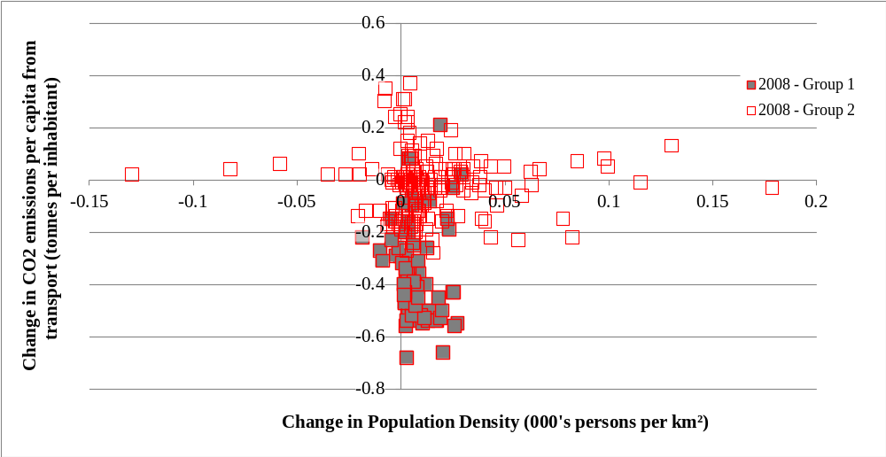

Figure 5: Changes in per capita CO2 emissions from transport and population across cities - 2008 in comparison to 2005
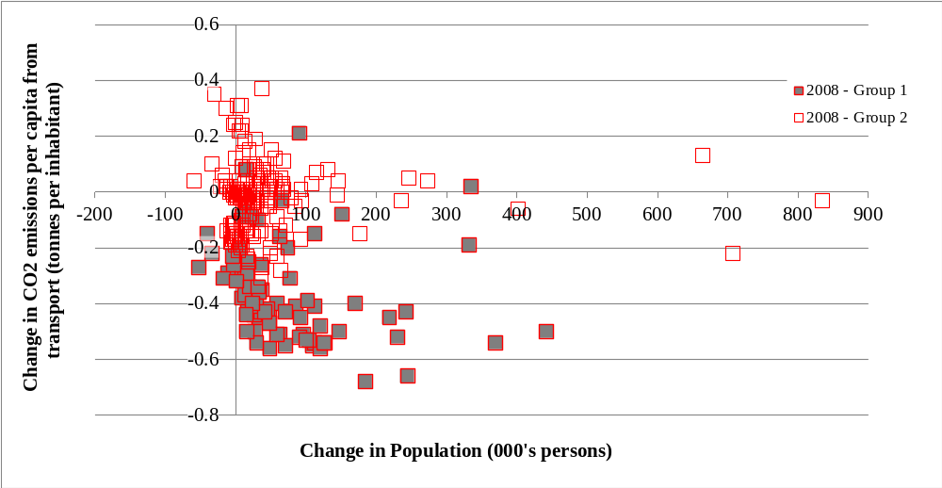

4. Bivariate analysis of per capita CO2 emissions
Having reviewed the relationship between the levels of per capita emissions and population density, as well as the relationship between the change in per capita emissions and the change in population density for the period between 2005 and 2008, this section discusses some important issues that should be considered upon reviewing the results of this paper. Section 4.1 reviews the unaccounted drivers of CO2 intensity, while section 4.2 focuses on polycentricity and the importance of density. Section 4.3 then reviews the proportion of people living in hinterland areas and the impact of fragmentation (based on the number of local governments within the city).

4.1 Unaccounted drivers of CO2 intensity
While this paper has established that a positive relationship between per capita emissions from transport and population density exists with the use of a richer group of cities/countries and multivariate analysis, the list of variables used within the analysis is not all encompassing. Important missing variables include the coverage of public transport within the city, the ownership of motor vehicles, vehicle kilometres travelled, policies related to supporting travel using different modes and the underlying mix of demographics within the city. And while future research should aim to explain the main determinants of the underlying structural differences between cities that are classified into group one and group two, it has been noted that CO2 emissions across cities and regions are primarily driven by motor vehicle use (Newman and Kenworthy, 1992; Kennedy et al., 2009). Indeed, it is expected that those cities that have a low carbon intensity of transport are also those that offer flexible options for travel, such as a variety of public transport options. Nevertheless, this was a key reason for including country specific dummy variables as they capture unexplained differences between the cities that are based on national differences.

In relation to the missing variables, the application of fixed effects allowed for the capture of city specific differences, but this also led to the removal of some heterogeneity. For the most part this paper has focused on country specific differences as it was expected that most of the unobserved variables (including many of those mentioned above) would be correlated with country level differences/preferences towards land use planning and the provision of public transport options. While the cities and countries that are part of the OECD Metropolitan Areas Database is broad, notable exclusions from the OECD are Australia and New Zealand. Nevertheless, as the OECD Metropolitan Areas Database has a high coverage of cities, future research should use this dataset to build upon this analysis with the aim of explaining the underlying differences that explain the differences in per capita emission levels between cities in group 1 and group 2. Previous studies that have reviewed the disparity between North American cities and other cities have highlighted a preference for driving, cheap fuel costs, urban sprawl and a predominance of highway infrastructure as key determinants of the differences in emission levels (Chapman, 2007), as well as a need for relatively high government expenditure on (or subsidisation of) transit systems due to higher costs related to low densities and city size (Poudenx, 2008).

4.2 Polycentricity and density
The impact of polycentricity on the carbon intensity of transport has been noted to depend upon the density of the localities involved and the average distance travelled during commutes to workplaces (Black and Katakos, 1981; Newman and Kenworthy, 1992). This is related to the concept of urban villages (Newman and Kenworthy, 1991; Newman, 1991) and the need for dispersed cities to also have transit systems that connect these areas to sufficiently large concentrations of activity (Newman and Kenworthy, 1992). Reviewing the impact of urban villages will need to account for the profile of the underlying transit system and further details on the manner of density within a city. The discussion surrounding polycentricity in section 2 noted that most of the cities in the dataset have two or less non-contiguous areas. Due to limited heterogeneity in polycentricity within the dataset, the percentage of the population that lives within the hinterland area and a measure of fragmentation have been included in the analysis to account for differences in the profiles of the cities beyond the issue of density. These factors are further discussed in section 4.3.

4.3 Population in the hinterland and fragmentation
The issue of differences in the level of suburbanisation and the outer urban density of cities between countries is an important factor. For example, upon focusing on the European countries in the Newman and Kenworthy (1989) data, Mindali et al. (2004) found a strong negative correlation between energy consumption and outer area employment and this led them to prescribe increases in outer area employment density. Indeed, the profile of a city’s extended areas should be the focus of further investigation. In this analysis the percentage of the population in hinterland areas was positively related to per capita CO2 emissions and statistically significant. A one percentage point increase in population in the hinterland corresponded with an increase in per capita emissions of between 0.0042 and 0.0047 tonnes. Upon reviewing the change between 2005 and 2008, a one percentage point increase in population in the hinterland was also associated with an increase in per capita emissions. Related to the proportion of the population in the hinterland is the geographical boundary of the city and the implication that this has for the specification of population density.

Fragmentation (as defined as the number of local governments per 100,000 inhabitants) has been included to account for the clustering of localities within each city. Note that rather than focusing upon the impact of local governments, this variable has been included to capture the spread of localities in the city as the variance in polycentricity was limited. The two variables have a low amount of correlation (0.07) and the limited amount of cities with polycentricity of greater than two is a factor. Both the level of fragmentation and the change in fragmentation between 2005 and 2008 were associated with a positive relationship with per capita CO2 emissions.

5. Conclusion
The validity of an inverse (or negative) relationship between per capita CO2 emissions from transport and per capita gasoline use/emissions has been widely debated. Reviewing this relationship using a broader dataset is important as the robustness of previous analysis and the size of the sample used have been identified as a key criticism (Gomez-Ibanez, 1991; van de Coevering and Schwanen, 2006, Baur et al. 2014). And while the coverage of the cities in Newman and Kenworthy (1989) and Kennedy et al. (2009) was an initial concern of the author, this paper has also found that analysis that does not account for country level differences in per capita CO2 emissions does find an inverse relationship within a dataset of over 200 cities from 28 countries. However, once country level differences are accounted for the analysis found a positive relationship between per capita CO2 emissions from transport and population density. This result holds when a range of variables are accounted for and the specification of the regression analysis captures the distinction between high/low emission intensity or city specific fixed effects.

Separating the data into two groups based on a crucial point of three tonnes of CO2 emissions per capita tends to improve the goodness of fit and this highlights how distinct North American cities are from the 24 countries that do not have a majority of cities classified as being in group 1 (or having high emission intensity). Upon separating key variables (population density and fragmentation) into these two groups the analysis finds a numerically larger relationship between per capita emissions and population density for group 1. Both groups have a significant positive relationship. With respect to the change between 2005 and 2008, a numerically larger relationship between the change in per capita emissions and the change in population density is also found for group 1. In this case the relationship for group 1, group 2 and the overall sample is negative. This reflects a general downturn in per capita emissions during the period between 2005 and 2008 and given the small time period involved it should be unsurprising that a preliminary review has pointed to evidence that this has been driven by an increase in population. However, it is acknowledged that this was a preliminary review of the issue and that future research should aim to confirm whether changes in population, the 2007-2008 financial crisis or structural changes in land use and the built environment drove these changes.

And while additional considerations should be made and future research conducted, the notion of a critical level of “population or activity density where effects from the positive land use/transport feedback start to become large” (Rickwood et al., 2008: 74) has been found to be implausible within an analysis that accounts for country level differences in per capita emissions that are unrelated to the level of population density. Such an inverse relationship has been associated with the policy prescription that “North American cities might ideally reduce per-capita emissions by pursuing smart growth policies that increase population density in tandem with design and diversity of transport options” (Kennedy et al., 2009: 7299). And while the prospect that the relationship is positive is one matter, increases in urban density as a policy prescription will be problematic as substantial increases would take many decades to achieve due to the longevity of urban infrastructure and may also coincide with considerable local opposition (Moriarty and Honnery, 2013). In addition, a review of population density and per capita emissions or energy use should account for the separation of the impact of an increase in population and the underlying structural change of a city. Reviewing how cities have changed over time will be an important contribution of future research that aims to explore the determinants of the changes that have occurred across countries and cities. As the time horizon reviewed within this paper is only three years, the change in per capita emissions has been found to be related to the change in population, which is highly correlated to the change in population density and a determinant of per capita emissions. The separation of the impact of changes in population from the underlying structural change of a city will be an important contribution of future research.

References
Baur, A., Thess, M., Kleinschmit, B., and Creutzig, F. (2014). Urban Climate Change Mitigation in Europe: Looking at and beyond the Role of Population Density. J. Urban Plann. Dev., 140(1), 04013003.
Black, J., & Katakos, A. (1981). Alternative urban spatial forms and fuel consumption in the journey-to-work: some fundamental considerations.
Gomez-Ibanez, J. A. (1991). A global view of automobile dependence. Journal of the American Planning Association, 57(3), 376-379.
Gordon, I. (2008). Density and the built environment. Energy Policy, 36(12), 4652-4656.
IPCC (2014) Sims R., R. Schaeffer, F. Creutzig, X. Cruz-Núñez, M. D’Agosto, D. Dimitriu, M. J. Figueroa Meza, L. Fulton, S. Kobayashi, O. Lah, A. McKinnon, P. Newman, M. Ouyang, J. J. Schauer, D. Sperling, and G. Tiwari, 2014: Transport. In: Climate Change 2014: Mitigation of Climate Change. Contribution of Working Group III to the Fifth Assessment Report of the Intergovernmental Panel on Climate Change [Edenhofer, O., R. Pichs-Madruga, Y. Sokona, E. Farahani, S. Kadner, K. Seyboth, A. Adler, I. Baum, S. Brunner, P. Eickemeier, B. Kriemann, J. Savolainen, S. Schlömer, C. von Stechow, T. Zwickel and J.C. Minx (eds.)]. Cambridge University Press, Cambridge, United Kingdom and New York, NY, USA.
Kennedy, C., Steinberger, J., Gasson, B., Hansen, Y., Hillman, T., Havranek, M., Pataki, D., Phdungsilp, A., Ramaswami, A. & Mendez, G. V. (2009). Greenhouse gas emissions from global cities. Environmental science & technology, 43(19), 7297-7302.
Kenworthy, J. R. (2003). Transport energy use and greenhouse gases in urban passenger transport systems: a study of 84 global cities.
Longden, T. (2015) CO2 intensity and the importance of country level differences: An analysis of the relationship between per capita emissions and population density, FEEM Working Paper No. 47.2015.
Maat, K., van Wee, B., & Stead, D. (2005). Land use and travel behaviour: expected effects from the perspective of utility theory and activity-based theories. Environment and Planning B: Planning and Design, 32, 33-46.
Mees, P. (2009). How Dense Are We?: Another Look at Urban Density and Transport Patterns in Australia, Canada and the USA. Road and Transport Research. Vol. 18, No. 4.
McIntosh, J., Trubka, R., Kenworthy, J., & Newman, P. (2014). The role of urban form and transit in city car dependence: Analysis of 26 global cities from 1960 to 2000. Transportation Research Part D, 33, 95-110.
Mindali, O., Raveh, A., & Salomon, I. (2004). Urban density and energy consumption: a new look at old statistics. Transportation Research Part A: Policy and Practice, 38(2), 143-162.
Mishalani, R. G., Goel, P. K., Westra, A. M., & Landgraf, A. J. (2014) Modeling the relationships among urban passenger travel carbon dioxide emissions, transportation demand and supply, population density, and proxy policy variables. Transportation Research Part D, 33, 146-154.
Moriarty, P., & Honnery, D. (2013). Greening passenger transport: a review. Journal of Cleaner Production, 54(1), 14-22.
Newman, P. W., & Kenworthy, J. R. (1989). Gasoline consumption and cities: a comparison of US cities with a global survey. Journal of the american planning association, 55(1), 24-37.
Newman, P. W., & Kenworthy, J. R. (1991). Transport and urban form in thirty‐two of the world's principal cities. Transport Reviews, 11(3), 249-272.
Newman, P. W., & Kenworthy, J. R. (1992). Is there a role for physical planners?. Journal of the American Planning Association, 58(3), 353-362.
Newman, P. (1991). Greenhouse, oil and cities. Futures, 23(4), 335-348.
OECD (2013) OECD Metropolitan Areas Database (accessed on 13 February 2015 via OECD Stat).
Poudenx, P. (2008). The effect of transportation policies on energy consumption and greenhouse gas emission from urban passenger transportation. Transportation Research Part A: Policy and Practice, 42(6), 901-909.
Rickwood, P., Glazebrook, G., & Searle, G. (2008). Urban structure and energy—a review. Urban policy and research, 26(1), 57-81.
van de Coevering, P., & Schwanen, T. (2006). Re-evaluating the impact of urban form on travel patternsin Europe and North-America. Transport policy, 13(3), 229-239.

The application of the Breusch-Pagan / Cook-Weisberg test for heteroskedasticity in Stata provides a Chi-Square estimate of 201.60 and this means the null hypothesis is rejected with a confidence interval of 1%.
These are calculated using the Huber/White/sandwich estimator included in Stata.
Analysis using only the two variables (density and emissions) and a time dummy variable for 2008 finds that the inclusion of country level differences results in a positive, rather than negative, relationship. Hence, establishing a positive relationship is not contingent upon the other city specific explanatory variables included in the analysis.
While the impact of the 2007-2008 financial crisis may have been a factor; it should be noted that the inclusion of the 2008 dummy variable and GDP per capita would have accounted for some of the impact of the crisis within this analysis.

