Are network planning guidelines based on equal access equitable?
Corinne Mulley¹, Liang Ma¹, Geoffrey Tilden Clifton¹ and Michael Tanner²
¹ITLS, University of Sydney
² Transport for New South Wales
Email for correspondence: corinne.mulley@sydney.edu.au
Abstract

The principles of public transport network planning include simplicity, legibility, frequency and spatial coverage. These principles are normally translated into a series of “Guidelines” setting out the specific standards for network design within a jurisdiction. In practice network planning principles guidelines usually concentrate on creating a bus network or on the role of buses within a multimodal network as rail-based routes are regarded as fixed in location and separate planning processes are typically used to design rail frequencies and stopping patterns.
The outcome of the network planning gives rise to trade-offs between the economic and institutional environments and is conditioned by historical legacy. Bus routes often continue because historically this is the route that was traversed or because a bus replaced a previous tram route. This paper offers a case study based on Sydney, Australia where the network planning guidelines for Metropolitan Sydney still place emphasis on equality of spatial coverage despite moving towards a more ‘integrated’ approach to network planning. This paper identifies that guidelines focusing on equal spatial coverage may inadvertently promote inequity through not taking account of the difficulties (and therefore higher cost) of serving challenging topographical areas.
This paper therefore examines the equity impacts of the implementation of service planning guidelines based on equal spatial coverage using Sydney as a case study. Criteria relating to equity will be established which are then measured using bus supply data, journey to work and socio-economic data. The conclusions of the paper are a contribution to network planning implementation with many cities both in Australia and elsewhere implementing similar guidelines to Sydney.

Introduction
Traditional network or service planning guidelines (SPGs) emphasise the importance of providing a minimum level of service across the network: this is often expressed in terms of ensuring that a particular percentage of the population lives within a certain distance of a bus service offering a minimum level of service. The contrasting approach, which has been labelled ‘integrated’ network planning in Sydney (Transport for New South Wales (2013, hereafter TFNSW 2013), places emphasis on providing service to areas of greatest need and greatest patronage potential.
By way of example, the guidelines for Sydney have evolved over the last 11 years towards an integrated model. Between 2006 and 2013 the guideline was that ‘90 percent of households should be within 400 metres (as the crow flies)’ of a public transport route during the daytime (New South Wales Ministry of Transport 2006). The latest guidelines (TFNSW 2013) have, on the one hand, strengthened this so that service should now be provided such that 90 percent of households are within 400 metres of a public transport stop during the day but, on the other hand, has placed less importance on achieving this goal.
Given limited budgets, guidelines that emphasise geographical coverage must lead to networks that do not place as much emphasis on directing services to areas of most need (e.g. those people who lack access to a private car or those people who would most benefit from supporting access to jobs, education and services) or areas where demand might be highest (see Nielsen, et al. 2005 and Walker 2008).
Modern SPGs appear to be introducing more flexibility than their predecessors by placing less emphasis on the requirements for spreading service levels across the service area (e.g. the 2006 Sydney guidelines lowered the requirement from 95 percent to 90 percent of households within 400 metres of a service) and more emphasis on providing services designed to attract patronage from the private car. However, the question remains as to what impact these guidelines actually have on the provision of service across the network and whether or not they lead to an equitable distribution of resources.
Using the case study of Sydney, NSW, this paper uses the PTAL methodology (Transport for London 2010 and 2015) to assess the extent to which the guidelines are creating a network that simply spreads service levels across the urban area or provides higher services to either areas of greatest need or to areas of greatest demand. Whilst it would always be good to have more budget available, this is not the premise of this paper. The premise of the paper is that the existing budget used to support services maybe differently distributed over space if achieving equity is one of the aims of network planning. The paper is structured as follows, Section 2 discusses the modern and traditional approaches to service planning guidelines and discusses how transport equity can be measured and assessed. Section 3 summarises the PTAL methodology for measuring the level of supply of public transport services, discusses how to measure the socio-demographic need for public transport and the patronage potential of an area. Section 3 also introduces the methodology used in this paper to compare service levels against the measures of need and potential patronage for public transport. Section 4 looks at the results of the modelling exercise in terms of a number of maps of supply, need and patronage potential and in a number of regression models linking the three factors. Section 5 discusses what lessons can be learnt from the analysis of this paper and the implications for policy.

Literature Review

2.1 Service Planning Guidelines
Network or service planning guidelines (SPGs) exist in most urban areas where governments have responsibilities for, at a minimum, the subsidy of public transport services (Transport for London 2015; Victorian Auditor-General 2014; Public Transport Victoria 2012; ACT Government 2012, Pratt and Evans 2004 and New York Metropolitan Transportation Authority 2015). In New South Wales (NSW), the SPGs are provided in TfNSW 2013 which replaced the previous guidelines that were contained in New South Wales Ministry of Transport 2006.
Under the Strategic-Tactical-Operational (STO) framework (Van de Velde 1999 and Hensher and Macario 2002), Service planning guidelines (SPGs) are created at the tactical level to provide instructions to public transport network and route planners on how to implement the overarching strategy of the transport authority. Typically, this overall strategy will be to either match services to demand (e.g. TfNSW 2013, p3) or to match services to needs (e.g. TfNSW 2013, p18) or some combination of the two. The two types of networks are discussed in more detail in Nielsen, et al. (2005) and form the basis of the patronage network vs. coverage network distinction used by practitioners such as Walker (2008). In all cases, guidelines will also target value for money in terms of not providing subsidised service above that required to meet the other goals (e.g. TfNSW p15).
No matter what objectives the SPGs aim to achieve, all must account for the drivers of patronage: Fares, availability of alternatives, service attributes of the public transport mode, service attributes of the alternatives. In the examples of SPGs cited above, fares policy is outside the remit of the network planners who are then only concerned with service attributes. The service attributes of the public transport mode are all that are within the control of the planners have been grouped by Daniels and Mulley (2012) into four categories: Coverage, frequency (see Abrantes and Wardman 2011 for a discussion of the importance of this attribute), legibility (see Wardman 2001 and Paulley et al. 2006) and directness (see Jansson 2003 and Ljungber 2005).
Fixed budgets forming a cap on subsidies require trade-offs between the four categories of service attributes in planning networks. A network of frequent and direct routes creates legibility and supports patronage growth but at the expense of network coverage (see Nielsen, et al. 2005). As direct routes tend to require more walking, a network plan with the objective of providing a safety net of service for those without access to a private car will tend to favour higher coverage at the expense of frequency and directness.

2.2 Equity
Equity as a concept has been more often associated with social justice and fairness and discussed from a philosophical perspective (Miller, 1976, as cited by Bannister 1983). In the transport sector, it is recognised that transport policy gives rise to winners and losers (Wells 2012 and Eriksson et al. 2008) but the discussion of equity from a formal economic perspective (in terms of vertical and horizontal equity) is sadly lacking in the literature. There are some notable exceptions, for example, Peters and Kramer (2012) or Welch (2013) but these are used for the evaluation of particular policies, for example public transport subsidies (Peters and Kramer 2012) and public transport and affordable housing (Welch, 2013). Lagura et al (2011) provide a descriptive analysis of income and expenditure differences of inner and outer Melbourne and specific and disaggregated quantitative analysis A more quantitative approach to the spatial nature of transport provision has only been considered by one recent paper (Delbrosc and Currie 2011).
In policy frameworks it is perhaps the norm to consider first the efficiency outcomes of policy and then to consider if adjustments need to be made to meet equity concerns. In the transport domain, the way in which the spatial dimension is often ignored means that policy might inadvertently introduce inequity through a lack of attention to this dimension. Discussions of equity normally distinguish between horizontal and vertical equity. Horizontal equity requires the equal treatment of like persons. An example of this might be the charging of the same bus fare to all users for the same consumption of service: this user pays approach provides horizontal equity in relation to outcomes. Vertical equity requires fairness in the distribution of wealth amongst different income groups and is often the motivation behind the implementation of new transport infrastructure, although the cost benefit evaluation procedure, being based on the Kaldor-Hicks criterion (De Scitovszky 1941), does not require that equity considerations are central to the decision (even if there are significant equity implications). How to address this problem has been the concern of transport policy for some time and is well articulated in Thomopoulos et al (2010). In terms of public transport access, vertical equity is often assumed by the simple statement of giving equal opportunity to access but this simple definition ignores the spatial component.
The definitions of horizontal and vertical equity above suggest that determining horizontal equity is intrinsically easier than evaluating the degree of vertical equity when the spatial dimension is taken into account. Accessibility studies, such as accessibility planning in the UK, have become widespread as a way of measuring vertical equity, especially for the contribution that public transport, or transport more generally, can make for the transport disadvantaged (Mulley and Daniels 2011) but there is scepticism as to how successful approaches up to now have been in providing solutions (Curl et al. 2011). The evidence that exists suggests that more of a multidimensional approach needs to be taken to the question of equity and this is the motivation of this paper.
This paper is concerned with an analysis of the ‘fairness’ in the implementation of the network planning guidelines, using Sydney, New South Wales (NSW), Australia as a case-study. As detailed above, the network planning guidelines plan to offer public transport which emphasise equal spatial access to citizens. Also, as identified above, the guidelines for Sydney are little different to those implemented in many of the big cities around the world. However, the difference for Sydney is that the intent to have an equal spatial distribution of public transport might have different equity impacts to other cities because of the unique topographical conditions of Sydney and the distribution of the population with different socio-demographics. In all cities that promote equal spatial access for public transport, it is possible that unfairness is introduced through inadequate consideration being given to the spatial dimension.
This paper addresses the equity issue in a number of different ways. First, by considering whether there is a mismatch between demand and supply using maps of demand drivers and accessibility of supply. This is not straightforward since a single measure of supply which characterises the accessibility of public transport supply needs to take account of its location in space and its service quality: this paper uses the Public Transport Accessibility Level (PTAL), originally developed by the London Borough of Hammersmith and Fulham and later adopted by Transport for London as their standard measurement of accessibility (Transport for London 2012). This measurement recognises the multidimensional nature of transport supply focussed at the bus stop level and is, for this reason, capable of providing a better estimate of accessibility than the method adopted by Delbrosc and Currie (2012) which looks at supply at the Census Collection District (now the SA1) with a typical average population of 400 people. However, for this paper we have calculated PTALs at the meshblock level with a typical average population of 60 people, and then aggregated up to the SA1 level for the maps and regression modelling.
Second, building on the discussion on mismatch the paper presents a more formal modelling approach to this question to allow the simultaneous recognition of a number of variables, including those relating to spatial difference, to identify specific spatial areas where the network planning paradigm of equal spatial access might give rise to equity concerns. The paper concludes with discussion as to the policy implications.

Methodology and Data
As identified in the literature review, there are three questions addressed in this paper which is a first look at these equity issues in network planning. These questions are driven by an understanding of supply and demand in a spatial setting. This section describes the method and data used to investigate these research questions. This section is organised as follows: the next section discusses the level of aggregation of the data and the definition and calculation of the PTAL, this is followed by the methodology for the descriptive analysis, the methodology underpinning the modelling and the descriptive statistics for the data.

3.1 PTAL as a measure of supply and the level of aggregation
The spatial identification of supply is undertaken by a Public Transport Accessibility Level (PTAL) analysis undertaken at the Sydney Urban Centre (Sydney UC) level. The evidence for potential drivers of demand is taken from various Census variables at the SA1 geography. SA1s generally have a population of 200 to 800 persons and an average population of 400 persons (Australian Bureau of Statistics 2011a, hereafter referred to as ABS). This fits well with the Urban Centre (UC) classification (ABS 2011b) since the UCs are built up from the SA1 geographies. An UC is defined as a “cluster of contiguous SA1s with an aggregate population exceeding 1,000 persons contained within the SA1s that are of ‘urban character’” (ABS 2011b). Thus to identify whether an SA1 could belong to an UC, it must satisfy the criteria of urban character which relates to specific population density requirements. The method of looking at supply from Sydney UC and demand using SA1 geographies allows a comparison to be made using a sensible spatial correspondence.
Public Transport Accessibility Level (PTAL) is a measure of the accessibility of a point of interest (POI) to the public transport network (Transport for London 2010, hereafter TFL 2010). The PTAL methodology defines accessibility in terms of the time taken to walk to a public transport access point (i.e. bus stop or railway station), the average waiting time for a public transport service at that access point and the reliability of the mode. All access points within a certain walking distance of the POI (or meshblock for the purposes of this paper) are included in the calculation but only the nearest access point for each route is included.
The Total Access Time (TAT) from a POI to a particular access point is calculated as the sum of walking time, average waiting time and the mode reliability penalty. This is converted to an Equivalent Doorstop Frequency (EDF) using the formula EDF = 30/TAT. The sum of the EDFs for each route give the PTAL for that point (TfL 2010). Public transport access at a particular point can then be categorised according to the value of the PTAL index as shown in Table 1.

Table 1: PTAL index values
 |  | Range of index
PTAL | Accessibility | Minimum | Maximum | Map colour
1a | Very poor |  | 2.50
1b | Very poor | 2.51 | 5.00
2 | Poor | 5.01 | 10.00
3 | Moderate | 10.01 | 15.00
4 | Good | 15.01 | 20.00
5 | Very good | 20.01 | 25.00
6a | Excellent | 25.01 | 40.00
6b | Excellent | 40.01
Source: TfL 2010 and 2015.
The PTAL methodology allows for differences in the parameters used in calculating the PTAL values. Within NSW the parameters used are shown in Tables 2 and 3.
Table 2: Parameters for calculating PTAL values for NSW
Parameter | Value
Walk speed | 4 km/h
Maximum walk distance for bus | 400 m
Maximum walk distance for railway, ferry and light rail | 800 m
Source: Transport for NSW 2015
Table 3: Reliability penalty
Mode | Penalty (seconds)
Transitway and Metrobus routes | 30
Other bus routes | 157
Railway | 30
Ferry | 88
Light rail | 30
The methodology can be criticised for applying the same weighting to walking time, waiting time and unexpected waiting time when users display different valuations of time for these activities. The methodology can also be criticised for ignoring differences in the numbers and qualities of the destinations serviced by the available routes (TfL 2010), differences in the built environment (e.g. availability of footpaths) and for assuming that all people share the same walking speed, ability or willingness to walk to public transport access points and for ignoring cycling or driving to access public transport. In addition, the PTAL for hubs serving the city dominate any PTAL map. However since being developed in Greater London (Transport for London 2015) the methodology has been applied to other cities both by researchers (see for example Wu and Hine 2003 for Belfast, Northern Ireland and Kamruzzaman et al. 2014 for Brisbane, Australia) and by network planners (see Public Transport Victoria 2012, pp. 28-29).

3.2 Descriptive analysis using maps
The methodology for the descriptive part of this paper is to compare maps of supply with the maps of the potential drivers of demand. This looks at the outcome of applying the service planning guidelines on the basis of equal service access and considering what it means for the most vulnerable members of the community – the aged, households with low income and the indigenous population. This is the beginning of the horizontal equity investigation in which access to supply, based on equal service access, does not discriminate between different sectors of the population

3.3 Methodology for Modelling
Multivariate ordinary least squares (OLS) regression was employed with public transport supply (PTAL) as the dependent variable being explained in terms of demand drivers and need drivers as independent variables. The demand drivers include population density, employment density, elevation, distance to inland water, distance to harbour, distance to beach, distance to coast, and number of jobs within 30 minutes by public transport and by car. The need drivers include percentage of unemployed population, percentage of low-income population, percentage of indigenous population, percentage of older population, percentage of population with disability, and Socio-Economic Indexes for Areas (SEIFA). The PTAL score as described above, is calculated at SA1 level was matched with independent variables, also calculated at the SA1 level. The socio-demographic variables come from the latest census data of 2011. All distance measures were calculated in GIS from the centroid of the SA1 polygon to various destinations. Descriptive statistics for all variables is presented in Table 4.
The distribution of PTAL values are skewed toward the origin (zero) and a logarithm transformation of PTAL data was used to provide compliance with OLS assumptions. Separate models for the peak hour (7-8 am) and off-peak hour (10-11 am) were estimated. Different combinations of variables were tested before determining the final models based upon goodness-of-fit statistics (adjusted R²). Following a correlation analysis, some highly correlated variables were not used to avoid multicollinearity, and some variables that were not significant in any of the models were excluded.
Table 4: Descriptive analysis of the variables
Variable | Obs | Mean | Std. Dev. | Min | Max
PTAL at peak hours | 9093 | 35.93 | 40.34 | 0.34 | 555.36
PTAL at offpeak hours | 9065 | 28.69 | 37.66 | 0.34 | 513.61
Population density | 9154 | 43.54 | 48.44 | 0.00 | 1677.18
Employment density | 9154 | 18.31 | 91.76 | 0.01 | 2955.72
Maximum elevation | 9154 | 74.09 | 54.50 | 0.00 | 489.00
Distance to inland water by public transport | 9154 | 77.65 | 25.47 | 2.60 | 153.48
Distance to beach by public transport | 9154 | 50.76 | 27.69 | 0.20 | 118.86
% Low-income population | 9154 | 21% | 6% | 0% | 73%
% Indigenous population | 9154 | 1% | 2% | 0% | 93%
% Population aged over 75 | 9154 | 6% | 6% | 0% | 89%
SEIFA | 9154 | 1029 | 107 | 456 | 1234

Results
The evidence for the question as to whether there is a mismatch between supply and demand is addressed descriptively in Section 4.1 where maps of public transport accessibility or supply, as described by PTALs, are compared with potential drivers of demand.

Spatial matching of Supply and Demand
Figure 1 shows five maps. The top two maps are indicative of public transport accessibility, as determined by the PTAL for a peak hour period on the left and an off-peak hour period on the right. The blue areas are low or very poor accessibility whereas the red areas are high or very good accessibility to public transport. Comparing the top two maps with each other, the anticipated reduction in excellent accessibility in the off-peak period can be observed as a reduction in areas of red colour.
The bottom row provides two maps, presenting the spatial distribution of low income population in different ways. The right hand side map presents the absolute numbers of low income population in each SA1 and the left hand side, map presenting the spatial distribution of low income population as a percentage of all population in the SA1. In each of the maps on the bottom row, blue indicates low presence moving to red where the presence of low income households, whether controlled for by area or population, is high.
If there was no spatial mismatch, high potential demand represented by red areas on the bottom row would be matched by red areas of supply on the top row. However, the bottom row shows substantial variation between the maps, identifying that it is difficult to propose a single measure of demand and that each map needs to be considered in turn.
In terms of absolute numbers of low income population, the supply and demand is generally quite well matched with areas of higher absolute numbers of low income people being associated with areas of red on the supply side. PTAL maps. The map showing low income population as a percentage of population shows some more worrying trends. The left hand side map shows spatial mismatch in a more concentrated way in some of the south west areas of the metropolitan area and on the periphery of the metropolitan area, in both peak and off-peak times. This would suggest that low income people in these areas may well be constrained for economic inclusion through access to public transport for journey to work purposes as well as journeys in the off-peak that might be more socially based..

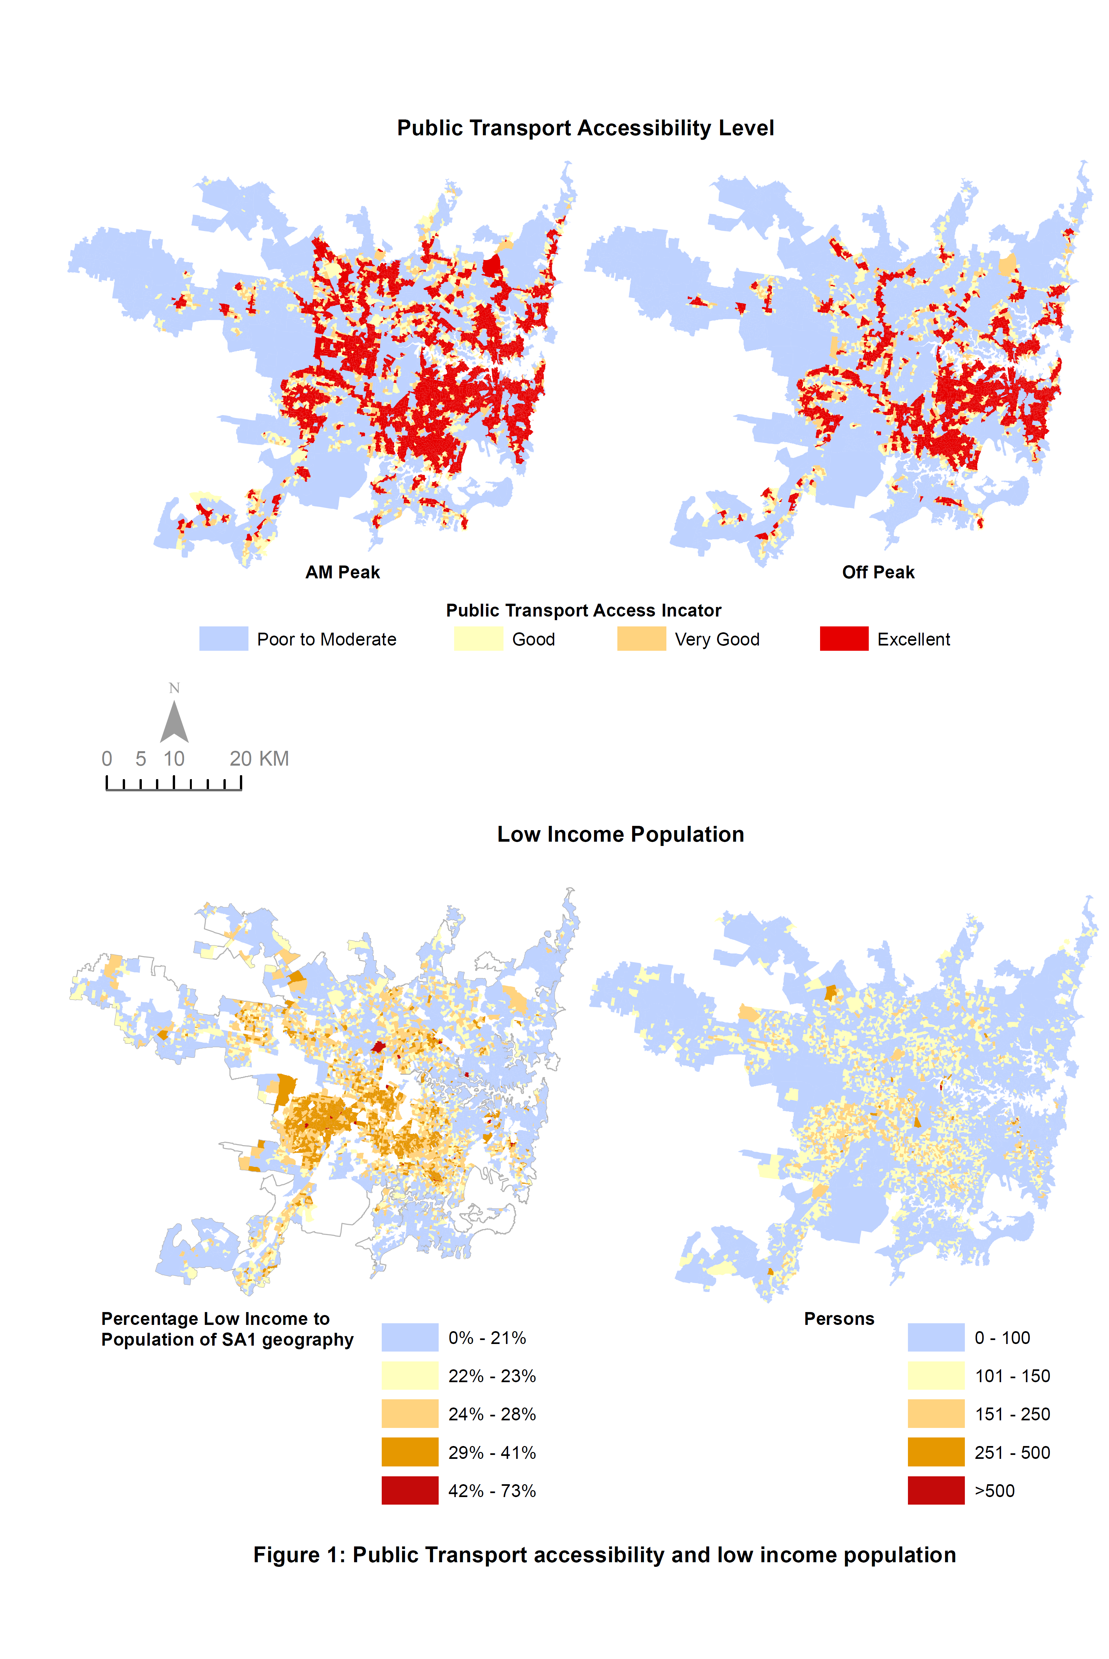
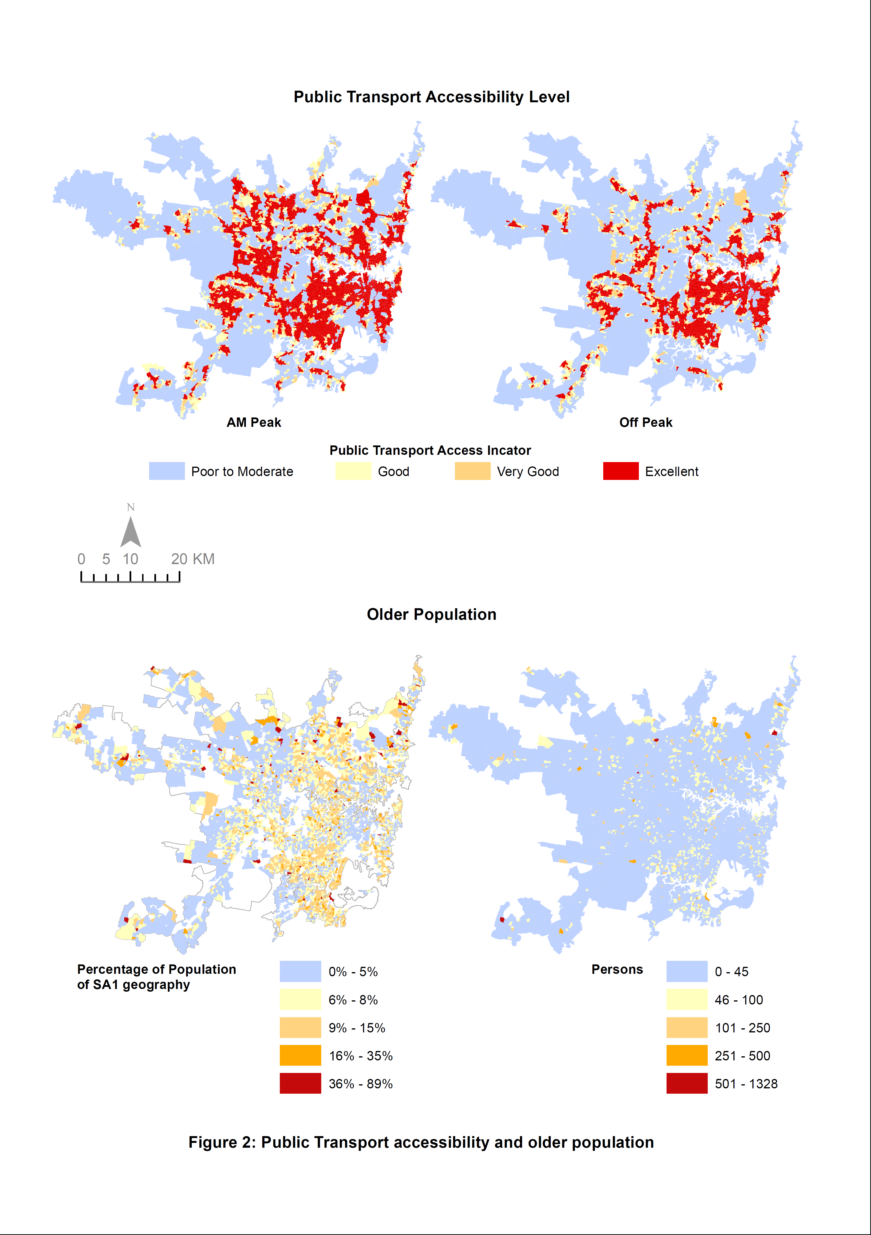
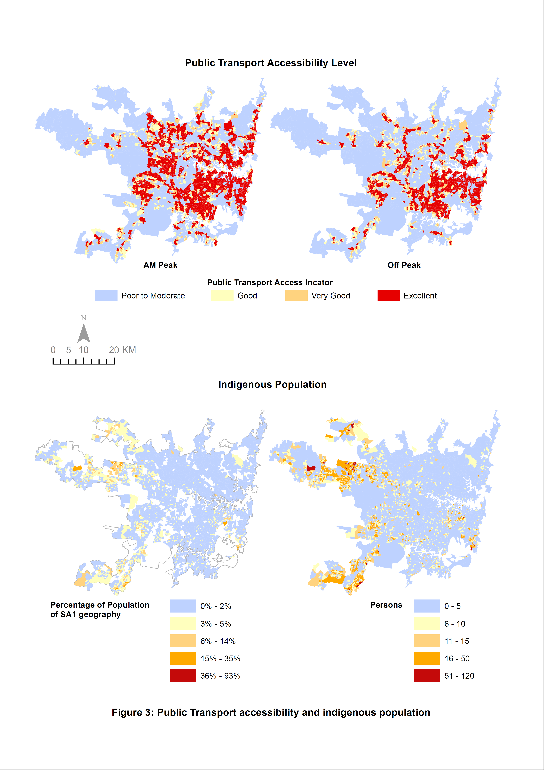
Figure 2 has the same basic layout as for Figure 1 with supply being shown on the top row as accessibility to public transport with the bottom row showing data for older people, defined as aged 75 or more. The top row maps showing accessibility are the same as for Figure 1, reproduced again to facilitate comparison. In terms of absolute numbers in the map on the right, the absolute number of older people is better matched with the peak period supply than the off-peak supply. This is in contrast with the needs of older people who would more likely want to travel in the off-peak period. This is reinforced by the left hand side map for the number of older people as a percentage population, which again shows mismatch at the periphery. .
Figure 3 again has the same basic layout as for Figure 1 with the upper row of maps representing supply and the bottom row showing data for the indigenous population. The indigenous population is recognized as being of low income, often unemployed and with high risk of social exclusion. It might be expected therefore that the maps on the bottom row of Figure 3 would show some similarities with Figure 1. However, there is much more of a clear spatial mismatch here between the supply and areas of high indigenous population whether considering absolute numbers (right hand side of the map) or whether the number of indigenous population are standardized by area.
These three figures show a fraction of the potential drivers of demand. However, for three groups of population that are typically thought of as disadvantaged, it is clear that there are causes for concern for horizontal equity. If all population groups had the same treatment through the network planning guidelines that have delivered the supply or accessibility to public transport, then we should see similar spatial matches or mismatches between all these maps. Thus there is some evidence of a lack of horizontal equity. It should however be noted that these three groups of population are very different in size. The absolute numbers vary from between 51-120 for red for the indigenous population, from 501 to over 1300 for red for older people and for over 500 for red for the low income population. This does not negate the observation for a lack of horizontal equity but it may be a policy decision that to provide service for small numbers, even of disadvantaged populations, may cost more than it provides benefits.
However, the scale and the need to ‘eyeball’ the maps is a constraint on providing an evidence base for potential mismatch of supply and demand. More importantly, this descriptive approach has only allowed for one variable at a time to be considered and the determination of supply, as with demand, is multi-dimensional. Many other variables could be considered as being indicative of disadvantage, for example unemployed, disabled. For this reason, a modelling approach is taken next to link the accessibility to public transport service to a number of quantitative factors simultaneously.

Modelling Results
The final model results for peak-hour and off-peak public transport supply (PTAL) are summarised in Table 5 and Table 6 separately. These tables show all independent variables significantly different from zero. Because of potential multicollinearity, variables were entered into each model in two steps. The key difference between the two steps is that the first step only includes a composite measure of need drivers using the SEIFA index, while in the second step the more detailed measures of need drivers were included. Both the peak and off-peak models explained about 37 percent of the variance of the PTAL.
As expected, population density and employment density are the two strong demand drivers of public transport supply. The elevation was negatively associated with PTAL value, indicating that public transport supply decreased at areas with increased elevation: for Sydney this means supply decreasing the further from the coast. Interestingly, in the peak-hour model, the SEIFA was positively associated with PTAL, suggesting, everything else being held constant, socio-advantaged areas have better public transport supply or conversely, everything else being equal, there is less public transport supply socio-disadvantaged areas. However, this relationship is reversed in the off-peak hour model. Both distance to inland water and distance to beach is negatively associated with the PTAL, indicating that public transport supply is better at areas close to inland water and beaches. Finally, the three variables measuring the need drivers, the percentage of indigenous population, percentage of low-income population, and percentage of older population, were all negatively associated with PTAL, indicating that the public transport supply is lower than expected for these demand drivers suggesting that supply is lower where public transport is most needed for both the peak and the off-peak hour.
Table 5: Model results for peak-hour PTAL.
 | Coef. | P>t | Coef. | P>t
Population density | 0.0060 | 0.000 | 0.0039 | 0.000
Employment density | 0.0015 | 0.000 | 0.0014 | 0.000
Maximum elevation | -0.0034 | 0.000 | -0.0024 | 0.000
SEIFA | 0.0002 | 0.031 | -0.0020 | 0.000
Distance to inland water by public transport |  |  | -0.0089 | 0.000
Distance to beach by public transport |  |  | -0.0096 | 0.000
Percentage of indigenous population |  |  | -3.9800 | 0.000
Percentage of low-income population |  |  | -1.0515 | 0.000
Percentage of older population |  |  | -0.3677 | 0.007
constant | 2.9655 | 0.000 | 6.6917 | 0.000
Number of obs | 9093 |  | 9093
R-squared | 0.2360 |  | 0.3650
Adj R-squared | 0.2350 |  | 0.3640

Table 6: Model results for off-peak-hour PTAL.
 | Coef. | P>t | Coef. | P>t
Population density | 0.0071 | 0.000 | 0.0049 | 0.000
Employment density | 0.0017 | 0.000 | 0.0015 | 0.000
Maximum elevation | -0.0045 | 0.000 | -0.0032 | 0.000
SEIFA | -0.0006 | 0.000 | -0.0029 | 0.000
Distance to inland water by public transport |  |  | -0.0076 | 0.000
Distance to beach by public transport |  |  | -0.0111 | 0.000
Percentage of indigenous population |  |  | -4.0433 | 0.000
Percentage of low-income population |  |  | -1.2319 | 0.000
Percentage of older population |  |  | -0.3479 | 0.028
constant | 3.4363 | 0.000 | 7.3294 | 0.000
Number of obs | 9065 |  | 9065
R-squared | 0.2710 |  | 0.3730
Adj R-squared | 0.2710 |  | 0.3720

As the model is a semi-log functional form, the estimated coefficients may be interpreted as percentage change to the dependent variable. Both Table 5 and Table 6 show that a change in the percentage of population has a very significant effect on the PTAL for both the peak and off-peak models (over 300% and 400% respectively). However, whilst these percentages are big, a 1% increase in the indigenous population would represent a doubling of the indigenous population (see Table 4). This does not mean that it is unimportant but that the impact of change of the independent variable needs to be understood in the context of the means of the variables.
Figure 4 shows the residual distribution of the peak hour model. This shows where the model is over and underestimating the match between supply, measured by PTAL, and the combined effect of all independent variables. The blue/green areas show where the level of supply is lower than might be expected from the model, whereas the orange/red is the opposite – where the level of supply is higher than might be expected from the model. This shows clearly greater lower supply at the periphery of the map but also clear red areas following the strategic corridors where the network planning has deliberately built up frequency.

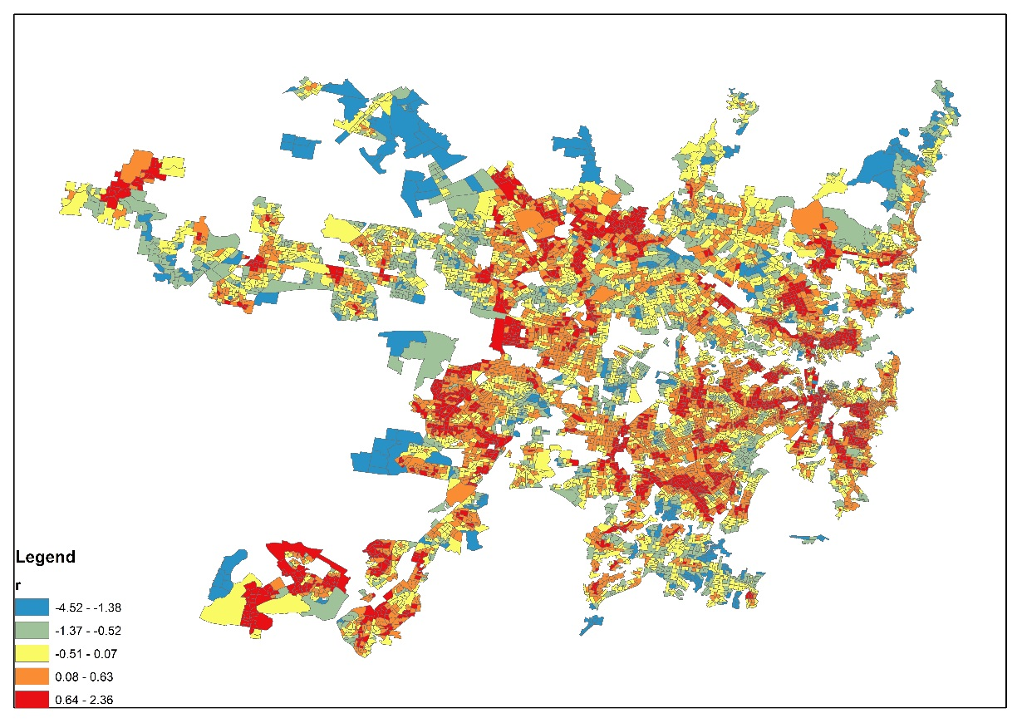
Figure 4: Residual distribution of peak-hour model

Conclusions
This paper examines the equity impacts of the implementation of service planning guidelines based on equal spatial coverage using Sydney as a case study. Modern planning guidelines appear to be introducing more flexibility than their predecessors in that whilst there is a preponderance of expectation that there should be equal coverage of service provision for citizens, this is increasingly tempered by the need to take account of demand.
These newer guidelines do appear to recognise the way in which equal coverage is not necessarily equitable. However, in the case of Sydney, the modelling shows that the relaxation of the equal coverage mantra appears to be relatively small with emphasis towards demand in the peak and emphasis towards coverage in the off-peak. This is consistent with Ho and Mulley (2014) which identified the contribution of new services in the Sydney network to linking regional centres and ‘arms’ of the radial heavy rail network. In the future, when the network proposed in Sydney’s Bus Future plan (NSW Government 2013) is introduced, there may well be more emphasis placed on allowing patronage to drive the supply of services.
PTALs, as a measure of supply, have been shown to be simple, consistent and effective even if the sophistications of different valuations of a passenger journey are not included. Whilst there is some criticism in the literature as to their use, their simplicity has allowed a good comparison to be made in the case study of Sydney. In the future, because PTAL is an internationally recognised measure, this study could be extended to compare Sydney with other global cities.
In terms of results, a comparison of PTALs with measures of low-income, indigenous and older populations showed some mis-match, especially by head of population measures. However, the maps of this paper are univariate in measurement and, as the modelling shows and experience notes, network planning is more complicated than this. The modelling results, even using a simple framework, shows that the commuter is doing well in Sydney, as a result of the more integrated planning framework. This suggests a movement towards more vertical equity is possible.
Disadvantaged people are more likely to be captured passengers on public transport. Although income for the state is progressively raised, the equity analysis here suggests that greater public transport subsidies are going to areas of higher socio-economic means than areas of greater need. The evidence from Sydney suggests that network planning guidelines that attempt to spread public transport provision across an urban area have a tendency to undersupply both areas of concentrated need and areas of concentrated demand.
In the future, some better variable definitions e.g. replacing elevation by slope might inform more about the impact of topography on supply and also separate out the issues of being close to the coast from changes in elevation. Looking at more than one peak and off-peak hour period might also reveal variation not observed by only comparing two one hour periods. Including patronage data at the mesh block level, which is becoming available through the Opal smart card, would allow realised demand to be modelled and this could take account of the simultaneity of demand and supply. In addition, the use of spatial regression techniques would identify if spatial dependency is a problem and, if spatial dependency is present, would be an improvement over the multivariate analysis used in this paper.
These conclusions are a contribution to network planning implementation with many cities both in Australia and elsewhere implementing similar guidelines to Sydney.

References
Abrantes, P.A.L. and Wardman, M.R. 2011, ‘Meta-analysis of UK values of travel time: An update’, Transportation Research Part A, vol. 45, no. 1, pp. 1-17.
ACT Government 2012, Transport for Canberra: Transport for a sustainable city 2012-2031, ACT Government Environment and Sustainable Development Directorate.
Australian Bureau of Statistics 2011a Australian Statistical Geography Standard (ASGS): Volume 1 – Main structure and greater capital city statistical areas, July 2011, catalogue no. 1270.0.55.001, ABS, Canberra
Australian Bureau of Statistics 2011b, Australian Statistical Geography Standard (ASGS): Volume 4 – Significant Urban Areas, Urban Centres and Localities, Section of State, July 2011, catalogue no. 1270.0.55.004, ABS, Canberra.
Daniels, R. and Mulley, C. 2012, ‘Planning public transport networks – The neglected influence of topography’, Journal of Public Transportation, vol. 1, no.4, pp. 23-41.
De Scitovszky, T. 1941, ‘A note on welfare propositions in economics’, The Review of Economic Studies, vol. 9, no. 1, pp. 77-88.
Delbosc, A. and Currie, G. 2011, ‘Using Lorenz curves to assess public transport equity’, Journal of Transport Geography, vol. 19, no. 6, pp. 1252-1259.
Eriksson, L., Garvill, J. and Nordlund, A.M. 2008, ‘Acceptability of single and combined transport policy measures: The importance of environmental and policy specific beliefs, Transportation Research A, vol. 42, pp. 1117–1128.
Hensher, D. and Macario, R. 2002, ‘Organisation and ownership of public transport services’, Transport Reviews, vol. 22, no. 3, p. 350-357.
Ho, C. and Mulley, C. 2014 'Metrobuses in Sydney: How high capacity and high frequency services are benefiting the Metropolitan fringe', Research in Transportation Economics, vol.48, pp. 339-348.
Jansson, J. O. 2003, ‘Key factors for boosting the bus transport market in medium-size towns’, 8th Conference on Competition and Ownership in Land Passenger Transport (Thredbo Series), Rio de Janeiro, Brazil.
Lagura, E., Norman, P., Richmond, M., & Watling, R. 2011 The Public Transport Usage of Two Melbournes. Conference paper delivered at the 34th Australasian Transport Research Forum (ATRF) Proceedings in Adelaide,,Australia. .
Kamruzzaman, M., Baker, D., Washington, S. and Turrell, G. 2014, ‘Advance transit oriented development typology: Case study in Brisbane, Australia’, Journal of Transport Geography, vol. 34, pp. 54-70.
Ljungberg, A. 2005, ‘Using Geographic Information System (GIS) doing CBA on new bus route systems—An empirical example of the city of Linkoping’, 9th Conference on Competition and Ownership in Land Transport (Thredbo Series), Lisbon, Portugal.
New South Wales Government 2013, Sydney’s bus future: Simpler, faster, better bus services, New South Wales Government, Sydney.
New South Wales Ministry of Transport 2006, Service planning guideline: Sydney contract regions, Ministry of Transport, Sydney.
New York Metropolitan Transportation Authority 2015, What is Bus Rapid Transit (BRT)?, Metropolitan Transportation Authority, New York, viewed 29 June 2015, http://web.mta.info/mta/planning/sbs/whatis.htm.
Nielsen, G., Nelson, J.D., Mulley, C., Tegner, G., Lind, G. and Lange, T. 2005, HiTrans best practice guide 2: Public transport – Planning the networks, HiTrans.
Paulley, N., Balcombe, R., Mackett, R., Titheridge, H., Preston, J., Wardman, M., Shires, J. and White, P. 2006, ‘The demand for public transport: The effects of fares, quality of service, income and car ownership’, Transport Policy, vol. 13, no. 4, pp. 295–306.
Peters,J.R. and Kramer,J.K., ‘2012, ‘Just who should pay for what? Vertical equity, transit subsidy and road pricing: The case of New York City Journal of Public Transportation, vol. 15, pp. 117-136.
Pratt, R. and Evans, R. 2004, ‘Bus routing and coverage’, Traveler response to transportation system changes, TCRP 95, Transportation Research Board, Washington, D.C.
Public Transport Victoria 2012, Network development plan: Metropolitan rail, Public Transport Victoria, Melbourne.
Thomopoulos, N. Grant-Muller,S. and Tight, M.R., 2009, ‘Incorporating equity considerations in transport infrastructure evaluation: Current practice and a proposed methodology’, Evaluation and Program Planning, vol. 32, no. 4, pp. 351-359.
Transport for London 2010, Measuring Public Transport Accessibility Levels: PTALs summary, Transport for London, London
Transport for London 2015, Assessing transport connectivity in London, Transport for London, London.
Transport for New South Wales 2013, Integrated public transport service planning guidelines: Sydney metropolitan area, Transport for New South Wales, Sydney.
Transport for New South Wales 2015, Public Transport Accessibility Level (PTAL), unpublished.
Van de Velde, D.M. 1999, ‘Organisational forms and entrepreneurship in public transport’, Transport Policy, vol. 6, no. 3, pp. 147-157.
Victorian Auditor-General 2014, Coordinating public transport, 2014-15:2, Victorian Auditor-General, Melbourne.
Walker, J. 2008, ‘Purpose-driven public transport: creating a clear conversation about public transport goals’, Journal of Transport Geography, vol. 16, no. 6, pp. 436-442.
Wardman, M. 2001, ‘A review of British evidence on time and service quality valuations’, Transportation Research Part E, vol. 37, no. 2, pp. 107-108.
Welch,T.F. 2013, ‘Equity in transport: The distribution of transit access and connectivity among affordable housing units’, Transport Policy, vol. 30, pp. 283-293.
Wells, P. 2012, ‘Converging transport policy, industrial policy and environmental policy: The implications for localities and social equity’, Local Economy, vol. 27, no. 7, pp. 749–763.
Wu, B.M. and Hine, J.P. 2003, ‘A PTAL approach to measuring changes in bus service accessibility’, Transport Policy, vol. 10, pp. 307-320.

