Does residential property price benefit from light rail in Sydney?

Corinne Mulley1, Chi-Hong (Patrick) Tsai2 and Liang Ma1

1ITLS, University of Sydney

2PwC Australia, Darling Park 201 Sussex Street Sydney NSW 2000

Email for correspondence: corinne.mulley@sydney.edu.au

Abstract

Land rent theory identifies that unimproved land value is determined by its accessibility to goods and services. In theory therefore, public transport provision which increases accessibility should in turn increases land values. The objective of this paper is to identify if land values in the neighbourhood of a light rail have sustained long run price increases due to the presence of the light rail. The motivation for the paper is whether public transport infrastructure creates sufficient uplift to land values to be able to capture this uplift to contribute to investment plans of government. This is especially important in contemporary Sydney as plans are being rolled out to implement new light rail systems with the NSW Government, in common with many other governments, being subject to budgetary constraints which does not allow the implementation of all transport infrastructure evaluated as good value for money.

The case study of this paper is Sydney’s Inner West Light Rail line which was built along the right of way of a former goods line. This line is 7.2 km light long with 14 stops and takes 28 minutes to travel from end to end.

Using transaction house prices from 2011 as the dependent variable, this paper uses Geographically Weighted Regression (GWR) to identify the uplift attributable to the presence of the light rail. The attributes of the residential property (e.g. number of bedrooms, bathrooms etc) and neighbourhood effects, as measured by census data, are used as controlling independent variables to expose the value of the underlying unimproved land through its accessibility to public transport. The GWR methodology provides a global model as a first stage with the second stage of GWR providing a local model to examine the spatial distribution of the uplift to residential properties.

The results show the expected and significant spatial variation in the value of accessibility. Overall, the light rail has had more impact outside the areas of the city centre, close to Central station. The analysis and discussion includes the different valuation of accessibility to bus services vis à vis accessibility to light rail services.

# 1 Introduction

Land rent theory identifies that unimproved land value is determined by its accessibility to goods and services. In theory therefore, public transport provision which increases accessibility should in turn increases land values. The objective of this paper is to identify if land values in the neighbourhood of a light rail have sustained long run price increases due to the presence of the light rail. The motivation for the paper is whether public transport infrastructure creates sufficient uplift to land values to be able to capture this uplift to contribute to investment plans of government. This is especially important in contemporary Sydney, Australia as plans are being rolled out to implement new light rail systems with the NSW Government, in common with many other governments, being subject to budgetary constraints which does not allow the implementation of all transport infrastructure evaluated as good value for money.

The case study of this paper is Sydney’s Inner West Light Rail line which was built along the right of way of a former goods line. Using transaction house prices from 2011 and Geographically Weighted Regression (GWR) to identify the uplift attributable to the presence of the light rail, this paper contributes to the literature through identifying how uplift varies spatially.

The rest of the paper is organized as follows. The next section synthesises the literature with respect to studies measuring uplift from the implementation of different public transport modes. This is followed by a description of the case study in Sydney, and the methodological approach followed. The methodology sections outlines the criteria that makes GWR an appropriate methodology and identifies and provides a commentary on the data employed and a discussion about the functional form estimated. The penultimate section provides the results and some discussion of the global and local models with the final section providing some concluding comments.

# 2 Literature Review

Identifying the uplift in land values created by transport infrastructure investments has been the subject of a large body of research. [Smith, Gihring, and Litman (2013](#_ENREF_23)) and [RICS (2002](#_ENREF_18)) review more than 200 documents that explore the value created by public transport investments and methodologies that could be used to capture that value. This wide body of research has shown the theoretical underpinnings to value capture (improved accessibility leads to increases in land value) are empirically validated through generally positive impacts on land values resulting from improvements in transport access.

The interest in the land value impacts of increased transport infrastructure stems from the possibility of capturing some of the value created by a transport infrastructure project in order to pay for part or all of the costs of that project. [Doherty (2004](#_ENREF_8)) conducted a thorough review of methods that could be used to capture land value increases and the suitability of each method for funding transport infrastructure in Australia. He concluded that pressure for finding a way of raising capital is growing as governments dislike increasing debt and noted that, for Australia, the success of value capture will be dependent on associated urban consolidation programs that allow higher patronage at lower infrastructure cost. However, the discussion of how to capture any increased value of land must be preceded by how much land value does increase. This is the focus of this paper.

Amongst this wide selection of studies, several have been concerned specifically with the impacts of proximity to light rail (LRT). [Knaap, Ding, and Hopkins (2001](#_ENREF_14)) found that the announcement of a LRT extension resulted in an increase in the value of vacant residential lots in a suburb of Portland, Oregon, US by a huge 70% within the year of announcement of the scheme but this was not maintained suggesting that maybe there were developers ‘standing by’. [Hess and Almeida (2007](#_ENREF_13)) examined many studies and found up to 32 per cent premium but found much more modest gains in a long term cross sectional study for Buffalo, New York of between 2-5 per cent which is attributed to the way this area was in significant decline.

There is limited research evaluating how the quality of the service provided effects the impact that a new line has on land values. [Ryan (1999](#_ENREF_20)) found that transport infrastructure improvements only have an impact on land values when the improvement has a significant impact on travel times. New infrastructure that does not have an impact on travel times should not be expected to have a significant impact on the land values of properties nearby. [Debrezion, Pels, and Rietveld (2011](#_ENREF_7)) examined the impact of a service quality index on property prices and found that the index had a significant impact in some areas. The index took into account the frequency of service, the connectivity to the rest of the network, travel times to other locations on the network and the fares charged to get to other locations on the network. In addition, [Debrezion, et al. (2011](#_ENREF_7)) also compared the impact of distance to the closest rail station to the impact of the distance to the most frequently used rail station in the area. In the more urbanised areas, the most frequently chosen station had a more significant impact on real estate prices than the nearest one.

This study is concerned with an area in Sydney, NSW where there is accessibility to both bus and LRT. [Barker (1998](#_ENREF_2)) has found some evidence of local bus services having an impact on land values but this is somewhat anecdotal and does not provide information for bus services where there is also access to LRT. However, it is clear that when there are transport services and infrastructure that provide only marginal increases in accessibility this may have a minor impact on property values and be a small effect which is difficult to detect.

Overall, these results highlight the fact that the increases in property values resulting from transport infrastructure improvements are related not to the infrastructure itself, but to the access provided by that infrastructure. This paper looks at the value uplift provided by the LRT system in Sydney in the context of access to the infrastructure of the LRT and also to the access to the bus system. In this way the paper contributes to the literature by looking at the valuations placed on the different modes but in the same geographical location.

# 3 Case Study- the Sydney Inner West Light Rail

Sydney’s Inner West Light Rail line was built along the right of way of a former goods line. Trains ceased operating on the Darling Harbour line in 1984 and on the section between Darling Harbour and Rozelle Bay in 1996. The line was then converted to LRT, with the first stage, to Wentworth Park, opening in 1997 followed by the extension to Lilyfield in 2000 ([Brooker & Uddin, 2011](#_ENREF_6); [Transport NSW, 2010](#_ENREF_24)). The section of the goods line between Rozelle Bay and Dulwich Hill closed in 2009 and LRT service on this section opened 27 March 2014 ([Transport NSW, 2014a](#_ENREF_26)), extending the line 5.6km and adding nine stops.

This extension was not open during the study period covered by this paper as the data used in this study is from 201. The paper therefore covers the period after the announcement of the expansion in 2010 ([Transport NSW, 2010](#_ENREF_24)) but before opening of the extension. It is likely that the announcement of the extension in practice will not have had any significant impact on the value of proximity to the line since the announcement was made by an outgoing government renowned for announcing and cancelling projects ([Moutou & Mulley, 2012](#_ENREF_15)). The new government announced that the project would still be built, but would be significantly delayed ([Saulwick, 2011](#_ENREF_22)).

Services on the Inner West Light Rail line run every fifteen minutes between 6:00 am and 11:00 pm, with later services provided on Friday and Saturday nights. Service between the Star, a casino located in Pyrmont, and Central are provided through to the early hours of the night every day of the week ([Transport NSW, 2014a](#_ENREF_26)).

The 7.2 km LRT line has 14 stops and takes 28 minutes end to end ([Transport NSW, 2014d](#_ENREF_29)). This is an average speed of just over 15 kilometres per hour. As Figure 1 shows, the line begins at Central Station, the station that all City bound suburban rail services pass through as well as being the starting location for many of Sydney’s intercity services. From Central the line passes by Haymarket and Sydney’s Chinatown. The line then continues around the peninsula and neighbourhood of Pyrmont, passing the Sydney Convention and Exhibition Centre, the Darling Harbour Shopping Centre, the Star casino and hotel complex and the Sydney Fish market. From there the line proceeds to the neighbourhood of Glebe and on to the terminus in Lilyfield ([Transport NSW, 2014c](#_ENREF_28)).

The Pyrmont Ultimo neighbourhood was undergoing significant redevelopment when the LRT line opened. In 1978, the neighbourhood population had declined to 1,800 from a peak of 30,000 in 1900. Nearly all industry had moved out oC:\Documents and Settings\kevinm\Desktop\lightrail-map.tifff the area as well. The neighbourhood received a significant capital injection to encourage redevelopment under the Building Better Cities program in the 1990s. By 2001, the population had increased back to 12,700 and had also seen a significant number of businesses move into the area ([Bounds & Morris, 2005](#_ENREF_5)).

Figure 1 Lilyfield Light Rail Line ([Transport NSW, 2014d](#_ENREF_29))

Due to the high frequency of stops and the winding nature of the LRT alignment, there are several stations along the LRT line where travel times to Central are similar or faster by bus. The trip from the Glebe stop takes 20 minutes by LRT ([Transport NSW, 2014b](#_ENREF_27)) and 17 minutes on the number 431/433 bus. While the bus is more likely to be subject to delay it has a higher frequency throughout the day. Similarly, the 470 takes 18 minutes to reach Central from Lilyfield while the LRT line takes 28 minutes. Furthermore, in each case, the bus continues north from Central to serve the rest of the CBD while the LRT terminates at Central, requiring travellers wishing to access the rest of the CBD to change services. Similarly, bus route 443 provides frequent service from Pyrmont directly to Town Hall and Circular Quay.

The fares on the Inner West Light Rail Line have historically lacked integration with other transport fares. In June, 2011 the LRT line was added to the MyMulti passes, a periodical ticket that covers fares on buses trains and ferries in the Sydney Region ([Berejiklian, 2011](#_ENREF_3)). Prior to this, travellers using the LRT line and another mode of public transport for the rest of their journey would typically be paying higher fares.

# 4 Methods

## 4.1 The choice of GWR

There are a number of different methods used in the literature to evaluate impacts. These are reviewed by [Salon and Shewmake (2011](#_ENREF_21)) most recently. [Mulley (2014](#_ENREF_16)) extends this review to support the choice of Geographically Weighted Regression (GWR) as a methodology for examining the spatial distribution of accessibility values.

In general, it is the earlier literature that uses either simple comparison methods or hedonic pricing models which are unadjusted or adjusted for spatial interaction effects. The former of these, the simple comparison models, are unable to take account of the multi-dimensional features which underpin property values. Hedonic models, even when taking account of spatial dependence cannot easily consider the spatial distribution of accessibility values without creating sub-markets ([Adair, McGreal, Smyth, Cooper, & Ryley, 2000](#_ENREF_1)) but this requires an arbitrary establishment of sub-market boundaries.

An alternative, GWR, developed by [Fotheringham, Brunsdon, and Charlton (2003](#_ENREF_12)), takes account of spatial dependency in the estimation process. GWR offers a number of advantages over the creation of submarkets to examine spatial variability. In the production of a local model using the co-ordinates of the variables, the output of the GWR local model is mappable and clearly shows the spatial distribution of variables of interest. GWR was first used in the transport sector by ([Du & Mulley, 2006](#_ENREF_9), [2007](#_ENREF_10), [2012](#_ENREF_11)) to compare hedonic pricing and local modelling approaches for land value uplift for light rail with more recent application being trip end demand estimation for rail ([Blainey, 2010](#_ENREF_4)) and bus rapid transit ([Mulley, 2014](#_ENREF_16)).

## 4.2 Geographically Weighted Regression

GWR as described by [Fotheringham, et al. (2003](#_ENREF_12)), is a cross sectional model which extends the basic linear regression model shown in (1)

 (1)

where $Y_{i}$, $X_{ki}$, and $ε_{i}$ are dependent variable, $k^{th}$ independent variable and the Gaussian error at location $i$.

The extension provided by GWR methodology is to expand the basic model to a form which allows for local variations in the parameter values by taking account of the coordinates of individual regression points. With the coordinates $(u_{i}, v_{i})$ equation (1) becomes the GWR local model shown in (2):

 (2)

where $(u_{i}, v_{i})$ is the x-y coordinate of the $i^{th}$ location.

The parameters are estimated at the location $(u_{i}, v_{i})$ using a weighted least squares method and a predicted value of y effectively giving a regression at each point of the dataset. Estimation is a trade-off between efficiency and bias in the estimators with a weighting process using spatial kernels which capture the data points to be regressed by moving the regression point across the region ([Fotheringham, et al., 2003](#_ENREF_12)).

The newest GWR4 software uses adaptive kernels and a bi-square function, as expressed in Equation (3) ([Nakaya, Charlton, Yao, & Fotheringham, 2014](#_ENREF_17)). The adaptive kernels, as opposed to the fixed kernels, ensure each of the data points is estimated by the same number of neighbouring data points and this approach is generally recommended for data points that are not evenly distributed across a study area. This is the case here where residential properties tend to cluster in some particular areas and there are some areas such as parklands that have no property developments. The bandwidth of the kernels is determined using the “golden selection search method” embedded in GWR 4 which determines the optimal bandwidth based on small sample bias corrected AIC minimization ([Nakaya, et al., 2014](#_ENREF_17)).

 (3)

where:

$w_{ij}$ is the weight of the observation at location $j$ for estimating the coefficient at location $i$;

$d_{ij}$ is the Euclidean distance between $i$ and $j$;

***θi(k)*** is an adaptive bandwidth size defined as the $k_{th}$ nearest neighbour distance.

This analysis uses the newly released GWR4 software (version 4.0.72) developed in partnership between the National Centre for Geocomputation (NUIM), Ireland and Ritsumeikan University, Japan ([Nakaya, et al., 2014](#_ENREF_17)).

## 4.3 Model specification and data acquisition

Using a hedonic pricing model approach, it is hypothesized that property prices are determined by the internal characteristics of the property, the neighbourhood attributes in which it is located and the accessibility of the property location to nearby amenities. As the interest of this paper is in relating the unimproved land value the accessibility to LRT and bus services so the modelling approach must control for the internal characteristics of the property and its neighbourhood. The transaction price of a property $i,$ ($P_{i }$), is the dependent variable and is related to explanatory variables as shown in Equation (4) where C, N and T are vectors of the internal property characteristics, neighbourhood features and accessibility measures respectively.

${\text{P}}_{\text{i = }}\text{ (C, N, T)}$ (4)

The study area was defined by an 800m buffer around each of the LRT stations, as the NSW Government ([Transport NSW, 2013](#_ENREF_25)) suggests a walking catchment of 800m for mass and intermediate public transport services. The property data are retrieved RPdata capturing all the sales for the year of 2011. RP data combines data from different sources to provide details of the transaction price, property type (house or unit), area size, number of bedrooms and bathrooms and the number of parking places. The study area included 1,522 observations on property prices for analysis. Figure 2 presents the study catchment with the distribution of the properties.

# N:\ITLS\PT-Team\Project - ARC Property values Mar 2010 and FBr\Sydney LRT\GIS maps\SydneyLRT_study area.jpg

Figure 2: The study catchment area with the distribution of properties

The neighbourhood features were controlled using the unemployment rate and household income, collected at the Statistical Area 1 (SA1) level (the smallest geography available) from the 2011 Census as shown in Table 1. The SA1 geography is population based with each SA1 aiming to contain 400 persons (with a minimum of 200 and a maximum of 800). Each property price observation was linked to the associated SA1 demographic variables so that all properties lying in the same SA1 area are associated with the same values.

Accessibility variables were calculated using GIS tools. These were calculated as network distances for each variable of interest - to the nearest LRT station, to the nearest bus stop and to the CBD. In addition a buffer was created around each station since some studies identified a difference in accessibility values for properties very close to a station. A number of other accessibility variables were considered in preliminary modelling including distance to the harbour, train stations, shopping centres and parks, but the inclusion of these variables did not give better modelling results and in some cases caused multicollinearity problems and were thus removed from the final model.

Table 1: Descriptive Statistics of variables in the model

|  |  |  |  |  |  |
| --- | --- | --- | --- | --- | --- |
|  | N | Minimum | Maximum | Mean | Std. Deviation |
| Price | 1,522 | 126,000 | 6,350,000 | 805,908 | 550,485 |
| Bedrooms | 1,522 | 0.00 | 7.00 | 1.95 | 1.03 |
| Bathrooms | 1,522 | 1.00 | 5.00 | 1.46 | 0.64 |
| Parking | 1,522 | 0.00 | 4.00 | 0.81 | 0.75 |
| Type (0=House, 1=Unit) | 1,522 | 0.00 | 1.00 | 0.70 | 0.46 |
| Buffer of 100m around station | 1,522 | 0.00 | 1.00 | 0.03 | 0.17 |
| Unemployment | 1,522 | 0.00 | 0.27 | 0.03 | 0.02 |
| Household \_income | 1,522 | 0.00 | 2.83 | 1.87 | 0.58 |
| Distance to LRT | 1,522 | 0.02 | 1.57 | 0.68 | 0.35 |
| Distance to CBD | 1,522 | 0.12 | 5.57 | 2.06 | 1.27 |
| Distance to bus stop | 1,522 | 0.01 | 1.04 | 0.20 | 0.14 |

# 6. Results

## 5.1 Global Model

Table 2 presents the global regression results of the GWR model. A semi-log (dependent variable in logarithmic values) model is employed because the transformed log variable has the advantage of mitigating heteroscedasticity as a result of the reduced scale of the values ([Rodríguez & Mojica, 2009](#_ENREF_19)). The adjusted R-square is 0.686 which suggests that 68.6 per cent of the variation of the property price is explained by the regression model.

The property attributes are all significant which means, holding all else constant, the property price is higher with more bedrooms, bathrooms and parking spaces. The “*type*” variable is also significant showing the average price of units is lower than house prices. It is important to note that the “*buffer\_100m*” variable is significant with a negative sign. This indicates that properties located within 100m of a LRT station receive a negative impact from the provision of a station. The literature suggests this is possibility due to the negative externalities from LRT such as noise pollution and vibrations. In addition, in the context of this case study, there has been not much “transit-oriented development” around the stations with the consequence that there are not many amenities such as restaurants and shops attracting local residents to live just nearby the stations.

In terms of neighbourhood attributes, the level of household income has a positive relationship with the property price as expected. The unemployment rate is insignificant despite its low Variance Inflation Factor (VIF) which means the multicollinearity is not factor in the insignificance of the unemployment variable.

The focus of this analysis, the distance to LRT station, is found to be significant with a parameter value of -0.058. This suggests that a one kilometer decrease in the distance to the station would increase the property price by 5.8 per cent, holding everything else constant. Or, for every 100m closer to the LRT station, the property price is just over 0.5% higher. Very close to stations this does not offset the buffer discussed above but overall shows that the properties have benefited from the increased accessibility offered by the Inner West Light Rail. A similar relationship can be observed with the distance to CBD variable with greater proximity to the CBD increasing property prices. In contrast, the accessibility to bus stops shows the reverse relationship, suggesting that the impact of the accessibility to a bus stop on the property price is negative. Buses are much more intrusive in the neighborhood and can be noisy within a local area and this might account for this effect or alternatively it might just be that buses are regarded as lacking in permanence and hence have not added to the value uplift of properties.

Table 2 Regression results of the global model

|  |  |  |  |  |  |
| --- | --- | --- | --- | --- | --- |
| Variable | Coeff. | s.d. | t | p-value | VIF |
| (Constant) | 12.589 | 0.066 | 191.81 | 0.00 |  |
| Bedrooms | 0.238 | 0.015 | 16.40 | 0.00 | 3.29 |
| Bathrooms | 0.187 | 0.019 | 10.03 | 0.00 | 2.11 |
| Parking | 0.161 | 0.013 | 11.97 | 0.00 | 1.52 |
| Type (0=House, 1=Unit) | -0.260 | 0.029 | -8.88 | 0.00 | 2.72 |
| Buffer\_100m | -0.117 | 0.050 | -2.33 | 0.02 | 1.12 |
| Unemployment | 0.224 | 0.566 | 0.40 | 0.69 | 1.26 |
| Household \_income | 0.124 | 0.017 | 7.19 | 0.00 | 1.40 |
| Distance to LRT | -0.058 | 0.027 | -2.17 | 0.03 | 1.28 |
| Distance to CBD | -0.065 | 0.009 | -7.26 | 0.00 | 1.93 |
| Distance to bus stop | 0.462 | 0.066 | 7.00 | 0.00 | 1.25 |
| Adj. R-square | 0.686 |  |  |  |  |
| AIC | 834 |  |  |  |  |
| Number of observations | 1,522 |  |  |  |  |

## 5.2 Local Model

In the GWR local model, each regression point is being estimated by its neighbouring data points within the kernel and hence each regression point has its own parameter value. The local model demonstrates an improved model fit as compared with the global model, as evidenced by the higher adjusted R-square of 0.849 (0.686 in the global model) and a lower AIC value at 130.

The local parameter value of each data point can be plotted on GIS maps for clearer visualisation of the spatial variation. Figure 3 presents the local parameter estimates of the distance to LRT variable, where properties with insignificant parameter values are excluded from the map. The properties coloured in red receive a negative impact from the increasing distance to LRT stations, that is, properties closer to the LRT stations have higher values as hypothesised. In contrast, the properties coloured in green show the reverse impact from the distance to the LRT stations.

Whilst the global model shows an average parameter value of the distance to LRT variable, the local model demonstrates that there is a certain degree of variation within the study area. Properties located around the middle section of the LRT line including Jubilee Park, Glebe and Wentworth Park stations benefit most from the accessibility to LRT. In comparison, the impact of the accessibility to LRT for properties located in the west and east end of the study area is less significant or negative. This is possibly because residents living around the two ends of LRT have other alternative modes of travel, and hence LRT is less attractive in these areas.

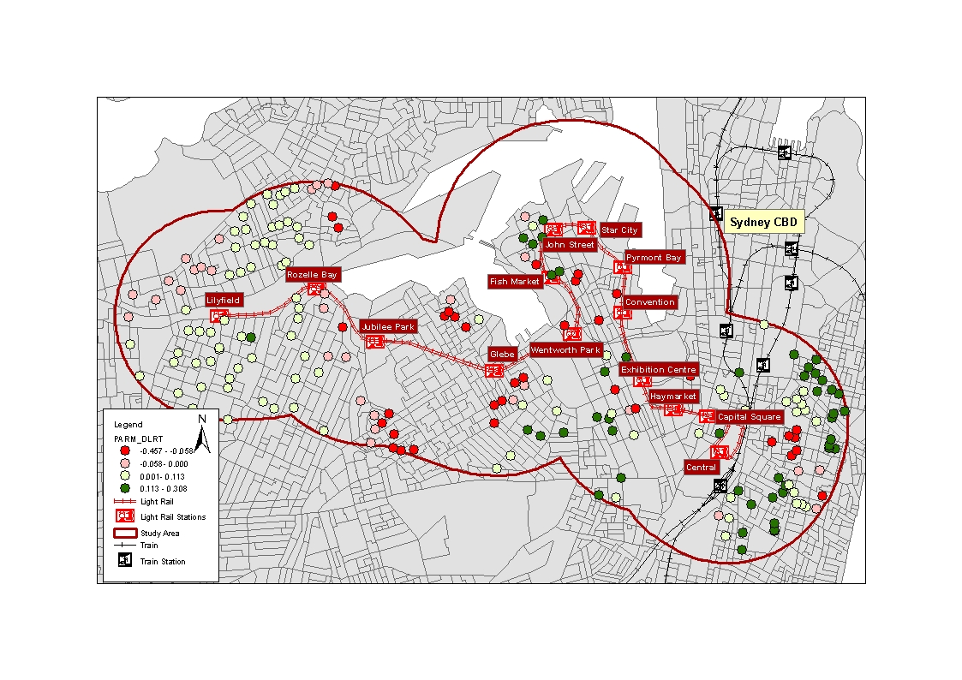

Figure 3 Local parameter of distance to LRT

Although the distance to CBD appears to have a greater impact (bigger parameter estimate) in the global model, Figure 4 shows quite extreme outcomes around Lilyfield station in the west end of the LRT for the map of the local parameter values. Property prices in the north-east of Lilyfield station increase with distance to CBD, whereas properties in the south of Lilyfield station have the reverse relationship. It is possible that properties in the north-east of Lilyfield station are impacted by the industrial area around Rozelle Bay, and this impact might also be captured by the distance to CBD variable.

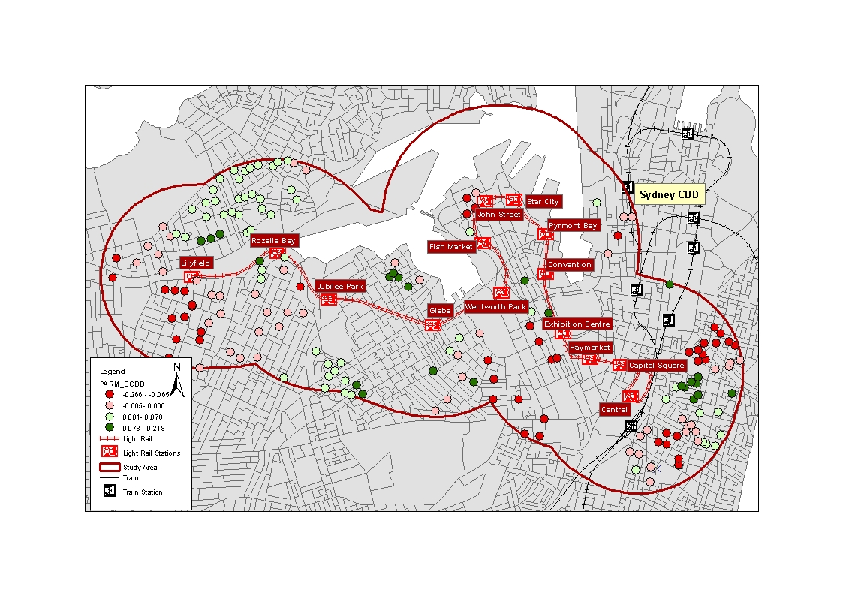

Figure 4 Local parameter of distance to CBD

Figure 5 displays the local parameters of the distance to bus stop variable. It is clear that most of the properties in the inner west do not have a statistically significant benefit from the accessibility to bus stops. One of the possible reasons is the noise and air pollution produced by buses as discussed earlier. Perhaps more importantly, the provision of a bus stop does not necessarily guarantee a high frequency bus service. Future research may benefit from identifying whether accessibility to a bus stop with high frequency services to lead to value uplift by taking account of bus service frequency in the model.

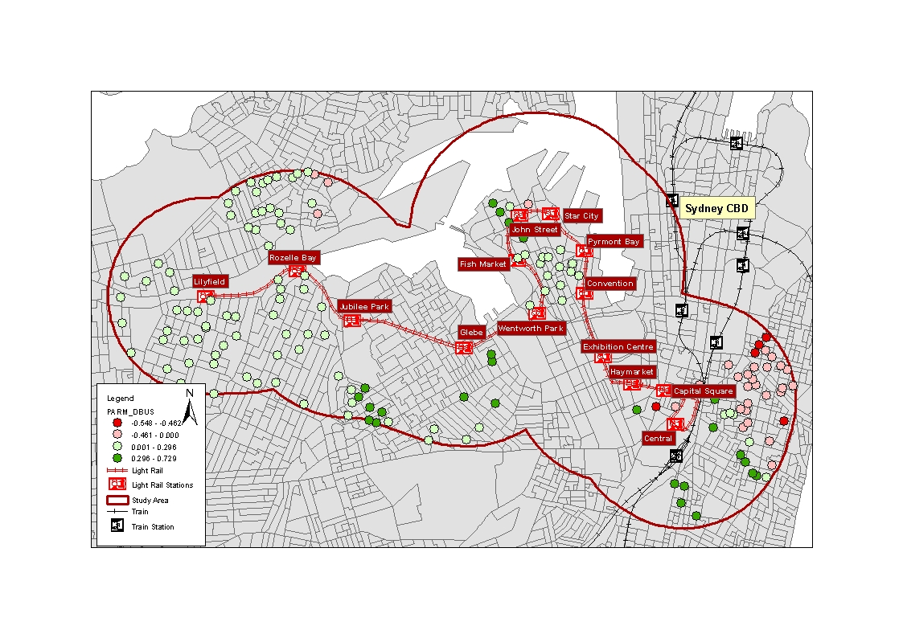

Figure 5 Local parameter of distance to bus stop

# 6 Conclusions

Value capture has been considered as an alternative option of funding transport infrastructure not only in Australia but also globally. The evidence of the positive impact of public transport infrastructure on property values has been identified in other countries as discussed in Section 2.

However, identifying if there is value uplift is a precursor to developing a value capture approach. If there is no uplift then value capture will not work. The motivation for this study was to identify if there was long run uplift following the introduction of light rail in the Inner West of Sydney. The finding of this study confirms that the property values do benefit from the provision of LRT services, with an average of just over ½ per cent increase in value for each 100m nearer to an LRT station. However, the local model of GWR identifies significant variations in the areas where properties have gained greatest uplift from the investment (i.e. Jubilee Park, Wentworth Park and Glebe). This variation may make it difficult to impose a single value tax as part of a value capture mechanism. Future research could advise on this by investigating the drivers of these differences in the impact of LRT in the local areas.

In the context of NSW, the NSW government has been identifying new LRT corridors in Parramatta and to extend the CBD South-East Light Rail about to be built. Given the current funding constraints, alternative funding options may be considered for future investment. This study provides an evidence base for future value capture policy considerations.

# References

Adair, A., McGreal, S., Smyth, A., Cooper, J., & Ryley, T. (2000). House prices and accessibility: The testing of relationships within the Belfast urban area. *Housing studies, 15*(5), 699-716.

Barker, W. G. (1998). *Bus Service and Real Estate Values*. Paper presented at the 68th Annual meeting of the Institute of Transportation Engineers, Toronto, Ontario. <http://www.ite.org/Membersonly/annualmeeting/1998/AHA98B25.PDF>

Berejiklian, G. (2011). Pensioners, families big winners in light rail ticket changes. Retrieved 28 March 2014 <http://www.transport.nsw.gov.au/sites/default/files/releases/110614_light_rail_myzone_integration2.pdf>

Blainey, S. (2010). Trip end models of local rail demand in England and Wales. *Journal of Transport Geography, 18*(1), 153-165.

Bounds, M., & Morris, A. (2005). High-rise gentrification: the redevelopment of Pyrmont Ultimo.

Brooker, T., & Uddin, A. (2011). *The Future Inner Sydney Light Rail Network.* Paper presented at the Australasian Transport Research Forum.

Debrezion, G., Pels, E., & Rietveld, P. (2011). The impact of rail transport on real estate prices an empirical analysis of the dutch housing market. *Urban Studies, 48*(5), 997-1015.

Doherty, M. (2004). Funding public transport development through land value capture programs. Retrieved 11 April 2014 <http://ecotransit.org.au/ets/files/land_value_capture_mdoherty2004.pdf>

Du, H., & Mulley, C. (2006). Relationship between transport accessibility and land value: local model approach with geographically weighted regression. *Transportation Research Record: Journal of the Transportation Research Board, 1977*(1), 197-205.

Du, H., & Mulley, C. (2007). Transport accessibility and land value: a case study of Tyne and Wear. *RICS Research paper series, 7*(3), 52.

Du, H., & Mulley, C. (2012). Understanding spatial variations in the impact of accessibility on land value using geographically weighted regression. *Journal of Transport and Land Use, 5*(2), 46-59.

Fotheringham, A. S., Brunsdon, C., & Charlton, M. (2003). *Geographically weighted regression: the analysis of spatially varying relationships*: John Wiley & Sons.

Hess, D. B., & Almeida, T. M. (2007). Impact of proximity to light rail rapid transit on station-area property values in Buffalo, New York. *Urban studies, 44*(5-6), 1041-1068.

Knaap, G. J., Ding, C., & Hopkins, L. D. (2001). Do plans matter? The effects of light rail plans on land values in station areas. *Journal of Planning Education and Research, 21*(1), 32-39.

Moutou, C., & Mulley, C. (2012). Transport. In D. Clune & R. Smith (Eds.), *From Carr to Keneally: NSW Labor in Office 1995-2011* (pp. 181-192). Sydney, Australia.

Mulley, C. (2014). Accessibility and residential land value uplift: Identifying spatial variations in the accessibility impacts of a bus transitway. *Urban Studies, 51*(8), 1707-1724.

Nakaya, T., Charlton, M., Yao, J., & Fotheringham, A. S. (2014). GWR4 User Manual. <http://gwr.nuim.ie/?page_id=18>

RICS, P. U. (2002). Land value and public transport: stage 1-summary of findings. *UK: Office of the Deputy Prime Minister*.

Rodríguez, D. A., & Mojica, C. H. (2009). Capitalization of BRT network expansions effects into prices of non-expansion areas. *Transportation Research Part A: Policy and Practice, 43*(5), 560-571.

Ryan, S. (1999). Property values and transportation facilities: finding the transportation-land use connection. *Journal of planning literature, 13*(4), 412-427.

Salon, D., & Shewmake, S. (2011). Opportunities for value capture to fund public transport: A comprehensive review of the literature with a focus on East Asia. *Available at SSRN 1753302*.

Saulwick, J. (Producer). (2011). Light rail delayed, greenway is canned. *Sydney Morning Herald*. Retrieved from <http://www.smh.com.au/nsw/light-rail-delayed-greenway-is-canned-20110906-1jvza.html>

Smith, J. J., Gihring, T. A., & Litman, T. (2013). Financing transit systems through value capture: an annotated bibliography: Victoria Transport Policy Institute, Canada.

Transport NSW. (2010). Sydney Light Rail Extension – Stage 1, Inner West Extension, Product Definition Report. Retrieved 20 March 2014 <http://www.transport.nsw.gov.au/sites/default/files/b2b/rail/SLRE-Stage-1-Final-Product-Definition-Report_Updated-19Jul10.pdf>

Transport NSW. (2013). Integrated Public Transport Service Planning Guidelines. <http://www.transport.nsw.gov.au/sites/default/files/b2b/integrated-public-transport-service-planning-guidelines-syd-metro.pdf>

Transport NSW. (2014a). Inner West Light Rail Extension. Retrieved 28 March 2014 <http://www.transport.nsw.gov.au/lightrail-program/inner-west-light-rail-extension>

Transport NSW. (2014b). Light Rail Map. Retrieved 21 March 2014 <http://www.transportnsw.info/resources/documents/lightrail-map.pdf>

Transport NSW. (2014c). Light rail network. Retrieved 21 March 2014 <http://www.transport.nsw.gov.au/lightrail>

Transport NSW. (2014d). Route L1 Lilyfield Line. Retrieved 20 March 2014 <http://www.transportnsw.info/en/maps-and-timetables/timetables-result.page?routeNum=L1%20Lilyfield%20Line&wca=false&mode=tram&date=2014-03-20&direction=inbound&type=normal&directionName=(030L1)&operator=LR&motDesc=Sydney%20light%20rail&count=2>