Real-time Monitoring and Communicating Roadworks Delays
Jason van Paassen, Partner (flos) – Data Audit Systems, Director ingen2 Pty Ltd
and Manager – Transport (Calibre Consulting)
¹4 McKoy Street, Cooper Plains QLD 4108
Email for correspondence: jason@dataaudit.com.au
Abstract
The impact of major roadworks becomes quite pronounced when these roadworks projects hit-the-ground and are being constructed. Managing delays arising from roadworks is critical to the free flow of traffic in our busy cities. Indeed, reliable and timely information is key to the success of any traffic management campaign during roadworks construction. The detection of mobile phone signals provides a valuable opportunity to deliver reliable and consistent travel-time information in real-time for the purpose of effective traffic management during roadworks. Real-life Case Studies are discussed and each serves to highlight the value of using the data rich mobile signal resource for travel time monitoring to benefit our communities.
1. Introduction
The changing landscape across the road based data acquisition space has recently been strongly influenced by the emergence and growth of mobile devices internationally. This new mobile landscape has presented a wave of potential opportunities to monitor and provide data that enable data applications to derive value as part of an organisations business intelligence platform. These changes have occurred not just within the transport sector but also more broadly across the community including retail, tourism and manufacturing.
This paper reviews the current state-of-play in the delivery of data for one particular mobile data market segment, that is, for monitoring the travel time and congestion impact of construction works on our transport networks. Example Case Studies are presented alongwith a comparison between various technologies that can be deployed to support data acquisition for construction within the transport sector. The Case Studies illustrate the opportunity that a mobile / digital based platform brings to the monitoring and management of congestion arising from construction works.
2. Background
The technologies available for transport data acquisition were relatively static up until around 2005. The systems were previously based on essentially “analogue” (or physical) processes to obtain information, be it pneumatic tube counters or staff physically counting or recording data at each location with this data then needing to be entered prior to presentation. The older methodologies are typically slower and more resource intensive (labour and time) if compared to the latest automated digital approaches that are available.
From 2005 digital processes, including the mobile phone, have become more mainstream and commonplace. In some cases they have the capability to replace the original analogue processes, or, at least complement the physical processes. This has meant that the options for data acquisition have improved beyond the physical and now into the digital.
Post-2005 was also the period of more rapid development and acceptance of the Smartphone (including the iPhone’s release) meaning that mobile phone technologies were now becoming embedded within our communities as an everyday consumer item (see Figure 1 for global growth from 2009). With this rapid take-up of mobile phones (including Smartphone’s) by consumers an opportunity has presented itself for new data to be used to support transport sector planning and decision making. Smartphone take-up in 2014 indicates that in Australia 81% of people own a Smartphone with take-up increasing by 21% since 2012 (Alcorn, Buchanan & Voon, 2014, p. 3). 57% of Australians also consider it their “go-to device” (Alcorn, Buchanan & Voon, 2014, p. 3).
Figure 1: Historical Smartphone Take-up Globally 2009-2013
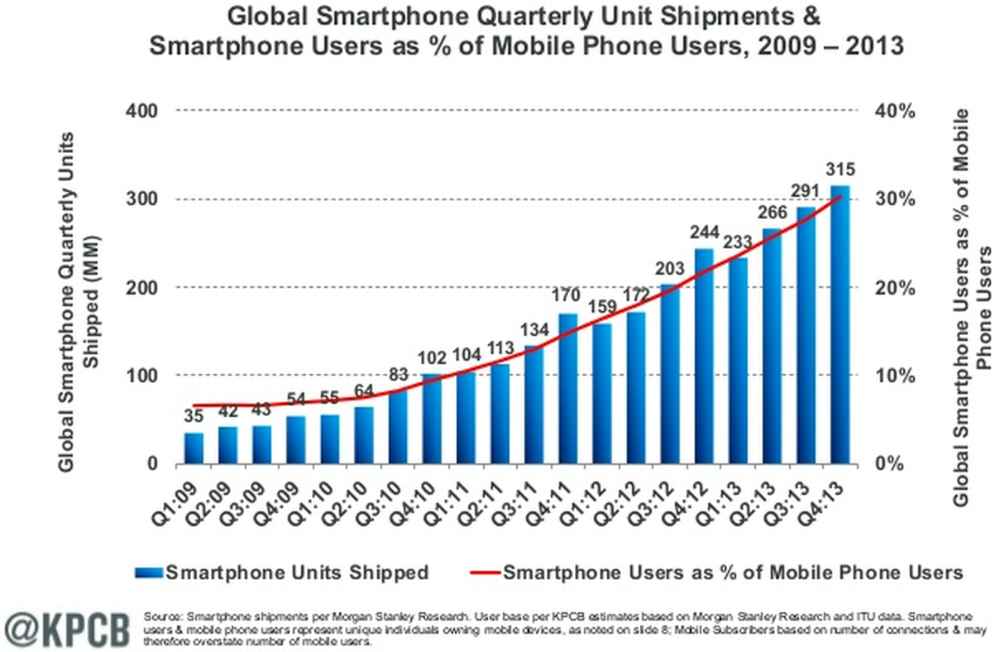
(Lee, 2014)
As Broderick suggests the relentless changes that we have seen in technology are only set to continue and change into the future “...trajectories will start its visible run up the right hand side of the graph (growth axis) within ten or twenty years, and by 2030 (or 2050 at the latest) will have put into questions everything we hold self evident” (Broderick, 2001, p. 343) . It is clear then that the disruption of existing business processes and models will continue without any fear or favour for the incumbent systems, processes or organisations.
3. Road Congestion Costs
The “avoidable” cost of congestion for the Australian capitals is set to reach $20.4bn by 2020 from the 2005 estimated cost of $9.4bn (BITRE, 2007, p. 10). Based on these costs it is clear that methods to cost effectively minimise congestion costs present an opportunity for our cities to maximise traffic flow whilst minimising overall travel time delay and “avoidable” congestion costs.
The amount attributable to construction work delays is more difficult to quantify. However, a UK Study in 2005 referenced work that suggested “…street works are responsible for about 5% of the total amount of congestion” (Goodwin, 2005, p.3). In the same study Goodwin also referenced a value up to 4 times this amount at 20% (Goodwin, 2005, p. 3). Buchanan & Arter (2010) have estimated that in London alone, for example, the annual cost is of the order of 750 million pounds (about $1.5bn). These studies do indicate that the cost is a real one and it is therefore important to focus on trying to minimise these community costs and potential impacts.
The potentially negative experience of road users to roadworks delays is real. For example, in Perth, Western Australia on 24 June 2014 the Transport Minister, Dean Nalder, apologised to the Perth community due to the large amount of roadworks delay impacts, he said “Until the works are completed we won’t get that full flow of traffic, so it does create some of the challenges for people out there” (Emerson, 2014).
In the US it is suggested that estimates of the likely costs associated with road related works can be undertaken utilising the methods defined within the US Department of Transportation, Federal Highway Administrations “Work Zone Road User Costs – Concepts and Applications: Chapter 2. Work Zone Road User Costs” (USDOT: 2015). The FHWA identifies various elements that make up road user costs for Work Zones broadly including Monetised Impacts and Other Impacts (see also Figure 2).
Figure 2: Work Zone Road User Cost Components
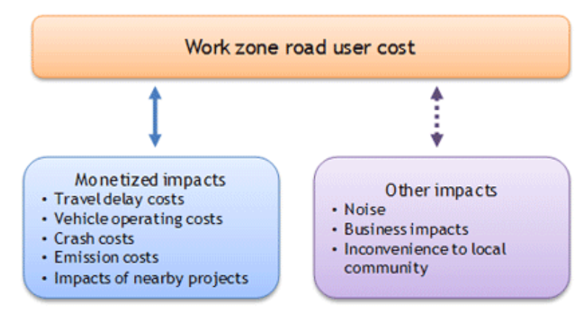
(USDOT, 2015)
The USDOT / FHWA indicates that various methodologies may be utilised for road work zone estimates of delay, including simulation models and demand-capacity analyses. Equally the USDOT / FHWA recognise that “Delay time during construction also can be estimated using the floating-car technique…” (USDOT, 2015). The use of mobile phone signal tracking is now recognised as being able to achieve a comparable result to the traditional floating-car methodology. Indeed, Queensland Transport and Main Roads and other roads agencies and local authorities within Australia are now adopting mobile phone (Bluetooth) based methodologies for the monitoring of both construction roadwork impacts and also for wider road network travel time (congestion) monitoring in lieu of a floating-car methodology.
4. Delivering Cost Effective Real-time Data
The advent of near-field communications (NFC) as part of mobile devices has provided a new suite of options for transport data acquisition. Various methodologies exist, however, this paper only focuses on signals via Bluetooth (BT) and Wi-Fi.
Systems that utilise the potential dataset that is available from Bluetooth and or Wi-Fi signals obtain a unique code from each device that passes within the receiving proximity (signal area) for that device at that location. The code is unique to each device from the date of manufacture and no records exist from the manufacturer that identifies the “owner” of a mobile device related to this code.
Privacy for users is not compromised through the use of these systems. Privacy only becomes a potential issue if an owner of a mobile device chooses to register their details linking themselves with the code of their mobile device. Of course, the recipient of this information, namely the organisation that obtained the code data from the owner then has a responsibility consistent with the Privacy Act to ensure the security of this information.
Once a sensor, or receiver system (see Figure 3), has captured this data it can then register the time it receives the code as a data record. Quayle et al (2010) suggest that for data matching a suitable strategy is matching of the “first-to-first” and “last-to-last” detection times of a pairing of sensors. The units at each location then send the received information through to a central data server to compile the data into meaningful reports and datasets. Depending on the complexity of the data system some systems can provide weekly data reporting or in some instances effectively real-time data. One such example system is the flos (pronounced “flows”) system developed and utilised by Data Audit Systems (Data Audit Systems (flos): 2015). flos displays real-time data via a dashboard. The dashboard continuously provides clients with travel time and congestion data within a given area or network. Systems that utilise mobile phone tracking are recognised as methodologies by AustRoads in the “Guide to Traffic Management Part 3: Traffic Studies and Analysis” (AustRoads: 2013, p192).
Figure 3: Example Sensor System (Bluetooth and WiFi), “flos” system
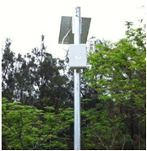
(Data Audit Systems (flos): 2015)
5. The Comparative Advantage of Digital versus Analogue Methods
The various methodologies to capture transport related data have developed progressively since the first known records of traffic counting in the 1920’s, not long after the Model-T Ford and other vehicle makes had become more mainstream and traffic signals needed to be calibrated to match demands (Masters, 2013). The original concept of automated traffic counting (around 1936) was developed for the purposes of understanding traffic volumes and vehicle classification to provide an understanding of the quantum of demand (Popular Mechanics, 1936). Since then methods have been refined and new methodologies added with the advent of computing in the 1950’s once again progressing the methodologies and processes that were used. The latest methods utilise various technological improvements, including the advent of the digital age, to obtain better data for transport applications including those for construction works monitoring. The advantages and disadvantages associated with the various methodologies are briefly outlined below in Table 1 to demonstrate the context and value of the analogue and digital methods.
Table 1: Comparison of survey methods
Survey method | Approach | Advantages | Disadvantages
- Traffic Count Survey (Physical) | - Capture of classified movement counts and origin-destination survey data for general traffic and public transport movements by using staff on-site. | - Can capture a lot of detail during survey  - Can adapt to changes as staff are on-site during survey | - High cost  - Very labour intensive  - Requires staff to travel to each site  - Subject to weather conditions  - High cost limits ability to undertake continuous surveys for extended periods
- Floating Car Travel Time | - Capture of travel time between points or continuously using GPS coordinate logging at defined intervals for general traffic and public transport movements either by using staff travelling as a floating-car or logged with an automated GPS system on say a bus or other PT vehicle. | - Can capture a lot of detail during survey  - Can adapt to changes as staff are “on-site” during a floating car survey | - High cost  - Can be labour intensive for floating car  - Requires staff to travel to each site  - Subject to weather conditions  - High cost limits ability to undertake continuous surveys for extended periods  - Potentially limited number of data points due to labour intensive process
- Pneumatic Tube Counters | - Capture of classified movement counts for a road link section for general traffic (including buses) using an analogue tube pressure sensing system. | - Can capture a lot of detail in terms of traffic movements at the survey point  - Installation cost not high and relatively quick | - Requires staff to obtain data from counters at a regular interval due to low storage memory and no comms back-to-base  - Can be costly if over an extended period due to memory limitations and labour requirements  - Extra cost from replacement of tubes risk of breakage resulting in data loss
- Automatic Number Plate Recognition (ANPR) | - Capture of classified movement counts for a location with the potential to determine travel time and origin-destination patterns if part of a network of ANPR cameras | - Can capture a lot of detail (vehicle type, number of vehicles, o-d patterns) in terms of traffic movements at the survey point  - Installation cost not high and relatively quick | - Requires staff to obtain data from the cameras due to the limited memory and difficulty to transfer high quality video unless a quality internet/comms connection is available  - Can be costly if over an extended period due to the need to extract the data regularly from each site because of the memory / comms limitations  - High capital cost per camera unit
- Traffic Count Survey (Cameras) | - Capture of classified movement counts for a location with the potential to determine travel time and origin-destination patterns if part of a network of cameras | - Can capture a lot of detail (vehicle type, number of vehicles, o-d patterns) in terms of traffic movements at the survey point  - Installation cost not high and relatively quick | - Requires staff to obtain data from the cameras due to the limited memory and difficulty to transfer high quality video unless a quality internet/comms connection is available  - Can be costly if over an extended period due to the need to extract the data regularly from each site because of the memory / comms limitations  - High capital cost per camera unit
- BT/WiFi Sensor | - Capture of a sample of movements from a fixed location allowing travel time and travel patterns to be determined after matching of data between locations (Michau et al: 2013).  - Can be used for various modes including private vehicles and public transport (Kieu, Bhaskar and Chung: 2013) | - Data can be made available in real-time  - costs lower than traditional methods  - richer data temporally and spatially if across a network  - 24/7 data  - not weather dependent  - temporary installation costs are low and easy installation discrete data acquisition with small footprint | - Require a network of locations (linear or in an area) for matching purposes  - Setup cost at installation can be high (only for semi-permanent or permanent applications)
6. Case Studies for Real-Time Monitoring
As major transport infrastructure for roads or public transport is delivered there is the potential for congestion (road user delay costs) to be increased in the area surrounding the works. Being able to monitor these impacts cost effectively and in real-time is an advantage for the roads agency, local authority and community. This is because the information can be made available to better manage and communicate potential impacts. This data may also be used to assist in the planning of future traffic management strategies for construction works that may impact the transport network. Outlined below in Table 2 are some example Case Studies from transport infrastructure projects in Queensland. These examples demonstrate the value that Bluetooth travel time monitoring can bring to the better management of transport construction projects.
Table 2: Example Case Studies
Project and Location | Key Features and Discussion | Example Site Arrangement /  Data Reporting
M1 Motorway 6 Laning Upgrade Works (Springwood) | - sensor either end of a 2km section  - 9 month semi-permanent deployment  - solar power and 3G mobile for communications  - near real-time data delivery to server  - automated weekly reporting and graphics via website dashboard  - utilises “flos” system | 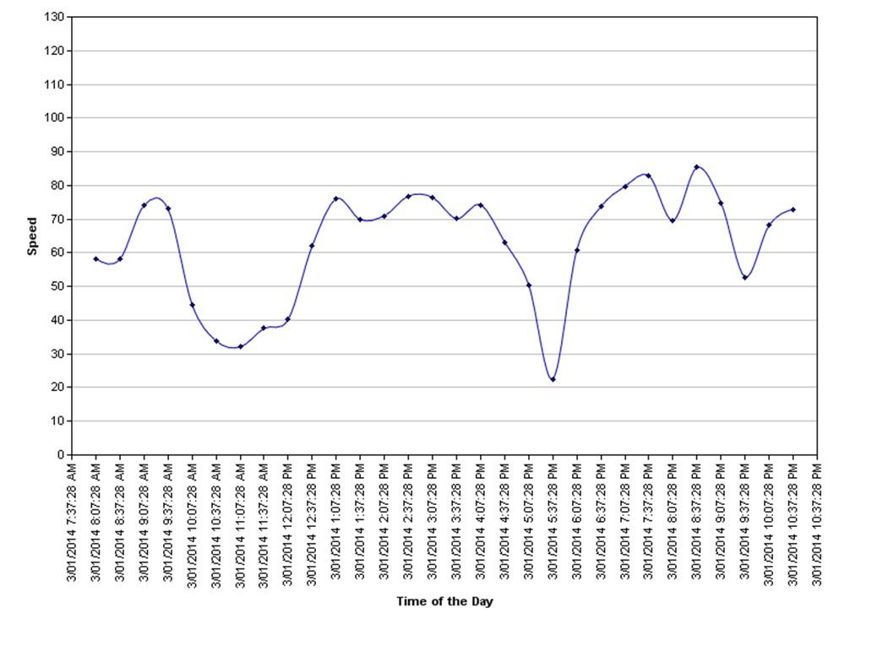  Example Daily Monitored Travel Speed Profile – note morning and evening sags
National Disaster Relief and Recovery Arrangements (NDRRA) Program (Ipswich to Roma) | - twelve sensors from Ipswich to Roma and Warwick including up and down the Toowoomba range on the Warrego Highway and Cunningham Highway  - real-time data display on VMS for Toowoomba range and for Toowoomba to Dalby sections  - 3 year semi-permanent deployment  - solar power and 3G mobile for communications  - near real-time data delivery to server  - daily reporting and graphics updates via website dashboard  - real-time updates for VMS for Toowoomba – Dalby and Toowoomba range sections  - utilises “flos” system | 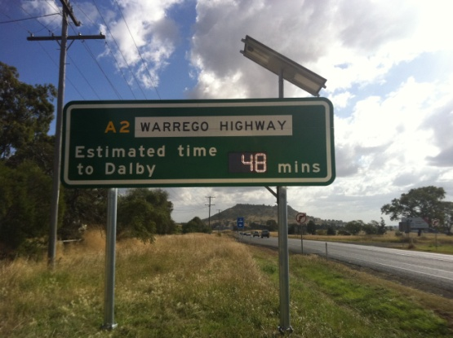  Warrego Highway Traffic Update LED Signage – west of Toowoomba. Updated utilising “flos” system.
Gateway Motorway Upgrade South – Mt Gravatt Capalaba Road | - five sensors along the Gateway Motorway, Mt Gravatt Capalaba Road and Broadwater Road  - real-time data and graphical display on website dashboard  - 1 ½ year semi-permanent deployment  - solar power and 3G mobile for communications  - near real-time data delivery to server  - automated weekly reporting via website dashboard  - utilises “flos” system | 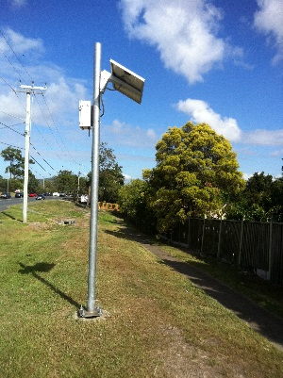  Typical arrangement adjacent to roadway – “flos” system. Captures both directions of traffic from one-side.

Future developments for the provision of travel time data from sensor applications will likely include a predictive capability. This improvement will build-on the current historical reporting, that provides the latest captured data, to then add a predictive layer for the next time period based on the previous periods’ data. Depending on the corridor type predictive methodologies that may be applied include SARIMA (Seasonal Auto Regressive Integrated Moving Average) (Tong and Liang, 2005). The steps for predicting future values by SARIMA are shown below in Figure 4. Similarly, other improvements may include dynamic lane closures to cut time and cost impacts on motorways. For example, the UK Highways Agency have adopted these technologies to enable faster roadworks and utilise traffic speed data (may be from cameras or sensors) captured before and during the actual roadworks. This process enables the Highways Agency to better plan works windows and to also manage the roadworks periods to minimise any possible impacts (ITS, 2014).
Figure 4: Time series prediction by SARIMA modelling
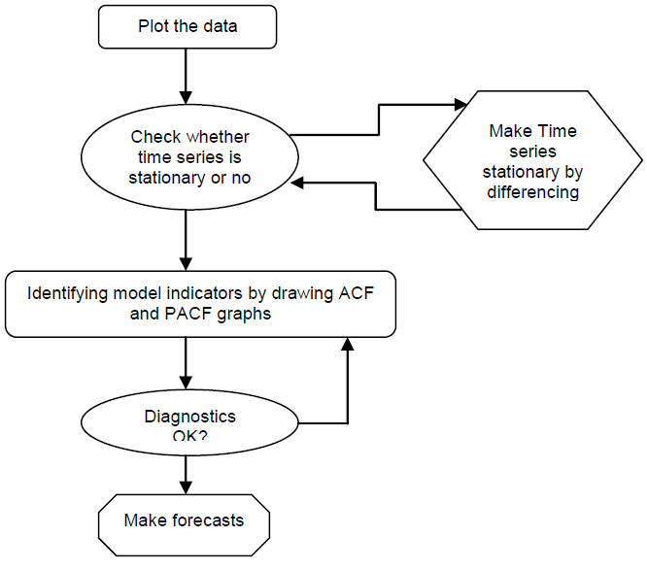
(Khoei, Bhaskar and Chung, 2013, p.5)
Note: ACF – Auto-Correlation Factor, PACF – Partial Auto-Correlation Factor)
7. Conclusions
The impact of information technology on the transport sector will continue at an ever increasing rate. Our individual mobility is, and will, continue to change in response to new technologies whether they assist in how we move about more efficiently or cost effectively, or indeed how we make travel choices such as when to travel because of congestion. How we acquire and utilise data is also changing as systems seek to keep up with improvements in communication and data sensing technologies.
This paper has demonstrated that we are only at the start of a new age in data capture that will continue to evolve at an ever increasing rate. Mobile based systems will be an integral part of how we construct, manage and utilise our transport networks into the future.
8. References
Alcorn, N., Buchanan, L. and Voon, G., Deloitte, Media Consumer Survey 2014, Australian Media and Digital Preferences – 3rd Edition, 2014.
AustRoads, Guide to Traffic Management Part 3: Traffic Studies and Analysis, Sydney, 2013, AGMT03-13.
Broderick, D., 2001. The Spike - How Our Lives Are Being Transformed by Rapidly Advancing Technologies. New York: Forge.
Buchanan, C., and Arter, K., Economic Impact of Road Works, Association of European Transport and Contributors, 2010
Bureau of Transport and Regional Economics (BITRE), Australian Government, Department of Transport and Regional Services, Estimating urban traffic congestion cost trends for Australian cities, Working Paper No 71, 2007.
Data Audit Systems (flos), 2015, http://dataaudit.com.au/flos/
Emerson, D., 2014. Roadworks blamed for congestion, The West Australian, Perth, Western Australia, 24 June 2014.
Goodwin, P., Utilities’ Street Works and the Cost of Traffic Congestion, Centre for Transport & Society, University of the West of England, Bristol, February 2005.
ITS International, Dynamic lane closures cut time, cost and congestion on motorway roadworks, January / February 2014, http://www.itsinternational.com/sections/cost-benefit-analysis/features/dynamic-lane-closures-cuts-time-cost-and-congestion-on-motorway-roadworks/
Khoei, A. M., Bhaskar, A. & Chung, E., Travel Time Prediction on Signalised Urban Arterials by Applying SARIMA Modelling on Bluetooth Data, Australian Transport Research Forum, Proceedings, 2 – 4 October, 2013, Brisbane.
Kieu, L M., Bhaskar, A. & Chung, E., Empirical Evaluation of Public Transport Travel Time Variability, Australian Transport Research Forum, Proceedings, 2–4 October, 2013, Brisbane.
Lee, K., Ultimate guide to mobile social media: phone and tablet strategies for Twitter, Facebook, Linkedin, and Google+, June 9 2014, https://blog.bufferapp.com/mobile-social-media-marketing-strategy
Masters, N., CityDig: Should I Stop or Should I Go? Early Traffic Signals in Los Angeles, Los Angeles Magazine, January 4, 2013.
Michau, G., Nantes, A. & Chung, E., 2013. Towards the Retrieval of Accurate OD Matrices from Bluetooth Data: Lessons Learned from 2 Years of Data, Australian Transport Research Forum, Proceedings, 2 – 4 October, 2013, Brisbane.
Popular Mechanics, Strip Across Road Counts Cars and Registers Hourly Total, July 1936
Quayle, S., Koonce, P., DePencier, D. & Bullock, D. M., 2010. Arterial Performance Measures using MAC Readers: Portland, Oregon Pilot Study. Portland. Oregon, Transportation Research Board.
Tong, L. I. & Liang, Y. H., Forecasting Field Failure Data for Repairable Systems using Neural Networks and SARIMA Model. International Journal of Quality & Reliability Management, 22, 410-420.
US Department of Transportation, Federal Highway Administration (FHWA), Work Zone Mobility and Safety Program, Work Zone Road User Costs – Concepts and Applications, Chapter 2. Work Zone Road User Costs, 2015, http://ops.fhwa.dot.gov/wz/resources/publications/fhwahop12005/sec2.htm

