Valuing Public Transport Service Quality using a Combined Rating & Stated Preference Survey

By Douglas N.J.¹

Neil Douglas is Manager of Douglas Economics, Wellington NZ

Abstract

This paper presents the results of a study commissioned by the NZ Transport Agency in 2011 to look at the trade-off between price and quality for bus and train users in the three largest cities of New Zealand. The valuations were estimated through a large scale survey of 12,557 bus and rail passengers carried out between November 2012 and May 2013 on 1,082 different bus and train services.

The aim of the study was to develop a method to value vehicle and stop/station quality from a passenger perspective. Unlike previous studies that focussed on specific attributes, the study adopted a top-down approach in which overall quality was rated on a five star system similar to that used by restaurants, films and hotels. Vehicle and stop/station quality were then included in a Stated Preference questionnaire alongside in-vehicle time, service frequency and fare to estimate ‘Willingness to Pay’ values.
To ‘atomise’ the vehicle and stop/station ratings, a ‘rating’ survey was undertaken which used a nine point scale to rate vehicle and stop/station attributes. ‘Objective’ data on bus age, type and station features was also used to explain the ratings and assess the effect of station and train upgrades, new buses, bus and train types, vehicle age etc. The analysis is also extended to include ‘halo’ effects using Sydney train rating data.
The advantages of the SP/Rating are considered to be three-fold. Firstly, unlike previous 'bottom-up' methods, no 'capping' of package values or downwards adjustment is required to assess improvements or changes in quality. Secondly, the approach lends itself to assessing ongoing operator performance in terms of vehicle cleanliness and staff behaviour and the quality of the vehicles and stop/stations provided. Thirdly, the approach is cost-effective in the use of onboard self-completion questionnaires that could be undertaken as part of general customer satisfaction monitoring.

Keywords:
Rating Surveys, Stated Preference, Trolley Buses, Value of Time, Valuations, Halo effects, Fashioning Super Models

1. Introduction

The study, commissioned by the NZ Transport Agency in 2011, looks at the trade-off between price and quality for bus and train users in the three largest cities of New Zealand. The valuations were estimated through a large scale survey of 12,557 bus and rail passengers carried out between November 2012 and May 2013 on 1,082 different services. The survey involved two types of questionnaire: a rating survey which was completed by 7,201 passengers (57% of the total sample) and a Stated Preference questionnaire which was completed by 5,356 (43%) passengers. The use of a hybrid rating/SP questionnaire approach was considered new since the literature review undertaken at the start of the study did not find a similar approach. The closest was a system-wide study of Sydney rail in the mid 2000s that used the same type of rating survey but used a ‘stated intention’ approach rather than a SP approach to value the rating changes, Douglas & Karpouzis (2006). Most of the other studies revised valued vehicle and station attributes individually such as ‘no steps (onto a bus) versus one step’ and then constructed ‘package’ values by adding the attribute valuations. In doing adding the values however, the resultant values for the package were often considered too large and required ‘capping’ or adjustment downwards.

Section 2 summarises the literature review. Section 3 provides an overview of the hybrid rating-SP approach. Section 4 then summarises the vehicle ratings and section 5 the station ratings. Section 6 looks at the inter-relationship between attribute ratings and how halo effects can increase the direct effect of individual attribute improvements. Section 7 describes the SP approach and presents some results. Section 8 shows how the quality values can be applied and section 9 gives some concluding remarks.

2. Literature Review

Thirteen studies which valued vehicle and stop/station quality were reviewed. The studies included 7 Australasian studies and 6 international studies that straddled more than two decades dating back to a 1991 study of public transport services in Wellington. Table 1 lists the studies.

Most of the studies used SP but other approaches were used. For example, the Wellington Rail study (8) used a Priority Evaluator (PE) approach in which a shopping list of service improvements including a travel time saving was presented. Respondents were asked to allocate $100 across the items listed to indicate their relative priority for improvement. Although respondents were able to complete the shopping list, the total package value when expressed in train minutes was implausibly highly.

The review converted the valuations of the 13 studies reviewed into (i) equivalent minutes of onboard bus/train time (IVT) and (ii) the percentage of the average fare paid. Where only a fare value or a time value (but not both) were estimated, an ‘external’ value of time was imported. For instance the 2004 Sydney Rail rating study (7) used a value of time estimated by another study, Douglas Economics, 2004 and Wellington rail station survey (8) used the value of time given in the NZ Economic Evaluation manual.

Some of the studies provided estimates bus and rail which meant that the number of observations exceeded the number of studies. For vehicles, 17 IVT valuations were provided by the 13 studies and 16 percentage fare valuations. The value of the vehicle and station ‘packages’ varied widely across the observations reflecting differences in study context, study methodology and in the make-up of the packages themselves such as whether ‘ongoing’ maintenance aspects were included (e.g. cleanliness, staff friendliness etc) as well as physical aspects (new versus old, low floor versus steps etc).

Table 1: Public Transport ‘Quality’ Studies Reviewed
# | Short Title & Author | Location | Modes | Survey | Citation
1 | “Quality of Public Transport”  - SDG NZ Ltd Wellington (1991) | Wellington NZ | Bus & Rail | 1991 | ATC (2006)
2 | “Value of Rail Service Quality”  - PCIE Sydney (1995) | Sydney, Aus | Rail | 1995 | ATC
3 | “Liverpool - Parramatta Transitway Market Research” - PPK/PCIE (1998) | Sydney, Aus | Bus | 1998 | ATC
4 | “Developing a Bus Service Quality Index” - Hensher (1999 & 2002) | Sydney, Aus | Bus | 1999-2002 | ATC Balcombe (2004) Bristow (2009)
5 | “Valuing UK Rolling Stock” Wardman & Whelan (2002 ) | UK | Rail | Pre 2001 | Balcombe, Bristow
6 | “Survey of Rail Quality Dandenong”  - Halcrow (2005) | Victoria, Aus | Rail | 2003 | ATC
7 | “Value of Sydney Rail Service Quality using Ratings” - Douglas & Karpouzis (2006) | Sydney, Aus | Rail | 2004-5 | Litman (2011) Bristow
8 | “Tranz Metro Wellington Station Quality Surveys” - Douglas Economics (2005) | Wellington, NZ | Rail | 2002 & 2004/5 | *
9 | “London, Bus & Train Values”  - SDG LUL (2004 & 2008) | London,  UK | Bus & Rail | 1995-2007 | Bristow
10 | “Values for Package of Bus Quality Measures in Leeds” Evmorfopoulos (2007) | Leeds,  UK | Bus | 2007 | Bristow
11 | “Soft Measures influencing UK Bus Patronage” AECOM (2009) | Provincial Cities, UK | Bus | 2009 | *
12 | “Valuing Premium Public Transport in US” - Outwater et al (2010) | Four Cities, USA | Bus & Rail | 2010 | *
13 | “Universal Design Measures in Public Transport in Norway” - Fearnley (2011) | Norway | Bus | 2007 | *

Given the wide range, the review calculated the median and the inter-quartile range as well as the mean. For vehicles, the median value of the improvement package 4.3 minutes compared to a mean of 7.3 minutes which was skewed upwards by two high values. The inter-quartile range was 3.4 to 7.4 minutes. The values when expressed in terms of the percentage of the average fare paid were closer. The median value was 27% and the mean 34%.

Table 2: Value of Vehicle Improvements
Statistic | IVT Mins | % Fare
Mean | 7.3 | 34%
Upper Quartile 75% | 7.4 | 54%
Median | 4.3 | 27%
Lower Quartile 25% | 3.4 | 14%
Observations | 17 | 16

The highest value for a package of vehicle quality improvements was estimated by Hensher in a 1999 survey of bus users. The package of improvements (wide entry doors, very clean, very smooth buses and very friendly drivers) was worth 32 minutes or 90% of fare. Next highest was an AECOM (11) study which valued a package of new buses with low floors, (air conditioning, trained drivers, on-screen displays, audio announcements, CCTV, leather seats, operating to a customer charter to be worth 15 minutes of onboard travel time (27% of fare).

The US study (12) estimated a ‘premium’ bus service with WIFI, comfortable seats, temperature control and clean vehicles was worth 3 to 6 minutes of travel time whereas a similar premium rail service was valued at 4.3 minutes plus 0.13 minutes per minute of train time.
The SDG London study (9) estimated that travelling by the ‘best’ rather than ‘worst’ vehicle was worth 2.4 minutes for buses and 3.6 minutes for trains.

Table 3 presents the same analysis but for bus stops and train stations. It is worth mentioning here that most studies did not say whether the values applied to passengers who transferred or alighted at the stop/station as well as to boarders (i.e. the value was some or sort of weighted average). In the absence of any definition, it is presumed that the values are for passengers who boarded their first bus or train at the stop/station. The likelihood is that the values for alighters would be less (probably around a half) since ‘exposure’ is less.

Only the 1995 Sydney rail study (2) made reference to the number of stations ‘experienced’ factoring the values down by 2.1 (the average number of stations per trip). The 2004 Sydney study (7) asked passengers about their board station and the Wellington survey (8) referred to a nominated station (which could be the board or the alight station).

As with vehicles, the composition of the stop/station packages varied. Some included information such as the Hensher study (4). The US study (12) included personal security whereas most of the other studies considered weather protection, seat provision and lighting.

The highest package value was 44 minutes by the Wellington Priority Evaluator study (8). As previously mentioned, the high value probably resulted from focusing attention on station attributes and away from travel time (included to derive valuations). Next highest was the Norwegian study (13) which valued weather protection and seating at 14 minutes but which also probably overestimated the values by unduly focussing attention on them.

The London 2007 survey (10) valued ‘worst to best’ bus stops at 1.9 minutes and 3.6 minutes at train stations. The Dandenong study (6) which used a Priority Evaluator, valued a package of rail station improvements at 5.4 minutes (91% of the average fare).

Again the median value of 5.7 minutes is considered more reliable than the mean of 9.8 minutes which was affected by high ‘outliers’. There were fewer percentage fare than time based observations (9 versus 12). The median estimate was 25% of fare.

Table 3: Value of Stop/Station Improvements
Statistic | IVT Minutes | Percent of Fare
Mean | 9.8 | 41%
Upper Quartile 75% | 10.7 | 58%
Median | 5.7 | 25%
Lower Quartile 25% | 4.2 | 10%
Observations | 12 | 9

Of the studies reviewed, the system-wide study of Sydney rail users (7) which used a rating questionnaire in tandem with a ‘what if’ questionnaire to derive values for the rating changes was considered the most promising to build on. Most of the other studies valued individual attributes such as ‘no steps versus one step to board’ then constructed ‘package’ values by addition. In doing so, the resultant valuations were often large and required downwards adjustment such as in the SDG London study (9) which capped improvements at 27 pence.

Where it was considered that the Sydney study could be improved on was by replacing the ‘what if’ question with a Stated Preference survey of overall vehicle and stop/station quality measured by a rating score.

3. Combined Stated Preference & Rating Approach

Figure 1 shows how the Rating and Stated Preference surveys were combined. The rating survey measured vehicle and stop/station quality from the passengers’ perspective and by sampling a wider range of buses, trains, bus stops and rail stations in Auckland, Christchurch and Wellington, attempted to determine the relative importance of attributes such as cleanliness, seating and driver friendliness. The ratings were linked to ‘objective’ data provided by Environment Canterbury, Greater Wellington Council and Auckland Transport (AT) on the type of buses and trains surveyed and the facilities provided at the train stations.

The Stated Preference questionnaire presented a set of pair-wise choices in which vehicle and stop/station quality were varied alongside fare, service frequency and onboard travel time. By covering short, medium and long trips as well as low, medium and high frequency routes, the study was also able to explore how the sensitivity to vehicle quality varied with trip length and how the sensitivity to stop/station quality varied with waiting time.

Figure 1: Hybrid Rating & Stated Preference Approach
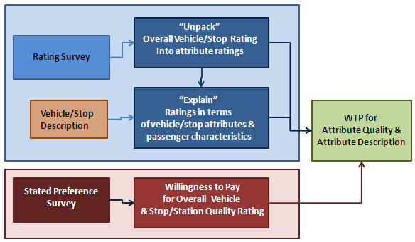

Pilot surveys were undertaken in Wellington between 17th October 2012 and 2nd November 2012. Both interviewer-led and self-completion methods were tested. Interviewing on platforms or stations was ruled out since respondents had not yet experienced the quality of the bus or the train. Interviewing on moving buses was found too difficult.

Self-completion questionnaires handed out and collected onboard buses and trains by surveyors worked well especially when interviewers gave a short explanation of the SP exercise. Surveyors also recorded details of the bus or train, the time of the survey and the weather conditions.

The main survey was undertaken between November 2012 and May 2013. Altogether 12,557 completed questionnaires were returned comprising 7,201 (57%) rating and 5,356 SP (43%). A total of 1,082 different bus and train services (individual trips) were surveyed covering 198 bus routes and 7 rail lines provided by fifteen operators (13 bus and 2 rail).

The sample was more than three times the original target, the large size attributable to the cost-effectiveness of a self-completion questionnaire versus an interview led survey.

Table 4: Questionnaires Completed
Survey | Completed Questionnaires |  |  | Total
 | Christchurch | Wellington | Auckland
Rating | 595 | 3,575 | 3,031 | 7,201
SP | 790 | 2,326 | 2,240 | 5,356
Total | 1,385 | 5,901 | 5,271 | 12,557
Survey | Services Surveyed |  |  | Total
 | Christchurch | Wellington | Auckland
Rating | 82 | 354 | 427 | 863
SP | 134 | 340 | 384 | 858
Total^ | 157 | 458 | 467 | 1,082
^ Total less than Rating + SP because both surveys were undertaken on most services

Surveys were undertaken throughout the day (6am to 10pm) on all days of the week. Most surveys were undertaken on Thursday (22%) followed by Tuesday (20%) with just over 1,700 surveys (14%) completed on Saturday/Sunday. Response was aggregated into peak (weekday before 0930 and 1630-1830) and non-peak.

As well as estimating values for vehicle and stop/station quality, the study provided a snap-shot profile of the travel market in New Zealand’s three largest cities. As an example, Table 5 presents the journey purpose profile. Wellington rail had the highest commuting share (84% peak, 39% non-peak) and Christchurch bus the lowest (47% peak, 26% non-peak).

Table 5: Journey Purpose Profile by City & Time Period
 | Peak |  |  |  |  |  | Non Peak
 | Bus |  |  | Rail |  | All | Bus |  |  | Rail |  | All
Journey Purpose | CHC | WTN | AUC | WTN | AUC |  | CHC | WTN | AUC | WTN | Auc
To/from Work | 47% | 64% | 52% | 84% | 64% | 68% | 26% | 35% | 29% | 39% | 21% | 31%
To/from Education | 19% | 8% | 31% | 4% | 23% | 14% | 13% | 11% | 31% | 9% | 21% | 18%
Personal Business | 17% | 9% | 5% | 3% | 2% | 5% | 18% | 17% | 11% | 10% | 9% | 13%
Company Business | 0% | 1% | 0% | 2% | 1% | 1% | 1% | 2% | 1% | 2% | 1% | 1%
Shopping | 6% | 4% | 4% | 1% | 3% | 3% | 23% | 13% | 10% | 10% | 17% | 14%
Visiting Friends/Rels | 6% | 7% | 4% | 4% | 4% | 5% | 11% | 10% | 9% | 15% | 9% | 11%
Entertainment/Hol/Sport | 3% | 5% | 3% | 2% | 4% | 3% | 6% | 10% | 8% | 12% | 22% | 11%
Other | 2% | 2% | 1% | 1% | 1% | 1% | 3% | 2% | 2% | 3% | 1% | 2%
Airport/Ferry/Train | 0% | 1% | 0% | 0% | 0% | 0% | 0% | 0% | 0% | 0% | 0% | 0%
Valid Response | 231 | 823 | 1,114 | 1,863 | 600 | 4,631 | 1,111 | 1,609 | 2,448 | 1,537 | 954 | 7,659

4. Vehicle Ratings

Thirteen vehicle attributes were included on the bus rating questionnaire as listed in Figure 2. The train rating questionnaire was similar except for ‘driver’ which was replaced by ‘onboard staff’.

The SP survey only asked an overall rating. A five star system was used to match the levels depicted on the show cards. Figure 3 shows the train rating question.

Figure 2: Bus Rating Question on Rating Questionnaire
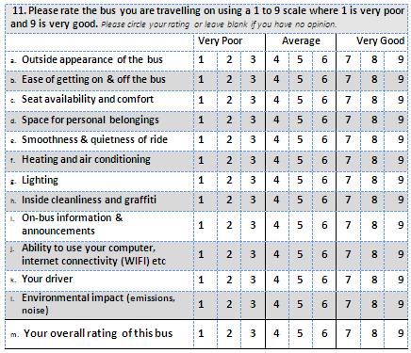

Figure 3: Train Rating Question on SP Questionnaire
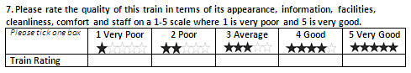

The response to the nine point rating and five star SP scales were converted onto a percentage scale.

Nine Point Scale: .....(1) Five Point Scale:.....(2)
A subsidiary research question was whether different rating scales affected response. Figure 4 shows that the response to the rating and SP questions was necessarily different with a taller histogram for the five star SP survey than the 9 point rating survey but despite this, the two surveys gave a near identical mean rating for vehicles: 72% Rating and 71% SP.

Figure 4: Five Star (SP) versus Nine Point (Rating) Rating of Vehicles
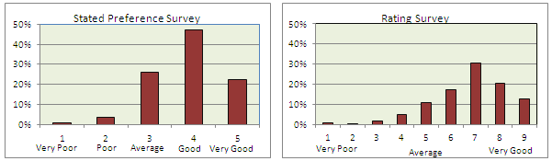

Table 6 shows how the vehicle ratings varied by city. Wellington rail scored the highest rating of 78%. Auckland buses scored 71% with Wellington buses on 70% and Christchurch buses on 68%. Lowest rated scoring 67% was Auckland rail which was surveyed just prior to electrification and the introduction of new rolling stock. The range in vehicle rating from top to bottom was 11% points.

Table 6: Bus & Train Ratings by City
 | Average Rating % |  |  |  |  |  | Sample Size
 | Bus |  |  | Rail |  |  | Bus |  |  | Rail
Attribute | CHC | WTN | AUC | WTN | AUC | ALL | CHC | WTN | AUC | WTN | AUC | ALL
Outside Appearance | 69% | 71% | 72% | 79% | 62% | 72% | 534 | 1,167 | 1,719 | 2,292 | 1,171 | 6,883
Ease of On & Off | 76% | 76% | 77% | 82% | 70% | 77% | 542 | 1,171 | 1,709 | 2,296 | 1,171 | 6,889
Seat Av & Comfort | 74% | 75% | 74% | 77% | 68% | 74% | 536 | 1,166 | 1,708 | 2,297 | 1,170 | 6,877
Space for Bags | 65% | 64% | 64% | 72% | 61% | 66% | 531 | 1,154 | 1,686 | 2,279 | 1,163 | 6,813
Smooth & Quiet | 56% | 62% | 63% | 72% | 54% | 64% | 537 | 1,156 | 1,695 | 2,296 | 1,162 | 6,846
Heating & Air Con | 64% | 66% | 68% | 75% | 64% | 69% | 508 | 1,134 | 1,668 | 2,243 | 1,121 | 6,674
Lighting | 68% | 70% | 72% | 81% | 72% | 75% | 504 | 1,129 | 1,655 | 2,281 | 1,165 | 6,734
Inside Clean & Graf | 61% | 72% | 75% | 84% | 71% | 75% | 537 | 1,154 | 1,689 | 2,278 | 1,162 | 6,820
Toilet Av & Clean | na | na | na | 76% | na | na | na | na | na | 105 | na | na
Info & Announce | 55% | 54% | 56% | 74% | 69% | 64% | 498 | 1,056 | 1,620 | 2,230 | 1,152 | 6,556
Computer & Internet | 33% | 36% | 39% | 45% | 43% | 41% | 403 | 762 | 1,381 | 1,426 | 925 | 4,897
Driver/Staff | 75% | 71% | 74% | 76% | 68% | 73% | 533 | 1,141 | 1,696 | 2,266 | 1,130 | 6,766
Environ Impact | 58% | 58% | 61% | 69% | 54% | 62% | 503 | 1,027 | 1,629 | 2,032 | 1,115 | 6,306
All | 68% | 70% | 71% | 78% | 67% | 72% | 1,280 | 2,374 | 3,501 | 3,340 | 1,495 | 11,990

The ratings for the individual attribute ratings followed a similar pattern. The highest rated attributes were lighting and inside cleanliness and graffiti which scored 75%. The lowest rated attribute was ‘the ability to use your computer and internet connectivity’ which at 41% was noticeably lower than other attribute ratings. It is worth noting that the average rating was only calculated for passengers who gave a rating and for ‘the ability to use your computer and internet connectivity’ response was lower (4,897 versus around 6,800).

Wellington rail rated the highest in all attributes reflecting the introduction of the new Matangi trains which were less than a year old when surveyed. The highest rated attribute was ‘cleanliness and graffiti’ (84%) followed by ‘ease of getting on and off’ (82%) and lighting (81%). Computer/internet connectivity (WIFI) scored particularly lowly (45%) with ‘environmental impact (noise and emissions)’ also rating lower than other attributes (69%).

Twenty-eight bus and seven different train types were surveyed (see Appendix for details). The details of the vehicles were combined with the respondent profile data to explain the variation in the overall rating. Linear and logit models were fitted with the linear model holding the advantage of easily interpreted parameters (percentage ratings). By contrast, the logistic model parameters require transformation but the model does have the advantage of constraining the rating within the 0-1 interval.

Given the large number of attribute - profile - vehicle combinations, variables were entered sequentially. The final model which had 14 variables is presented in Table 7. Although ‘bus’ rated 17% points lower than train (the base), a variety of factors reduced the ‘gap’. For instance, as vehicles aged, the rating reduced with bus age (less strong) than train age (measured from new or last major refurbishment). Buses with more seats tended to rate higher than smaller buses such as midis. Retired passengers tended to rate higher and younger respondents rate lower than other respondents. Premium bus routes rated 6.7% higher than other routes and Wellington’s electric trolley buses rated 2.7% higher than other vehicle types. Auckland respondents tended to rate lower than Wellington and Christchurch respondents.

Table 7: Vehicle Rating Explanatory Model
 | Linear |  |  | Logit
Variable | Beta | STE | |t| | Beta | STE | |t|
Bus | -0.169 | 0.018 | 9.4 | -0.881 | 0.093 | 9.5
Vehicle Age (years) | -0.0188 | 0.0006 | 30.8 | -0.097 | 0.003 | 32.3
Bus*Age (years) | 0.014 | 0.001 | 18.7 | 0.073 | 0.004 | 18.3
Bus * Seats (number) | 0.0012 | 0.000 | 3.1 | 0.005 | 0.002 | 2.5
Bus * Premium Bus Route | 0.067 | 0.009 | 7.4 | 0.375 | 0.054 | 6.9
Auckland | 0.024 | 0.004 | 6.0 | 0.107 | 0.020 | 5.4
Trolley Bus | 0.027 | 0.011 | 2.5 | 0.129 | 0.054 | 2.4
PM Peak | -0.024 | 0.004 | 6.0 | -0.116 | 0.021 | 5.5
Entertainment/Holiday | 0.038 | 0.007 | 5.8 | 0.195 | 0.035 | 5.6
Visit Friends Relatives | 0.018 | 0.006 | 2.9 | 0.089 | 0.032 | 2.8
Female | 0.016 | 0.003 | 5.3 | 0.079 | 0.018 | 4.4
Retired | 0.055 | 0.007 | 7.4 | 0.298 | 0.041 | 7.3
Aged under 18 | -0.035 | 0.006 | 6.3 | -0.168 | 0.028 | 6.0
Aged 18 - 24 | -0.019 | 0.004 | 4.8 | -0.093 | 0.021 | 4.4
Constant | 0.837 | 0.068 | 12.3 | 1.596 | 0.025 | 63.8

A second type of model was fitted to determine the relative importance of individual attributes measured via their ability to explain the overall vehicle rating. Again linear (equation 3.1) and logistic models (3.2) were fitted.

Linear: .....(3.1)
Logistic: .....(3.2) where:
= overall rating on 0-1 scale
= rating of attribute X on 0-1 scale
= estimated parameters

The model was estimated sequentially. Outside vehicle appearance, seat availability/comfort, smoothness/quietness and staff were the most powerful explanatory variables with each attribute explaining around 10% of the overall rating.

The importance of the environmental rating varied the most by type of respondent. Females attached less importance and more to the cleanliness of their bus or train when compared to males. Likewise passengers visiting friends or relatives attached less importance to the environment rating and more to getting a comfortable seat. By contrast, passengers making entertainment/holiday trips tended to attach more importance to the environmental rating.

The importance of seating also varied by type of respondent with retired passengers and passengers visiting friends/relatives attaching a greater importance contrasted by young passengers (<18) attaching a lesser importance.

Passengers aged 18-25 attached less importance to the outside appearance of the vehicle. Passengers making trips longer than 40 minutes attached more importance to toilet availability/cleanliness.

Table 8: Grand Final Vehicle Rating Explanatory Model
 | Linear |  |  | Logit
Variable | β | STE | |t| | β | STE | |t|
Outside Vehicle Appearance | 0.120 | 0.009 | 13.3 | 0.640 | 0.065 | 9.8
Ease of On & Off | 0.075 | 0.009 | 8.3 | 0.408 | 0.064 | 6.4
Seat Availability & Comfort (SEAT) | 0.102 | 0.009 | 11.3 | 0.491 | 0.064 | 7.7
Space for Bags | 0.024 | 0.008 | 3.0 | 0.178 | 0.051 | 3.5
Smoothness & Quietness | 0.119 | 0.008 | 14.9 | 0.633 | 0.055 | 11.5
Heating & Air Conditioning | 0.062 | 0.008 | 7.8 | 0.324 | 0.055 | 5.9
Lighting | 0.029 | 0.009 | 3.4 | 0.153 | 0.056 | 2.7
Inside Cleanliness & Graffiti (CG) | 0.065 | 0.009 | 7.2 | 0.269 | 0.059 | 4.6
Toilet Availability & Cleanliness (TOILET) | - | - | - | - | - | -
Information & Announcements | 0.052 | 0.006 | 8.7 | 0.325 | 0.037 | 8.8
Computer & Internet | 0.008 | 0.005 | 1.7 | 0.078 | 0.032 | 2.4
Driver/Staff | 0.123 | 0.007 | 18.0 | 0.647 | 0.049 | 13.2
Environmental Impact (ENV) | 0.106 | 0.009 | 12.2 | 0.614 | 0.056 | 11.0
Trip>40mins * TOILET | 0.013 | 0.004 | 3.3 | 0.066 | 0.022 | 3.0
Female * ENV | -0.031 | 0.01 | 3.1 | -0.149 | 0.069 | 2.2
Female * CG | 0.039 | 0.008 | 4.6 | 0.216 | 0.054 | 4.0
Retired * SEAT | 0.090 | 0.014 | 6.4 | 0.495 | 0.123 | 4.0
Retired * ENV | -0.072 | 0.017 | 4.2 | -0.258 | 0.152 | 1.7
Aged 18-25 * OSAPP | -0.023 | 0.005 | 4.6 | -0.151 | 0.028 | 5.4
Aged < 18 * SEAT | -0.021 | 0.005 | 4.2 | -0.151 | 0.035 | 4.3
Entertainment/Holiday * ENV | 0.018 | 0.008 | 2.3 | 0.132 | 0.053 | 2.5
Visit Friends/Rels * SEAT | 0.052 | 0.014 | 3.7 | 0.271 | 0.104 | 2.6
Visit Friends/Rels * ENV | -0.054 | 0.019 | 2.8 | -0.272 | 0.141 | 1.9
Constant (α)* | 0.119 | 0.004 | 29.8 | -2.132 | 0.053 | 40.2
* Overall ratings tabulated. Estimated on 6,800 observations

5. Bus Stop & Train Station Ratings

The bus and train questionnaires differed in terms of how the stop/station attributes were covered. The bus questionnaire asked whether the stop the passenger had boarded at had shelter, seating, a timetable and an electronic timetable. Respondents were then asked to rate the bus stop in terms of weather protection, seat availability and comfort; cleanliness and graffiti; lighting, information on bus times and provide an overall rating.

The rail station questionnaire had a longer list of 14 attributes but did not ask whether or not the attributes were provided at the station. The attributes were platform weather protection, seating, platform surface, ease of on off, information, lighting, cleanliness, staff, retail, ticket purchase, car parking, bus transfer and an overall rating.

Overall, there was little difference in the average ratings of bus stops and train stations. The overall stop/station rating was 66% and ranged from 67% for Auckland train stations and bus stops down to 63% for Christchurch bus stops.

Table 9: Overall Bus Stop & Train Station Ratings by City
Survey | CHC | WTN Bus | AUC Bus | All Bus | WTN Rail | AUC Rail | All Rail | ALL
Rating | 63% | 66% | 67% | 66% | 64% | 67% | 65% | 66%
Sample | 1,291 | 2,407 | 3,534 | 7,232 | 3,303 | 1,475 | 4,778 | 12,010

There was a much greater range by train station and aggregated bus stop as Figure 5 shows. Ratings ranged from 80% down to 25%. Hub rail stations (described later) and bus stations rated the highest. For major and local rail stations, there was a wide range in rating which was greater than for city centre and suburban bus stops.

Figure 5: Ranking of Bus Stop & Train Stations by Type
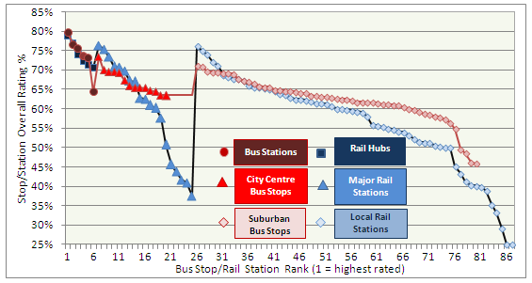

A model was fitted to explain the overall bus stop rating in terms of its location, facilities and respondent profile. The model is presented in Table 10. Shelter was the most important attribute, increasing the rating by 13.7% points, Real time information (RTI) increased the rating by 5.4%, seating by 4.5% and a timetable by 3.3%. Retired passengers tended to rate their stop higher than other passengers.

Respondents who were surveyed when it was raining gave a 3.4% lower rating. City centre and suburban bus stops rated lower than bus stations. Longer waiting times tend to reduce the bus stop rating but only slightly.

The bus stop and train station ratings were analysed separately because of the different list of attributes. For bus stops, an explanatory model (similar to equation 3) was fitted to determine the relative importance of bus stop attributes in explaining the overall rating. Table 11 presents the estimated parameters.

Weather protection, seating and cleanliness were the most important with each explaining around one fifth of the overall rating. Information and lighting were of lesser importance. There were differences by type of respondent with retired passengers attaching a greater importance to weather protection and young respondents placing more importance on information. Long waits (>10 minutes) increased the importance of information but somewhat surprisingly decreased the importance of seating and weather protection.

Table 10: Disaggregate Bus Stop Rating & Facilities Model
 | Linear |  |  | Logit
Variable | Beta | STE | |t| | Beta | STE | |t|
SHELTER (1,0) | 0.137 | 0.011 | 12.5 | 0.599 | 0.046 | 13.1
SEATING (1,0) | 0.045 | 0.013 | 3.5 | 0.189 | 0.058 | 3.3
TIMETABLE (1,0) | 0.033 | 0.012 | 2.8 | 0.148 | 0.057 | 2.6
REAL TIME INFO (1,0) | 0.054 | 0.008 | 6.5 | 0.261 | 0.035 | 7.5
RETIRED PAX | 0.055 | 0.011 | 5.1 | 0.229 | 0.056 | 4.1
RAINING | -0.034 | 0.010 | 3.3 | -0.148 | 0.046 | 3.2
CITY CENTRE | -0.047 | 0.008 | 5.6 | -0.230 | 0.038 | 6.1
SUBURBAN STOP | -0.076 | 0.008 | 9.9 | -0.358 | 0.035 | 10.2
WAIT TIME (mins) | -0.003 | 0.0003 | 10.6 | -0.015 | 0.002 | 9.5
CONSTANT | 0.536 | 0.015 | 37.0 | 0.264 | 0.073 | 3.6
Models fitted on 7,232 observations (mean values input for shelter, seating, timetable and real-time info)
Base group is a bus station, fine weather, not retired passenger, zero wait time.

Table 11: Bus Stop Rating Explanatory Model
 | Linear |  |  | Logit
Variable | β | STE | |t| | β | STE | |t|
Weather Protection (WP) | 0.205 | 0.011 | 18.3 | 1.026 | 0.070 | 14.7
Seating (SEAT) | 0.204 | 0.012 | 16.9 | 1.05 | 0.076 | 13.8
Information (INFO) | 0.134 | 0.011 | 12.2 | 0.691 | 0.073 | 9.5
Lighting (LGHT) | 0.088 | 0.009 | 10.1 | 0.483 | 0.055 | 8.8
Cleanliness & Graffiti (CG) | 0.217 | 0.009 | 24.7 | 1.077 | 0.058 | 18.6
Retired * WP | 0.040 | 0.012 | 3.4 | 0.376 | 0.098 | 3.9
Young * INFO | 0.045 | 0.010 | 4.5 | 0.265 | 0.057 | 4.7
Wait >10mins * WP | -0.047 | 0.022 | 2.1 | -0.258 | 0.136 | 1.9
Wait >10mins * SEAT | -0.053 | 0.025 | 2.1 | -0.276 | 0.166 | 1.7
Wait >10mins * INFO | 0.063 | 0.019 | 3.3 | 0.288 | 0.126 | 2.3
Constant (α) | 0.140 | 0.008 | 18.4 | -1.876 | 0.052 | 36.1
Observations | 3,479 |  |  | 3,479

The survey provided ratings for 87 rail stations. The six larger ‘hub’ stations (Wellington, Porirua, Waterloo, Paraparaumu, Britomart and Newmarket) achieved the highest ratings (74%) reflecting the greater range in facilities provided. The 19 Major stations averaged 60% with the 62 local stations scoring 56% as shown in Table 12.

Table 12: Average Rail Station Ratings by Class
Class | WP | Seat | Plat | OnOff | Info | Light | C&G | Toil | Staff | Ret | Tick | Car | Bus | All | Obs
Hub | 69% | 59% | 71% | 75% | 68% | 71% | 71% | 59% | 70% | 63% | 71% | 65% | 71% | 74% | 6
Major | 57% | 51% | 63% | 66% | 59% | 60% | 60% | 34% | 49% | 35% | 51% | 59% | 61% | 60% | 19
Local | 53% | 50% | 64% | 72% | 56% | 59% | 61% | 25% | 35% | 22% | 42% | 53% | 48% | 56% | 62
Note 85 stations with ratings for individual attributes (Manor Park, Matarawa zero)

An explanatory model was fitted to explain the variation in the overall station rating which is presented in Table 13. After including respondent profile variables, the rating advantage of hub stations increased to14% above major stations and 17% above local stations. Stations that had been upgraded within five years scored 13% higher and stations upgraded within ten years 7.3% higher than non upgraded stations.

Table 13: Explanatory Model of Overall Rail Station Rating
 | Linear |  | Logit
Variable | Beta | |t| | Beta | |t|
OFFPK | 0.025 | 3.1 | 0.112 | 3.8
ENT/HOL | 0.042 | 3.8 | 0.199 | 3.4
RETIRED | 0.055 | 3.9 | 0.264 | 3.4
HSEPERS | 0.053 | 2.3 | 0.253 | 2.0
CAR&PARK | -0.027 | 3.1 | -0.118 | 3.1
HUB | 0.124 | 15.5 | 0.575 | 14.7
LOCAL | -0.029 | 3.6 | -0.121 | 3.4
UPG10Y | 0.071 | 7.9 | 0.317 | 8.1
UPG≤5Y | 0.033 | 3.3 | 0.161 | 3.6
CONSTANT | 0.561 | 73.8 | 0.252 | 7.2
Models fitted on 4,778 observations

An explanatory model was fitted to determine the relative importance of the individual rail station attributes through their ability to explain the overall station rating. Table 14 presents the model. The most important attribute was station cleanliness and graffiti which explained 19% of the overall rating with weather protection second on 13%. Staff, lighting and bus transfer facilities were of lesser importance scoring between 2% and 5%. Bus transfer facilities were only important for passengers accessing by bus (8% of respondents).

Table 14: Rail Station Importance Model
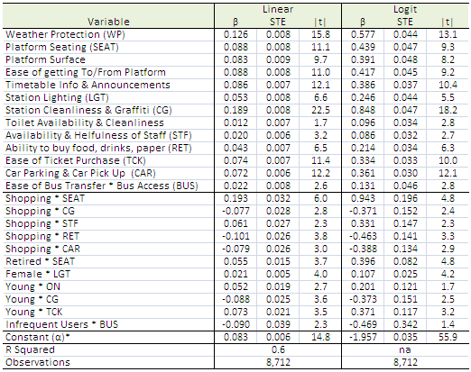

6. Halo Effects

The analysis of attribute importance both for vehicles and stop/stations assumed that the service attributes were independent of each other. Thus improving one attribute, for example station lighting had no effect on the rating of other attributes. In other words, there were no indirect or ‘halo’ effects. It is more likely that improvements in one attribute e.g., lighting would have a halo effect on how passengers see other aspects for example the timetable or the getting on/off the train; and, by increasing the rating of other attributes, the overall rating will increase.

The NZ study did not estimate halo effects but a similar large study of Sydney rail services has been extended to cover halo effects, Douglas Economic (2015). As a guide to the likely size of halo effects, Table 15 presents estimates from the Sydney study which used a two-step approach. The first step fitted a set of models to explain the rating of each attribute in terms of the other attributes. The second step multiplied the coefficients by the respective direct effect coefficients.

The typical multiplier for a improving a train attribute was around 2 implying that the direct effects presented in Table 7 understated the total impact by around one half. These multipliers are only valid however for a single attribute since as more attributes are improved, the ‘intra’ attribute effect gets larger and the halo effect (which is outside of the direct attribute effect) gets smaller. In extremis, if all attributes were improved there would be no halo effect and the total effect would be as given in Table 7 for NZ trains and buses.

Table 15: Halo Effects for Train Attributes - Sydney Rail (2015)
Attribute | Direct* | Halo* | Total* | Multiplier
Outside Appearance | 0.07 | 0.10 | 0.17 | 2.43
Ease of On/Off | 0.11 | 0.08 | 0.19 | 1.73
Seat Av & Comfort | 0.10 | 0.09 | 0.19 | 1.90
Space for Belongings+ | 0.01 | 0.07 | 0.08 | 8.00
Smoothness/Quietness | 0.08 | 0.13 | 0.21 | 2.63
Heating & Air Conditioning | 0.06 | 0.06 | 0.12 | 2.00
Lighting | 0.09 | 0.11 | 0.20 | 2.22
Cleanliness/Graffiti | 0.10 | 0.07 | 0.17 | 1.70
Onboard Information | 0.05 | 0.06 | 0.11 | 2.20
Ability to use elect devices (wifi) | 0.04 | 0.04 | 0.08 | 2.00
Personal Security | 0.05 | 0.08 | 0.13 | 2.60
Onboard Staff | 0.06 | 0.04 | 0.10 | 1.67
Environment | 0.05 | 0.05 | 0.10 | 2.00
Toilets | 0.02 | 0.03 | 0.05 | 2.50
Layout | 0.12 | 0.08 | 0.20 | 1.67
Notes: Parameters are for a 100% increase. ^ Total effect divided by Direct effect. + direct effect parameter was statistically weak. * Numbers rounded two decimal places. Douglas Economics (2015)

7. Stated Preference Survey

The SP survey presented bus and train users with a series of pair-wise choices that ‘traded-off’ vehicle and stop/station quality, travel time, service frequency and fare. Figure 6 presents an example show card.

Twenty-two SPs were designed to cater for the range in travel times, service frequencies and fares across the three cities. Each design had 25 show cards that were divided into three sets (8, 8 and 9 questions each). In total, 39,865 responses from the 5,356 completed questionnaires were obtained.

One choice was a straightforward time versus money trade-off: pay a dollar to save eight minutes. For the 1,630 respondents who answered the question, the percentage was exactly 50% choosing A and 50% B. Thus the median value of time was $7.50 per hour. The percentage did vary across the routes surveyed however as can be seen from Figure 7. Nearly three quarters of respondents on the Wellington Airport Express (WBA), who already pay a higher fare to use the premium service, were willing to pay a dollar to save eight minutes whereas only 40% of Christchurch medium bus (CBM) respondents were willing.

Figure 8 presents mean score graphs for service interval, in-vehicle time and fare. The fare, onboard time (IVT) and service interval (SI) graphs slope downwards to the right reflecting that as service A became more expensive (or took longer), less people chose it. All three graphs were approximately linear. For vehicle and stop/station quality, the graphs sloped the opposite way reflecting the tendency for more people to choose service A as its quality improved relative to service B. The two ‘quality’ graphs also show that response non-constant with respondents becoming less sensitive to differences in quality, the higher the quality.

Figure 6: Example Stated Preference Show card
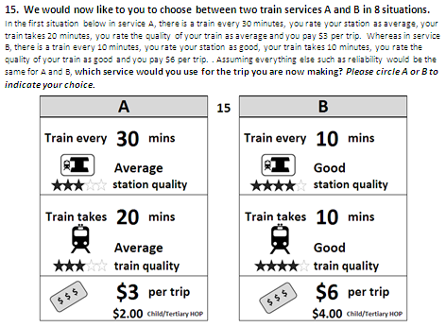

Figure 7: Fare - Travel Time Trade-Off
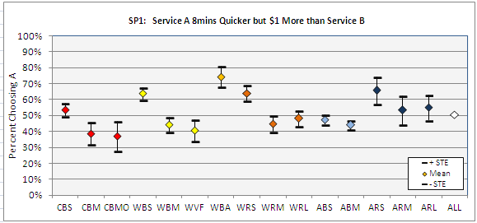

Figure 8: Mean Score Graphs
Percent Choosing Service A by Attribute Level
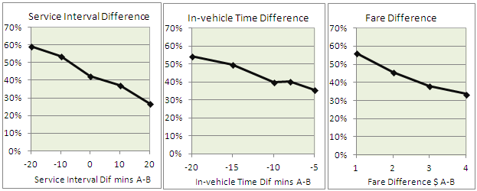

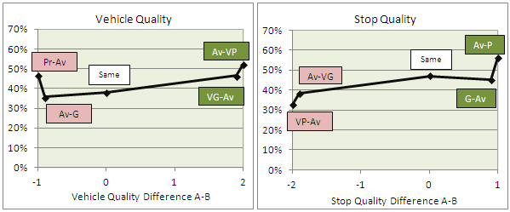

To take account of the non linear response to quality, the vehicle and stop/station quality variables were transformed by applying a power function. For vehicle quality, the transformed variable was where was a number between 0 and 1. Figure 9 shows the effect of the power parameter.

Figure 9: Quality ‘Power’ Function
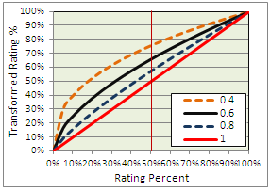
At the two extremes of the rating scale (0% and 100%), the power parameter has no effect; it only affects ‘the path’ taken between very poor and very good. With a power parameter of 0.8, an ‘average’ rating of 50% was ‘increased’ to 57%. With a parameter of 0.6 it was increased to 66% and with a parameter of 0.4 it was increased to 76%. Thus the smaller the parameter, the greater the weight attached to low ratings and the less weight to high ratings.

The logistic function shown in equation 4 was fitted to the individual response data. A quality ‘power’ parameter of 0.7 was used for station quality and 0.65 for vehicle quality after testing different values.
where
..... 4
proportion choosing A
difference in fare in dollars per trip A-B
difference in in-vehicle time in minutes A-B
difference in service interval (minutes between departures) A-B
bus/train quality rating (subtracted from 1 to change sign to negative)
bus stop/train station rating (subtracted from 1 to change sign to negative)
parameters to be estimated
fare concession entitlement taking a value of 1 if entitled to a concession else zero.

The parameters of the fitted model are presented in Table 16. All the attributes had correct negative sign with fewer people choosing the option the lower the time, cost or quality. The parameters were also highly significant, far exceeding the 95% confidence threshold of 1.96. Service interval was the strongest with a |t| value of 36 in the overall model. Next was onboard time followed by fare and stop quality with |t| values of around 30. Least important was vehicle quality at 22. The weakest parameters were the concession fare parameter and the constant with |t| values of 14.4 and 7.8 respectively (which was a desirable result).

The relative valuations are presented at the bottom of the table and graphed in Figure 10 (which also shows the 95% confidence range).

The overall value of onboard time was $9.84/hr which was noticeably higher than the ‘recommended’ values. At the time of survey (circa 2012), the recommended NZ Transport Agency values of time for evaluating transport improvements were $7.41/hr for commuting and $4.81/hr for ‘other’ trip purposes, Wallis (2013). Given the trip purpose shares in Table 1, the average value of time would have been $5.60/hr. The survey estimate of 9.84/hr therefore represents a major increase of 75% on the ‘recommended’ value.

At $19/hr, the Auckland rail estimate was double the average but the estimate should be treated with caution given the high sampling error ($10 to $27/hr). The lowest value was $6.57/hr for Christchurch bus passengers. Wellington bus respondents had a value of $12.07/hr and Auckland bus respondents $9.70/hr. At $9.41/hr, the value for Wellington rail users was three quarters that of Wellington bus users. Auckland rail users raised the rail average to $10.91/hr which was 10% above the bus average of $9.80/hr.

The overall value of service interval was 0.6. The value was close to that estimated by Beca (2002) of 0.63 which has been the basis of the recommended values in the NZ Economic Evaluation Manual, NZTA (2010).

Table 16: Estimated Stated Preference Model
 | Bus |  |  |  | Rail |  |  | ALL
Parameter Estimates | CHC | WTN | AUC | ALL | WTN | AUC | ALL
SI Dif | -0.042 | -0.043 | -0.036 | -0.039 | -0.028 | -0.036 | -0.030 | -0.036
IVT Dif | -0.045 | -0.074 | -0.053 | -0.058 | -0.067 | -0.070 | -0.068 | -0.060
Fare Dif | -0.411 | -0.368 | -0.328 | -0.355 | -0.427 | -0.221 | -0.374 | -0.366
Stop Qual Dif | -0.900 | -0.861 | -0.879 | -0.875 | -1.200 | -1.286 | -1.216 | -0.958
Veh Qual | -1.068 | -1.113 | -0.985 | -1.037 | -1.625 | -1.112 | -1.484 | -1.142
Concession Fare Constant | -0.308 | -0.440 | -0.447 | -0.447 | 0.093 | -0.520 | -0.814 | -0.879
Constant | -0.382 | -0.442 | -0.364 | -0.390 | -0.031 | -0.621 | -0.171 | -0.303
|t| Values | CHC | WTN | AUC | ALL | WTN | AUC | ALL | ALL
SI Dif | 21.0 | 21.5 | 36.0 | 39.0 | 14.0 | 12.0 | 15.0 | 36.0
IVT Dif | 9.0 | 18.5 | 17.7 | 29.0 | 13.4 | 8.8 | 17.0 | 30.0
Fare Dif | 13.3 | 16.0 | 17.3 | 27.3 | 17.1 | 4.7 | 17.0 | 33.3
Stop Quality Dif | 10.2 | 12.9 | 16.0 | 23.0 | 16.2 | 10.1 | 19.0 | 29.0
Veh Quality Dif | 8.0 | 10.6 | 11.6 | 17.6 | 13.5 | 5.6 | 14.5 | 22.4
Concession Fare Constant | 3.0 | 3.3 | 7.0 | 8.9 | 0.1 | 5.7 | 11.0 | 14.4
Constant | 3.8 | 5.7 | 5.6 | 8.7 | 0.3 | 4.1 | 2.3 | 7.8
Observations | 5,941 | 9,478 | 14,060 | 29,479 | 7,672 | 2,714 | 10,386 | 39,865
Interviews | 759 | 1,197 | 1,765 | 3,721 | 1,002 | 343 | 1,345 | 5,057
Relative Valuations | CHC | WTN | AUC | ALL | WTN | AUC | ALL | ALL
Service Interval / IVT (mins) | 0.93 | 0.58 | 0.68 | 0.67 | 0.42 | 0.51 | 0.44 | 0.60
Value of Onboard Time $/hr | 6.57 | 12.07 | 9.70 | 9.80 | 9.41 | 19.00 | 10.91 | 9.84
Max Stop Quality / IVT mins | 20 | 12 | 17 | 15 | 18 | 18 | 18 | 16
Max Veh Quality / IVT mins | 24 | 15 | 19 | 18 | 24 | 16 | 22 | 19
Vehicle Quality Percent of Av IVT | 113% | 72% | 71% | 78% | 76% | 53% | 68% | 70%
Stop Quality Percent of Av Fare | 90% | 58% | 86% | 76% | 44% | 135% | 55% | 66%
Vehicle Quality Percent of Av Fare | 107% | 75% | 96% | 90% | 59% | 117% | 67% | 78%
Average Fare ($/trip) | 2.43 | 4.05 | 3.13 | 3.26 | 6.46 | 4.30 | 5.93 | 3.98
Average Trip (IVT mins) | 21 | 21 | 26 | 23 | 32 | 30 | 32 | 27

Bus respondents valued SI higher than rail (0.67 versus 0.43) reflecting higher bus frequencies both in the SP designs and actually experienced. The value was noticeably higher for Christchurch bus respondents (0.93) although it had a wide range.

Figure 10: Estimated Relative Valuations
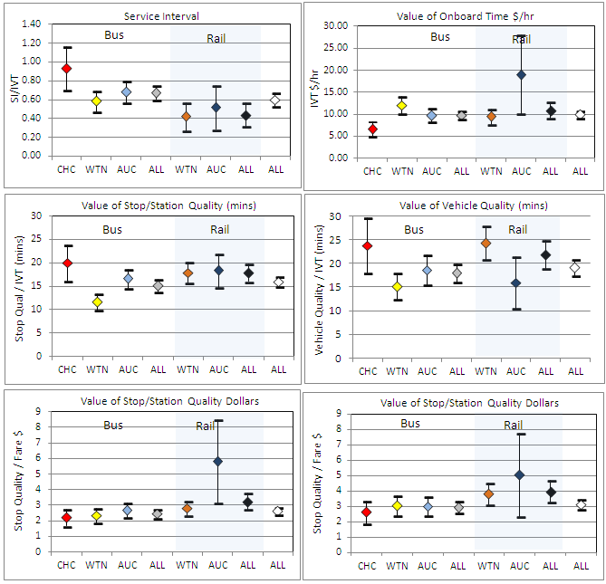

In terms of vehicle quality, the maximum value (i.e. very poor to very good) was worth 19 minutes (70% of the average trip of 27 minutes) or 80% of the average fare of $3.98. Across the market segments, the value ranged from 15 minutes (Wellington Bus) to 24 minutes (Christchurch and Wellington Rail). It should be stressed that this is a maximum value unlikely to be experienced in the aggregate given the tendency for people to rate differently from one another (it would be most improbable for everyone to rate a bus as ‘very poor’ as it would be for everyone to rate a bus as ‘very good’).

The range in vehicle quality across the bus and train routes surveyed was much narrower at 63% to 83% and this range was worth 2.8 minutes of onboard time (11% of fare). The quality of the individual vehicle types surveyed was wider at 37% to 82% (see Appendix Table 1) and this range was worth 6.8 minutes (28% of fare). These values compare with the median vehicle quality value of 4.3 minutes (27% of fare) established by the literature review (Table 2).

At 16 minutes, the maximum value of stop/station quality was 3 minutes less than for vehicle quality. The value was lowest for Wellington bus respondents at 12 minutes and highest at for Christchurch bus respondents at 20 minutes. The value for train stations was 18 minutes. In terms of the percentage of the average fare paid, Wellington rail respondents had the lowest value (44%) and Auckland rail respondents the highest (135%).

Again like vehicle quality, this is a maximum value for stop quality that is unlikely to be realised. As a guide, the difference in rating between local and hub rail stations was 56% to 74% (Table 2) and this range was worth 2.3 minutes (9% of fare). The range in individual stop/station ratings was much wider ranging from 25% to 80% (see Figure 5). The value of this range in stop quality was worth 7.6 minutes (31% of fare). The values compare with 5.7 minutes determined by the literature review (Table 3).

More detailed analysis of the response to the SP survey was undertaken. This work included developing a curvilinear function for the service interval valuation and assessing the effect of personal income on the value of time.

For service interval, a curvilinear function was estimated whereby the relative valuation for SI declined as the service interval lengthened. Figure 11 presents the estimated function. For high frequency services departing every 5 minutes, the SI/IVT valuation was 0.95. For such high frequency services, passengers are likely to ‘turn up at ‘random’ at the bus stop rather than consult a timetable. Given random arrivals, the wait time would be half the headway and the SP valuation of 0.95 implies the time spent at the stop would be valued at 1.9 times that of in-vehicle time (which is close to the common assumption of 2xIVT). At 15 minutes, the valuation declined to 0.71 and at 40 minutes it was 0.36. Thus for infrequent services, because passengers time their arrival at the stop, they wait proportionately less than they would for high frequency services. For these less frequent services, the ‘cost’ of frequency increasingly reflects timetable inconvenience (not being able to travel when you want to) rather than just waiting time. In using the function, it is recommended that the mid-point is used to value a change in service frequency. Thus to assess a change in frequency from every 40 minutes to every 20 minutes, the 30 minute valuation (0.47) should be used.

Figure 11: Curvilinear SI/IVT Valuation Function
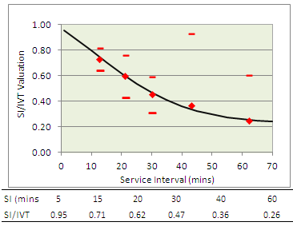

Respondents were asked to indicate their annual personal income (before tax) from five categories. For those who did not give an income (about 20%), the income was ‘in-filled’ using a probabilistic technique developed by Douglas and Jones (2013). By fitting the SP response to the income categories, it was possible to estimate the relationship between the value of time and income as presented in Figure 12. For respondents with an income less than $30k, the value of time was $8.91/hr which increased to $13.62/hr for respondents with incomes over $120k. As can be seen, the relationship was relatively flat with the VOT increasing at 3 cents per hour per thousand dollars of income (from a base of $8.54/hr).

Figure 12: Value of In-vehicle Time with Income
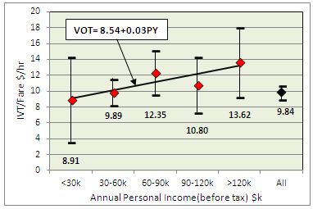

A ‘super model’ was fashioned that brought together passenger profile and mode/city characteristics. Table 17 shows the effects that were statistically significant.

Table 17: Explanatory ‘Super Model’ of Attribute Sensitivity
Variable | Parameter | Effect^
Gender (Base = Female) | Male*IVT | -22%
Journey Purpose  (Base = Work) | Comp Business * Fare | -44%
 | Shopping * SI | -22%
 | Shopping * Stop Quality | 39%
 | VFR * Vehicle Quality | 38%
 | Ent/Hol * Vehicle Quality | 52%
Socio-Econ Status  (Base = Employed) | House Person * SI | -33%
 | House Person * IVT | -27%
 | Unemployed * IVT | -44%
Age Group  (Base = 25-64) | Age <18 * Fare | 12%
 | Age 18-24 * Fare | 9%
 | Age>64 * SI | -43%
 | Age>64 * IVT | -43%
 | Age>64 * Fare | -59%
Time Period  (Base = non PM Peak) | PM Peak * SI | 30%
Mode (Base=Bus) | Rail * Stop Quality | 44%
City & Mode  (Base = WTN Bus) | WTN Rail * SI | -48%
 | WTN Rail * Vehicle Quality | 56%
 | AUC Bus * SI | -30%
 | AUC Bus * IVT | -17%
 | AUC Bus * Fare | -13%
 | CHC Bus * Fare | 22%
^ the effect compared to sensitivity in the ‘base’ model.
Males were less bothered about travel time than females. Company business trips (likely to seek reimbursement) and older passengers (>64) who were more to be entitled to free travel (gold card) were less sensitive to fare whereas younger passengers were more fare sensitive.

House persons and unemployed passengers were less sensitive to travel time as were older passengers and Auckland bus users. Passengers making shopping trips, house persons, older passengers and Auckland bus users were less sensitive to service frequency whereas respondents travelling in the PM peak were more sensitive. Auckland bus users were less sensitive to fare and Christchurch bus users more sensitive than Wellington bus users.

Rail respondents in general and shoppers in particular were more sensitive to stop quality.

People visiting friends and relatives or making entertainment/holiday trips were more sensitive to vehicle quality than other commuters. Wellington rail users also tended to be more sensitivity to vehicle quality.

8. Applying the Quality Valuations

Section 6 gave some examples of how the quality values can be used to value vehicles and stop/stations based on passenger ratings.

It is also possible to build packages of attributes and value their worth. The bus rating questionnaire asked passengers whether a shelter (W) seats (S), a timetable (T) and real time information (R) was provided at their bus stop. The sample of 3,349 respondents covered all the sixteen possible combinations of facility provision as shown in Figure 13. The facility combinations were able to be valued based on the average ratings provided. At the extremes, a bus stop with no facilities rated at 46% compared to 75% for a stop with all four facilities. The SP valued the rating difference at 16% of the average fare. Providing shelter was worth 9%, seating 3%, real time information (RTI) 3% and a timetable 2%.

Figure 13: Value of Bus Stop Facilities
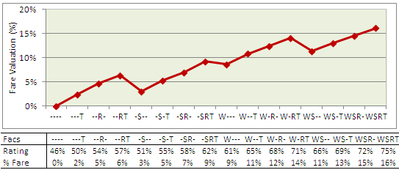

The approach can also be used to monitor performance since the rating survey is akin to a conventional customer satisfaction survey. The advantage is that the SP survey enables changes in ratings to be valued in dollars (or minutes) which can then be translated into lost or gained patronage by applying demand elasticities.

Imagine a planning authority wishing to take account of the onboard cleanliness/graffiti of a bus operator. Suppose, the cleanliness rating is 50% compared to an average of 70% and the operator’s overall rating is 60%. From Table 8, cleanliness explains around 8.5% of the overall vehicle rating (averaging males and females). Thus the 20% difference in cleanliness would account for 1.7% of overall rating difference. Applying the power function of 0.65 (to take account of the declining quality sensitivity) reduces the cleanliness effect to 1.3%. Taking 1.3% of the maximum WTP of 19 minutes (Table 16) gives a cost of 0.25 minutes or 4c per trip which is the direct effect. If the same ‘halo’ multiplier as estimated for Sydney applied (1.7) the total effect would increase to 0.43 mins or 7c per trip.

8. Conclusions

By using ratings combined with Stated Preference based valuations, a methodology was developed that could value ‘packages’ of improvements in service quality.

As well as being able to assess new vehicles and station refurbishment, the method enables changes in operational factors such as cleanliness/graffiti and staff performance to be valued.

By using self-completion questionnaires handed out and collected onboard buses and trains, the method was able to get the views of passengers ‘as they travelled’ in a cost-effective way. Thus the ratings relate to actual ‘on the day’ experiences’. The method also represents an enhanced ‘customer satisfaction survey’ approach by providing ‘objective’ valuations of qualitative changes.

The survey also estimated the value of travel time and service frequency for bus and train users in the three largest cities in New Zealand. At $9.84/hr, the value of in-vehicle time was an increase of 75% on the recommended value and therefore would have a marked uplift on the economic merit of public transport investments if adopted. The value of service interval at 0.6 was close to the recommended valuation and exhibited a similar curvilinear relationship whereby the valuation declined with the frequency of service.

The same hybrid rating and SP approach has subsequently been used in Sydney in 2013-14 to survey bus, rail, LRT and ferry services and in Melbourne in 2014 by Public Transport Victoria to survey bus, tram and rail services. Of particular note is the estimation of indirect ‘halo’ effects for Sydney Rail which approximately doubled the direct effect of improvements to individual attributes. There would be merit in estimating a matrix of halo effects using the NZ data and in merging the results of the NZ, Sydney and Melbourne studies to develop a wider library of vehicle and stop/station parameters.

References

AECOM (2009) “The Role of Soft Measures in Influencing Patronage Growth and Modal Split in the Bus Market in England” Final Report for the UK Department of Transport”, October 2009.
Australian Transport Council (2006) “National Guidance for Transport System Management in Australia”
Balcombe et al (2004) “The Demand for Public Transport: A Practical Guide (TRL 593)”.
Beca Carter Hollings & Ferner in association with SDG, Forsyte Research Brown Copeland & Co (2002) “Evaluation Benefit Parameter Values” report to Transfund April 2002.
Booz Allen and Hamilton and PCIE (1995) “Ultimo – Pyrmont Light Rail CBD Patronage Study” report for NSW Department of Transport.
Booz Allen Hamilton and PCIE (2001) “Market Research Sydney Ferries” report for State Transit NSW
Bristow A.L. and Davison L.J. (2009) “The Determinants of Bus Patronage in England – Literature Review” report undertaken as part of Aecom (2009) study see above.
Douglas N.J. and Jones M. (2013) “Estimating Transfer Penalties & Standardised Income Values of Time by Stated Preference Survey” ATRF Brisbane 2013.
Douglas N.J. and Jones M. (2013) “Estimating Transfer Penalties & Standardised Income Values of Time by Stated Preference Survey” ATRF Brisbane 2013.
Douglas N.J. (2014) “Who are your Urban Bus Passengers and What are they Willing to Pay for” Paper presented at the Annual Bus & Coach Association Conference, AKL, July 2014.
Douglas, N., and G. Karpouzis, (2006) “Valuing Rail Service Quality Attributes through Rating Surveys” 29th Australasian Transport Research Forum, Gold Coast, 2006,
Douglas Economics (2005) “Tranz Metro Passenger Survey”, report to Tranz Metro by Douglas Economics dated April 2005.
Douglas Economics (2015) “Service Quality Values of Rail Transport in Sydney” report to Sydney Trains by Douglas Economics dated August 2015.
Evmorfopoulos A.P. (2007) “Valuing “soft” factors improvements in urban bus services”. MSc Dissertation, Institute for Transport Studies, University of Leeds.
Fearnley N, Flugel S and Ramjerdi F (2011) “Passengers’ valuations of universal design measures in public transport” in Research in Transportation Business & Management January 2011.
Halcrow (2005) “Dandenong Rail Corridor Market Assessment Stated preference Survey of Train Passengers” Report provided to Department of Infrastructure Public Transport Division.
Hammer F and Nordheim B (1993) “Bus Passengers Valuation of Service Improvements – A Conjoint Analysis on the Basis of Market Surveys in three Norwegian Towns Institute of Transport Economics” report 166 1993.
Hensher D.A. and Prioni P. (2002) “A Service Quality Index for Area-wide Contract Performance Assessment”. Journal of Transport Economics and Policy 36 (1) 93-113
Hensher, D.A., Stopher, P., and Bullock, P., (2003) “Service Quality—Developing a Service Index in the Provision of Commercial Bus Contracts” Transportation Research, Vol. 37A, No. 6, 2003, pp. 419–517.
Litman, T., (2008) “Valuing Transit Service Quality Improvements: Considering Comfort and Convenience in Transport Project Evaluation” Research Report, Victoria Transport Policy Institute, Victoria, BC, Canada.
NZ Transport Agency (2010) “Economics Evaluation Manual Volume 2”, reported prepared by NZ Transport Agency dated January 2010.
Outwater ML Spitz G Lobb J Campbell M (2010) Resource Systems Group TCRP H-37 “Characteristics of Premium Transit Services that Affect Mode Choice Summary of Phase I”
Pacific Consulting (1995) “Value of Rail Service Quality”, Report to State Rail Authority Planning and Development 1996.
SDG (1991) “The effects of quality improvements in public transport” Part IIB detailed Market Research results and parameter estimates, Final Report to Wellington Regional Council, April 1991
Thorndike, EL (1920), "A constant error in psychological ratings", Journal of Applied Psychology 4 (1): 25–29.
Transport for London (2004) Business Case Development Manual,
Transport for London (2008) Business Case Development Manual, report issued by TfL Investment Programme Management Office dated May 2008.
Wallis I.P. and Gromit N.J. (2013) “Economic appraisal of public transport service enhancements” Report to the New Zealand Transport Agency dated October 2013.
Wardman M. and Whelan G. (2001) “Valuation of improved railway rolling stock: a review of the literature and new evidence” in Transport Reviews, Volume 21, Number 4, 1 October 2001 , pp. 415-447(33)

Appendix - Summary of Vehicle Types Surveyed & Ratings
 |  |  | Vehicle Details |  |  |  |  |  |  | Rating
# | Vehicle | M | Age | Seats | BikeRack | Air Con | Super Low | WChair | Euro | Overall | Sample
 | Type |  | Years | N | CCH (%)* | (%) | Floor (%) | Acc (%) | Engine | Rate % | Size
1 | ADL | B | 1.5 | 37 | na | 100% | 100% | 100% | 5 | 75% | 905
2 | BCI | B | 5 | 38 | na | Na | na | na | 3 | 79% | 14
3 | DLMacr | B | 10 | 43 | na | 100% | 100% | 100% | 3 | 75% | 40
4 | DLMerc | B | 8 | 39 | 100% | 0% | 100% | 100% | 3 | 75% | 28
5 | MAN11 | B | 14.9 | 39 | 84% | 0% | 80% | 60% | 1 | 66% | 1137
6 | MAN12 | B | 9.9 | 41 | 100% | 20% | 100% | 100% | 3 | 69% | 930
7 | MAN13 | B | 5.2 | 32 | na | 100% | 100% | 100% | 3 | 75% | 15
8 | MAN14 | B | 5.4 | 39 | na | 100% | 100% | 100% | 3 | 69% | 253
9 | MAN15 | B | 5 | 41 | na | 100% | 100% | 100% | 4 | 74% | 9
10 | MAN16 | B | 5.2 | 41 | 100% | 30% | 100% | 100% | 3 | 69% | 306
11 | MAN17 | B | 8.2 | 50 | 100% | 50% | 100% | 100% | 3 | 69% | 1010
12 | MAN18 | B | 2.6 | 43 | 100% | 80% | 100% | 100% | 4 | 71% | 104
13 | MAN1A | B | 2.2 | 41 | 100% | 100% | 100% | 100% | 4 | 71% | 255
14 | MAN22 | B | 21 | 53 | na | 0% | 0% | 0% | Pre | 60% | 37
15 | MANSG | B | 30 | 76 | na | 0% | 0% | 0% | Pre | 66% | 11
16 | MRC30 | B | 10.6 | 43 | na | 0% | 0% | 0% | 1 | 67% | 27
17 | MRC709 | B | 16 | 25 | na | 0% | 0% | 0% | 1 | 50% | 6
18 | NISSL | B | 14 | 38 | na | 0% | 100% | 0% | Pre | 60% | 12
19 | NISSS | B | 16.4 | 38 | na | 0% | 90% | 40% | Pre | 62% | 47
20 | OPTL | B | 13 | 40 | 0% | 0% | 100% | 100% | 2 | 59% | 35
21 | OPTMR | B | 18 | 22 | na | 0% | 0% | 0% | Pre | 64% | 70
22 | OPTX | B | 15 | 40 | na | 0% | 100% | 100% | 2 | 58% | 15
23 | SCAN | B | 3.7 | 47 | 100% | 90% | 100% | 100% | 4 | 74% | 1054
24 | TROLY | B | 3 | 43 | na | 0% | 100% | 100% | T | 73% | 316
25 | VOLB10 | B | 29 | 43 | Na | 0% | 0% | 0% | 1 | 37% | 19
26 | VOLB12 | B | 10 | 54 | Na | 0% | 0% | 0% | 3 | 81% | 4
27 | VOLB7 | B | 5.3 | 45 | Na | 40% | 100% | 100% | 4 | 72% | 391
28 | Zhong | B | 2.9 | 39 | 100% | 10% | 100% | 100% | 4 | 62% | 104
29 | RA_ADK | R | 11 | 68 | Na | 100% | na | na | Diesel | 67% | 84
30 | RA_ADL | R | 11 | 68 | Na | 100% | na | na | Diesel | 66% | 897
31 | RA_SA | R | 9 | 60 | Na | 100% | na | na | Diesel | 68% | 481
32 | RA_SD | R | 9 | 60 | Na | 100% | na | na | Diesel | 69% | 33
33 | RW_DIE | R | 5 | 64 | Na | 100% | na | na | Diesel | 78% | 288
34 | RW_GM | R | 13 | 74 | Na | 0% | na | na | Electric | 59% | 499
35 | RW_MAT | R | 1 | 75 | Na | 100% | na | na | Electric | 82% | 2553
* Bicycle racks were only available on Christchurch buses with percentage only calculated for CHC buses

The paper draws upon material provided to the NZ Bus and Coach Council and presented at the 2014 Bus and Coach Conference in a paper entitled “Who are your Urban Bus Passengers and What are they Willing to Pay for”, Douglas (2014).
For Wellington, two earlier rating surveys undertaken in 2002 and 2004 by Douglas Economics for Tranz Metro provided additional response which was used in the rail station analysis. The 2002-04 data when combined with the 2012-13 surveys also enabled a ‘before and after’ of the effect on ratings of station upgrades and had the added advantage of ‘control stations where no improvements had been undertaken. Description of this analysis was beyond the scope of this paper.
For the attributes (i.e. excluding the model constant), the average ratio of the logistic parameter over the linear parameter was 4.9 compared to 1.5 for the constant. The logistic models were estimated using NLOGIT5 using robust estimation to correct for non constant error variance that otherwise inflated the standard errors.
The halo effect was named by psychologist Edward Thorndike in reference to a person being perceived as having a halo. Halo effects have been studied in relation to how an overall impression of a person, company or brand is influenced by the assessment of component attributes, characteristics or properties. The halo effect is whereby positive feelings in one area cause other attributes to be viewed favourably. The effect can work in the converse negative direction (the horns effect) whereby if the observer dislikes one aspect of something, they will have a negative predisposition towards other aspects.
The full halo effect matrix is presented in Douglas Economics (2015).
This value of time is slightly inflated since no adjustment has been made for child and fare student discounts. This is done in the disaggregate analysis.

